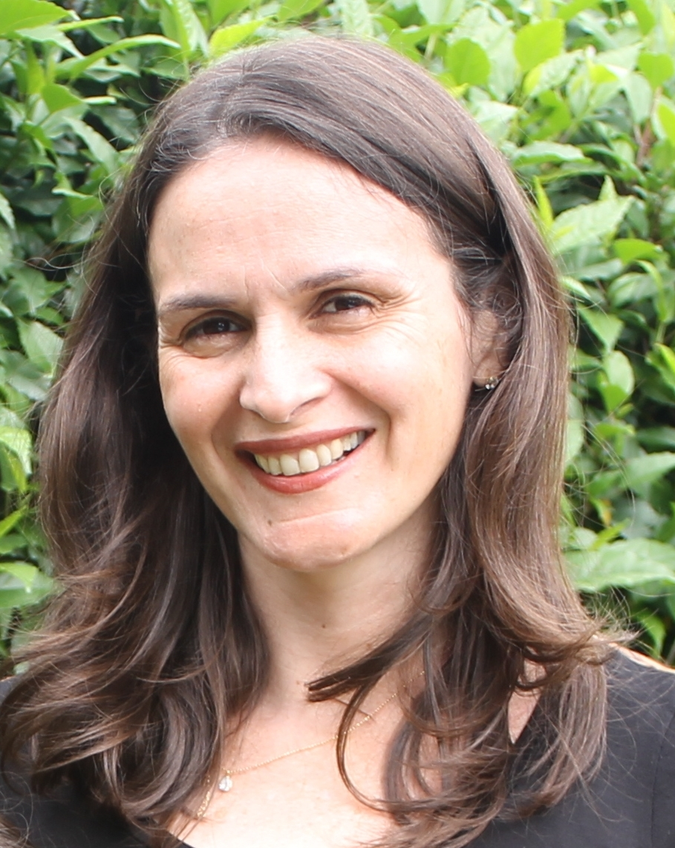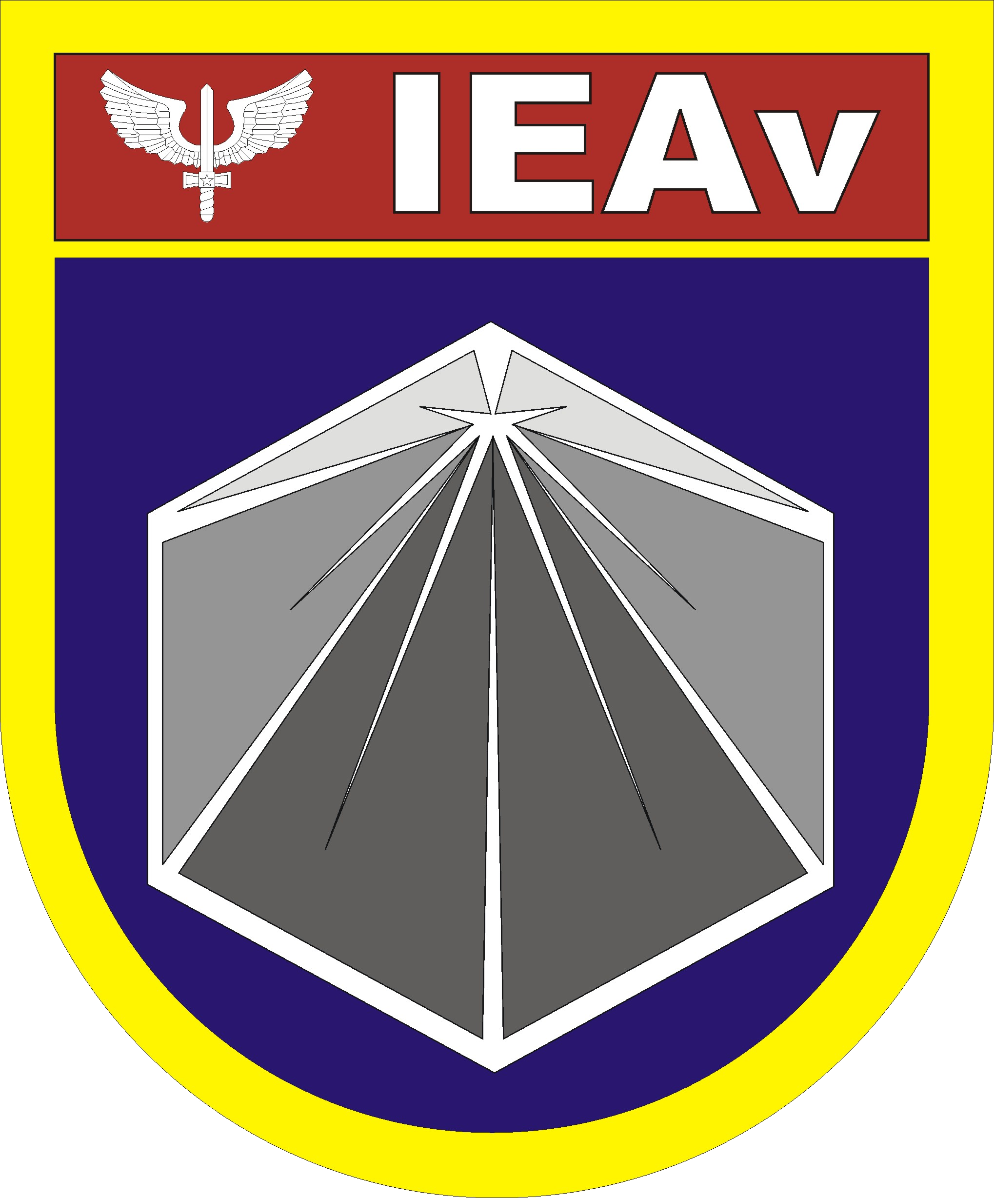

The data acquisition and download satellite scheduling problem
Maria José Pinto, PhD, IEAv (Institute of Advanced Studies), Brazil Mönica M De Marchi, PhD, IEAv (Institute of Advanced Studies), Brazil Ana Cláudia Iwazaki, Electrical Engineer, IEAv (Institute of Advanced Studies), Brazil

Abstract
This work addresses the scheduling problem of gathering and download data for a constellation of satellites and associated ground stations. This problem is related with an effectiveness evaluation for collecting imagery to monitor different locations (targets) with different priorities for a given planning horizon, with several operational constraints. In previous work the proposed mathematical model focused on ensuring that target observations would take place within the available observation time-windows, enforcing precedence constraints between acquisition and download of data as well as the satellites processing time capacities. It also explicitly modeled the revisit time (the time between successive observations of the same target) and the due time (the latest possible moment that the collected imagery is available at the ground station). Improvements to the previous modeling were proposed afterward by incorporating the setup time between two consecutive acquisitions which is required to adjust the sensor to capture the target imagery requests with a certain acquisition mode. Also the current model can cope with satellite storage capacity. In this paper, the practicability of the methodology will be demonstrated in different monitoring contexts such as deforestation, oil spill and border control as well as for updating information on search and rescue scenario. As a result it is expected to increase the situation awareness and enable early detection of disasters and/or mitigation actions.

Key words: Scheduling, Data Acquisition and Download, Mathematical Model, Constellation of Satellites, Regular Monitoring, Imagery Collection.

Image

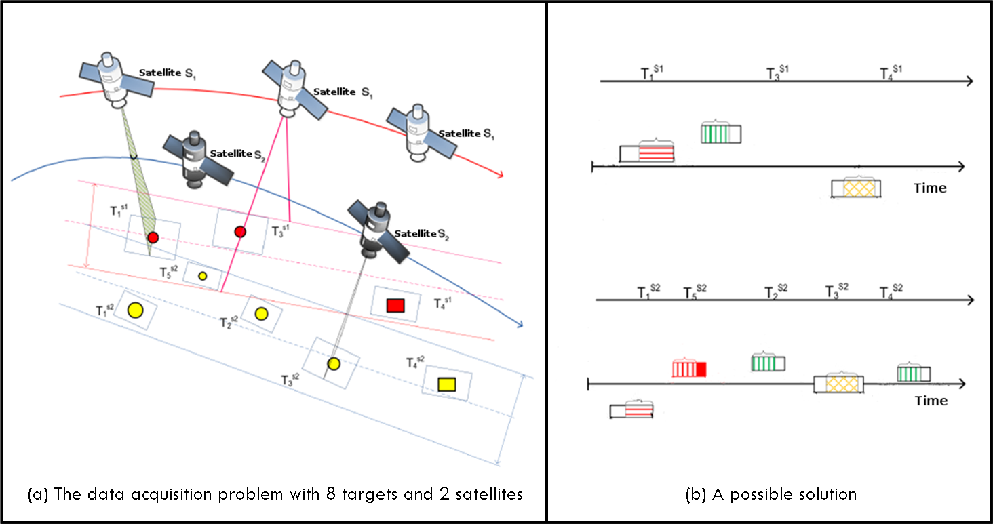
Figure 1: Illustrative instance
Recent Publications
- Kim H, Chang J K (2015) Mission scheduling optimization of SAR satellite constellation for minimizing system response time. Aerospace Science and Technology 40: 17-32.
- Cho D-H, Kim J-H, Choi J-L, Ahn J (2018) Optimization-based scheduling method for agile earth-observing satellite constellation. Journal of Aerospace Information Systems 15: 611-626.
- Pinto M J, Barros A I, Noomen R, Van Gelder P H A J M, Lamballais Tessensohn T (2018) A new model proposal for integrated satellite constellation scheduling within a planning horizon given operational constraints. Proceedings of the 7th International Conference on Operations Research and Enterprise Systems (ICORES), 312-319. ISBN 978-989-758-285-1. DOI: 10.5220/0006655003120319.
- Zhang S, Xiao Y, Yang P, Liu Y, Chang W, Zhou S (2019) An Effectiveness Evaluation Model for Satellite Observation and Data-Downlink Scheduling Considering Weather Uncertainties. Remoting Sensing 11: 1621-1640.
- Pinto M J, De Marchi M M (2019) Análise do Modelo Matemático Referente ao Sequenciamento para Aquisição e Download de Dados por uma Constelação de Satélites. Proceedings of the LI Simpósio Brasileiro de Pesquisa Operacional (SBPO), Limeira, SP (in Portuguese).
- Pinto M J, De Marchi M M, Barros A I (2019) Adaptação do Modelo Matemático referente ao Planejamento para Aquisição e Download de Dados Espaciais (in Portuguese). Proceedings of the XXI Simpósio de Aplicações Operacionais em Áreas de Defesa (SIGE), São José dos Campos, SP (in Portuguese).

Biography
Maria José Pinto is a researcher at Institute of Advanced Studies (IEAv) since 2002. The IEAv is an organization of the Department of Aerospace Science and Technology (DCTA). Her post-doc was developed in partnership with TNO and TU Delft in The Netherlands. She has a PhD degree in Applied Computing (Operational Research) at National Institute for Space Research (INPE), a Master of Science degree in Computer Science and Computational Mathematic (Optimization) at University of São Paulo (USP) and an undergraduate education in Mathematic at Federal University of Viçosa (UFV). Her main research areas are Operations Research and Decision Support Systems.

Presenting author details
Full name (As per the passport): Maria José Pinto
University/Industry/Organization name: Institute of Advanced Studies
Designation (Director/Prof/Assistant or Associate prof/Researcher/Student): Researcher
Country: Brazil
Mobile number (country code – number): +55 12 99707-9945
Track number: Track 1
Category (Oral presentation/ Poster presentation/Young researcher forum/E-poster): Oral presentation
Research interest: Operations Research, Decision Support System, Spatial Systems Applications
Your profile page URL in your department: http://www.ieav.cta.br/
Year of birth: 1971
Linked In/Facebook/twitter account: linkedin.com/in/maria-josé-pinto-460b9b170 / https://pt-br.facebook.com/mariajosepinto.lamosa

Note: Please fill up the Red mark fields so that it would be easier for us to cite your details in the conference particulars. (Please do not forget to fix your photo and Logo above the title)

