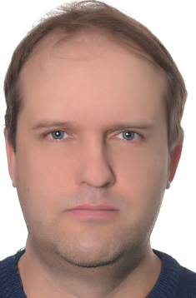 Official Photo 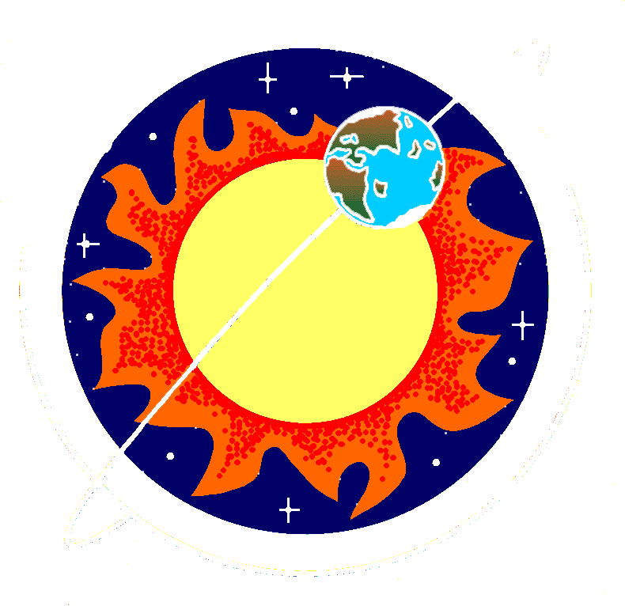 University/Organization Logo

GNSS carrier phase noise as a promising mean to reconstruct fine structure of the ionosphere
Vladislav V Demyanov, PhD, Irkutsk State Transport University, Russia
Yuri V. Yasyukevich, PhD, Institute of Solar and Terrestrial Physics, Russia

Abstract (300 word limit)
Ionospheric activities and natural hazard events are accompanied with ionospheric disturbances at different spatial and temporal scales. For example, multi-scale-ionospheric GNSS-TEC disturbances are observed during certain periods of time before and after the main phase of geomagnetic storms and earthquakes. Rocket launches are also accompanied with TEC-waves of different scales. Earlier it was revealed that both existence time and propagation distances are substantially different for the ionospheric waves at different scales. The small-scale ionospheric turbulences have weaker intensity, but they live longer and propagate with different speeds in comparison to the large-scale ionospheric disturbances. Thus, we could consider small-scale ionospheric disturbances as an additional means to improve the efficiency and reliability of ionospheric activity monitoring. In this report, the second-order derivative of the GPS signal phase is considered as a promising means to detect the small-scale weak ionospheric disturbances. Our modeling and experimental results show that the second-order derivative of the GPS-signal phase can be utilized to detect the weak small-scale ionospheric disturbances with size of decades and hundreds of meters. As the single-frequency data interpreting strictly depends on the L2P(Y) or L2C data were processed we discuss the likely cause for these differences: L1-aided tracking used to track both the L2P(Y) and L2C signals as well.

Key words: GNSS- Remote sensing, Small-scale ionospheric turbulences, Ionosphere, Scintillations indices

Recent Publications

- V.V. Demyanov, Yu.V. Yasyukevich, A.B. Ishin, E.I. Astafyeva. Effects of ionosphere super-bubble on the GPS positioning performance depending on the orientation relative to geomagnetic field // GPS Solut (2012) 16:181-189. DOI: 10.1007/s10291-011-0217-9. Available from: http://www.researchgate.net/publication/257493065_Ionospheric_super-bubble_effects_on_the_GPS_positioning_relative_to_the_orientation_of_signal_path_and_geomagnetic_field_direction
- E.L. Afraimovich, E. I. Astafyeva, V.V. Demyanov, et al. A review of GPS/GLONASS studies of the ionospheric response to natural and anthropogenic processes and phenomena // J. Space Weather Space Clim. 3 (2013) A27. DOI: 10.1051/swsc/2013049. Available from: http://www.researchgate.net/publication/259477790_A_review_of_GPSGLONASS_studies_of_the_ionospheric_response_to_natural_and_anthropogenic_processes_and_phenomena
- V.V. Demyanov, R.V. Likhota The method of GNSS positioning availability control for transportation applications // Machines, Technologies, Materials / Issue 5. 2015. ISSN 1313-0226. P. 11-13. Available from: http://mech-ing.com/journal/Archive/2015/5-2015.pdf
- V.V. Demyanov, Yu.V. Yasyukevich, T.V. Kashkina Detecting the small-scale ionospheric irregularities based on GNSS data // Proc. of SPIE Vol. 10035 1003574-1. DOI:10.1117/12.2249347
- V. V. Demyanov, Yu. V. Yasyukevich and SG Jin (2013). Effects of Solar Radio Emission and Ionospheric Irregularities on GPS/GLONASS Performance, Geodetic Sciences - Observations, Modeling and Applications, Prof. Shuanggen Jin (Ed.), ISBN: 978-953-51-1144-3, InTech. Available from: http://www.intechopen.com/books/geodetic-sciences-observations-modeling-and-applications/effects-of-solar-radio-emission-and-ionospheric-irregularities-on-gps-glonass-performance

Biography
Prof. Vladislav Demyanov, Dr.Sc in Engineering, has actually been working as a full professor of Irkutsk State Transport University since November, 2009. Besides Prof. Demyanov works as a senior research scientist of the GNSS Remote Sensing Research Group, Institute of Solar and Terrestrial Physics (Siberian Branch of Russian Academy of Science).
Dr. Yuri V. Yasyukevich, PhD, has actually been working as a senior research scientist of the GNSS Remote Sensing Research Group, Institute of Solar and Terrestrial Physics (Siberian Branch of Russian Academy of Science).

Presenting author details
Full name (As per the passport): Vladislav Demianov
University/Industry/Organization name: Irkutsk State Transport University
Designation (Director/Prof/Assistant or Associate prof/Researcher/Student): Professor
Country: Russia
Mobile number (country code – number):7-950-051-3095
Email:vv.emyanov@gmail.com; sword1971@yandex.ru
Track number: https://satellite.conferenceseries.com/call-for-abstracts.php (For track number follow this link)
Category (Oral presentation/ Poster presentation/Young researcher forum/E-poster): Oral presentation
Research interest: Space Weather: geomagnetic storms and Solar radio flares and their impact on GNSS and SBAS performance; GNSS\SBAS integrity and positioning availability control under irregular external impacts; GNSS remote sensing of the ionosphere; GNSS application on transportation.
Your profile page URL in your department: https://www.researchgate.net/profile/Vladislav_Demyanov/
Year of birth: 1971
Linked In/Facebook/twitter account: No

Note: Please fill up the Red mark fields so that it would be easier for us to cite your details in the conference particulars. (Please do not forget to fix your photo and Logo above the title)

