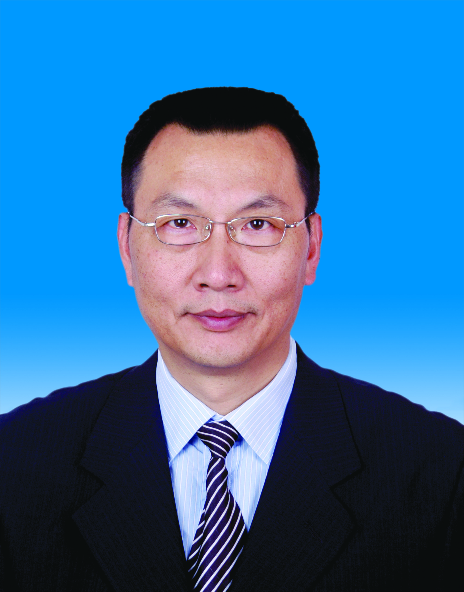

Selection of Optimum Time for Spacecraft Collision Avoidance Operation
Zhang Rong-Zhi, State Key Laboratory of Astronautic Dynamics, Xi’An Satellite control center, P.O.Box 505 Xian’ning’dong’lu 462 Xi’An Shaanxi 710043 CHINA

Abstract (300 word limit)

More than 23000 space objects around the earth orbits in total are regularly tracked by the space surveillance network and maintained in the catalogue, which cover objects whose size are larger than approximately 5 to 10 cm in low earth orbit(LEO). Most of these space objects, especially the size of only several centimeters, are called space debris which are very dangers for in-orbit operational spacecraft because of potential collision. Space debris collision avoidance has almost been a routine activity for incapable space powers for the purpose to ensure the security of their spacecraft operation. In view of the current engineering and technological basics, the confidence level of collision warning is still to be further improved. In engineering, both the ability of tracking space objects of surveillance network and the integrality of measuring data limit the accuracy of orbit determination of space objects. But according to current technologies, the prediction accuracy of orbit dynamics model, especially low orbit atmospheric model, seriously decreases the accuracy of precise orbit prediction with time prolongs. On one hand, the shorter the time duration between the prediction and potential and potential collision is, the higher confidence level of the collision avoidance warning will be. On the other hand, the preparation procedure of spacecraft maneuver and the power consumption budget require that the collision avoidance to be made earlier. This paper focuses on the selection of the optimum time for spacecraft collision avoidance operation.

Key words: Space object, Spacecraft collision avoidance operation, Precise orbit prediction

Image
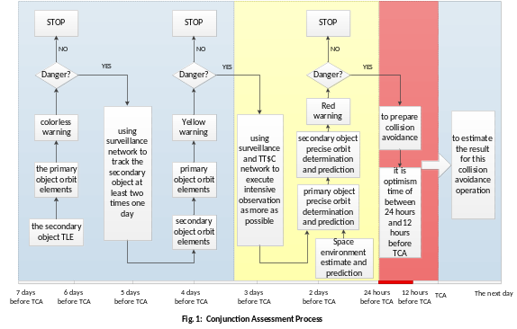
Recent Publications (minimum 5)
- LIOU,J-C, and N.L,JOHNSON(2006) Risk in space from orbit debris. Science 311;340-341.
- Miao juan,liu siqing et al.(2011)atmospheric density calibration using the real-time satellite observation, space sci 31:459-466.
- Arudra A K. (2011)Atmospheric density estimation using satellite precision orbit ephemerides. University of Kansas,2011,1-93.
- Zhang rong zhi et al.(2017) Spacecraft collision avoidance technology, National Defense Industry press ISBN 978-7-118-11345-7:154-166.
- Hedin A E. MSIS-86 (1987) THERMOSPHERIC MODEL. Journal geophys.Res.1987,92:4649.

Biography
ZHANG RONG ZHI has her expertise in evaluation and passion in the spacecraft collision avoidance warning and operation. He leads a team for spacecraft collision warning and avoidance operation is Xi’an satellite control center about two decade.

Presenting author details
Full name (As per the passport):ZHANG RONG ZHI
University/Industry/Organization name: State Key Laboratory of Astronautic Dynamics, Xi’An Satellite control center
Designation (Director/Prof/Assistant or Associate prof/Researcher/Student):PROFESSOR
Country:CHINA
Mobile number (country code – number):0086-13572170322
Email:rongzhizhang@sina.com
Track number: https://satellite.conferenceseries.com/call-for-abstracts.php (For track number follow this link)
Category (Oral presentation/ Poster presentation/Young researcher forum/E-poster):ORAL PRESENTATION
Research interest: SPACE MISSION
Your profile page URL in your department:
Year of birth:
Linked In/Facebook/twitter account:

Note: Please fill up the Red mark fields so that it would be easier for us to cite your details in the conference particulars. (Please do not forget to fix your photo and Logo above the title)

