Earth Observation from Large Platforms
Huadong Guo, Changyong Dou, Guang Liu and Yixing Ding, Institute of Remote Sensing and Digital Earth, Chinese Academy of Sciences, Beijing, China

Abstract (300 word limit)
The large manned objects flying in low Earth orbit, e.g., the U.S. and Russia’s human space vehicles, the International Space Station (ISS), and Chinese Tiangong-1, 2 experimental space laboratory, provide unique platforms for Earth observation applications from space. On the other hand, as the only nature satellite of the Earth, the moon provides a potential good Earth observation platform from deep space. Both of these space vehicles and the moon can be categorized as large Earth observation platforms, which have many common advantages, such as holding various different kinds of Earth observing sensors, which can measure multiple environmental parameters simultaneously under the same view geometry, illumination and atmospheric conditions.
Accompanying the development of manned space flight programs, Earth observation activities from large space vehicles have acquired various and large amount of datasets using both handheld cameras by crewmembers and automated sensors installed onboard these platforms. These datasets have been applied in multiple Earth science studies, demonstrating the importance and uniqueness of studying Earth from a vantage point of large platforms. For instance, the first near global digital elevation model (DEM) was produced by data obtained during the shuttle radar topography mission (SRTM).
Our humanity are ambitious in deep space exploration and have achieved gratifying progress. One objective of the exploration is to build the livable base in other planets. Moon base building could be the most achievable step in the near future. After the moon base being constructed, Earth observing is one of its three main objectives (two others are studying the moon itself and observing the deep space from it). Extending Earth observing activities from the traditional artificial satellites in lower Earth orbit to the moon may trigger revolutionary applications for the Earth system studies by remote sensed datasets from space. The Earth-moon distance is far enough to ensure the sensors can collect datasets covering half of the Earth surface. By studying events captured in these datasets may reveal the relationship of natural phenomena in large scale. Furthermore, utilizing different kinds of Earth observing sensors deployed on moon, detecting different parameters of the Earth, we can study the mechanism of the whole Earth’s environmental system. In a word, the Earth observation from large platforms played important role in Earth study, and will play more important role in the future.

Image
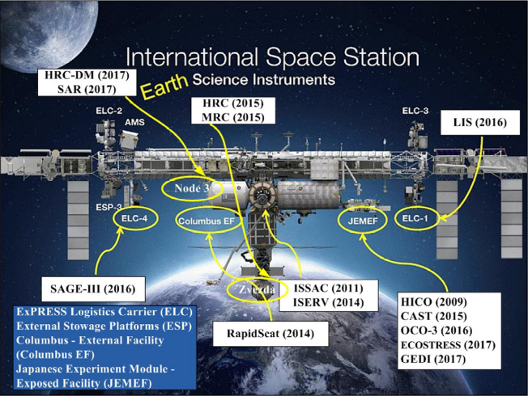
Figure 1. The locations and launch dates of the Earth observing instruments deployed in the International Space Station.(Guo et al, 2016 )
Recent Publications (minimum 5)
- Huadong Guo, Changyong Dou*, Xiaodong Zhang, Chunming Han and Xijuan Yue (2016) Earth Observation from the Manned Low Earth Orbit Platforms. ISPRS Journal of Photogrammetry and Remote Sensing, 115, pp.103-118.
- Huadong Guo (2010) Understanding global natural disasters and the role of earth observation. International Journal of Digital Earth, 3(3), pp. 221-230.
- Huadong Guo, Zhen Liu, Hao Jiang, Changlin Wang, Jie Liu and Dong Liang (2016) Big Earth Data: a new challenge and opportunity for Digital Earth’s development. International Journal of Digital Earth, 10(1), pp. 1-12.
- Changyong Dou, Xiaodong Zhang, Huadong Guo*, Chunming Han and Ming Liu. “Improving the Geolocation Algorithm for Sensors Onboard the ISS: Effect of Drift Angle”. Remote Sensing, 2014, 6(6), 4647-4659.
- Changyong Dou*, Xiaodong Zhang, Hojin Kim, Jaganathan Ranganathan, and Huadong Guo. “Geolocation Algorithm for Earth Observation Sensor onboard International Space Station” Photogrammetric Engineering & Remote SensingSensing, 2013, 79(7), pp.625-637.

Biography (150 word limit)

Huadong Guo was a Project Leader of over ten key programs related to Earth observation. For the past tens of years, he has been one of the Principal Investigators for Spaceborne Imaging Radar-C/X-Band Synthetic Aperture Radar (SIR-C/X-SAR), Japanese Earth Resources Satellite-1 (JERS-1) SAR, ERS-1/2 SAR, Radarsat-1/2, Environmental Satellite, Shuttle Radar Topography Mission, and Advanced Land Observing Satellite (ALOS) programs. He is currently with the Key Laboratory of Digital Earth Sciences, Institute of Remote Sensing and Digital Earth, Chinese Academy of Sciences, Beijing. He is also currently a Guest Professor of seven universities in China. He has authored or coauthored over 200 papers and 17 books. Prof. Guo is a member of the International SAR Working Group, the Chairman of the Association on Environment Remote Sensing of China, and the Secretary General of the International Society for Digital Earth. He is an Editorin- Chief of the International Journal of Digital Earth and a member of the CoDATA executive committee. He was a recipient of three national awards on science and technology and nine awards by the Chinese Academy of Sciences.
Email: hdguo@radi.ac.cn

Notes/Comments:

Presenting author details
Full name: Huadong Guo
Contact number:
Mail id: hdguo@radi.ac.cn
Category: (Oral presentation/ Poster presentation)

