Numerical research of steady fluidic characteristics inside triangular and trapezoidal enclosures
Bo AN, UPC PhD, Univeritat Politècnica de Catalunya,BarcelonaTech, ESEIAAT-UPC Colom, 11 08222 Terrassa, Spain.

Abstract
Considering the present work, the flow inside 2D lid driven triangular and trapezoidal cavities is investigated based on the lattice Boltzmann method. It is important to notice that the steady fluidic characteristics are the only concerns in the present work. The numerical cases are tested in many enclosures of different geometries The equilateral triangular cavity is the first geometry to be studied, the simulation is performed at Reynolds number 500 and the numerical prediction is compared with previous work done by other scholars. Several isosceles triangular cavities are studied at different initial conditions, Reynolds numbers ranging from 100 to 3000. A series of trapezoidal cavities with different top/base ratios are also studied at low Reynolds numbers. Compared with the lid driven condition, for each trapezoidal geometry, the driven velocity is also tested on the base line, regardless of the geometry studied, the top lid is always moving from left to right and the driven velocity remains constant. Results are also compared with previous work performed by other scholars, the agreement is very good.

Image

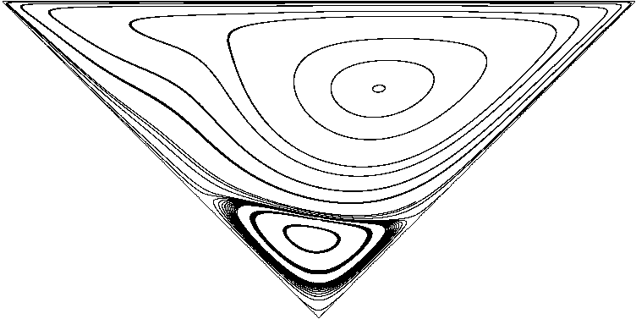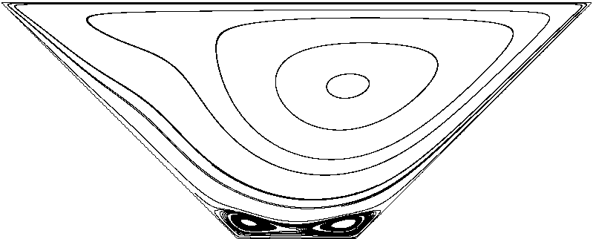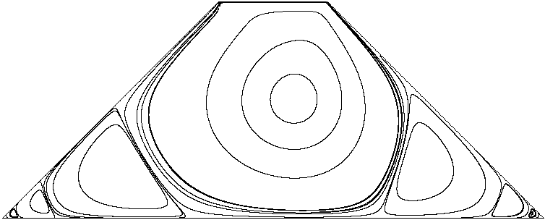

Recent Publications (minimum 5)
- McQuain W.D., Ribbens C.J., Wang C.Y., Watson L.T. (1994) Steady viscous flow in a trapezoidal cavity. Computers & Fluids 23, 4: 613-626.
- Jyotsna R., Vanka S.P. (1995) Multigrid calculation of steady, Viscous Flow in a Triangular Cavity. Journal of Computational Physics 122, 1: 107-177.
- Li M., Tang T. (1996) Steady viscous flow in a triangular cavity by efficient numerical techniques. Computers & Mathematics with Applications 31, 10: 55-65.
- Gaskell P.H., Thompson H.M., Savage M.D. (1999) A finite element analysis of steady viscous flow in triangular cavities. Journal of Mechnical Engineering Science 213, 3: 263-276.
365: 519-530.
- Kohno H., Bathe K.J. (2006) A flow-condition-based interpolation finite element procedure for triangular grids. International Journal for Numerical Methods in Fluids 51, 6: 673-699.
- Erturk E., Gokcol O. (2007) Finite Grid Numerical Solutions of Triangular Cavity Flow. The European Physical Journal-Applied Physics 38: 97-105.
- Pasquim B.M., Mariani V.V. (2008) Solutions for Incompressible Viscous Flow in a TriangularCavity using Cartesian Grid Method. CMES: Computer Modeling in Engineering & Sciences 35, 2: 113-132
- Zhang T., Shi B.C., Chai Z.H. (2010) Lattice Boltzmann simulation of lid-driven flow in trapezoidal cavities. Computers & Fluids 39, 10: 1997-1989.
- González L.M., Ahmed M., Kühnen J., Kuhlmann H.C., Theofilis V. (2011) Three-dimesional flow instability in a lid-driven isosceles triangular cavity. Journal of Fluid Mechanics 675, 1: 369-396.
- Che Sidik N.A., Munir F.A. (2012) Mesoscale Numerical Prediction of Fluid Flow in a Shear Driven Cavity. Arabian Journal for Science & Engineering 37, 6: 1723
- Idris M.S., Nor Azwadi C.S., Izual N.I.N. (2012) Vortex structure in a two dimensional triangular lid-driven cavity. AIP Conference Proceedings, the 4th International Meeting of Advance in Thermofluids 1440,3.

 Biography (150 word limit)

Bo An has his expertise in fluid mechanics. He graduated as a Bachelor from Northwestern Polytechnical University in 2010. He got his Master degrees from Northwestern Polytechnical University and Universidad Politécnica de Madrid in 2013 and 2015 respectively. Now he is working on Fluid control, lattice Boltzmann method, ice accretion and linear stability.
Email: bo_alan_an@163.com

Notes/Comments:

