Hemodynamics and hemolysis of blood flow through mechanical aortic heart valves: a numerical study.
Anh V Nguyen, University of Rome “Tor Vergata”, Italy Roberto Verzicco, University of Rome “Tor Vergata”, Italy

Abstract (300 word limit)
Statement of the Problem: The purpose of this research is to numerically investigate blood flows over an aortic bileaflet mechanical heart valve employed in the human heart through valve implantation surgery. The modeled valve used in the simulation is a St. Jude Medical valve with three sinuses Valsava grafts (Fig. (a)). Many previous studies of bileaflet mechanical heart valves have been done but there are still lacks of investigations of hemolysis of the blood at the closure of the valve leaflets as well as at the highly turbulent flows due to high viscous shear stresses of the flow in the ascending aorta. Methodology & Theoretical Orientation: The computational method is a Fluid-Structure Integration (FSI) algorithm that couples Direct Numerical Simulation (DNS) and Immersed Boundary Method (IBM). The FSI model is used to modeling blood flow through the aortic valve to investigate physiological characteristics of the blood flow in silico. Boundary conditions and flow geometry are set with the same physiological condition as the real model of the prosthetic heart valve that is used in reality (Fig. (b)). Findings: Physical parameters of hemodynamics in the aortic prosthesis in a number of cardiac cycles were obtained. The results indicate that there are strong turbulences occur in the flow field downstream after the heart valve (Fig. (c)), especially in the sinuses of Valsava. Hemolysis takes place frequently in the trailing edges of the leaflets that affects quality of blood pumping into the ascending aorta. Conclusion & Significance: Shear-induced effects play an important role in blood damage as well as platelets damage in the systolic phase of cardiac cycle. The closing phase of cardiac cycle also generates blood damage at the trailing edges of the leaflets as well as at the hinge regions of the leaflets.

Image

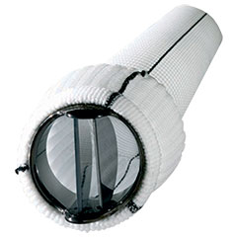
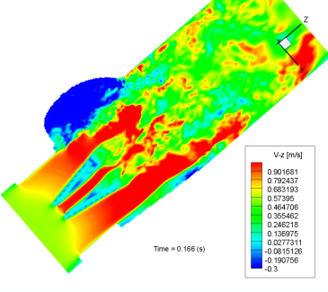

(c)

(a)

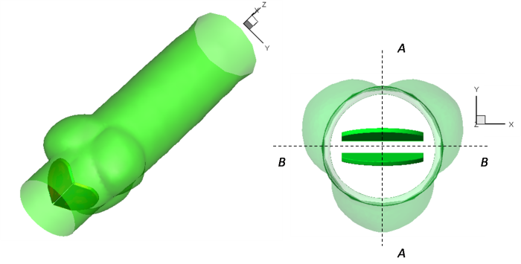
(b)

Recent Publications (minimum 5)
- Verzicco, R. & Orlandi, P. (1996) A finite difference scheme for three-dimensional incompressible flows in cylindrical coordinates. J. Comput. Phys. 123, 402–413. (doi:10.1006/jcph.1996.0033)
- de Tullio, M., Cristallo, A., Balaras, E. & Verzicco, R. 2009 Direct numerical simulation of thepulsatile flow through an aortic bileaflet mechanical heart valve. J. Fluid Mech. 622, 259–290. (doi:10.1017/S0022112008005156)
- De Paulis, R., Schmitz, C., Scaffa, R., Nardo, P., & Reul, H. (2005) “In vitro evaluation of aortic valve prosthesis in a novel valved conduit with pseudosinuses of Valsalva” J. Thorac. Cardiovasc. Surg. 130, 1016–1021. (doi:10.1016/j.jtcvs.2005.04.028)
- Lee H, Ikeuchi Y, Akagawa E, Taenaka Y, Yamamoto T (2009) ”Effects of leaflet geometry on the flow field in three bileaflet valves when installed in a pneumatic ventricular assist device.” J Artif Organs. 1434-7229, 1619-0904. (10.1007/s10047-009-0453-8)
- De Paulis, R., Tomai, F., Bertoldo, F., Ghini, A., Scaffa, R., Nardi, P. & Chiarello, L. 2004 Coronary flow characteristics after a Bentall procedure with or without sinuses of Valsalva. Eur. J. Cardio Thorac. Surg. 26, 66–72. (doi:10.1016/j.ejcts.2004.04.031)

Biography (150 word limit)
Anh V Nguyen is a prospective PhD at University of Rome “Tor Vergata”, Italy. His research interests are Computational Fluid Dynamics, Numerical Simulations of Multiphase flows, Particle flows, Experiments in Fluids and Fluid Mechaincs. He completed his Master’s study at Ritsumeikan University, Japan in the field of Fluid Mechanics.
Email: nvietanh242@gmail.com

Notes/Comments:

