A recent study found that more married men engaged in unprotected sex die of heart attacks than women
Name: Rahul Hajare
Affiliation: Post Doc Fellow Indian Council of Medical Research
Abstract
Recent study has revealed that havingunprotected sex men die of heart attacks than women. Researchers from the University of Pune analysed physical intimacy, as well as partner support or conflict, overall relationship satisfaction and stress in 129 MEN in long-term relationships.Blood samples were taken from the study's participants to determine their telomere length.The preliminary study found that men who reported having sex with their partner during the course of the week tended to have significantly longer telomeres, the protective end caps on our DNA.Relationship satisfaction, stress and partner support or conflict had no impact on telomere length.Lead researcher from Pune University said that over time, shortened telomeres may contribute to chronic degenerative diseases and premature mortality.He added, "Sexual intimacy may dampen the effects of stress by down-regulating stress response systems and up-regulating immune response. Over time, these patterns of stress function should result in longer telomere length.A study has found that people did not recognise that men who collapsed has a cardiac arrest, leading to delays in calling the emergency sexual services and delays in providing resuscitation treatment.Chances of death for men who suffer cardiac arrest outside a hospital are more compared to women as they are less likely to be resuscitated by bystanders, a new study claims.
Biography
Dr. Rahul Hajare has been a hard worker all his academic life. After his Ph.D in Pharmacy from VMRF Salem which he completed with flying colours, he is fortunate to work NARI primer HIV research Institute to complete Post Docunder the of World Renowned Scientist Respected Dr. R.S.Paranjape., Retired Director & Scientist ‘G’ National AIDS Research Institute Pune. Dr. Rahul Hajare has Associate Professor of Pharmaceutical Medical Chemistry to Pune University (until 2020), he has serviced three times AssociateProfessor in Pharmaceutical Science and Analytical Science. Graduated from Amravati University in 2003, after an assignment he worked as an M.Pharm Scholar in the Institute of Pharmaceutical Education and Research passed with distinction, he has Post Graduate Teacher for Master of Pharmacy, he has more than 30 scientific and methodological works, 3 patents of scientific research. Dr. Rahul Hajare now Principal of Ishwar Deshmukh Institute of Pharmacy affiliated combined Amravati University and All India Council of Technical education New Delhi.
Email ID: rahulhajare17@gmail.com
Presenter Name: Rahul Hajare
Type of Presentation: Speaker

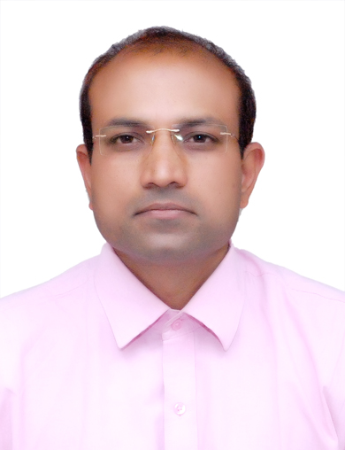
Contact Number: 9921707584

