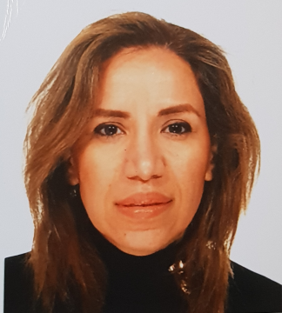
EFFICACY OF THE CURVES TRAINING PROGRAM FOR LOOSING BODY WEIGHT, BODY CIRCUMFERENCES AND FAT MASS PERCENTAGE: A NON RANDOMIZED CLINICAL TRIAL
Shima Gholamalishahi
Sapienza University of Rome, Department of Public Health and Infectious Diseases, Italy
Abstract
Purpose: Hypokinesia is the fourth cause of endemic death in the world. The prevalence of obesity, caused by hypokinesia, in the world continues to increase and it is a main risk factor of chronic diseases. Our aim was to evaluate the effectiveness of curves program and high intensity interval training (HIIT) in healthy women.Methods: The study design is a non-randomized clinical trial. Eighty women with age between 30 to 40 years (who train 3/4 times a week) over a period of six months. There were allocated into a “Curves” program group (n = 40) and a High Intensity Interval Training group (n = 40). BMI, body fat, fat mass percentage was calculating by OMRON body fat 306 TM at baseline and the end of intervention.Results: the results between High-intensity interval training and curves show that Curves scores were signiﬁcantly lower among Interval training. after 6 months the most impact was on “Abdomen loss “in Curves Group Mean(SD) = -4.48(1.70). According to the multivariate analysis, we can say that for all the dependent variables Weight loss -0.320 (<0.001), Trunk loss -0.376 (<0.001), Abdomen loss -0.276 (<0.001), Hip loss -0.302 (<0.001), Lower arm loss -0.248 (0.003) and Fat mass loss -0.153 (0.061) the Curves group shows significant results in comparison with the High-intensity interval training group (p < 0.001) while the civil status is significantly associated with only “Upper arm loss” variable (β = -0.357; p <0.001). Conclusions: This “Curves” program improved strength muscles, loss of fat and fat mass reduction more than High Intensity Interval Training.
Keyword : efficacy, curves, training, body weight, body circumferences, fat mass percentage, clinical trial
Biography
I am Shima Gholamalishahi Second year PhD student in Infection Disease, Microbiology and Public Health at Sapienza University of Rome, I graduated in Master of Physical Activity and Health Promotion at Tor Vergata university. I have published more than 3 papers in reputed journals.
Full name: Shima Gholamalishahi
Contact number:3318895661
Category: (Oral presentation/ Poster presentation
Contact email: shima.gholamalishahi@uniroma1.it

