Harmonic Analysis of PV Grid-connected Smart Building with High Penetration of Electronic Loads and LED Illumination

AbstractـــــThis paper discusses the problem of harmonics in the modern solar PV grid-connected smart buildings. An educational smart building with high penetration of electronic loads such as PCs and LED illumination is the case study. The distribution scheme of the building is modeled with all types of loads connected to it. LED illumination, electronic loads, elevators and AC units have their detailed simulation models developed based on practical waveforms of voltage and current compared to the actual operating conditions. FFT analysis is carried out at the point of common coupling using MATLAB/SIMULINK and the results have been analyzed and discussed.

Index TermsـــــRenewable energy, Distributed energy resources, Solar PV, smart-grid, power quality, harmonics, THD, FFT Analysis, MATLAB/SIMULINK

1. Introduction
Power generation, control and usage have witnessed unprecedented development in this century [1], [2]. The present problem of fossil resources which are at the verge of depletion due to enormous usage in the last decades has created an essential issue of concern. Also the serious problem of pollution due to gas emissions and deterioration are the main causes of the increasingly dependence of the renewable sources of energy around the world [3], [4], [5], [6]. These sources of energy are reliable, clean and almost free. Due to the increased global public awareness of the need for environmental protection, the desire for less dependence on fossil fuels for energy production and the reduction in CO2 emissions, the introduction of generation based on renewables become one of the most important topics for energy suppliers today [6], [7], [8].
Although these sources have different problems such as high initial cost and very fluctuating and uncontrollable power due its dependence on sun, water and wind power, many countries are taking steps towards these clean sources [9], [10], [11]. As a results many solar and wind farms have been established all over the world. While the power demand is increasing, the power
Figure 1
Supplied by Photovoltaic (PV) system to the grid is gaining more and more feasibility all over the world [12], [13], [14].
On the other hand, Electrical grids tend to be more distributed, intelligent, and flexible, and hence, the generation and consumptions areas cannot be separated. The concept of smart grid has been spread in a wide range of the world [15], [16].
The penetration of distributed energy resources (DERs) such as solar PV, small wind turbines, diesel genets and biomass has changed the old scheme of power system into more flexible one. The presence of DER units at distribution voltage level means the transition from traditional passive to active distribution networks [17]. DERs provide more flexibility in the power control and management at the demand side which is called demand side management DSM [18], [19], [20].
The new smart buildings are the result of this gradual progress in the building. Smart building means complex control and monitoring system for all DERs and all loads together connected to the utility grid to make the best use of the generated energy. Improving the power quality and reliability and of course improving the user welfare and satisfaction with the minimum cost is an important target [21]. On the other hand, this has led to the increasing use of nonlinear solid state based loads such as lighting electronic ballasts, electronic motor derives and controls and communication equipment [2].
As the power supplied to the utility grid by photovoltaic solar panels is gaining more and more reliability with respect to other DERs, Solid-state inverters is the enabling technology for connecting PV systems into the grid. These inverters convert dc output into ac with suitable voltage and frequency [22], [23]. In fact, using of these power inverters and nonlinear loads has created a major problem. Nonlinear loads are defined as the devices where the current passing through it is not proportional to the voltage. The nature of these devices is to distort in the current waveform leading to the distortion of the voltage waveform so the voltage waveform is no longer proportional to the current [17].
Among all power quality problems, Harmonic distortion is still the most significant one. These harmonics can cause problems ranging from overheating in the devices to degradation of conductors and insulating material in motors and transformers [24], [25], [26]. Therefore, it is important to gauge the total effect of these harmonics. The summation of all harmonics in a system is known as total harmonic distortion (THD) which is a good representation to the harmonic content in the system [27].

2. Total Harmonic Distortion Equations
The distorted voltage waveform can be analyzed using Fourier expansion as a fundamental signal and a number of harmonics (pure sine wave with a multiple of frequency according to the order of harmonic). For steady state conditions, we can represent the voltage and current as in the form;
$v\left(t\right)=\sum_{k=1}^{∞}{Vk(\sin{kωot+δk) }},$ (1)
$i(t)=\sum_{k=1}^{∞}{Ik(\sin{kωot+ϴk) ,} }$ (2)
So the RMS values of the voltage and currents can be represented in the form;
$V_{rms}=\sqrt{\sum_{k=1}^{∞}{\frac{{Vk}^{2}}{2}} }$=$\sqrt{\sum_{k=1}^{∞}{{V_{krms}}^{2}} }$ , (3)
$I_{rms}=\sqrt{\sum_{k=1}^{∞}{\frac{{I_{k}}^{2}}{2}} }=\sqrt{\sum_{k=1}^{∞}{{I_{krms}}^{2}} }$ , (4)
The total harmonic distortion can be represented mathematically as the ratio between the RMS value of the harmonics and the RMS value of the fundamental. So it will be computed as
${THD}_{v}=\frac{\sqrt{\sum_{k=2}^{∞}{{V_{krms}}^{2}} }}{V_{1rms}}$*100% =$\frac{\sqrt{\sum_{k=2}^{∞}{{V_{k}}^{2}} }}{V_{1}}*100\%$ , (5)
${THD}_{i}=\frac{\sqrt{\sum_{k=2}^{∞}{{I_{krms}}^{2}} }}{I_{1rms}}$*100% =$\frac{\sqrt{\sum_{k=2}^{∞}{{I_{k}}^{2}} }}{I_{1}} *100\% ,$ (6)
The 3rd, 5th, and 7th and other odd orders are usually the significant harmonics above the fundamental frequency. Typical values of current distortion limits for distribution network according to IEEE SM 519-1992 is illustrated in table 1 [4], [28], [29].

$$I_{sc}/I_{l}$$ | Harmonic Order (h)
$$I_{sc}/I_{l}$$ | h<11 | 11<h<17 | 17<h<23 | 23<h<35 | h<35
<20 | 4.0 | 2.0 | 1.5 | 0.6 | 0.3
20<50 | 7.0 | 3.5 | 2.5 | 1.0 | 0.5
50<100 | 10.0 | 4.5 | 4.0 | 1.5 | 0.7
100<1000 | 12.0 | 5.5 | 5.0 | 2.0 | 1.0
>1000 | 15.0 | 7.0 | 6.0 | 2.5 | 1.4
Table 1
For a smart building having DERs connected to grid through power inverters and feeding nonlinear loads, the harmonics problem is vital issue to analyze and treat. Unlike any conventional system, a smart grid with power inverters feeding valuable ratings of electronic loads such as LED luminaires and PCs. the THD is expected to reach unprecedented value. In This paper shall model this system using Simulink and gauge the total effect of harmonics in the system and compare the results with the standard limits of power quality and reliability of the smart buildings.
This paper consists of number of sections. Section (I) is the introduction, section (II) is scientific approaches and Section (III) contains the methodology, system modeling and simulation. In section (IV) the obtained results will analyzed and discussed. Finally, the conclusion is section (V)

loads | LED luminaires | PCs ـــــUPS | AC unit ــــــ Water pumps | elevators | Water Heaters ـــــ Microwave ـــــ Fridges ــــ others
No of units | 756 | 200 5 | 17 4 | 4 | 10 5 2 --
Unit ratings | 1-ph 220v, 50Hz, 80watt. | 1-ph, 50Hz, 220v, 2000watt. | 1440rpm, 1-ph, 4.5Hp, 220V, 50Hz | 3-ph, 5Hp, 400V, 50Hz
  220V,50Hz, 1500KVA | 220V,50Hz, 1200KVA | 220V,50Hz, 800,0KVA | 220V,50Hz, 1000KVA
Model rating | LED Model 3-ph, 50Hz,400V 80Kwatt | Electronic-load 3-ph,50Hz, 400V,70Kwatt | 1-ph induction motor,50Hz, 220V, 20Hp, 0.85pf | 3-ph IM, 50Hz, 400V, 20Hp, 0.8pf | Linear load 3-ph resistor 400V, 50Hz, 20Kwatt

Table 2

3. System modeling
Research Building no 4 in MTC in Cairo, Egypt is the case study. This smart building consists of 4 floors on area of about 1000 m3. A grid-connected PV system supplies around 100kVA of computer laboratories, 80KVA of LED luminaires, and 100hp of AC units, water pumps and elevators and other domestic loads. The considerably heavy loads are classified into four categories, Illumination, electronic loads, AC units and
elevators and linear loads with ratings illustrated in Table 3. The solar PV system consists of 10 solar panels of 5kwatts for each one and is connected to two power inverters each of power equals 25kwatts. The solar irradiance profile in the region is illustrated in fig 1. This irradiance profile with the weather temperature is represented as signal builder in the Simulink model. The PV system is modeled as solar PV block and a boost converter to raise the voltage to a certain value. Three-level bridge converter is used as the power inverter and is controlled by a VSC control block. Ac power system has receiving end of 380 V 50HZ represents the grid and is connected to the inverter at the point of common coupling PCC as shown in Figure 4.
On the other hand, LED luminaires has become the most attractive light source around the world in the recent years. Despite their several drawbacks, they have many advantages that make them a powerful candidate to override the other types of lambs. High reliability, long life time, small size and high color rendering index made them commercially the most suitable for street lighting, domestic and industrial applications [30]. As illumination load construct a considerable power rating among other loads in the smart building as mentioned before, and besides its high weight of harmonic injection in the system, the illumination load is the most important model in this case study. The integrated buck-boost (IBBD) converter derived LED lamb described in [31] is utilized to model the illumination load of the building. Three-phase supplied block and consists of diode based rectifier and integrated double buck–boost chopper all series with a resistor representing the whole illumination load as illustrated in the Figure 2 a.

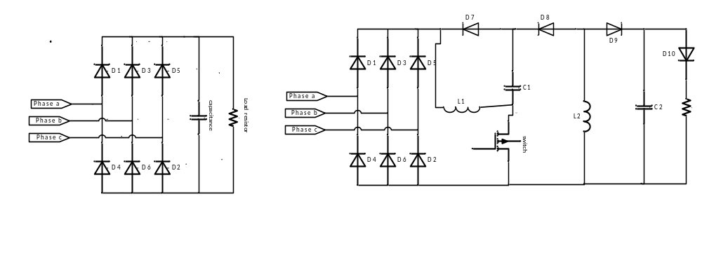
Figure 2

Personal computers, UPS and other electronic loads are non-linear loads to ac system. Switch Mode Power Supply (SMPS) used in computers is a serious source of harmonics. These loads are considerably high in such a smart-building. We shall use a three phase rectifier and a resistor adjusted to representing the power of this load as illustrated in Figure 2 b.
This smart building has four elevators with speed control to manage the power consumption at the period of power shortage. Elevators are modeled as 20hp three-phase squirrel cage induction motor. AC units are modeled as 20*4.5Hp single phase induction motor as shown in Figure 5. These motors have the parameters illustrated in table 1. The whole system is integrated in the model shown in Figure 4 and is ready for simulation and analysis.

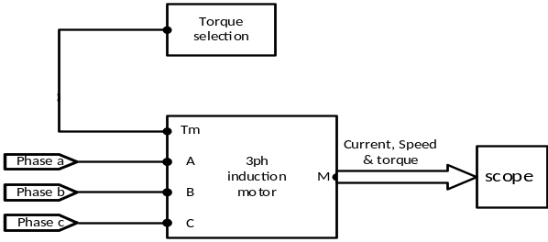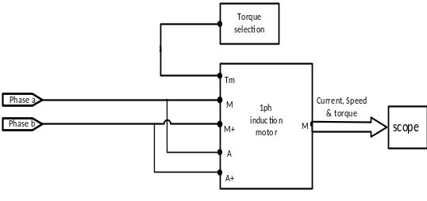
Figure 3

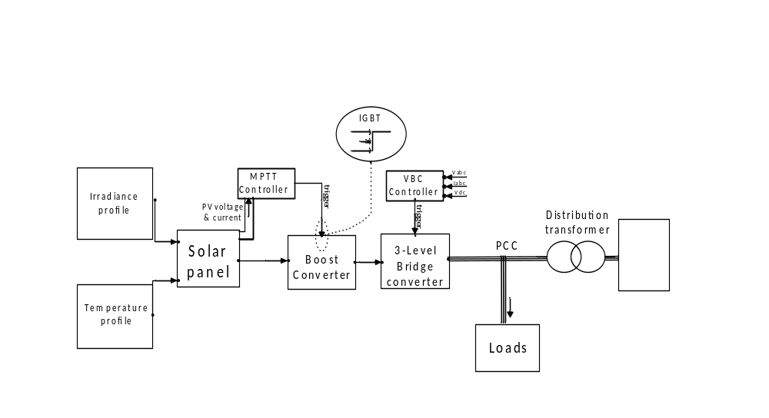Figure 4

4. Simulation and Results Discussion
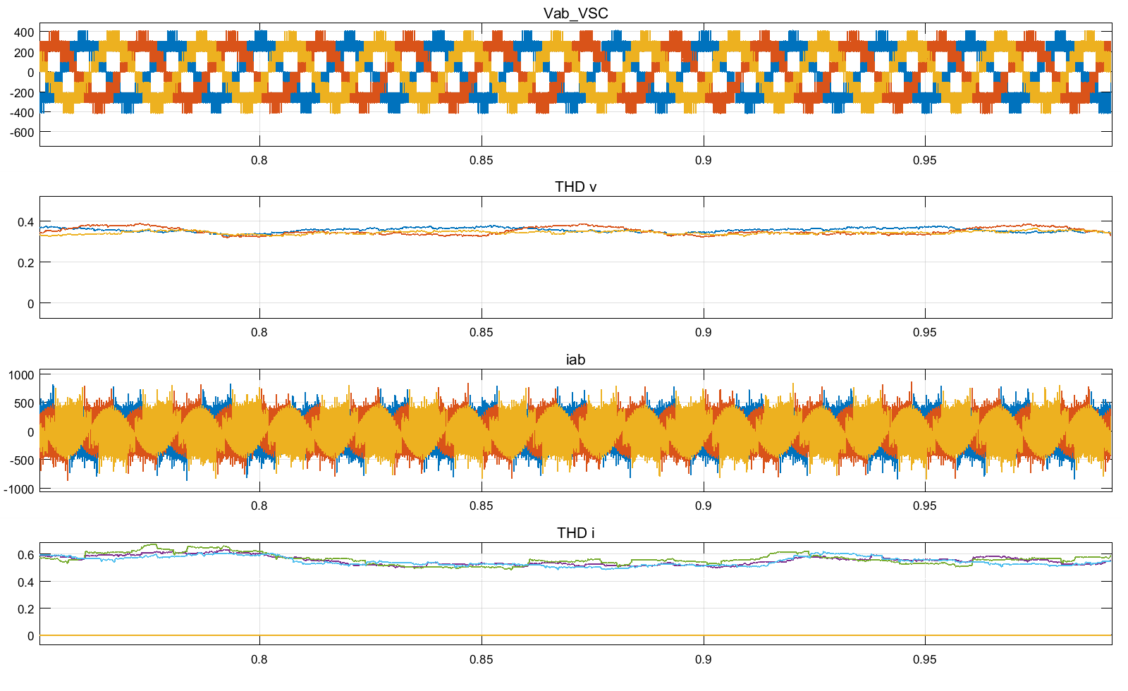
Figure 5

The simulation is performed and the real time values of current, THDi, voltage and THDv at the PCC are shown in Figure 5. The FFT analysis is performed to the voltage and current wave forms as shown in Fig 8. It shows that the THD of the voltage wave form at PCC is reaching 26% and the THD in the current wave form exceeds 35%. These measures are repeated for different load configurations and the results are recorded as in Table 4. These values exceed the limits of THD mentioned in the IEEE standard 519 (IEEE SM 519-1992) for harmonic control in power system.
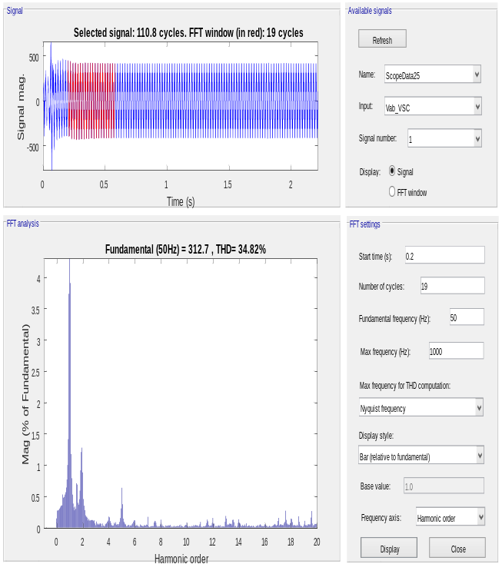 | 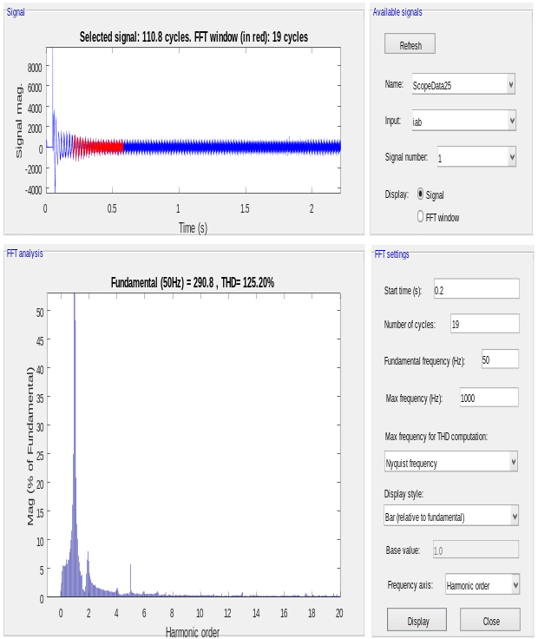
Figure 6

Load state | all loads connected |  | LED 30% FL |  | LED is 50% FL |  | LED 80% FL |  | AC units are off |  | PCS are off
 | THDi | THDv | THDi | THDv | THDi | THDv | THDi | THDv | THDi | THDv | THDi | THDv
Phase a | 125.41 | 36.65 | 62.64 | 36.45 | 37.15 | 39.34 | 52.41 | 56.27 | 62.64 | 65.76 | 36.65 | 37.34
Phase b | 124.31 | 36.22 | 62.01 | 36.94 | 37.62 | 39.15 | 53.01 | 56.31 | 62.01 | 65.63 | 36.22 | 37.65
Phase c | 125.08 | 36.04 | 62.08 | 36.45 | 37.64 | 39.45 | 52.6 | 56.01 | 62.08 | 65.31 | 36.04 | 37.05

Table 4

5. Conclusion
AS a conclusion, the use of nonlinear loads is increasing day by day in residential, industrial and commercial levels. Also the solar energy is gaining more and more feasibility and so the solid state power converters which is considered one of the major sources of harmonics. So, the great penetration of DERs to the smart buildings in the last few years has affected the power system at the distribution level. The THD may reach excessive values in such a case which may seriously affect the quality and reliability of the system. The distortion in the voltage and current waveforms will reach an excessive value as discussed in the results. The harmonic analysis of these smart buildings should be put into consideration.
6. References
[1] A Review of Hybrid Renewable/Alternative Energy Systems for Electric Power Generation: Configurations, Control, and Applications; DOI: 10.1109/TSTE.2011.2157540.
[2] Harmonics Measurement in Computer Laboratory and Design of Passive Harmonic Filter using MATLAB 1Muhammad Usman Keerio, 2Muhammad Shahzad Bajwa, 3Abdul Sattar Saand and 4Munwar Ayaz memonDepartment of Electrical Engineering QUEST NawabshahSindh, Pakistan
[3] Grid of the future IEEE Power Energy Magazine, 7 (2) (2009), pp. 52-62
[4] Evaluating the impacts of real-time pricing on the usage of wind generation IEEE Transactions on Power Systems, 24 (2) (2009), pp. 516-524
[5] Demand response in smart electricity grids equipped with renewable energy sources: A review
[6] BP Statistical Review of World Energy, 〈bp.com/statistical review〉; June 2013 [accessed on 13/8/2013].
[7] A. Brown, S. müller, Z. Dobrotková Renewable energy: markets and prospects by technology Int Energy Agency Inf Paper (2011)
[8] S.R. Bull Renewable energy today and tomorrow Proc IEEE, 89 (8) (2001)
[9] Renewable energy resources: Current status, future prospects and their enabling technology
[10] M.Shahzad Bajwa, Aslam pervez Memon, Jamshed A.Ansari,M.Tarique Bhatti (2016), “ An Experimental Investigation Based onMathematical And Software Modeling of Total Harmonic Distortion inPersonal Computer ” , Bahria university journel of information andcommunication Technologies Vol.9 ,Issue 1 , pp.62-73.
[11] Kaushik Aryan and Varanasi Jyothi. (2014), „„Harmonic VoltageDistortions in Power Systems due to Non LinearLoads‟‟, InternationalJournal of Applied Power Engineering (IJAPE) , V. 3, No. 1, pp. 67-74.
[12] J. P. Benner, L. Kazmerski, "Photovoltaics gaining greater visibility", IEEE Spectr., vol. 29, no. 9, pp. 34-42, Sep. 1999.
[13] Solar photovoltaic (PV) energy; latest developments in the building integrated and hybrid PV systems10.1016/j.renene.2005.08.007
[14] Tsao, J.Y.: ‘Solid-state lighting: lamps, chips, and materials for tomorrow’, IEEECircuits Devices Mag., 2004, 20, pp. 28–37, Doi: 10.1109/MCD.2004.1304539
[15] Real Time Smart Grid Load Management ByIntegrated and Secured Communication 10.1109/ITCE.2018.8316634
[16] Hierarchical Control of Droop-Controlled AC and DC Microgrids—A General Approach Toward Standardization 10.1109/TIE.2010.2066534
[17] B.B. Ambati, V. Khadkikar, "Optimal sizing of UPQC considering VA loading and maximum utilization of power electronic converters", IEEE Trans. on Power Delivery, vol. 29, no. 3, pp. 1490-1498, June 2014.
[18] Autonomous Demand-Side Management Based on Game-Theoretic Energy Consumption Scheduling for the Future Smart Grid 10.1109/TSG.2010.2089069
[19] Demand Side Management: Demand Response, Intelligent Energy Systems, and Smart Loads 10.1109/TII.2011.2158841
[20] Demand Side Management in Smart Grid Using Heuristic Optimization 10.1109/TSG.2012.2195686
[21] A System Architecture for Autonomous Demand Side Load Management in Smart Buildings 10.1109/TSG.2012.2217358
[22] A review of single-phase grid-connected inverters for photovoltaic modules 10.1109/TIA.2005.853371
[23] Renewable Energy Systems With Photovoltaic Power Generators: Operation and Modeling 10.1109/TIE.2008.920583
[24] Determination of allowable penetration levels of distributed generation resources based on harmonic limit considerations 10.1109/TPWRD.2003.810494
[25] Theoretical and experimental comparison of total harmonic distortion factors for the evaluation of harmonic and interharmonic pollution of grid-connected photovoltaic systems
[26] Design of Filters to Reduce Harmonic Distortion in Industrial Power Systems 10.1109/TIA.1987.4504938
[27] On the definition of total harmonic distortion and its effect on measurement interpretation DOI:10.1109/TPWRD.2004.839744
[28] Saha Srijan, Das Suman, Nandi Champa.(2014) „„Harmonics Analysisof Power Electronics Loads‟‟, International Journal of ComputerApplications,V.92 ,No.10.pp.32-36.
[29] Lalotra Jyoti , Sharma Shavet and Saleem Khan .(2013) „„ Investigatethe Effect of Different Combination of Loads on Harmonic Distortion‟‟,International Journal of Advanced Research in Computer Science andSoftware Engineering , V.3,Issue. 8,pp.587-590.
[30] Y. Fang, S.-H. Wong, and L. Hok-Sun Ling, “A power converter with pulse-level-modulation control for driving high brightness LEDs,” in Proc. 24th Annu. IEEE APEC , Feb. 15–19, 2009, pp. 577–581.
[31] Analysis and Design of the Integrated Double Buck–Boost Converter as a High-Power-Factor Driver for Power-LED Lamps J. Marcos Alonso, Senior Member, IEEE, Juan Viña, David Gacio Vaquero, Student Member, IEEE, Gilberto Martínez, and René Osorio

