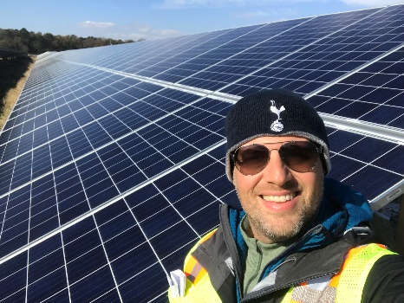

Title: Taking State governments, large corporations, and businesses a foot wide and a mile deep detailing a case study of a 100 MWe solar power plant located on the eastern shore of Maryland to provide a roadmap on decreasing their environmental footprint by adding renewable energy power plants for their increasing energy needs and overall energy usage.
Session description: With the constant changing policies coming out of Washington, a desire for more power from renewable energies and having the funding to pay for it are no longer the only battles that needs to be fought. Constructing a large scale renewable energy power plant is now only as good as the team that works behind the scenes to make sure the project is in compliance with the constant and fast changing Federal, State, and local regulations. As corporations look toward renewables for their energy requirements, through a success story in Maryland, I will discuss helping make that possible by not only including what it takes to bring large scale renewable energy onto the grid, but all the required non-construction work that must take place to approve a power plant. Specifically, I will dive "in the weeds" and outline the technical requirements to achieve large-scale power, the regulatory work required prior to construction, the compliance work required before, during, and after construction, as well as the legal side of making a large-scale power plant possible. I have experience building solar facilities, as well as providing expertise in both regulatory frameworks around renewable energy and environmental compliance that must coincide with renewable energy projects. I also have general legal knowledge in environmental compliance and regulations.
Biography: Nathan Goodman is an expert in environmental compliance bringing 20 years of experience working for consulting firms and the federal government. Mr. Goodman has done National Pollution Discharge Elimination System (NPDES) permitting and National Environmental Policy Act (NEPA) projects for the private sector and has spent the past 12 years as a senior project manager working on NEPA and environmental consultation efforts for the Federal government. Currently, Mr. Goodman heads up an office that focuses on environmental compliance for the renewable energy sector, focusing on large scale commercial projects.
Presenting author details:
Nathan Goodman
Vice President and Director of Environmental Compliance
The Baldwin Group
202-697-2120
ngoodman@tgbva.com

