Biomethane, variables and wastes conversion: Optimal process conditions for enhanced biomethanation of animal and fruit wastes.
Oluwafunmilayo O Aworanti, PhD, LAUTECH, NIGERIA
Oluwafunmilayo O Aworanti, PhD,LAUTECH,NIGERIA

Abstract
Biomethanation of animal and fruit wastes is an environmental benign and cheap source of energy. However, biomethanation has the problem of large hydraulic retention time and low gas production which has led to its underutilization. Therefore, research is focused on biomethanation enhancement for efficient and high yield biomethane production. Laboratory scale batch anaerobic digester was used to investigate the effects of operating variables [Total Solid Content (TSC), Temperature (TEMP), Agitation (AGT) and Feed/Inoculum Ratio (FIR)] on biomethane generation from mixture of animal wastes (cattle dung, pig dung and poultry droppings), co-substrates (orange, mango and pineapple wastes) and (chicken rumen). 5 different slurries [Animal and Orange wastes with Inoculum (AOI); Animal and Mango wastes with Inoculum (AMI); Animal and Pineapple wastes with Inoculum (API); Animal and the three fruits wastes with Inoculum (AOMPI) and Animal wastes (A)] were charged into the digester. The process were carried out for 70 days at these conditions TSC (2- 10%), TEMP (25 -60ºC), AGT (35- 70 rpm) and FIR (1:1, 1:2, 1:3, 2:1 and 3:1). Biomethane produced was collected continuously into a gas bag and analysed using Gas Chromatography. One-Factor-at-A-Time was used to select TEMP, TSC and FIR for Central Composite Design of experiment to obtain optimal conditions that maximise the yield of biogas (Y₁), biomethane content (Y₂) and minimise the hydraulic retention time (Y₃). Kinetic parameters of the process were estimated. Maximum yield (%) were obtained in API having the range 43.5 - 65.5; 65.5 - 69.5 and 50.1- 66.8 for TSC, FIR and TEMP, respectively. Maximum of 7.2 kg (Y₁), 71.54 % (Y₂) and 8 days (Y₃) were obtained at optimum conditions TEMP (55.2ºC), TSC (6.25 %) and FIR (1:2). MG model best fitted the experimental data. Use of pineapple waste as a co-substrate is more productive in biomethanation. Operating variables enhanced biomethanation.


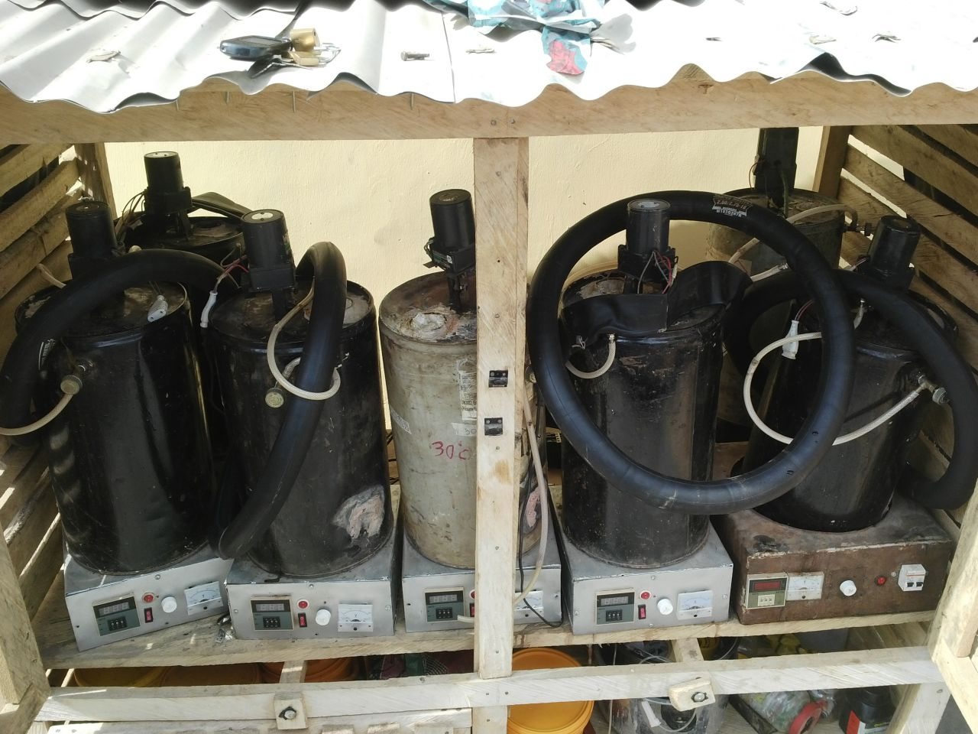

Plate 3.8: Set Up of the Biomethanation Rig
Recent Publications
- Ogunleye, O.O., Aworanti, O. A., Agarry, S. E. and Aremu, M. O.(2016) Enhancement of Animal Waste Biomethanation using Fruit Waste as Co-Substrate and Chicken Rumen as Inoculums .Energy sources, Part A: Recovery, Utilization, and Environmental Effects, 38(2):1653-1660
- Aremu, M. O., Aworanti, O. A. and Akinwunmi O.D. (2014) Reaction Parameters of Biodiesel from Cashew (Anarcadium Occidentale) Nut Reject Oil. Journal of International Environmental Application and Science, 9(4): 505-513.
- Agarry S.E, Aremu, M.O., Ajani A.O, Aworanti O.A, (2013) Alkali- Catalyzed production of biodiesel fuel from Nigerian Citrus Seeds Oil. International Journal of Engineering Science and Technology, (5):1682-1687.
- Aworanti, O. A., Agarry, S. E. and Ajani, A.O. (2012). A Laboratory Study of Effect of Temperature on Densities and Viscosities of Binary and Ternary blends of Soybean oil, Soy biodiesel and
- Aworanti, O. A., Agarry, S. E., Arinkoola, A. O. and Adeniyi, V. (2011). Mathematical modeling for the conversion of animal waste to methane in batch bioreactor. International Journal of Engineering Science and Technology, India, 3 (1): 573-581.

Biography
Oluwafunmilayo Aworanti completed her PhD at the age of 35 years from Ladoke Akintola University of Technology and postdoctoral studies from Ladoke Akintola University of Technology Nigeria. She is a lecturer of chemical engineering, in Ladoke Akintola University of Technology Nigeria. He has published more than 15 papers in reputed journals. She has more than 9 years of research and teaching experiences on bioenergy. She has successfully developed a laboratory biogas plant. She is expertise in conducting innovative research and technology development on the production of biofuels (biogas and biodiesel) from food and agricultural wastes.
Email: oaaworanti@lautech.edu.ng

Notes/Comments:

