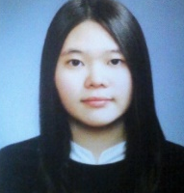 | 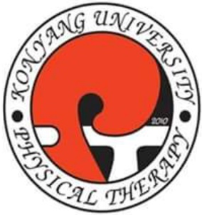

The Effects of Finger ROM, Muscle Strength and Function by Pneumatic Assisted Hand Exercise Device; Case Study
Hye-Jin Song¹, Eun-Gyun Yoon¹, Hee-ju Yu¹, Ji Young Lim², Dae-Sung Park¹

¹Department of Physical Therapy, Konyang University, Daejeon, Republic of Korea
²Department of Graduate Physical Therapy, Konyang University, Daejeon, Republic of Korea

The aim of this study was to improve the range of motion (ROM), strength, function of finger. A study is conducted by the exercise device with a patient who has finger contracture due to burn injury. The exercise device used in this study is to maintain mobility, prevent the development of the contracture and promote the functionality of hand. This study was conducted one patient with Limited of range of motion (LROM) of interphalangeal joint in chronic after 20 years from electrical burn injury in hand, A patient performed Pneumatic assisted Hand Exercise (PaHE) device for eight weeks. We measured ROM, strength and function of 2nd, 3rd finger at pre-posttest. After eight-week rehabilitation by PaHE showed improvement on 2nd DIP ROM (ext 35°, flex 5°), PIP ROM (ext 22.5° flex 15°), 3rd DIP ROM (ext 42.5°, flex 2.5°), PIP ROM (ext 27.5°, flex 5°), 2nd finger strength (pre 56.1nm, post 101.5nm), 3rd finger strength (pre 75.9nm, post 120.5nm) and Jebsen-Taylor Hand Function Test score (pre 46 score, post 54 score) of fingers. The PaHE device is useful to rehabilitation for a patient with LOM of finger. We had only one subject. The air tube of PaHE had a good structure for the second and third fingers. We propose that further study need more patients with an acute case of injury in hand and supplement the structure of the air tube for better outcome.

Biography
We started the research with support from the stem project. The study protocol was approved by the institutional review board of the KonYang university, Daejeon, South Korea.
We won the 9th Aid Device Idea Competition held at Gyeonggi Provincial Rahabilitiation Engineering Service Research Support Center.

Presenting author details
Full name: Dae-Sung Park
Contact number: 82-10-3771-9717
Twitter account: daeric7@gmail.com
Linked In account: none
Session name/ number: none
Category: (Poster presentation)

