What Is Cancer Rehabilitation
“Cancer Rehabilitation aims to allow the Patient to achieve optimal Physical,Social,Physiological and Vocational functioning within the limits imposed by the disease and its Treatment.”
(Mauk ,2012)

Role of Rehabilitation in Cancer Recovery?
When someone is undergoing cancer treatment, Rehabilitation may not be the first healthcare field that comes to mind. Cancer treatment is done with Oncologist, Oncosurgeon, and Radiation Oncologist.
However, People who are suffering from cancer should also consider the role of Rehabilitation in their cancer recovery.
Cancer treatment is a grueling course, leaving many people exhausted, weak and with a compromised immune system. Just getting out of bed can be a huge and daunting task, let alone exercising or playing at the park with grandchildren. This is where the role of Rehabilitation comes in. Despite advances in medical treatments, individuals that receive cancer treatments typically experience extensive physical limitations during and after treatments. These limitations include and are not limited to cancer-related fatigue (CRF),It also includes pain, nerve damage, Lymphedema, deconditioning, as well as incontinence.
There is strong evidence to support conservative management of these impairments through Rehabilitation. As each individual experiences different impairments during and after cancer treatment, it is important to have an individualized evaluation to focus your rehabilitation. Rehabilitation can address common cancer related impairments including:

Lymphoedema:
Effective lymphedema management is accomplished through Range of motion exercises, Manual lymphatic drainage, , Multi layered lymphatic bandaging.
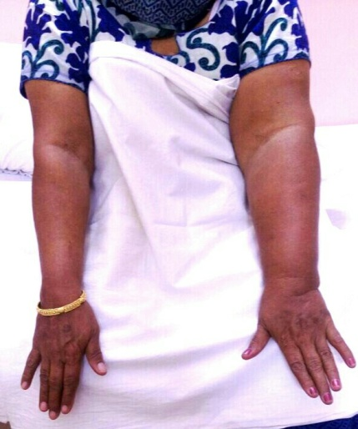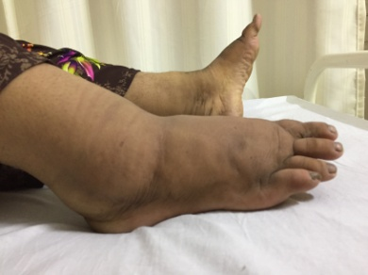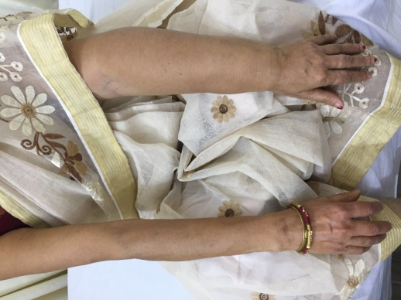
Restricted Joint Range of motion:
After Cancer Surgeries people have the joint restrictions. After Mastectomy Shoulder flexion and abduction get restricted. After Lipo Oral Surgeries Neck Shoulder Range of Motion get restricted. Active Range of Motion exercises, passive stretching, resistive exercises help to recover
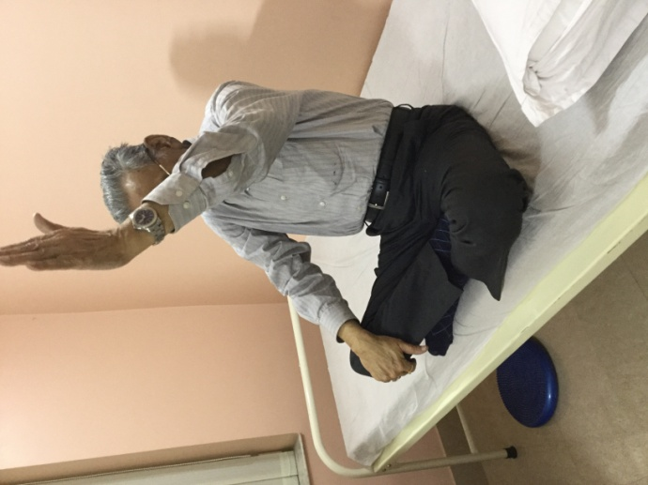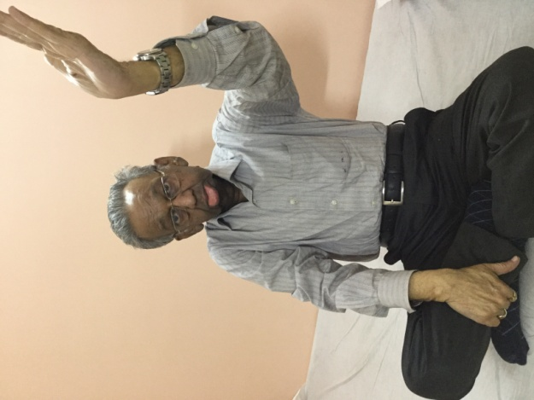

Pain:
There are many pain relief strategies that can reduce the intensity and frequency of pain after cancer treatment. Specifically, treatment strategies including soft tissue mobilization, Manual Lymphatic Drainage ,modalities like Transcutaneous Electrical Nerve Stimulator, Cold Laser,therapeutic stretching and strengthening help to reduce the Pain
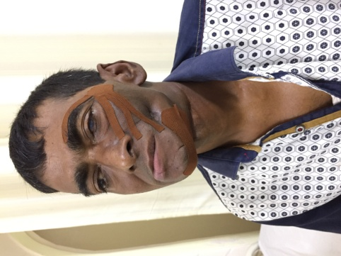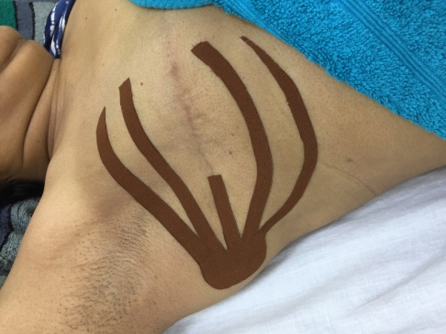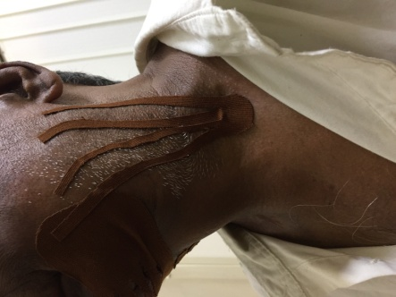
Trismus/ Lock Jaw
After Lipo Oral Surgeries TM Joint ROM gets restricted. Mouth Opening limited to1-2 inches. Active Exercises like Protraction and Retraction of TM Joint and Lateral to Medial movement of Jaw helps to improve.
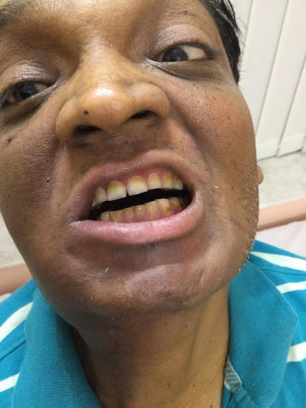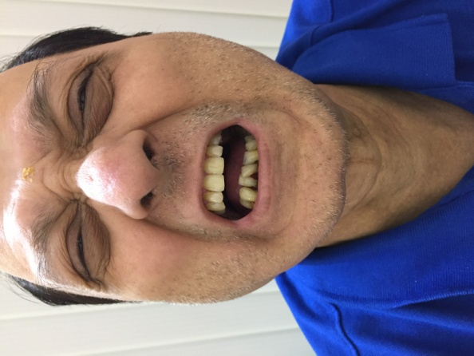
Deviation of Mouth:
After Oral Cancer Surgeries like CA Buccal Mucosa, Lower Alveolus , Tongue, Chick, face gets deviated and tongue movements get restricted.Oro facial exercises help to recover this problem. Along with these active exercises Kinesio Taping helps to improve the symptoms quickly.
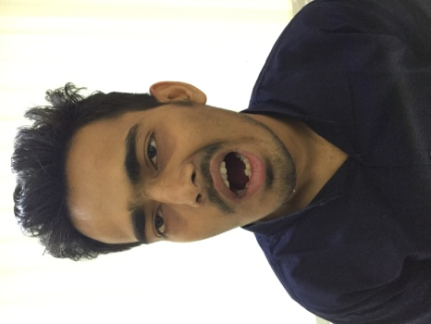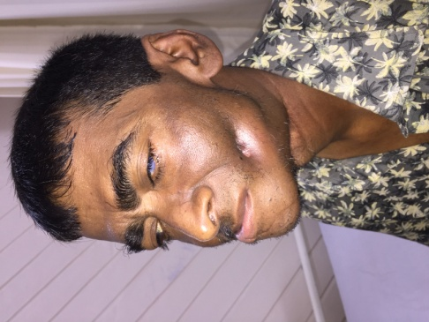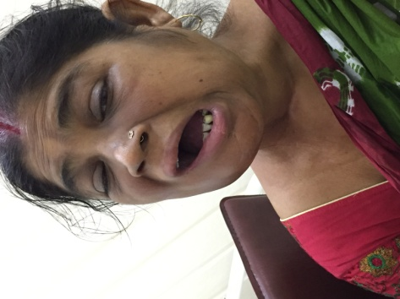

Head Oedema, Eye Oedema :
After head and neck surgeries and radiation number of lymph nodes of head and neck gets affected and leads to oedema
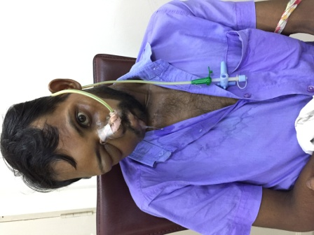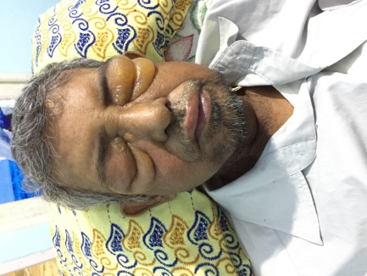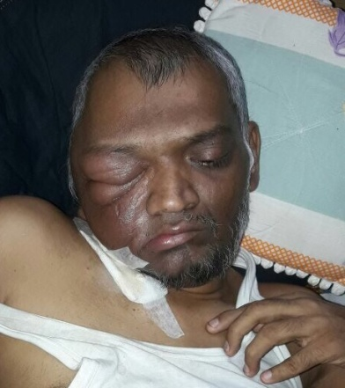

Cancer Related Fatigue:
Individualized strength training and functional management training is known to reduce effects of cancer related fatigue both during and after medical cancer treatments.
Peripheral neuropathy:
Sometimes cancer survivors experience peripheral neuropathy, which is abnormal nerve function that can be experienced as pain, numbness and tingling. Physical therapy can help to improve nerve function or compensate
Genitourinary complications:
For men undergoing treatment for prostate cancer and women undergoing treatment for bladder or ovarian cancer, incontinence and sexual dysfunction are common. A skilled physical therapist can help to rebuild the strength of the pelvic floor in order to improve urinary continence and reduce pain
After Cancer Surgeries and the Course or Chemotherapy and Radiation if people avail Cancer Rehabilitation program they can have a healthy and quality life. It’s never too late to start the treatment.

After Successful Rehabilitation:
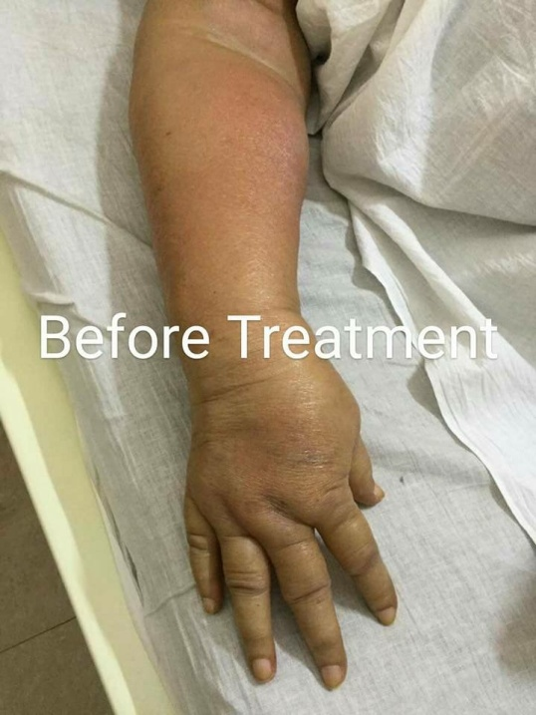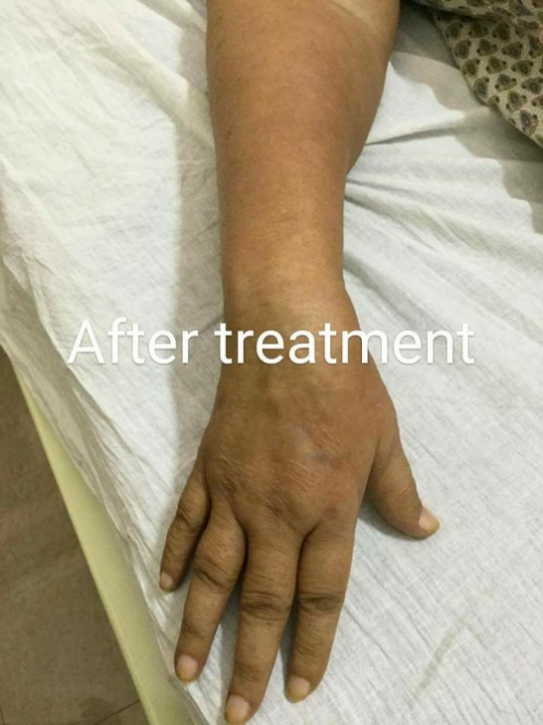

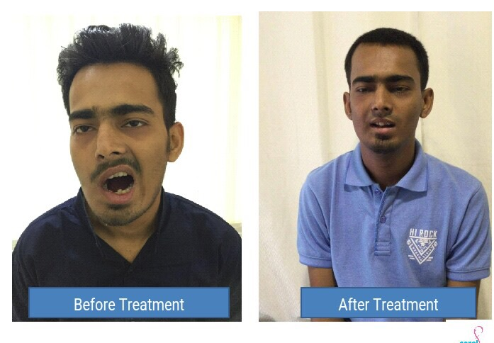
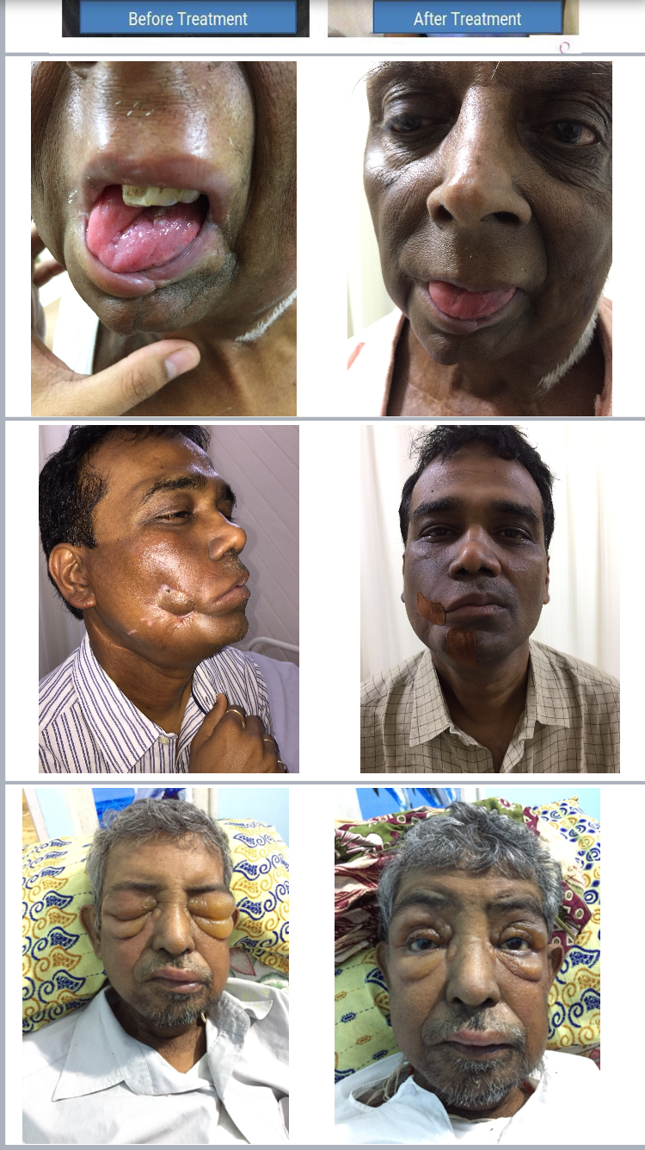

Dibyendu Roy started his Physiotherapy Carrier in the year of 2010 at Calcutta Medical Research Institute,India.In the year 2015 he did the Cancer Rehabilitation and Lymphoedema Management Study from Tata Memorial Hospital, Mumbai,India and for advanced Study moved to Lymphoedema Training Academy,UK under Jane Wigg .He gained experience in Wolverhamton Lymphoedema Service and Hadenham Health Care(UK)

He set Up his own Cancer Rehabilitation Clinic in India,named Corel.
Now he is engaged with several Cancer Rehabilitation program in various Institutions and Hospitals



Dibyendu Roy
Physiotherapist,B.P.T.(WBUHS),MIAP,MIASM
Certified Lymphoedema Therapist (Lymphoedema Training Academy,UK)
Wolverhampton Lymphoedema Service (UK)
Advanced Physiotherapeutic Management after Mastectomy (Del)
Physical Impairments arising from Breast Cancer and Management (Tata Memorial Centre, Mumbai)

