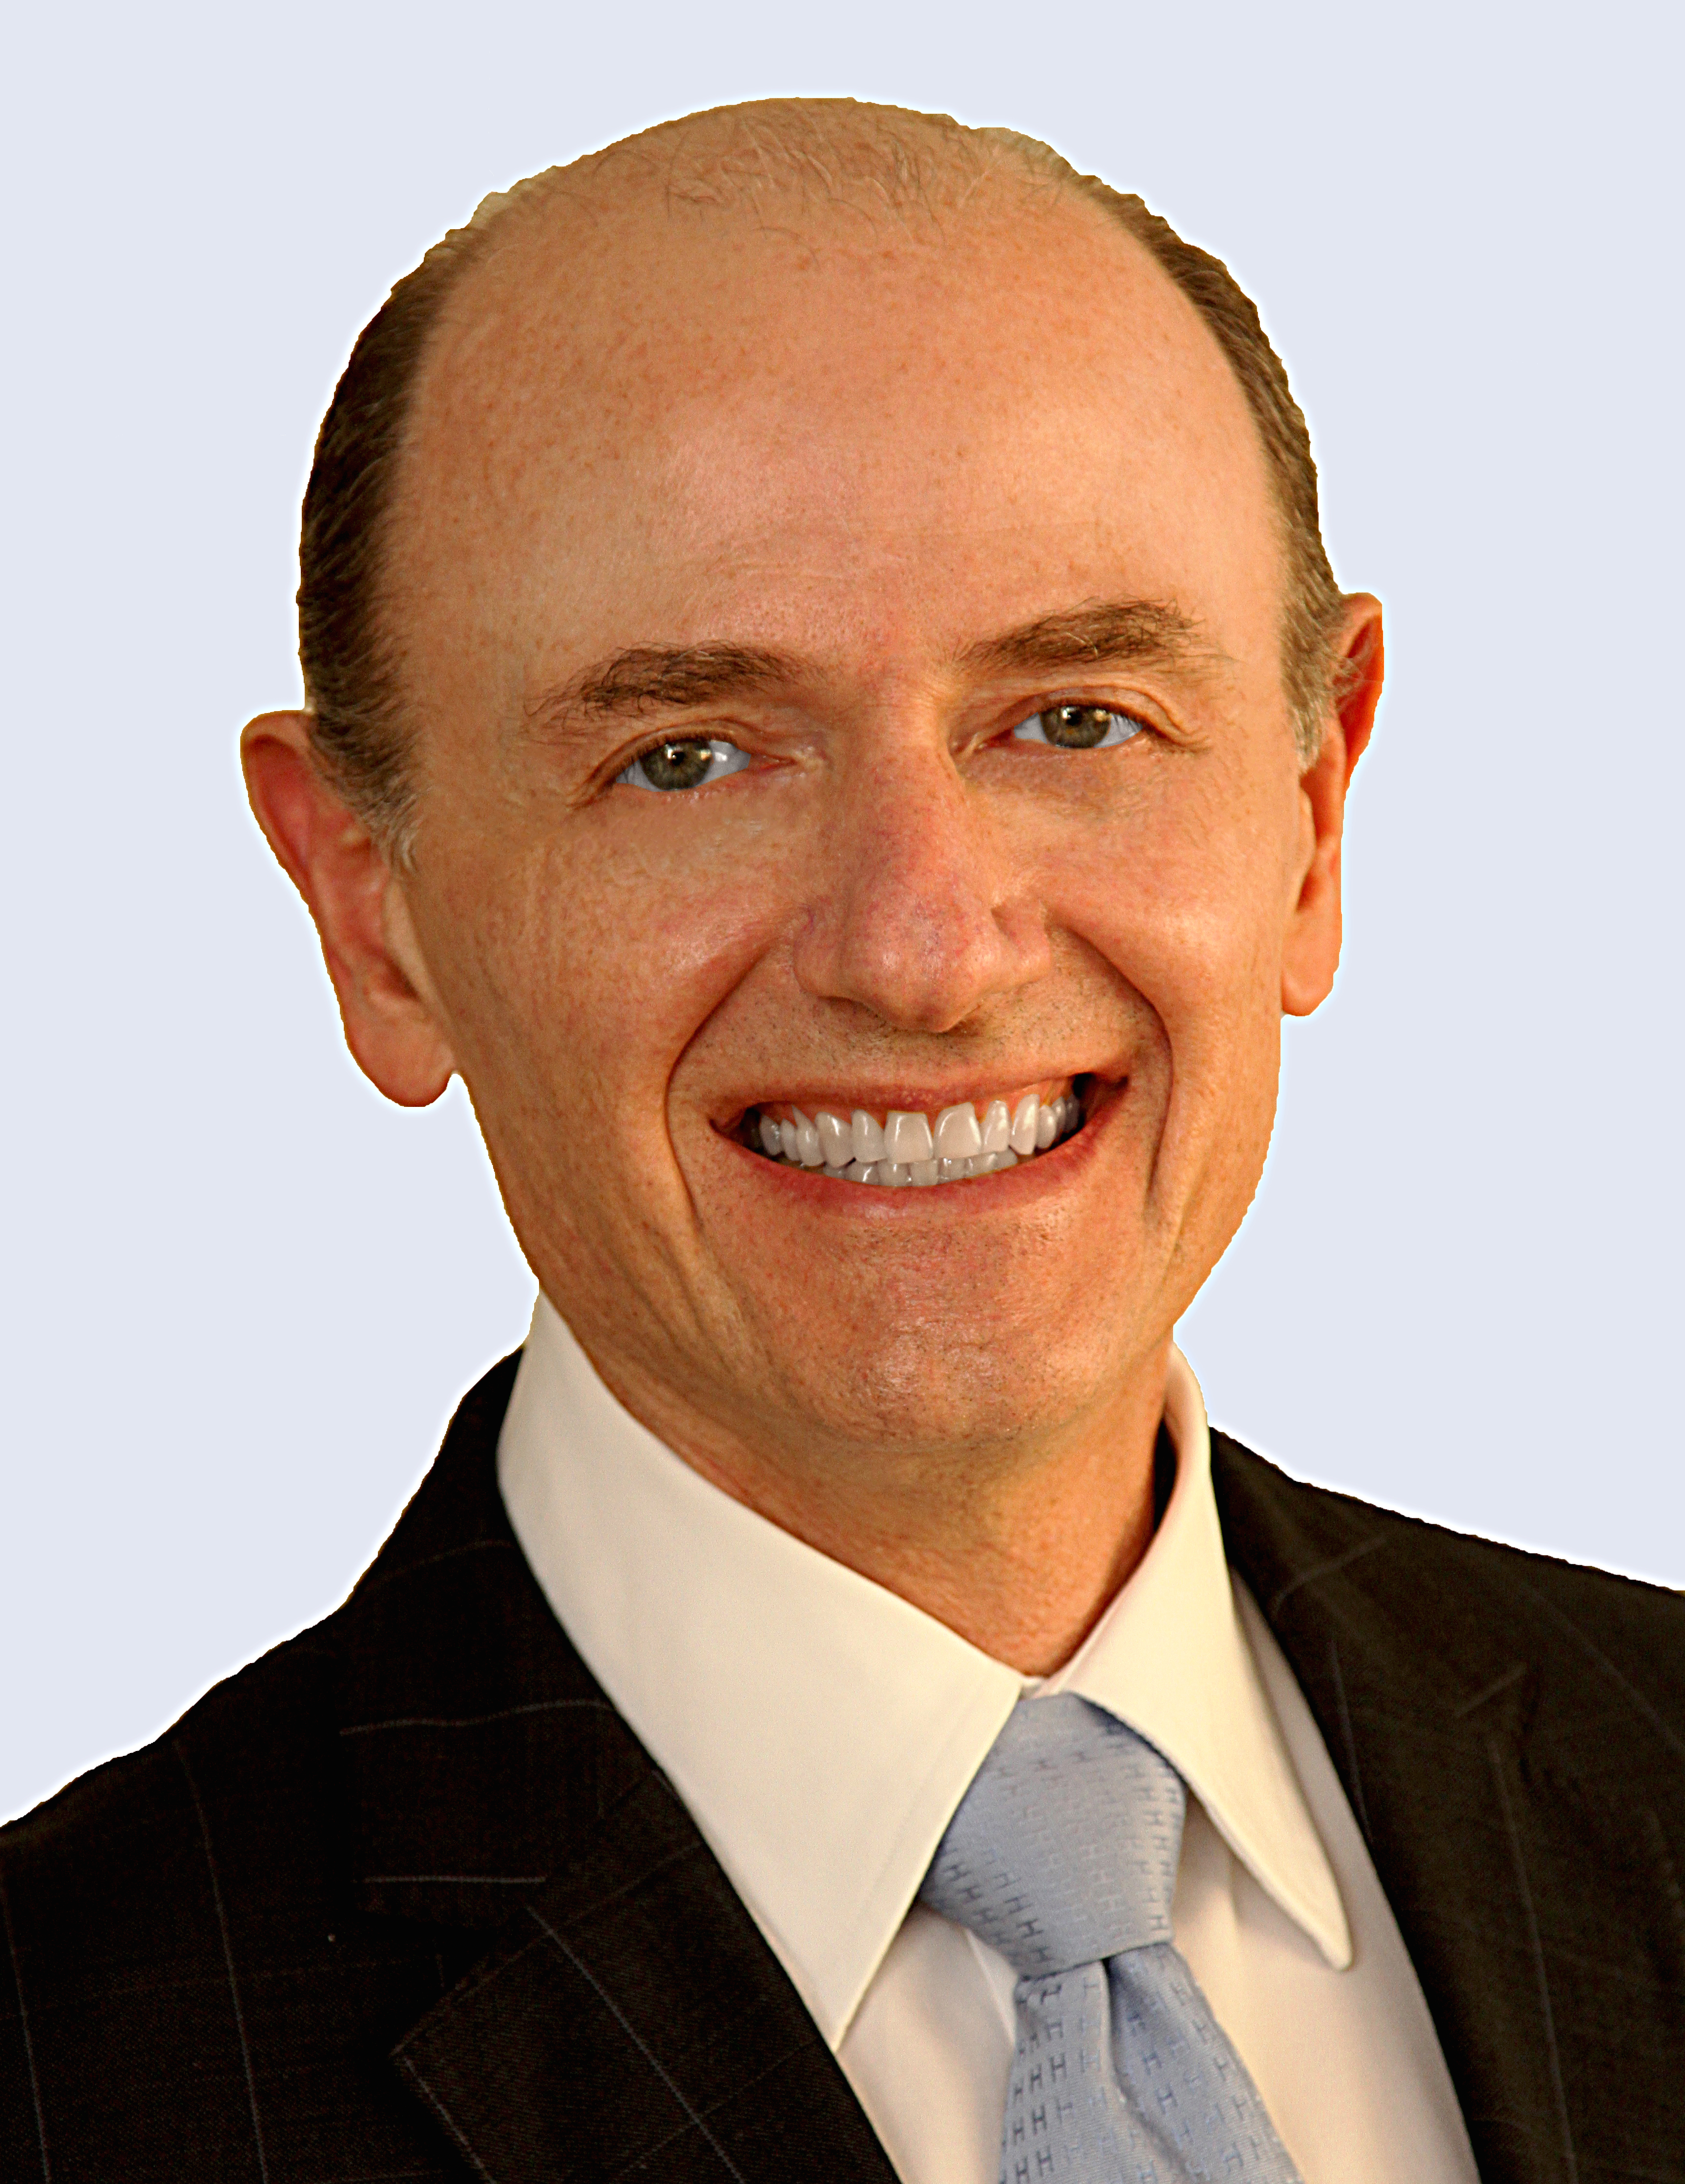
Title: Recently Developments for Regulatory Clinical Trial Approvals in Brazil
Name: Charles Schmidt
Faculdade de Ciencias Médicas da Santa Casa de Sao Paulo – FCMSCSP

Abstract

In the last 2 years Brazil has taken some actions to improve the timeline and quality for regulatory approvals in clinical trials. The Local Health Authority – ANVISA issue 2 new regulations for this process that also involves biosimilar and medical devices. The efforts has been showing some results, nevertheless adjusts has to be taken to increase transparece and reliable process for those procedures and also include better training of the ANVISA resources.
At the same time the association- Brazil Alliance for Clinical Reserach (Aliança Pesquisa Clinica Brasil Clinica Brasil) worked with the Brazilian Senators to issue a new law for Clinical Research that is still in analyses by the government but it will be a landamrk for the country and Latin America in this field.
We intend to discuss those new initiatives and clarifying the audience that Brazil is moving to the right direction regarding regulation for clinical trials following better GCP, Bioethics and Human Rights

Biography

Pediatrician with Master and Doctorate degree. He has been practicing and teaching while working in the biopharma for the past 25 years. He had developed and managed successfully big and mediun size CROs in Latin America and at their global level for more than 15 years. His experience also includes leadership roles in Medical Affairs, Pharmacovigilance, and Medical Monitoring in Pharmaceutical companies. Charles has an extensive background in clinical development efforts in many therapeutic areas in LatAm. He is an attending physician in coordinating the post-graduation program in clinical research at Santa Casa Medical School in Sao Paulo - Brazil since 2007. Also, he is the medical manager of the central institute of clinical research at Hospital de Clínicas - Sao Paulo. Charles was the founder and ex-president of the Brazilian Association of CROs and director of Brazilian Association of Pharmaceutical Physicians - SBMF.

Presenting author details
Full name: Charles Schmidt
Contact number: +55-11 999702473/ +55-11 36671974
Twitter account:
Linked In account:https://www.linkedin.com/public-profile/settings?trk=prof-edit-edit-public_profile
Session name/ number:
Category: (Oral presentation/ Poster presentation) : Oral presentation

