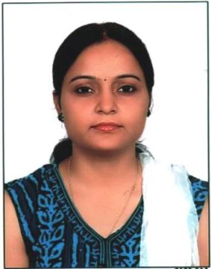
VANDNA PANDEY

Vandna Pandey, presently working as Lecturer ,College of Nursing, AIIMS ,JODHPUR(RAJASTHAN) INDIA. She has completed her Graduation in Nursing from RAK College of Nursing (DU), New Delhi and Post-graduation in Medical Surgical Nursing from RAK College of Nursing(DU) New Delhi . She has a vast experience in Nursing including teaching as well as clinical. She served as Nursing Tutor/Clinical Instructor at AIIMS Jodhpur(2013 to 2015). She also served in Mai Khadija Institute of Nursing Science as Lecturer, Jodhpur. She has also served as Sr. Lecturer at R.V.S.M College of Nursing, Jodhpur. By including all these she had more than 12 years of experience in the field of Nursing. She also published research papers in various journal of repute. She has been invited in various national conferences and workshop as resource person/ speakers. She is also examiners to the UG and PG nursing programme in various Universities in India. She has also guided many UG and PG students in completing their research work. She has also involved in mentorship programme for students at institute level. She is a good mentor and mentoring number of students on daily basis. She is also member of various national and international organizations.

