Biomimetic Porous Collagen Scaffold for Bone Tissue Engineering.
Malagón Escandón AM, Saniger Blesa JM, Piñón Zárate G, Chaires Rosas CP, Hernández Téllez B, Jarquín Yáñez K, Castell Rodríguez AE.
Laboratorio de Inmunoterapia Experimental, Departamento de Biología Celular y Tisular, Facultad de Medicina UNAM, Universidad Nacional Autónoma de México, México, D.F.

Abstract (300 word limit)
In recent years there has been a progress in conventional treatments for bone defects because tissue engineering and regenerative medicine present alternatives to restore or replace damaged or lost bone, this through the use of scaffolds in combination with autologous or mesenchymal cells. However, a therapeutic approach that can be considered as the gold standard and used as a routine treatment has not yet been found.
Therefore, we propose an extracellular matrix-based bioscaffolds derived from bovine cancellous bone, in combination with mesenchymal cells of Wharton's gelatin, which have shown in vitro e in vivo the ability to differentiate into multiple mesoderm, ectoderm and endoderm lineages, anti-inflammatory and immuno-modulatory effects that favors its allogenic use as well as the secretion of trophic and paracrine factors that induce the endogenous mechanisms of bone repair.
The obtaining of decellularized scaffolds have been successfully carried out in other organs and tissues; the effectiveness of its biosafety has also been previously evaluated in vivo and FDA approved.
In the specific case of bone, a more complex treatment is needed in comparison with other organs and tissues, because is necessary demineralization and collagen denaturalization maintaining the architecture and porosity of the scaffold that will favor colonization, vascularization and degradation. The present work was made in order to obtain a temporal scaffold that succeeds in degradation in an inversely proportional way to the synthesis of extracellular matrix and the maturation of the bone by the cells of the host.

Image

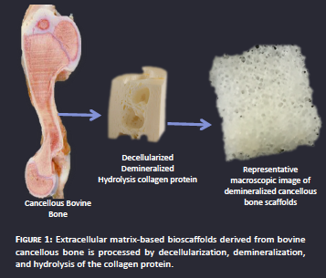

Recent Publications (minimum 5)
- Salinas, A. J., Esbrit, P., & Vallet-Regí, M. (2013). A tissue engineering approach based on the use of bioceramics for bone repair. Biomaterials Science, 1(1), 40-51.
- Chaparro, O., & Linero, I. (2016). Regenerative Medicine: A New Paradigm in Bone Regeneration. In Advanced Techniques in Bone Regeneration. InTech.
- Agarwal, R., & García, A. J. (2015). Biomaterial strategies for engineering implants for enhanced osseointegration and bone repair. Advanced drug delivery reviews, 94, 53-62.
- Campion, C., & Hing, K. A. (2017). Porous Bone Graft Substitutes. Mechanobiology: Exploitation for Medical Benefit, 347-371.
- Ong, J. L., & Guda, T. (Eds.). (2017). Translating Biomaterials for Bone Graft: Bench-top to Clinical Applications. CRC Press.




Biography (150 word limit)
Alda Malagón is a Ph.D. student in Biomedical Science Program at The National Autonomous University of Mexico with broad interests in biomaterials, medicine regenerative, stem cells.
Email: aldamalagon@icloud.com

Notes/Comments:

Presenting author details
Full name: Alda María Malagón Escandón
Contact number: 0445564277204
Mail id: aldamalagon@icloud.com
Category: Poster presentation

