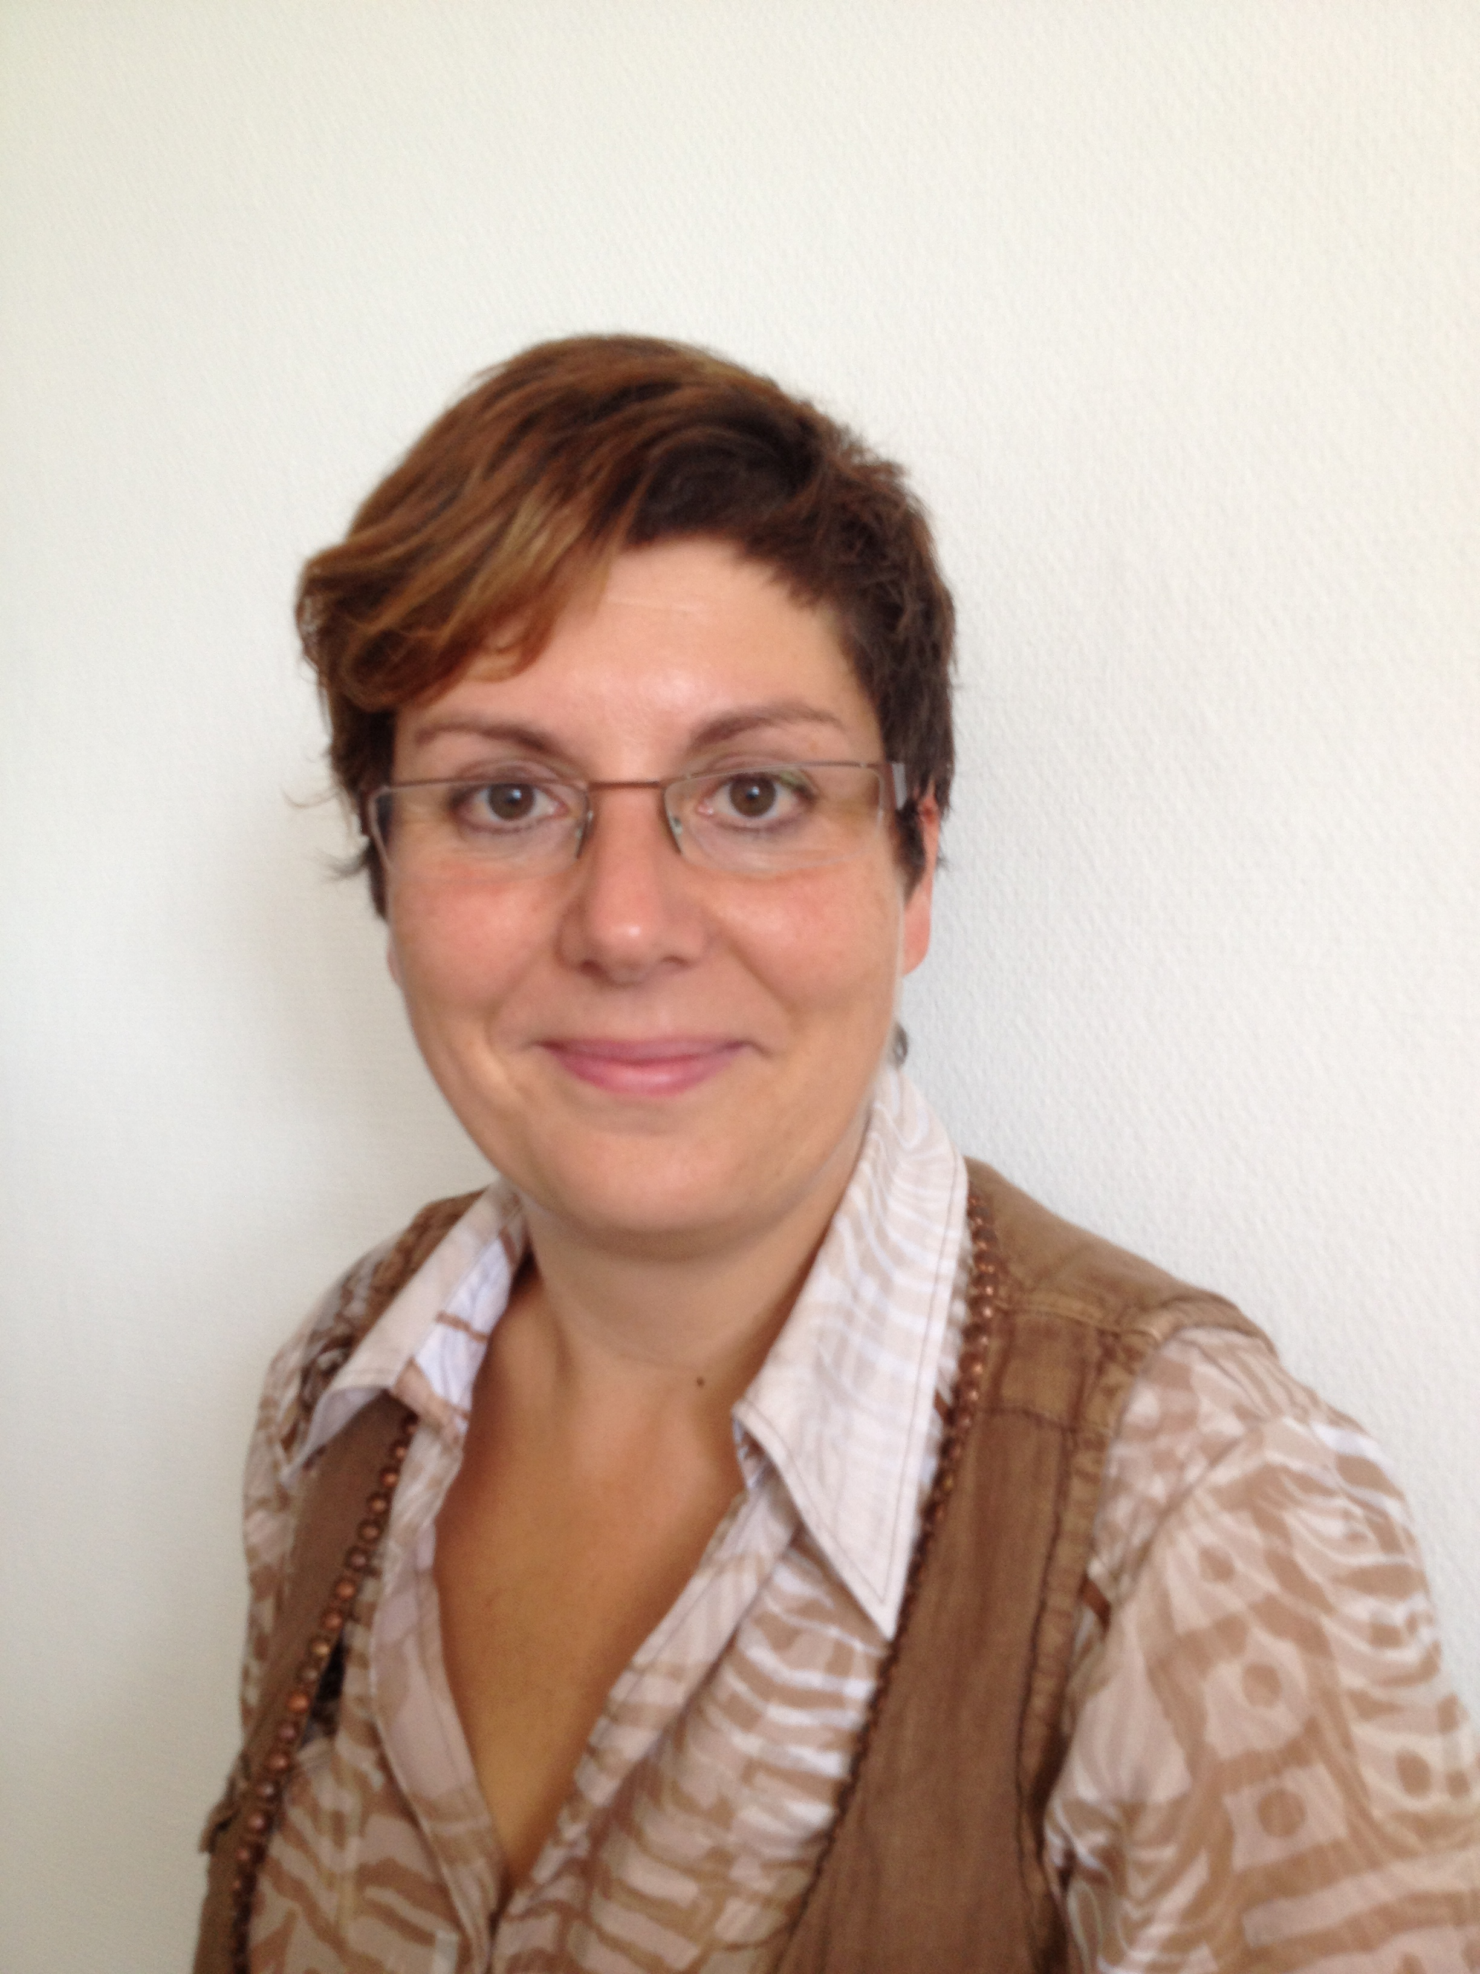

Title: Assessment of the osteogenic potential of human autologous bone meal - a cell and molecular biology pilot study

Christiane Kunert-Keil¹, Anne Kluge², Max Kemper², Thomas Zahnert², Marcus Neudert²

¹Department of Orthodontics, 2Department of Otolaryngology, Head and Neck Surgery, Carl Gustav Carus Campus, Technische Universität Dresden, Fetscherstr. 74, D-01307 Dresden, Germany

Regenerative therapeutic procedures are of paramount importance in head and neck surgery. In this process, autologous bone material obtained by different methods is used for reconstructions. There are so far few data on the regenerative potency and the extraction conditions. The aim of this study was to evaluate the osteogenic potency of human bone meal, which was collected under various conditions. To this end, freshly extracted bone meal from 13 patients was transferred into cell culture media and cultured over a period of 6 weeks. Three different specimens with different drill speeds were taken from each patient. Subsequently, the number of mature cells as well as the expression of stem cell markers (Sox2, Kitlg), growth factors (Bmp4, IGF1) and bone-specific genes (Runx2, Bglap, Alpl, Col1a1) were determined by qRT-PCR.
Depending on the speed, the mRNA expression of all the genes studied decreased significantly, with the exception of Sox2 and Col1a1. At 7000 rpm, the highest mRNA levels were detected. Nevertheless, within the observation period the cultivation of cells from all the bone meal samples succeeded, whereby the number of outgrowing cells was again inversely proportional to the rotational speed. The drill speed as a removal parameter has a demonstrable influence on the quality of the reimplantated bone meal. Both the molecular biology and the cell count indicate a lower rotational speed.

Biography
02/2000: PhD in molecular biology at the University of Greifswald, Germany
1999-2012: postdoctoral studies and research assistant at the University of Greifswald, Germany
Since 2012: head of the research laboratory at the Department of Orthodontics, Technische Universität Dresden, Germany
Doctor Kunert-Keil has authored more than 70 publications and book sections in the fields of muscle and bone physiology as well as regenerative medicine. In the last years, she is devoted to research in the fields of bone surrogates, bone regeneration and implantology. Furthermore, she is interested in Duchenne muscular dystrophy and its influence on the craniofacial morphology.

Presenting author details
Full name: Christiane Kunert-Keil
Contact number: +49-351-4587139
Linked In account: Kunert-Keil Christiane

