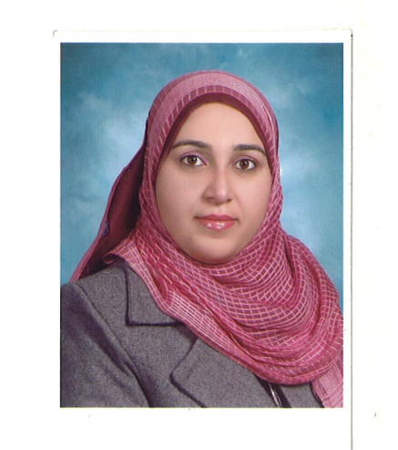
Mesenchymal stem cells cultured with platinum nanoparticles: a new strategy for treatment of osteoporosis in ovariectomized rats

Hadeer A. Aglanª, Hanaa H. Ahmedª, Riham M.A. El Saied^{b}, Naglaa A. Attiaª, Nadia S. Mahmoudª

ªHormones Department, Medical Research Division, National Research Centre, Giza, Egypt
^{b}Basic Dental Science Department, Oral & Dental Research Division, National Research Centre, Giza, Egypt

This study aimed to explore the therapeutic role of single intravenous dose of differentiated bone marrow derived MSCs (BM-MSCs) into osteoblasts through culturing with osteogenetic supplements (OS) and platinum nanoparticles (Pt-NPs) in experimental model of osteoporosis. MSCs were harvested from bone marrow of femoral bones, grown and propagated in culture, then characterized morphologically and by flow cytometry detection of cell surface markers (CD34, CD90 and CD105). The cellular effect of Pt-NPs on the proliferation of BM-MSCs as well as osteogenic differentiation and mineralization of BM-MSCs was determined by MTT assay and Alizarin red S staining respectively. Thirty adult female rats of Wister strain were classified into 3 groups (10 rats/group): Group (1): Gonad intact control group, Groups (2): untreated ovariectomized control rats and Group (3): ovariectomized rats infused via tail vein with differentiated rat BM-MSCs into osteoblasts through culturing with OS and Pt-NPs (3 × 10⁶ cells/rat). Our results revealed that treatment of BM-MSCs with Pt-NPs at doses 2 and 10 µg/ml led to positive effect on BM-MSCs proliferation after 24 h and 48 h. Furthermore, the addition of Pt-NP at dose 10 µg/ml with osteogenic supplements for 21 days enhanced the differentiation of BM-MSCs into osteoblasts which were visualized by staining of the calcium phosphate precipitates with Alizarin Red S stain. Regarding in vivo study, treatment of ovariectomized rats with differentiated BM-MSCs into osteoblasts in the presence of Pt-NPs led to significant decrease in serum BALP and BSP levels, insignificant increase in serum OSX level and insignificant decrease in serum SOST level with normal histological structure and normal size trabeculae. In conclusion, the present setup provided clear evidences that transplanting differentiated BM-MSCs into osteoblasts in the presence of Pt-NPs in ovx rats restore the remodeling balance between osteoblasts and osteoclast.

Biography
Hadeer A Aglan has completed her PhD from Faculty of Science, Ain Shams University. She is Researcher at Hormones Department, Medical Research Division, National Research Centre, one of the biggest research centers in Egypt. She has published more than 12 papers in reputed journals and 2 international books. Also, participated in 8 scientific projects.

Presenting author details
Full name: Hadeer A Aglan
Contact number: 00201001680080
Twitter account:
Linked In account:
Session name/ number: Stem Cell Treatments/ Track 6
Category: (Oral presentation/ Poster presentation)

