Plastics Recycling has Several Applications and Opportunities
Denis Rodrigue, PhD, Université Laval, CANADA

Abstract
Statement of the Problem: Day after day, plastics are generating a very high amount of waste every year, not only single-use plastics (SUP) for packaging, but also from several other applications such as automotive, building, construction, energy, sports and leisure, transport, etc. All these materials must now be recycled after their end of life (EOF) to comply with the concept of sustainable development (SD) and circular economy (CE), as well as to reduce their accumulation into landfills or even worse in the oceans. Methodology & Theoretical Orientation: In this work, some statistics on plastics recycling we gathered and analyzed to determine the main areas/applications generating plastics wastes. Then, several options were proposed for specific material recycling, in particular related to different structures/compositions (blends, composites, foams, multilayers, etc.). In all cases, the focus was on mechanical recycling. As a first applications, a two-component wheel was selected, each part being made of 100% recycled polymers. The internal part was made of high density polyethylene (HDPE) from rigid bottles, while the external part was a blend of the same HDPE (good interfacial adhesion/compatibility between both parts) with different concentrations (0-95% wt.) of ground tire rubber (GTR). The compounds were produced via twin-screw extrusion and the parts were produced by compression molding. Conclusion & Significance: The results showed that after processing conditions optimization (temperature, pressure, time, etc.), a wide of properties (rigidity, elasticity, hardness, impact strength, etc.) can be easily obtained by a simple change of the GTR concentration. This indicates that fully recyclable and sustainable plastics parts can be produced for an applications as presented in Figure 1. Depending on the original materials used, different looks can be obtained which do not need special processes and additives. These results also open the door for further development using different polymers for the dispersed phase (rubbers/elastomers) and the continuous phase/matrix (thermoplastic resins).
Image

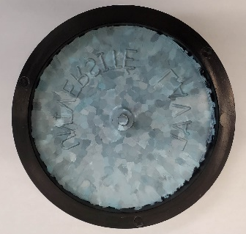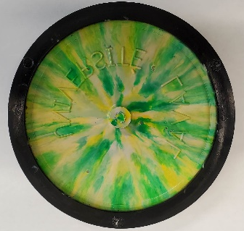
Figure 1. Typical examples of wheels based on 100% recycled materials.
Recent Publications
- Vázquez Fletes RC, Rodrigue D (2021) Effect of wood fiber surface treatment on the properties of recycled HDPE/maple fiber composites. Journal of Composites Science, 5(7): 177.
- Fazli, A, Rodrigue, D (2021) Effect of ground tire rubber (GTR) particle size and content on the morphological and mechanical properties of recycled high-density polyethylene (rHDPE)/GTR bends. Recycling, 6(3): 44.
- Fazli, A, Rodrigue, D (2021) Morphological and Mechanical Properties of Thermoplastic Elastomers Based on Recycled High Density Polyethylene and Recycled Natural Rubber. International Polymer Processing, 36(2): 156-164.
- Fazli, A, Rodrigue, D (2021) Recycling Waste Tires into Ground Tire Rubber (GTR)/Rubber Compounds: A Review. Journal of Composites Science, 4(3): 103.
- Fazli, A, Rodrigue, D (2021) Waste Rubber Recycling: A Review on the Evolution and Properties of Thermoplastic Elastomers, Materials: 13(3): 782.

Biography

Denis Rodrigue obtained a B.Sc. (1991) and a Ph.D. (1996) in chemical engineering from Université de Sherbrooke (Sherbrooke, Canada) with a specialization in non-Newtonian fluid mechanics. In 1996 he moved to Université Laval (Quebec City, Canada) where he is now full professor. Since then, he has been an invited professor at the University of Guadalajara (Mexico), the Technical Institute of Karlsruhe (Germany), the University of Castilla-La Mancha (Spain), the University of Arts and Sciences of Hunan (China), the Technical University of Lodz (Poland) and Polytech Tours (France). His main research areas are in the characterization and the modelling of the morphological / mechanical / thermal / rheological properties of polymer foams and composites based on thermoplastics and elastomers. His main focus is related to polymer recycling and rheology. He is the co-editor of two international journals: Current Applied Polymer Science and Journal of Cellular Plastics.

Email: denis,rodrigue@gch.ulaval.ca

Notes/Comments:

Presenting author details
Full name: Denis Rodrigue
Contact number: +418-656-2903
Session name/ number:
Category: (Oral presentation/ Poster presentation)

