Hot ECAP Implementation in Zirconia Reinforced Aluminium Chip Matrix (Al6061) Composite Production
Sami. Al-Alimi^{1,} , M.A. Lajis^{1,} , S.Shamsudin¹, Ahmed Wahib¹
^{1,} Sustainable Manufacturing and Recycling Technology, Advanced Manufacturing and Materials Center (SMART-AMMC), Universiti Tun Hussein Onn Malaysia, 86400 Parit Raja, Batu Pahat, Johor Malaysia
*samialalimi@gmail.com
Abstract
The demand of aluminium in transportation sector is growing rapidly due to the high strength to weight ratio requirement for fuel saving and performance purpose. There is a need to develop a sustainable recycling process without melting phase for the secondary aluminium production that can further save the energy, reduce the greenhouse gas emission level and global warming. Therefore, a meltless equal channel angular pressing (ECAP) method was introduced to process the aluminium wastes in the form of chips to achieve the forementioned agenda. In this study, the composites made of aluminium AA6061 chips reinforced with 5%, 10%, and 15% volume fraction of ZrO₂ powder were produced under the different processing temperatures of 450°C, 500°C, 550°C. The experimental results were analysed using the design and analysis of experiments (DOE) principle and assisted by the Minitab 18 software. It was reported that the maximum yield strength and hardness increased to 119.26 MPa and 65.25 VH compared to 100.26 MPa and 50 VH (as-received AA6061) respectively.
Keywords: Waste Materials, Mechanical and Physical Properties; Aluminium Chips; Equal Channel Angular Pressing (ECAP); Metal Matrix Composites (MMCs). Solid-state recycling.

1 Introduction
Aluminium alloy is extensively used in engineering automotive industries because of its properties, for instance, high strength, good toughness, superior workability. High amount of aluminium consideration has been focused when the product is manufactured, and chips are discarded. The need of recycling process in where the chips could be recycled without remelting process to avoid the disadvantages occurred by a conventional method. So, solid-state recycling is introduced due to its low cost and ability to recycle 95 percent of the materials [1],[2].
In recent years, ceramic particles-reinforced recycled metal matrix composites (MMCs) have been wide investigated in the past few decades due to their superior mechanical and physical properties [3]. Also, number of processing methods have been developed for the manufacturing of aluminium metal matrix composites (AMMC). ECAP method was invented by V.m Segal in 1972 so that, the main purpose of ECAP technique is to induce high mechanical properties and enhance high strain into billets [4]. However ECAP is an excellent SPD method for the enhancement of material ultra-fine grained (UFG) microstructure based composites by imposing large strain with the conservation of billet cross-dimensions [5]. ECAP is a useful and economical tool from the micro to nano-sized for the production of particle reinforced aluminium matrix composites [6]. Sanusi at el. [7] reported that AA6061 chips to be reinforced ceramics based composites to develop the ultra-fine grained material using by ECAP technique. The proposed study intensively reviewed the light metal recycled articles on MMCs composites, and the trends in the design of the ECAP die and processing its parameters. Abdizadeh at el. [8] has investigated the effect combining aluminium with zircon (ZrSiO₄) particles on material mechanical properties. Compressive strength was increased by increasing the zircon contents up to 248 MPa at 5% ZrSiO₄ and 650°C as an optimum value before start decreasing because of the internal stress and density of material dislocations and results for better composites properties. Naglieri et al. [9] studied different volume fraction of zirconia particles ranged from (5–20 vol %) by wet chemical method at 600°C for 1 h. the report shows a characterized homogeneity of ZrO₂ distribution in the matrix. The composites of 10 vol % ZrO₂ exhibited better hardness and the highest value of fracture threshold.
In short, several investigations on ECAP processing routes concentrated on room temperature and pure metallic alloys while limited studies that are reported of ECAP to AMMCs composites [10][11]. The used reinforcement particles in this study primarily 5%. vol ZrO₂, 10%. vol ZrO₂, and 15%. vol ZrO₂ contents and no reports are found on Al based chips reinforced with ZrO₂ ceramics. The process objective to be subjected to a hot ECAP at 300°C is to avoid the material failure billets segmentation. Finally, design of experiment (DOE) was used to determine the optimum combinations of yield strength composites mechanical properties.
2 Materials and Methods
The presented matrix in this study is basically turn into machining scraps by dry milling. Dry milling was conducted to minimize the complication due to the usage of coolant. The ECAP technique [12]. And commercial Al6061 chips with ZrO₂ particles were mixed by 3D mixer machine and compacted into billet with length of 80 mm and 12 mm diameter. The weighted Al/5%. vol ZrO₂, Al/10%. vol ZrO₂, and Al/15%. vol ZrO₂ samples were treated by at three types of temperature, 450°C, 500°C and 550°C for 3 hours. Once the experiment was prepared, the heat supply was controlled up to 300°C and recorded by K-type thermocouples which are connected to a data logger, so that to a void materials failure. In contrast, the designed table was statically performed to analyse and obtain the results, the Minitab 18 software designed the experiment and investigated the yield strength mechanical testing response. Also, inputted values named as temperature and volume friction of ZrO₂. The table 1 is explaining the designed values of the experiment.

Table 1. Values of the Design of Experiment
Parameters | Level used
 | Low (-) | Middle (0) | High (+)
ZrO₂ contents, % | 5 | 10 | 15
Temperature,°C | 450 | 500 | 550

The design of the experiment was conducted in this work to develop the MMCs composites optimization and propose the best overall optimum parameters such as materials strength properties [13]. Fig1. Shows the hot ECAP die schematic diagram.
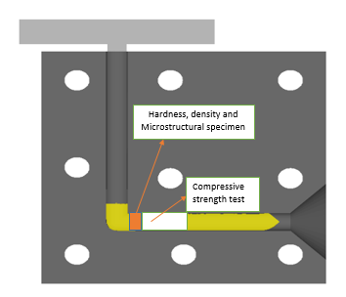
Figure1. Schematic Diagram for ECAP die
3 Results
3.1 Design of Experiment

The statistical software Minitab 18 were chosen to form the design table and analyse the experimental data. The input parameters namely temperature and B₄C volume fraction. Design of experiment (DOE) investigated the interactions between all parameters in order to determine the optimum values of responses. DOE factorial design of all combination of levels results in increasing the number of experiments as the parameters are increased [14]. This model is fit to apply for linear models but can not determine the curvature points with the same number of experiment. However, with two parameters at three levels were used for full factorial performance. With this type of design 11 experiments were achieved and another extended 4 experiments to the total runs of the experimental data.
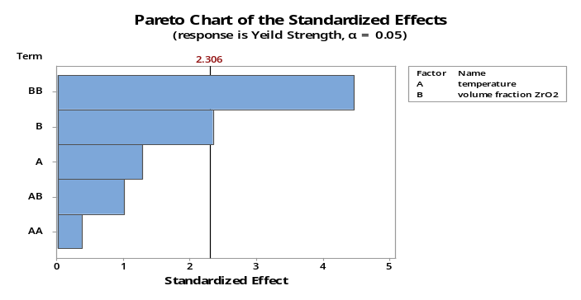
Figure 2. Pareto chart of standardization effect
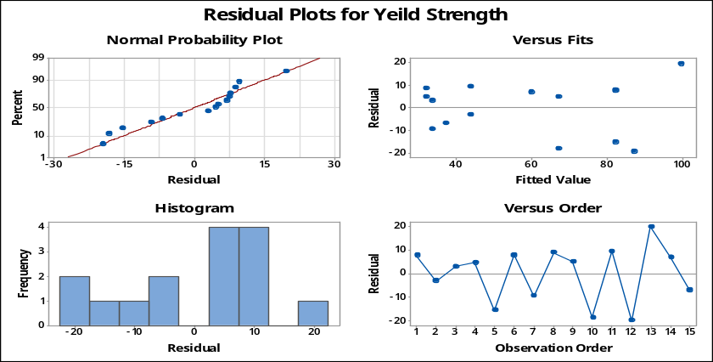
Figure 3. Design of experiment Al-ZrO₂
The effect of zircon ZrO₂ to the composite’s yield strength was analysed by (ANOVA) a statistical process that could summarise a set of logical conclusions based on the analysed experimental data. In the ANOVA table shows that F-value measure of variation of the presented data. Also, P-value presents the lowest value of significance to the hypothesis rejection. It shows the findings of (temperature, volume fraction of ZrO₂) coefficient interacted with tow process parameters where P-value significant to the composites yield strength. Although, table 2 indicated the yield strength is 80.73% which means the model is acceptable and the R² in this research is achieving good fitting of the outcome findings.
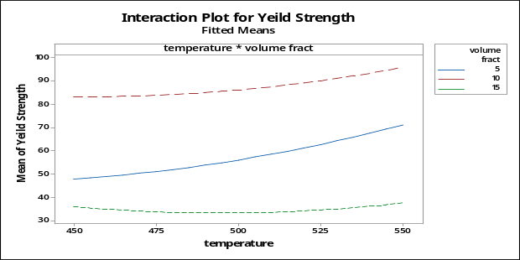
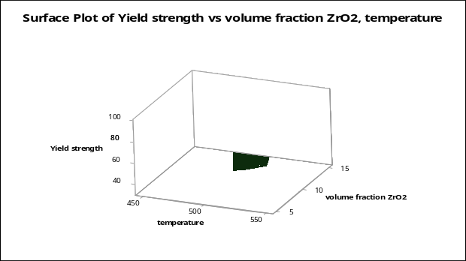
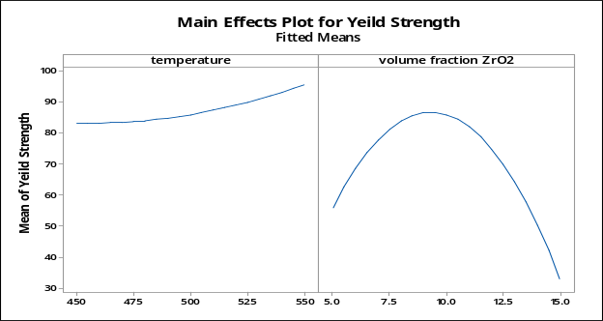
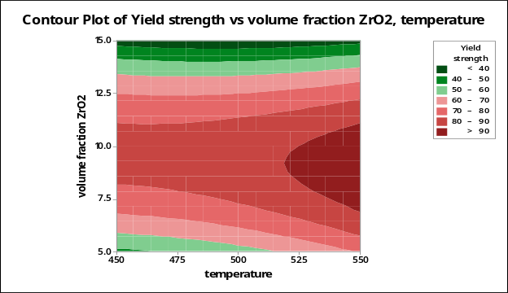

Figure 4. RSM Data analysis Al-ZrO₂ composites
Table 2. Model summary of the Al-ZrO₂ composite
S | R-sq | R-sq(adj) | R-sq(pred)
15.3083 | 80.73% | 66.28% | 13.76%

3.1 Yield Strength
Table 3. Design of experiment table
Sample notation | Std Order | Run order | V. F (B₄C) (%) | Temperature  (°C) | Yield Strength (MPa) | Experimental design
S₁ | 1 | 11 | 5 | 450 | 53.405 | Factorial design  Central design  Axial design
S₂ | 2 | 10 | 5 | 550 | 48.976 | Factorial design  Central design  Axial design
S₃ | 3 | 4 | 15 | 450 | 36.694 | Factorial design  Central design  Axial design
S₄ | 4 | 3 | 15 | 550 | 36.694 | Factorial design  Central design  Axial design
S₅ | 5 | 2 | 5 | 450 | 40.806 | Factorial design  Central design  Axial design
S₆ | 6 | 9 | 5 | 550 | 72.239 | Factorial design  Central design  Axial design
S₇ | 7 | 8 | 15 | 450 | 40.806 | Factorial design  Central design  Axial design
S₈ | 8 | 7 | 15 | 550 | 24.333 | Factorial design  Central design  Axial design
S₉ | 9 | 5 | 10 | 500 | 66.872 | Factorial design  Central design  Axial design
S₁₀ | 10 | 1 | 10 | 500 | 89.746 | Factorial design  Central design  Axial design
S₁₁ | 11 | 6 | 10 | 500 | 89.923 | Factorial design  Central design  Axial design
S₁₂ | 12 | 12 | 10 | 450 | 67.51 | Factorial design  Central design  Axial design
S₁₃ | 13 | 13 | 10 | 550 | 119.26 | Factorial design  Central design  Axial design
S₁₄ | 14 | 14 | 5 | 500 | 66.93 | Factorial design  Central design  Axial design
S₁₅ | 15 | 15 | 15 | 500 | 30.14 | Factorial design  Central design  Axial design

The compressive test was done at room temperature according to the (ASTM E9 – 09) standard at speed of 0.005 (m/m·min) with 5%, 10% and 15% Al-ZrO₂ content [15]. Fig 4. shows the results of tested composite samples with different zircon volume fraction and processing temperature. The yield strength was increasing gradually, by increasing the zircon contents. However, the optimum values of yield strength is 119.26 MPa at 8.94% ZrO₂ and 550°C while the lowest record is 24.333 MPa at 4594.29°C duo to the agglomeration of the particles. Although, increasing process temperature results in easier diffusion of composite’s atoms and improve materials bonding chips boundaries. Finally, the yield strength of the MMCs reaches to its higher value.

Figure 5. Yield strength analysis
3.2 Hardness
The purpose of conducting hardness measurement is to test the material resistance to the plastic deformation under a certain applied force [8]. The matrix was reinforced with 5% vol. ZrO₂, 10% vol. ZrO₂ and 15% vol.ZrO₂ particles for all designed samples according to ASTM (ASTM E92 - 82) standard. However, Fig 5. Shows the findings of Vickers hardness measurement that confirm the volume fraction and temperature increases to the MMCs composites. The report present that 65.39 (VH) is the highest of all hardness values at 550C and 10% vol. ZrO₂ while 51.69 (VH) is the minimum reported value at 450C and 10% vol. ZrO₂. The calculated values are an average of five readings [3]. Also, after 10% volume fraction the hardness readings were decreased due to material pores and particle’s agglomeration.

Fig 5. Hardness of Al-ZrO₂ samples
3.3 Density
The density of Al-ZrO₂ was obtained by archimede’s principle. Distilled water was used as immersion liquid in this measurement. The theoretical density was calculated by using the rule of mixing composites and to be compared with measured density. Table 4 indicates the finding of both theory and measurement and can be seen that higher temperature and volume present of zircon caused increases on MMCs overall densities due to agglomeration of ZrO₂ contents and rising the temperature which also results an easier diffusion during ECAP process. From another view point, more addition of zircon content particles, they agglomerate in one side of material regions. It is also confirms that more than 15% ZrO₂ is not flexible to the composites and caused weak binding between boundaries. The calculated densities have been obtained by using the following formula:-

$\frac{1}{ρ_{C}}=\frac{w_{f}}{ρ_{f}}+ \frac{w_{m}}{ρ_{m}}$ (1)
Where ρ is density, w volume fraction while m, f, c related to the composites and reinforcement [16].

Table 4. Densities and pores of Al-ZrO₂ samples
Materials | Theoretical Density (g/cm³) | Experimental Density (g/cm³)
ZrO₂ | 5.68 | -
Al6061 | 2.7 | -
Al-5 vol.% ZrO₂ | 2.84 | 2.65
Al-10 vol.% ZrO₂ | 2.99 | 2.72
Al-15 vol.% ZrO₂ | 3.17 | 2.74
4 Conclusion
Al-5 vol.% ZrO₂, Al-10 vol.% ZrO₂ and Al-15 vol.% ZrO₂ composites were successfully produced by ECAP technique under three types of temperature 450°C, 500°C and 550°C respectively. With increasing the zirconium contents and temperature, the yield strength, hardness and density were increased.
- The optimum reported value of yield strength was 119.26 (MPa) at 8.94% zircon content and 550°C, while the lowest value of yield strength was at 15% of ZrO₂ content and 494.29°C after RSM analysis.
- Response Surface Methodology (RSM) is applied to validate the response validity.
- Hot ECAP were set up for Al-ZrO₂ composites with die angle of 90° to overcome material failure and weak bonding boundaries due to ECAP high strain hardening and able to prevent the plastic deformation.
- No improvement was reported after 10% ZrO₂ particles due to composite particle’s agglomeration.
Overall, using hot ECAP techniques for solid-state recycling is highly recommended to create an environmentally friendly solutions and propose the MMCs products for the engineering applications such as automotive industries.

5 References
[1] A. I. Selmy, M. I. A. El Aal, and M. A. Taha, “The Egyptian International Journal of Engineering Sciences and Technology Solid-State Recycling of Aluminum Alloy ( AA-6061 ) Chips via Hot Extrusion Followed by Equal Channel Angular Pressing ( ECAP ),” vol. 21, no. October, pp. 33–42, 2016.
[2] S. Shamsudin, M. Lajis, and Z. Zhong, “Solid-state recycling of light metals: A review,” Adv. Mech. Eng., vol. 8, no. 8, p. 168781401666192, 2016.
[3] G. Ramu and R. Bauri, “Effect of equal channel angular pressing (ECAP) on microstructure and properties of Al-SiCp composites,” Mater. Des., vol. 30, no. 9, pp. 3554–3559, 2009.
[4] A. Azushima et al., “Severe plastic deformation (SPD) processes for metals,” CIRP Ann. - Manuf. Technol., vol. 57, no. 2, pp. 716–735, 2008.
[5] Q. Pham, Y. G. Jeong, S. H. Hong, and H. S. Kim, “Equal Channel Angular Pressing of Carbon Nanotube Reinforced Metal Matrix Nanocomposites,” Key Eng. Mater., vol. 326–328, pp. 325–328, 2006.
[6] M. J. Qarni, G. Sivaswamy, A. Rosochowski, and S. Boczkal, “Effect of incremental equal channel angular pressing (I-ECAP) on the microstructural characteristics and mechanical behaviour of commercially pure titanium,” Mater. Des., vol. 122, pp. 385–402, 2017.
[7] K. O. Sanusi, O. D. Makinde, and G. J. Oliver, “Equal channel angular pressing technique for the formation of ultra-fine grained structures,” S. Afr. J. Sci., vol. 108, no. 9–10, pp. 1–7, 2012.
[8] H. Abdizadeh, M. Ashuri, P. T. Moghadam, A. Nouribahadory, and H. R. Baharvandi, “Improvement in physical and mechanical properties of aluminum/zircon composites fabricated by powder metallurgy method,” Mater. Des., vol. 32, no. 8–9, pp. 4417–4423, 2011.
[9] V. Naglieri, P. Palmero, L. Montanaro, and J. Chevalier, “Elaboration of alumina-zirconia composites: Role of the zirconia content on the microstructure and mechanical properties,” Materials (Basel)., vol. 6, no. 5, pp. 2090–2102, 2013.
[10] T. Lokesh and U. S. Mallik, “Effect of Equal Channel Angular Pressing on the Microstructure and Mechanical Properties of Al6061-SiC _{p} Composites,” IOP Conf. Ser. Mater. Sci. Eng., vol. 149, no. September, p. 012119, 2016.
[11] S. M. Arab and A. Akbarzadeh, “The effect of Equal Channel Angular Pressing process on the microstructure of AZ31 Mg alloy strip shaped specimens,” J. Magnes. Alloy., vol. 1, no. 2, pp. 145–149, 2013.
[12] D. T. McDonald, E. W. Lui, S. Palanisamy, M. S. Dargusch, and K. Xia, “Achieving superior strength and ductility in Ti-6Al-4V recycled from machining chips by equal channel angular pressing,” Metall. Mater. Trans. A Phys. Metall. Mater. Sci., vol. 45, no. 9, pp. 4089–4102, 2014.
[13] D. Indumati, “STUDY OF MECHANICAL BEHAVIOUR OF METAL MATRIX COMPOSITES USING DESIGN OF EXPERIMENTS Driving motor Stirrer Rod Ball Bearing Stirrer Blade Crucible Holding Furnace,” vol. 6, pp. 303–309, 2011.
[14] S. Daneshpayeh, F. Ashenai Ghasemi, I. Ghasemi, and M. Ayaz, “Predicting of mechanical properties of PP/LLDPE/TiO2 nano-composites by response surface methodology,” Compos. Part B Eng., vol. 84, pp. 109–120, 2016.
[15] I. El-Mahallawi, A. Shash, and A. Amer, “Nanoreinforced Cast Al-Si Alloys with Al2O3, TiO2 and ZrO2 Nanoparticles,” Metals (Basel)., vol. 5, no. 2, pp. 802–821, 2015.
[16] S. Alalhessabi, S. A. Manafi, and E. Borhani, “The Structural and Mechanical Properties of Al-2 . 5 % wt . B 4 C Metal Matrix Nano-composite Fabricated by the Mechanical Alloying,” vol. 2, no. 8, pp. 39–44, 2015.

