INTEGRATED RESOURCE RECOVERY CENTERS (IRRC) SAKRAND TOWN
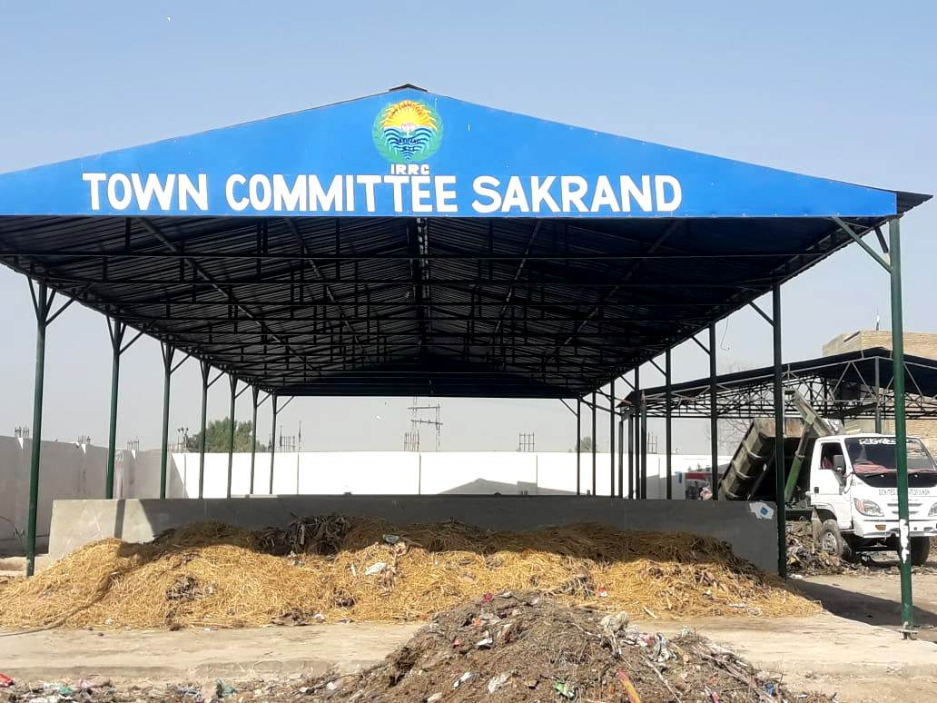

.
What is an Integrated Resource Recovery Center?
Integrated Resource Recovery Centers, IRRCs, aim at recovering valuable resources from
waste. Three major activities can be carried out by the IRRC: collection of segregated waste,
Processing of waste and sale of the resources generated. The main focus of IRRCs is on
Organic waste, which typically comes from kitchens, restaurants, and wholesale vegetables
or fruits markets. Inorganic waste –mainly paper, packaging materials made of plastic, glass, tin, aluminum, etc. –can also be collected and stored on an IRRC, for subsequent sale, when market rates are at its most favorable. One of the distinctive features of IRRCs is that they use simple
Mechanical technology. Local organizations can quickly become familiar with this technology and adapt it to the local context. Using technology that requires little energy keeps operation costs low and equipment breakdowns are minimal. Besides, simpler technology is also more labor intensive, thus creating more job opportunities for the poor. Through the processing of organic waste, IRRCs produce high-quality compost For this to happen, the segregation of waste at source is a key success factor As such, for an IRRC to function properly, the close involvement of the surrounding communities is a must, as households are trained on how to separate organic and inorganic waste With adequately sorted organic waste, IRRCs apply the aerated box composting method to produce good quality compost IRRCs are designed to be run as businesses, and therefore they aim to achieve, at a minimum, a revenue-cost balance. To ensure profitability, the proponent of an IRRC must formulate a business plan before starting the work, which should prove that the IRRC can be financially sustainable. IRRCs can be initiated and operated by municipalities, private-sector enterprises and civil society organizations, or combination of all the three through different partnership models. An IRRC can deliver the following benefits

.Economic Benefits
Nowadays IRRC Sakrand Town production started derived out of waste by converting waste
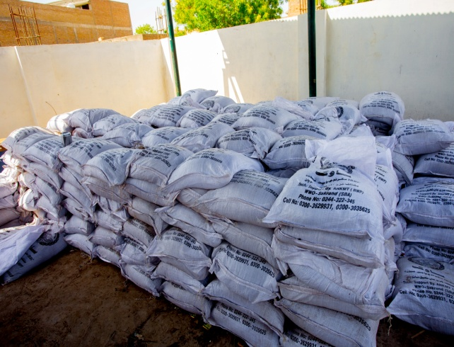
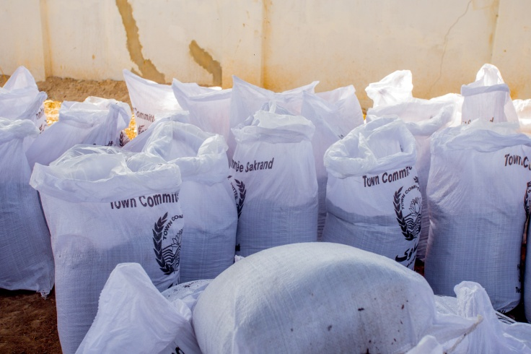
.

Environmental Benefits
Reduction of greenhouse gas emissions by treating the organic fraction of waste; avoids the
Formation of leach at water and the spread of bad odors.
Social Benefits
- creation of jobs for the urban poor, including waste
- pickers reduction of diseases from untreated waste
- Increased community awareness to 3R principle
Climate Change and Decentralized Solid Waste Management
One of the envisaged objectives of an IRRC is to achieve financial sustainability, i.e. that the
Revenues produced from waste recovery can outweigh the operational costs incurred. In order to improve the financial robustness of an IRRC, it should be possible to leverage carbon financing, considering the greenhouse gas emission reduction potential from Treating the organic component of waste. Until recently, the Clean Development Mechanism (CDM) has been the vehicle of choice for tapping into carbon financing for these projects. However, the recent sharp decline of carbon emission reduction prices prompted UN-ESCAP and UN-Habitat to look into alternative climate financing avenues. Among those, Nationally Appropriate Mitigation Actions (NAMAs) have been found to hold the greatest promise. UN-ESCAP and UN-Habitat has been conceptualizing a NAMA approach derived from the IRRC model and consultations are in process with the stakeholders under the leadership of Climate Change Division of Pakistan. Having as astarting point some of the core principles of this model, the NAMA program would hinge in the promotion of 3R principles, the avoidance of end-of-pipe solutions, and the biological treatment of the organic fraction of waste. Such program would be backed-up by International support in terms of finance, technology and capacity building

.

