Poster 2: Solid Wastes Recycled, Reused for the Increased in the wealth management

Raaginii Jaain
National Expert of Swachh Bharat Mission Empanelled by MoUD, Founder of Geetanjali Envirotech
Email: raaginiijaain@gmail.com
Tel: 98821280214

Abstract

Bioremediation and Biomining:
Urban India had no waste problem until the seventies, because farmers competed for the food waste in dustbins to take back for composting. Urea subsidies and citizens discarding newly-available plastics along with food waste killed this habit. So all our open dumps and hills of waste date from the eighties. These airless heaps of rotting waste take over 30 years to fully decompose. Meanwhile they produce methane and foul-smelling landfill gases that attract flies, as well as a highly polluting liquid called leachate that contaminates groundwater for decades.
But there is a very simple solution : expose all the waste to air. Oxygen in the air can convert all organic waste to humus-rich compost, like leaves on the forest floor. Raaginii Jaain has devised a quick and simple method in which mounds of rotting waste can be sliced into parallel vertical heaps which are sprayed with composting bio cultures to speed up decomposition. These are then turned weekly, four times, to fully stabilize the waste so that it no longer produces leachate or methane. This is called Bioremediation. It reduces the volume of waste by up to 40% and also reduces its moisture content.
This fully decomposed waste is then dry enough for screening into different useful fractions : fine organic-rich soil to improve farm fertility, a stony gravelly fraction usable for road-making, plastics blown out for shredding and use in long-lasting “plastic roads” and the coarsest fraction with combustibles like cloth for use as Refuse Derived Fuel (RDF). This screening for offsite use is called Biomining. It clears an old dumpsite of 90% waste to create space for unloading of fresh waste in windrows for turning and stabilizing.
Biomining is different from just moving rotted waste offsite to a new location. Untreated moist waste cannot be easily screened. It cannot be use in fields without prior bioremediation because that will rob nitrogen from the soil as it decomposes.

Biography (with 150-word limit):

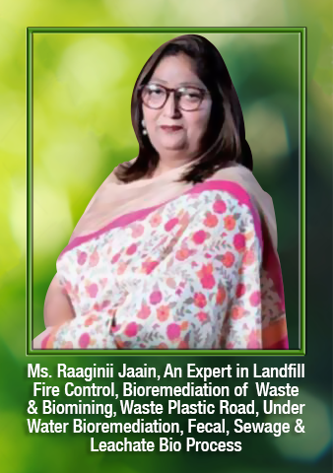
Raaginii Jaain – a Swachh Bharat Mission National Expert Empaneled by MoUD – having more than 3 decades of experience in recycling of solid waste, plastics, BOPP, PET, Green Toilet Technology, Infrastructure &Utilities in Sanitary facilities, sewage treatment plant, environment improvement and waste management is a social environmentalist, an entrepreneur, a consultant to various private sector entities/enterprises and Public Sector Undertakings.
CEO & Founder of Geetanjali Envirotech, a waste-management centre Mumbai based also India’s first private-public partnerships (PPP) model for plastic waste collection, segregation and recycling.
In this process, she has not only inculcated a clean environment but also enhanced employment and social awareness on cleanliness in surrounding areas and is continuing alongwith the support of the GOI the process in African country & various states in India. Just to name a few Chhattisgarh, Maharashtra, Karnataka, Jammu and Kashmir, Bihar, Rajasthan, Madhya Pradesh, Uttar Pradesh, Haryana, Gujrat, Punjab and adjoining Andaman and Nicobar Islands too.
In addition to this, she is also into designing, establishing, operating and maintaining Eco green Public sanitary facilities and other city infrastructure which have proved to be beneficial to the citizens.

