SEA CLEANING UNDER BIO REMEDIATION (TECHNOLOGIES SHARING FOR ALL KIND OF PLASTIC RECYCLING REUSED)
& SEWAGE TREATMENT.

By Mrs. Raaginii Jaain
National Expert of Swachh Bharat Mission Empanelled by MoUD
Founder of Geetanjali Envirotech
98821280214/ raaginiijaain@gmail.com
Abstract

Untreated wastewater and leachate pose serious environmental threats and have serious implications for human health. This has led to the enforcement of stringent guidelines for manufacturing industries, municipal sewage facilities and residential developments alike, to treat waste water before discharging it to public sewerage lines or natural water bodies. The key issues are reduction of sludge, elimination of odours and improvement of the overall quality of the discharged water, as per the guidelines.
Raaginii Jaain has perfected a proven, sustainable and cost-effective solution by way of Bio-remediation. It has developed a cocktail of naturally occurring and non-pathogenic GE microbes, which are effective in a broad range of temperatures (-50 to +60 degrees Celsius) and can operate in both aerobic and anaerobic conditions. These versatile microbes rapidly produce quality outcomes for treatment of stagnant waste water and leachate, as well as other polluted water bodies and even in flowing wastewater up to depths of 50m, without the use of harsh chemicals. This cocktail, which has been shown to reduce sludge, solids, and odours like ammoniacal nitrogen and hydrogen sulphide, can also destroy stable foams on polluted waters. It also lowers BOD, COD, TSS, TDS and can even achieve pH in the range of 6.5 to 7.1. Besides, any pathogenic bacteria present in the leachate/wastewater are also eliminated by this proprietary mix. Lastly, since no residual sewage sludge is produced, no further processing is required.
Our company has been working for the last 20 years in underwater bio-remediation, sewage treatment, lake treatment, leachate treatment and de-silting of rivers and drains using our proprietary microbes. Using these microbes, we can reduce the operating cost of wastewater treatment processes and can provide 100 % result in a very short duration. This paper showcases the effectiveness and versatility of these GE microbes, to process and provide a 100% successful solution in a very short duration, for the treatment of wastewater, leachate and water bodies, through different case studies across India.
Introduction

We have a prove microbial treatment using the process of bio-remediation.
Our company has been working for the last 20 years in underwater bio-remediation, sewage treatment, lake treatment, leachate treatment and de-silting of the rivers/drains using our proprietary microbes.

GE Microbes is cocktail of naturally occurring and non-pathogenic microbes which occur in nature using which we can degrade materials in waste water. These microbes can reduce sludge, solids, odour, phosphorous (break apart phosphorus foam) and ammonical nitrogen. They can also lower BOD, COD, TSS, TDS and can achieve pH of 6.5 to 7.1. Our microbes can operate in -50 to +60 degree Celsius. They can work in stagnant water, flowing waste and even up to depths of 5m.

Using these microbes, we can reduce the operating cost of the processes and can provide 100 % result in a very short duration.

Leachate Treatment
Leachate is the foul dark liquid that seeps out of municipal solid waste during its anaerobic decomposition. Leachate management is one of the major concerns when handling MSW. Leachate is corrosive in nature and contains heavy metals and pollutants, so it needs to be collected in an enclosed location and then transferred to a treatment plant or be treated in an in-house treatment plant.
Most of the garbage disposal locations in India are simply dumpsites of mixed waste rather than scientific landfills. They have no provision for leachate collection and containment. Hence leachate flows haphazardly according to the lay of the land, contaminating soil and ground water and even deep borewells in surrounding areas. This leads to scarcity of potable water and a health crisis with repercussions that would affect generations.
Our process of treatment focuses on in-situ treatment of this polluted water in the shallow lagoons where it usually collects. Any floating waste is first manually removed before our proprietary bio-culture is sprayed on the leachate and aeration provided.

Sewage Treatment
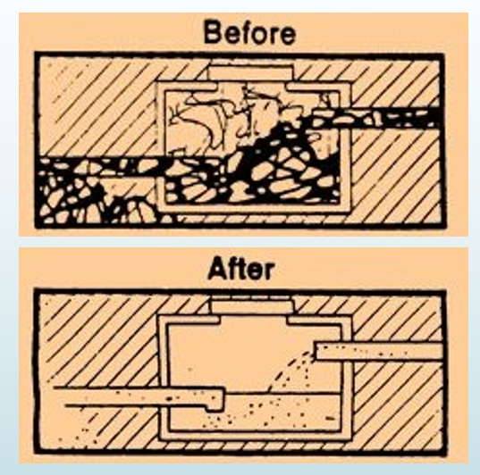
In developing nations according to UNDP and UN-Habitat 90% of wastewater generated is not treated by the STPs but released into the environment untreated. Only the primary treatment is conducted where the solids settle at the basin and oils, grease and lighter solids float up. The settled and floating materials are removed but no additional treatments are conducted.
Using our methods GE microbes are administered and they can operate both in aerobic and anaerobic conditions. They consume all the organic content and pollutents in the STPs and propagate free flow of the processed wastewater.
Mechanism of action of the bio-culture on the leachate/wastewater
The initial operation of the bio-culture is to digest floating foams and surface oil impurities wherever present in the leachate or wastewater. These may be manually removed to speed up the process. The biocultures immediately achieve very rapid odour control by oxidation of ammonical nitrogen, hydrogen sulphide and other foul-smelling gases.
After this, the suspended organic content present in the wastewater is digested by changing the conditions to accelerate this process. Any pathogenic bacteria also present in this leachate/ wastewater are also consumed by our microbes. Our process produces no residual sewage sludge and hence does not require any further processing.
The removal of ammonical nitrogen is also carried out at last. Our bio-culture also contains a blend of nitrifying and denitrifying bacteria. Nitrosomonas bacteria converts ammonia to nitrite and this nitite is converted nitrate by nitrobactor bacteria. This then produces free nitrogen and water molecules by redox reaction conversion.
Case Studies:
- Leachate Treatment
- Nagpur at Bandewadi dumpsite
Bandewadi dumpsite consisted of 15 lakh MT of unprocessed waste which was heaped to a height of 40 ft. This consisted of moisture which continued to produce leachate and large quantities of water which was used to treat this waste and any fires caused also used to increase the amount of leachate being generated. As observed in the photos the entire dumpsite was covered by leachate which was knee deep.
The unprocessed waste was made to generate the leachate and this was then collected and processed.
The entire dumpsite was covered in leachate
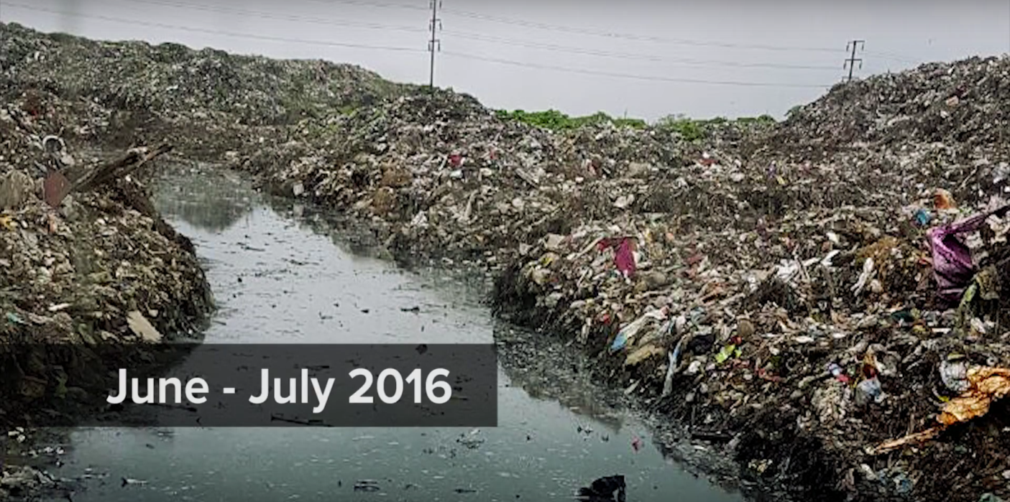
Leachate completely eaten up by the microbes from the dumpsite
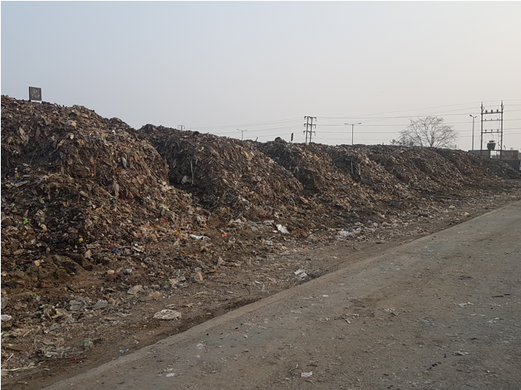
Dec 2016
- Gurugram-Faridabad dumpsite Bandhwari
The bandhwari dumpsite is a collection point of waste for the cities of Gurugram and Faridabad. The waste hadn’t been processed since 2013. This dumpsite consisted of 5 acres of leachate out the 34 acre plant. The processing of this waste began on 16th Oct, 2016. This leachate has been
reduced by 95 % in this dumpsite by Jan 2017. The groundwater tests conducted by the pollution control board show improvements in the quality of groundwater.

5 acres of the 34-acre dumpsite was covered with leachate
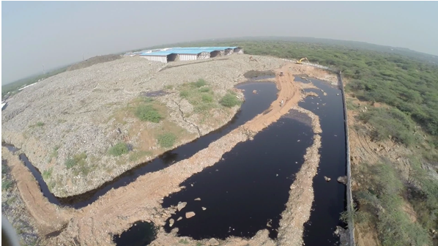

Most of this leachate has been eaten up by our microbes
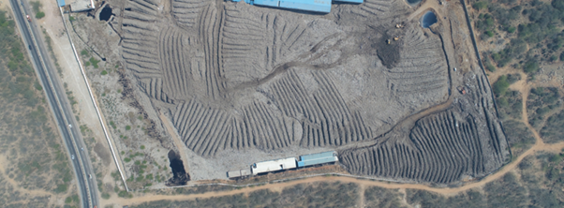

- Bangalore Quarries
Banagalore quarries which contained leachate ponds had a thick layer of foam and oil of about 1-2 feet covering its entire stretch. The same situation was observedat the Bellahalli, Mittganahalli and Baglur quarries. This foam was due to spraying lemon grass oil. This foam was broken apart and reduced in the span of 15 days. Labs tests were conducted by Karnataka State Pollution Control Board between samples of treated and untreated leachate, pH increase to 7.1 compared to 5.6, TDS of 4658 mg/L compared to 8470 mg /L, TSS of 156 mg/L compared to 2300 mg/L, Chloride levels at 592 mg/L compared to 1433 mg/L, COD at 4414mg/L compared to 15297 mg/L, BOD at 27°c at 1680mg/L compared to 5100 mg/L, total kjeidhal nitrogen at 243mg/L compared to 448 mg/L and ammonical nitrogen at 190 mg/L compared to 372mg/L.
Heavy metals like Copper, Zinc and Nickel which were present were also found to be about 0.05, 0.4 and 0.12 mg/L compared to 0.1, 1.1 and 0.3 mg/L.
This shows dramatic improvements in the characteristics of the leachate in 15 days.

Leachate treatment work at Bellahalli quarry
The quarry at the start of the process which was covered by a thick layer of foam from lemon grass oil spraying
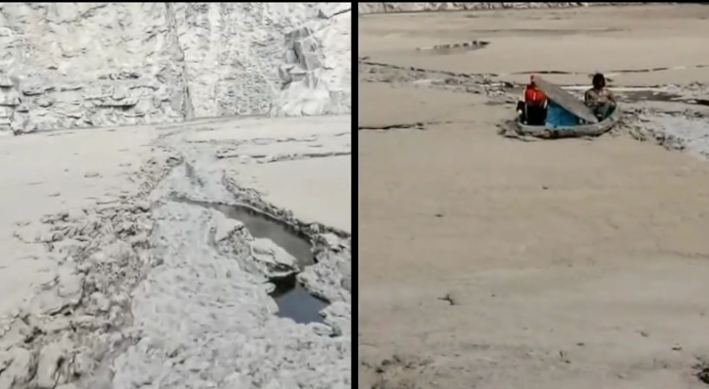

The thick layer of foam dissolved from the quarry pond
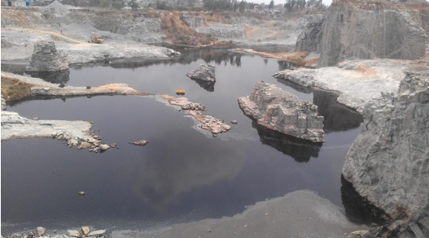
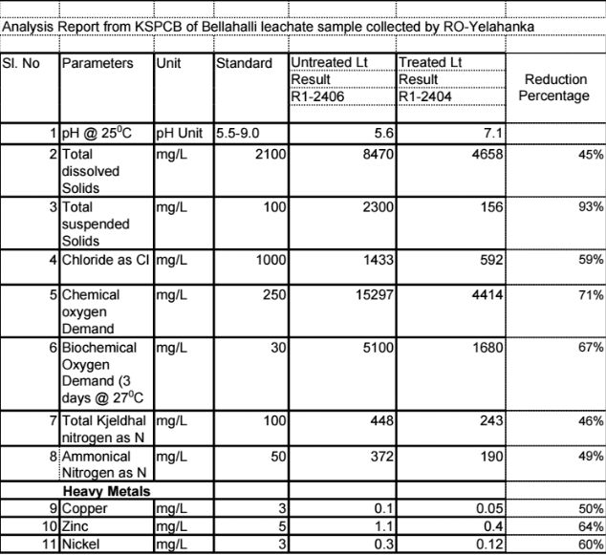

- Septic tanks

- Khopoli City Septic Tank Processing
Two septic tanks of ten sits public toilets at Varchi Khopoli & Bhanwaj Boudhhwada were inspected and treated. Observations were made on the first day till the 17th day at regular intervals.
It was observed that total depth of solid mass at the STPs reduced from 57” to 30”, depth of the mass from top of the top which was up to the brim was reduced by 13”, the colour of the effluent which was blackish brown had changed to colourless, odour which was highly odourous to having less odour at Varchi Khopoli and that total depth of solid mass at the STPs reduced from 42” to 20”, depth of the mass from top of the top which was up to the brim was reduced by 17”, the colour of the effluent which was blackish brown had changed to light brown, odour which was highly odourous to having less odour at Bhanwaj Boudhhwada. The nature of the solid mass at both these locations were found to be soft and liquefied green sludge compared to hard and solid on the initial day of inspection.
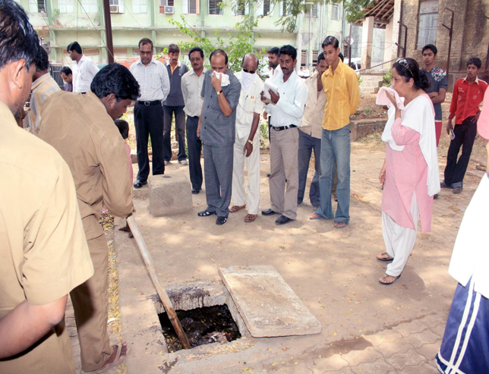

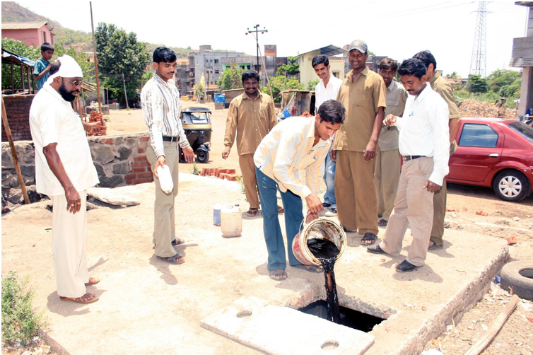

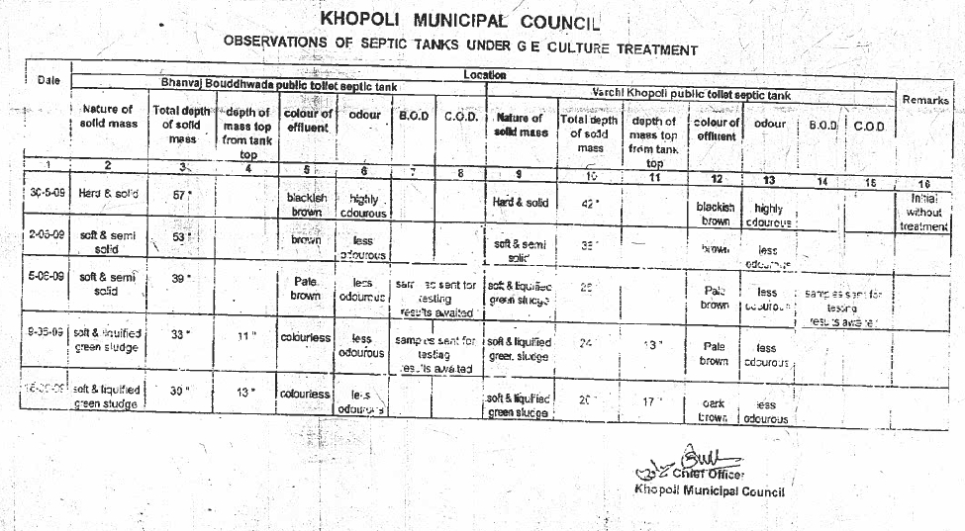
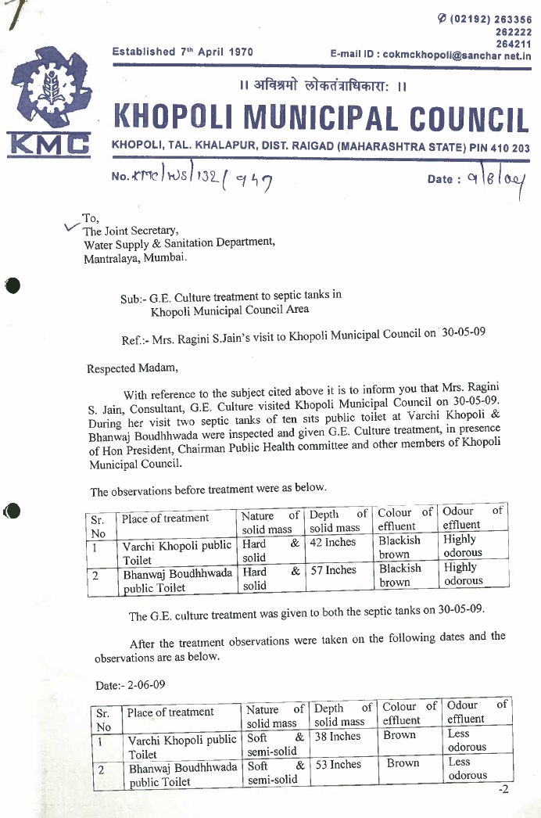
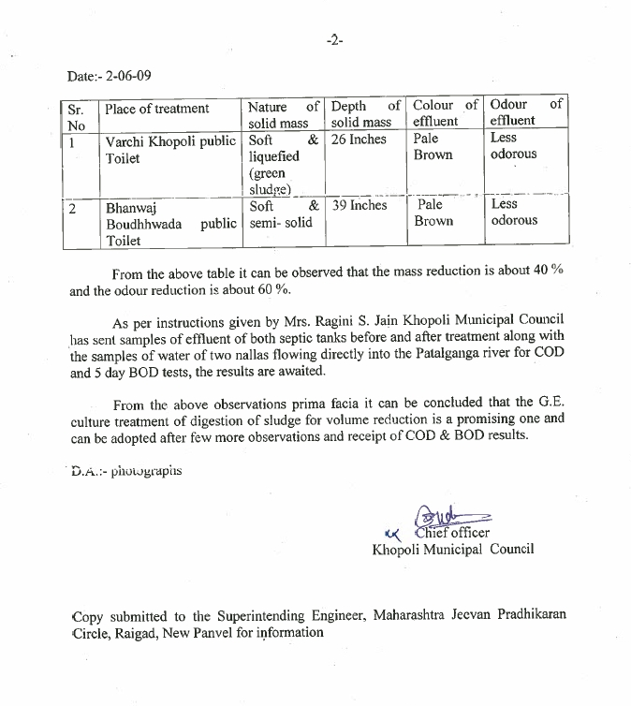
- Leh Ladakh

GE microbes were applied on an open drain and in seven days the smell was observed to be Nil, Water lever was observed to have come down by 70% and the blocked drain to be free of sludge and indigested garbage.

Excerpt of the report for our process at Leh Ladakh which proves that our culture is effective even at negative temperatures

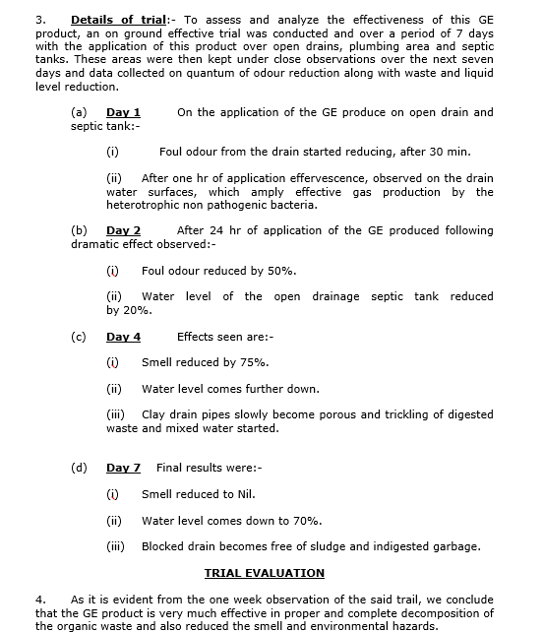

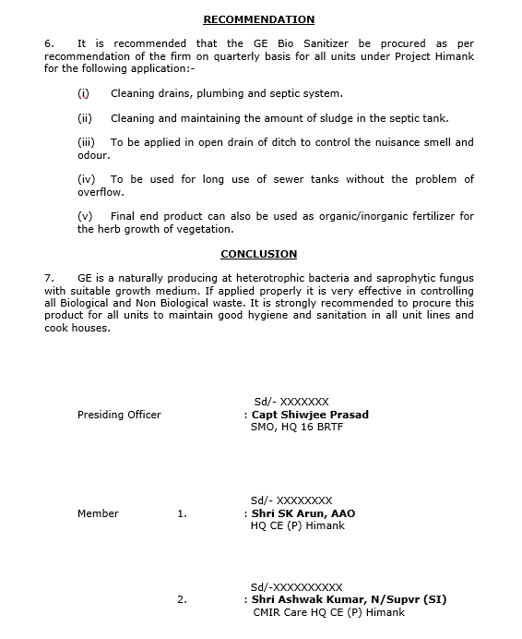

- Goa
GE microbes were administered at 3 tanks and at the end of day 7,
There was no smell, the colour of the was lighter in tank 1, cow dung colour in tank 2 and grey in tank 3 compared to jet black on day1 and there was the presence of few mosquitoes, lot of larvae and no presence compared to lots of mosquitoes, cockroaches and flies, larva and gutka wrapper in tank 1, no presence in tank 2 and a lot of bio-degradable material in tank 3.
Septic tanks processed in goa
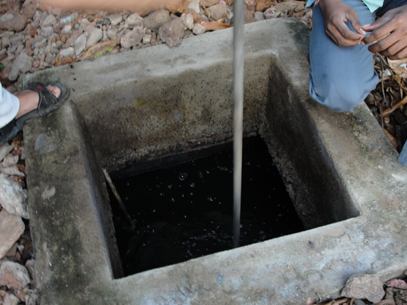

Following is the report of the three tanks before and after adding the bio-culture.
Bio Culture in Tanks

S.no. | Tank | Smell | Colour | Others
Before adding bio culture to the tank on 21.11.09
 | Septic tank behind kitchen | Very bad | Jet black | Lot of mosquitoes and cockroaches and flies, Larva and Gutka wrapper, pen, and others
 | Septic tank nehind toilet | - | - | -
 | Settlement tank | Very bad but not as bad as septic tank | Black | A lot of non-biodegradable things(Gutka wrapper, pen, and others)
After adding bio culture to the tank and mixing on 21.11.09
 | Septic tank behind kitchen | Less smell | Jet black | Larva and Gutka wrapper, pen, and others
 | Septic tank nehind toilet | - | - | -
 | Settlement tank | No smell | Black | A lot of non-biodegradable things(Gutka wrapper, pen, and others)
Before adding bio culture to the tank on 22.11.09
 | Septic tank behind kitchen | No smell | Colour light | Larva and Gutka wrapper, pen, and others
 | Septic tank nehind toilet | Intolerable smell | Black and yellow | -
 | Settlement tank | No smell | Colour light | A lot of non-biodegradable things(Gutka wrapper, pen, and others)
After adding bio culture to the tank and mixing on 22.11.09
 | Septic tank behind kitchen | No smell | Colour light | Larva and Gutka wrapper, pen, and others
 | Septic tank nehind toilet | Intolerable smell | Black and yellow | -
 | Settlement tank | No smell | Colour light | A lot of non-biodegradable things(Gutka wrapper, pen, and others)
After mixing the tank on 23.11.09
 | Septic tank behind kitchen | No smell | Black | Lot of mosquitoes and cockroaches and flies , Larva and Gutka wrapper, pen, and others
 | Septic tank behind toilet | No smell on opening but slight bad smell after mixing | Cow dung colour | -
 | Settlement tank | Little bad smell | Grey | A lot of non-biodegradable things(Gutka wrapper, pen, and others)
After mixing the tank on 26.11.09
 | Septic tank behind kitchen | No smell | Colour lighter then before | Few mosquitoes
 | Septic tank behind toilet | No smell | Cow dung colour | Lot of larvae
 | Settlement tank | No smell | Grey | -

Regards,
Vijayashree Irraker
Programme Manager
Arz- Anyay rahit zindagi
(Social work organization combating trafficking of persons in Goa, India)
Plot No.71, Next to ESI Dispensary
Sancoale Industrial Area, Zuarinagar, Goa.
India
Ph. 0832-2555446
Mobile: 9422438109
E-mail:arzindia@gmail.com

- Shri Amarnathji Yatra 2017
In the year 2017 we were entrusted to use our bio-culture to habdle the sanitation situation at the Shri Amarnathji Yatra. At the Baltal camp the langar STP which contained a thick layer of brownish of sewage was completely colourless and our microbes had consumed all the organic content
At the Nunwan camp also there was no sludge or faecal matter present in any of the STPs and pH and TDS levels of 6.8 and 170 were observed.

STP on 19-06-2017
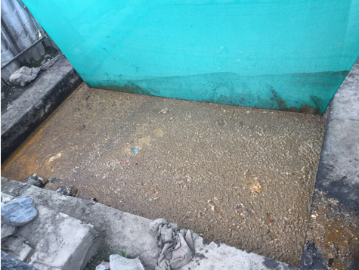

STP processing began using GE bio-culture on 20-06-17
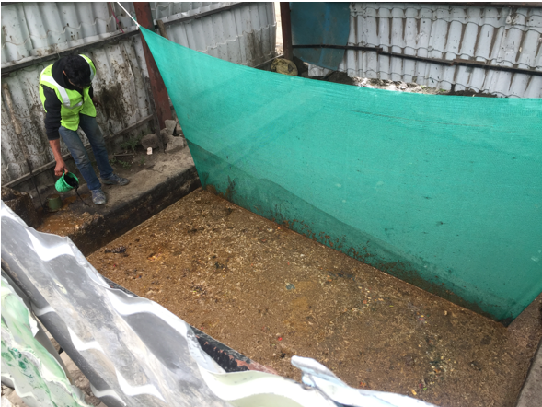

STP on 29- 07 -2017
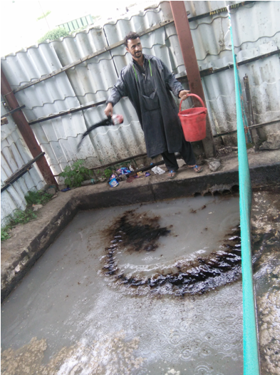

STP on the 5-08-2017
The microbes present in our bio culture have consumed
all the organic content in the STP
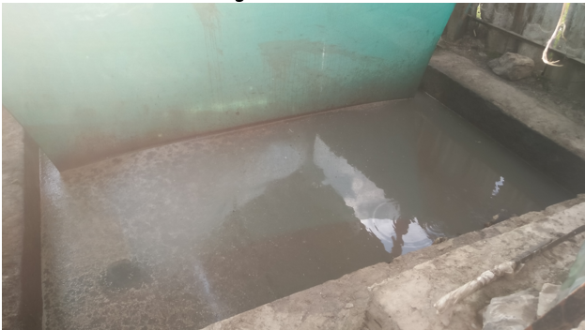

STP outlets with no sludge or faecal matter present as they have all been consumed by the microbes with 15 days
Observations on 5-08-2017
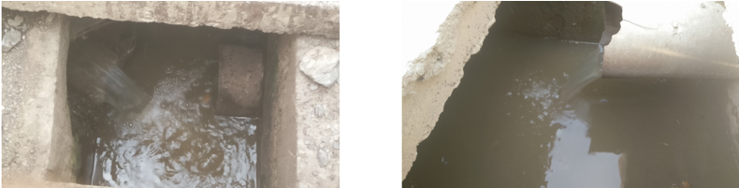

pH = 6.8 TDS = 170
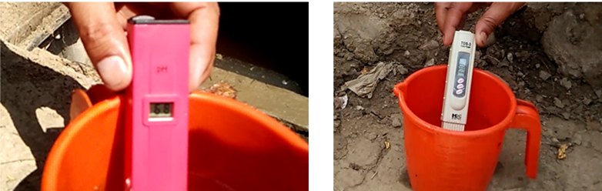

- Processing of water bodies
- Nag Nadi, Nagpur
Nag nadi in Nagpur had been completely chocked up by sewage. These sewage was bio-remediated and the organic content was reduced at the various chocking points to once again cause the proper movement of the water.

Nag nadi river was completely chocked up by sewage
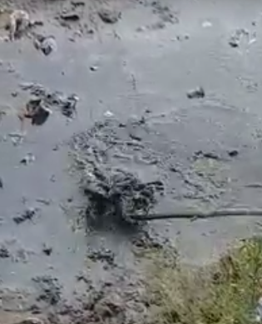

Nag nadi after desilting process
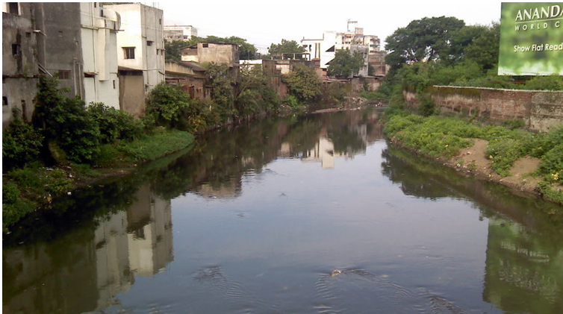

- Bellandur lake
Bellandur lake is internationally famous for the Phosphorous foam that its spews which flows over the kodi and covers the large span of the surrounding roads. At the invitation of Lake Development Authority, we processed the foam by created a barrier with sand bags containing our bio-culture and broke the foam in the span of the 2.5 days. Foam levels which were observed to 30 ft high was reduced to less than 1 feet.
Foam cover at bellandur on 17th Aug, 2017
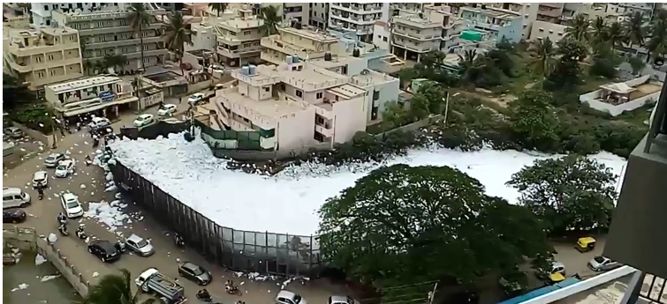

Sandbags with culture being laid to reduced foam formation
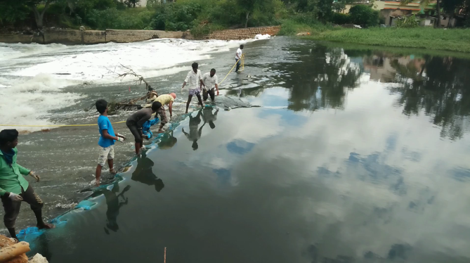

Foam levels reduced to less than 1 feet, 22nd Aug, 2017
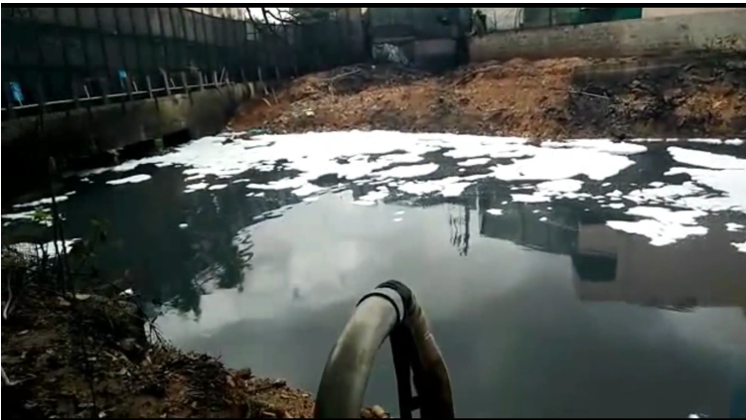

Conclusion
India with the advent of becoming a developing nation and this produces a large quantity of waste and this needs to be effectively handled and treated. This shows that the GE microbes provides a viable solution to the processing of wastewater, leachate and water bodies.

SOLID WASTES RECYCLED, REUSED FOR THE INCREASED IN THE WEALTH MANGEMENT

Abstract:

Our rapid bioremediation process through the usage of GE bio-culture on fresh waste and old waste stabilizes the waste faster with 40% reduction in volume and with near-zero emission of harmful gases into the atmosphere and no leachate (A leachate is any liquid that, in the course of passing through matter, extracts soluble or suspended solids, or any other component of the material through which it has passed). The contamination of soil and groundwater from leachate is hence prevented.

Though there have been earlier attempts at bioremediation, our method of bioremediation has been found to be the most effective.

This process yields 100% land recovery even at overfilled dumpsites after bio-mining and is sustainable and hence can be replicated in dumpsites of all sizes.

Introduction:

We have completed dumpsite bioremediation projects at

Bandhwadi dumpsite at Gurugram-Faridabad (25 lakh MT of old waste has been bioremediated and 1200 TPD of fresh waste, incoming from Gurugram, Faridabad, Manesar and Ballabhgarh has been stabilized and volume reduced)

Gurugram- Faridabad Bandhwari Dumpsite

Situation at the dumpsite before processing

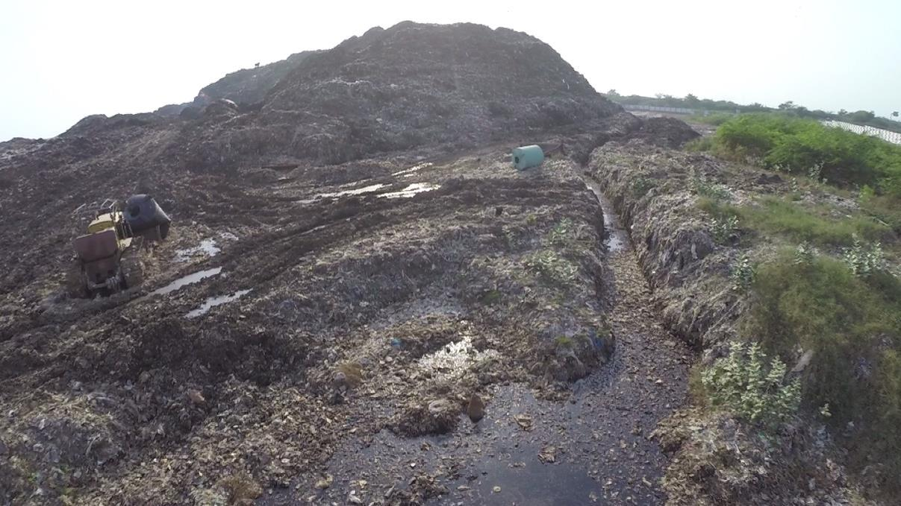

The 100ft mountain of old waste formed into conical
shapes for aeration

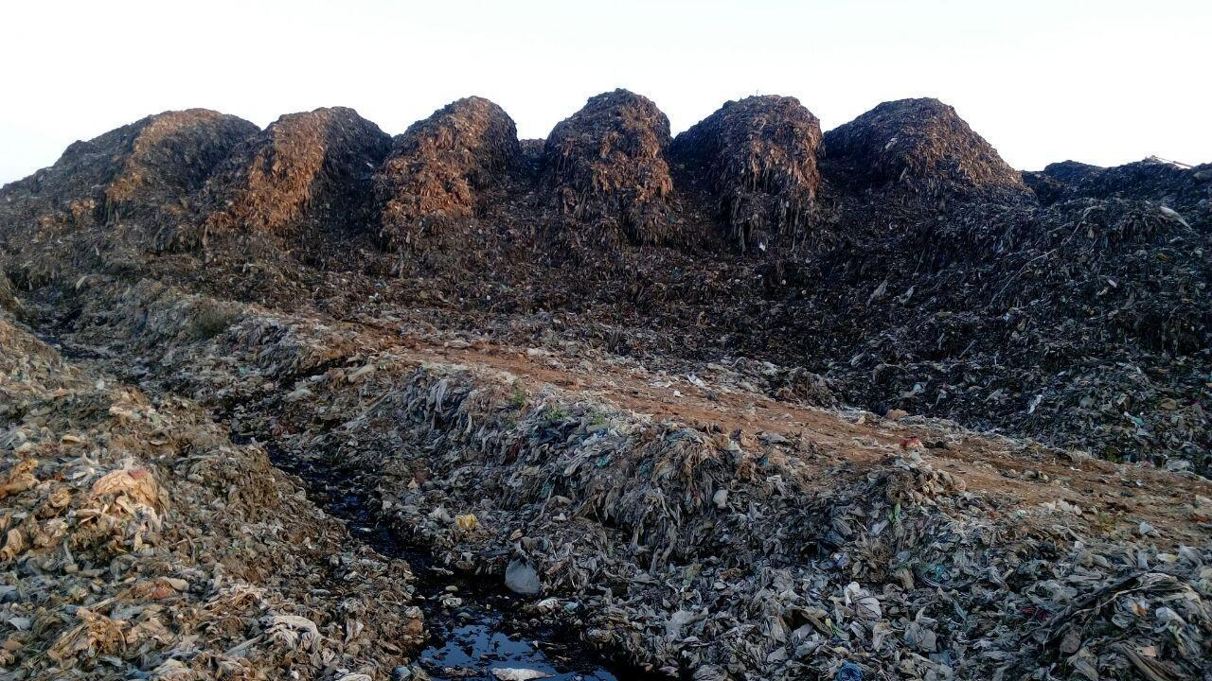

Stabilized waste ready of biomining in the dump site as on

Feb 2017

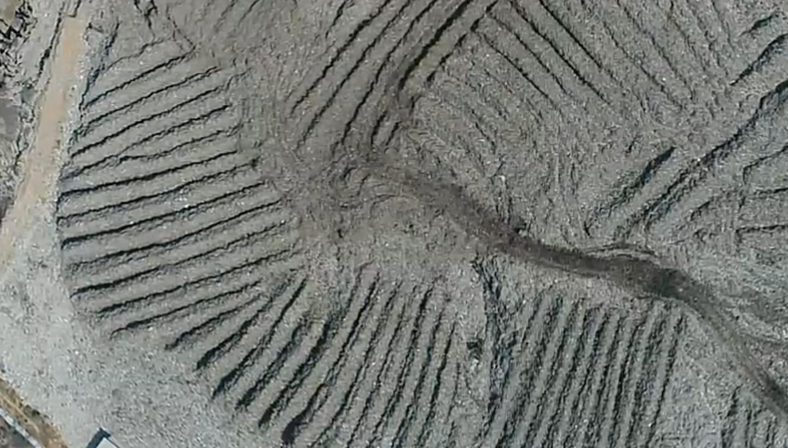

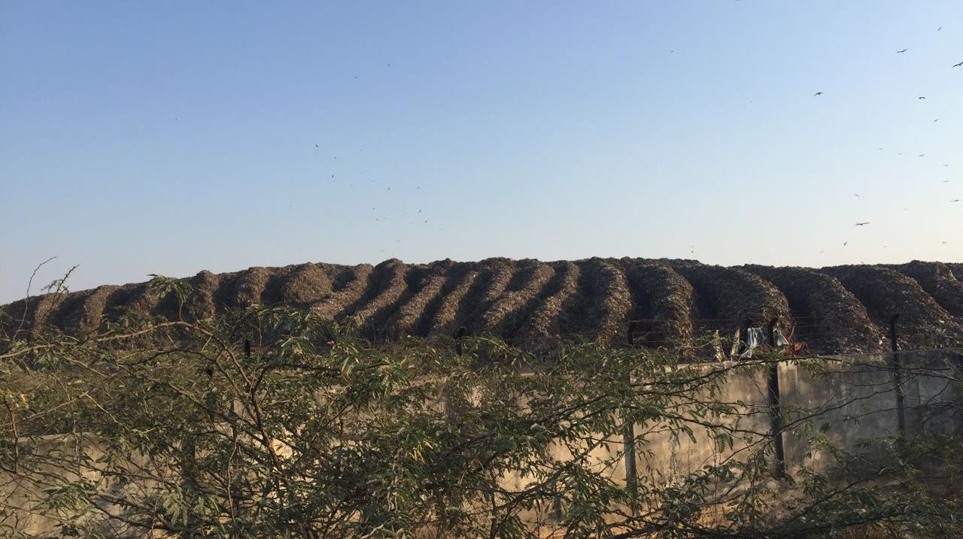

Biomining of the stabilized waste

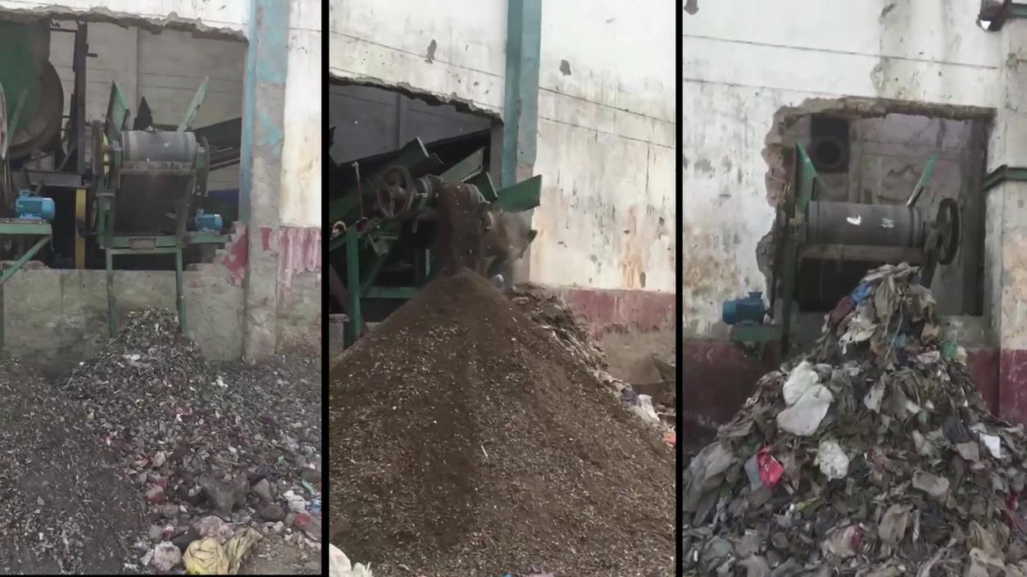

Bio-mined fractions from the stabilized waste

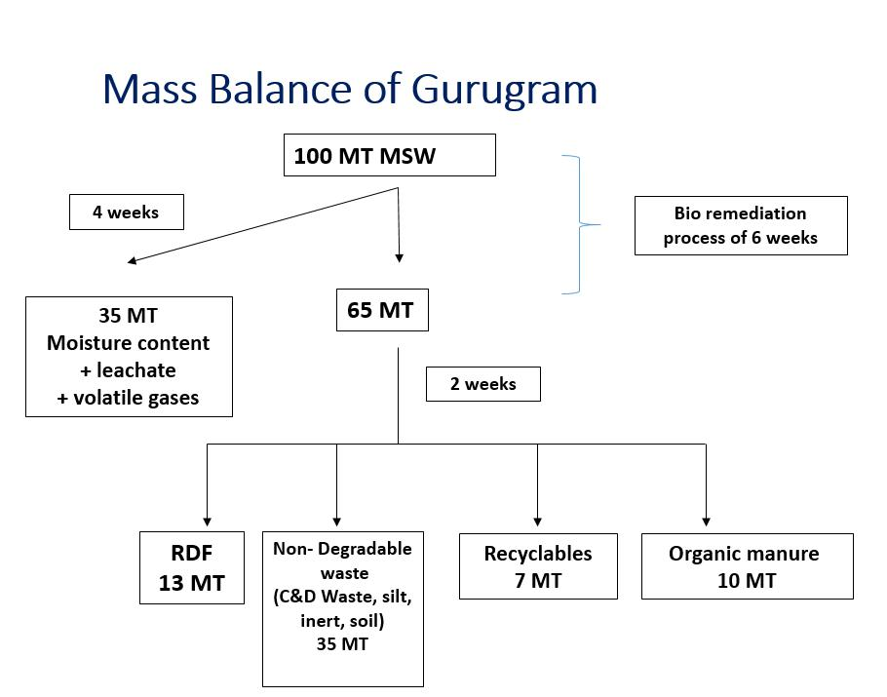

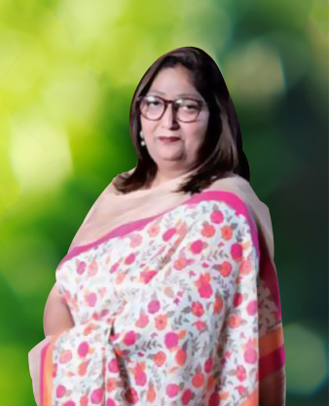

Mrs. Raaginii Jaain
National Expert of Swachh Bharat Mission Empanelled by MoUD
Founder of Geetanjali Envirotech
98821280214/ raaginiijaain@gmail.com

