Syngas Biomethanation

Wennan Zhang, PhD, Department of Chemical Engineering, Mid Sweden University, Sweden

Abstract (300 word limit)
Biogas as a heat and power resource as well as a vehicle fuel has been commercialized well in many countries such as Germany, Sweden etc.. However, further development of the biogas market is limited by the amount of available organic waste as well as the number of biogas filling station. On the other hand, biomass can be gasified into syngas and then synthesized into bio-SNG through catalytic methanation, or biomass gasification can be integrated into the biogas system to produce methane through biological methanation. In this way, biomethane can give a significant contribution to the energy market to replace natural gas. Biogas can be an important energy carrier in the future smart energy grids. By means of biogas system for electricity and vehicle fuel production, the increased proportion of variable renewable electricity (solar and wind) on the grid can be balanced. More importantly for the countries with rich biomass residues, biogas production can be increased to a full scale to meet heat & power and transport fuel demand by integrating biomass gasification into biogas system. For this purpose, a novel pathway is proposed to be studied in this project:
Biomass gasification > H2+CO > Biogas digester > Upgrading > Natural gas network

The review paper emphasizes 1) to develop suitable biomass gasifier for production of a good quality syngas, and 2) to study the biogas production from biological methanation or bio-methanation of syngas. The technology feasibility, the bioreactor design, the process synergy and the integration of the gasification plant with the biogas plant will be addressed. It can be concluded that the dual-fluidized bed gasifier can be a good choice to produce high concentration hydrogen syngas. It is possible to convert the most of CO2 in biogas from digesters into biomethane when syngas is added in the digesters. The commercialization of syngas biomethanation is discussed.

Image
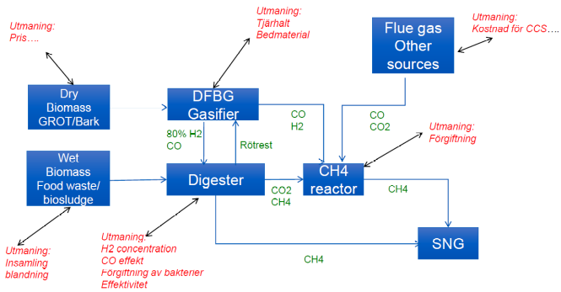
Recent Publications (minimum 5)
- Ding, Mingyue*, Longlong Ma, Qian Zhang, Chenguang Wang, Wennan Zhang and Tiejun Wang, “Enhancement of conversion from bio-syngas to higher alcohols fuels over K-promoted Cu-Fe bimodal pore catalysts”, Fuel Process Technology 159, 436-441, (2017),
- Zhang, Wennan*, Till Henschel, Ulf Söderlind, Khanh-Quang Tran and Xu Han, ”Evaluation of various biomass feedstocks by using thermogravimetric and online gas analysis”, Energy Procedia 105, 162-167, (2017)
- Tran, Khanh-Quang*, Aksel Junge Klemsdala, Wennan Zhang and Judit Sandquistc, “Fast hydrothermal liquefaction of native and torrefied wood”, Energy Procedia 105, 218-223, (2017)
- Göransson K., Söderlind U., Henschel T., Engstrand P. & Zhang W*., ”Internal tar/CH4 reforming in a biomass dual fluidised bed gasifier”, Biomass Conversion and Biorefinery, 5, 355-366, (2015)
- Zhang W*., He J., Engstrand P. & Björkqvist O., ”Economic evaluation on bio-synthetic natural gas production integrated in a thermomechanical pulp mill”, Energies, 8 (11), 12795-12809, (2015)
- Göransson K., Söderlind U., Engstrand P. & Zhang W*., ”An experimental study on catalytic bed materials in a biomass dual fluidised bed gasifier”, Renewable Energy 81, 251-261, (2015)

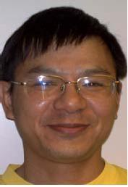Biography (150 word limit)
Wennan Zhang received PhD at Chalmers University of Technology in Energy Engineering in 1995. He has been working on bioenergy since 1996 at Mid Sweden University as a Senior Lecturer and Assocoate Professor. His main work is to lead a biomass gasification research group which is turned to be BTL(biomass-to-liquid) group. A BTL laboratory at Mid Sweden University has been built up under his leadership. The central unit of the laboratory is a 150kW biomass dual fluidized bed gasifier developed by him and his colleague for synthetic gas production. He had been the coordinator of a 4th EU frame-work project “Process simulation of CFB with combustion/gasification of biomass”, from 1998 to 2001. He has developed and taught two courses, “Biofuels” and “Bio-automotive fuels”, to engineer education students at Mid Sweden University since 1998. He is also guest professor in Chinese Academy of Science and Zhejiang University.

Email: wennan.zhang@miun.se
Contact Number: +46 725818639

Notes/Comments:

