Removal of Pb²⁺, Ni²⁺, Cd²⁺, Zn²⁺ from wet process phosphoric acid by mueroxide impregnated activated bentonite
Mohamed N. Rashed ª, Mohamed F. Cheira^{b}*, Adila E. Mohamedª, Mohamed A. Awadallahª
ªChemistry department, Faculty of Science, Aswan University, Egypt.
^{b} Nuclear Materials Authority, P.O. Box 530 El Maadi, Cairo, Egypt.
*E-mail: mf.farid2008@yahoo.com (Mohamed. F. Cheira)
Abstract
The harmful inorganic impurities in wet process phosphoric acid are essentially removed by a simple and inexpensive method for environment applications. In this work, the highly efficient removal of Pb²⁺, Ni²⁺, Cd²⁺, and Zn²⁺ cations ( > 99%) from WPPA were investigated through a batch technique using mueroxide impregnated activated bentonite. The used adsorbent was prepared within a dry method. The experimental data showed high adsorption capacity of mueroxide impregnated activated bentonite toward Pb²⁺, Ni²⁺, Cd²⁺, and Zn²⁺ cations into its active sites as 170, 115, 143 and 190 mg/g at 5 M acid concentration, respectively. Moreover, most of the heavy metals were completely adsorbed from WPPA (> 98%) at 5 M acid concentration. The providing data indicated that the batch sorption technique retained its functionality to effectively remove Pb²⁺, Ni²⁺, Cd²⁺, and Zn²⁺ cations even after six reuse/cycles, where the mueroxide impregnated activated bentonite can be regenerated using HCl. The real impurities removal from the Abu Zabaal wet process phosphoric acid using the adsorbent was assessed through the proposed protocol under optimum conditions.

Image
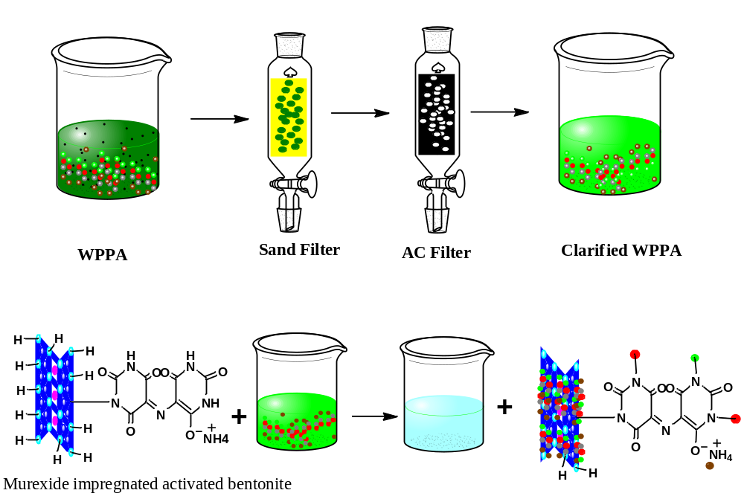
Mechanism of removal of metal ions impurities from WPPA using mueroxide impregnated activated bentonite
Recent Publications
- Cheira M F (2015) Characteristics of uranium recovery from phosphoric acid by an aminophosphonic resin and application to wet process phosphoric acid. European Journal of Chemistry 6 (1): 48‐56.
- Cheira M F, Zidan I H, Manaa E A (2014) Potentiality of white sand for the purification of wet process phosphoric acid from some metallic elements (U, Zn, Cd). Chemical Technology 9(6): 224-233.
- Abdien H G, Cheira M F, Abd-Elraheem M A, Saef El-Naser T A, Zidan I H (2016) Extraction and pre-concentration of uranium using activated carbon impregnated trioctyl phosphine oxide. Applied Chemistry 100:43462-43469.
- Gomaa H, Shenashen M A, Yamaguchi H, Alamoudi A S, Abdelmottaleb M , Cheira M F, Seaf El-Naser T A , El-Safty S A (2018) Highly-efficient removal of As^{V}, Pb²⁺, Fe³⁺, and Al³⁺ pollutants from water using hierarchical, microscopic TiO₂ and TiOF₂ adsorbents through batch and fixed-bed columnar techniques. Journal of Cleaner Production 182: 910-925.
- Al-Harahsheh M, Hussain Y A, Al-Zoubi H, Batiha M, Hammouri E (2017) Hybrid precipitation-nanofiltration treatment of effluent pond water from phosphoric acid industry. Desalination 406: 88–97.
--------------------------------------------------------------------------------------------------------------------------------------
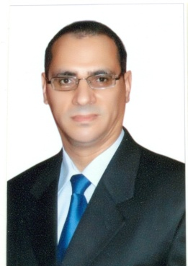

Biography
Mohamed Cheira has eighteen years of diverse experience in applied research, management, as well as hands-on experience in the areas of Materials Synthesis, Mineral Processing, and Chemical Hydrometallurgy. Dr. Cheira is an Associate Professor of inorganic chemistry and Head of Uranium and Thorium, Analysis Lab Member of Technical Office of the Labs and Member of Scientific Office, Nuclear Materials Authority.
Email: mf.farid2008@yahoo.com
--------------------------------------------------------------------------------------------------------------------------------------
Presenting author details
Full name: Mohamed Farid Cheira
Contact number: +201001373114
Mail id: mf.farid2008@yahoo.com
Category: Oral presentation

