Valorization of rice and wool waste in the bio-building sector
Marina Zoccola, Alessia Patrucco, Rosalinda Caringella, Raffaella Mossotti, Alessio Montarsolo, Claudio Tonin.
Italian National Research Council, Institute for Macromolecular Studies, Italy

Abstract
Natural fibres by products represent sustainable and locally available raw materials for application in bio architecture. These materials, which are renewable, abundant, cheap and lightweight, may replace man-made synthetic or artificial insulating materials (extruded polystyrene, glass wool and rock wool) which are more energy demanding. They are easy recyclable and carbon dioxide neutral, i.e. they do not return excess carbon dioxide into the atmosphere when they are composted at the end of the life cycle. Natural fibres display good thermal-insulating, sound-proofing and mechanical properties. They also enable better handling and working conditions in processing and laying regarding dermal and respiratory irritation, and show less concern with safety and health as for end use properties. Moreover, their thermal-moisture behavior is close to the human body demands (they enhance and stabilize indoor humidity microclimate) and they may contribute to reduce the sick building syndrome due to airborne VOCs (Volatile Organic Compounds) in existing and new constructions.
This work was focused on the preparation of biocomposite stiff boards entirely made with natural fibres, exploiting the different properties of protein and cellulose components submitted to mild alkali treatments. Waste wool was used in combination with rice straw. Thermal properties were determined on testing specimens of insulation boards. Wool-rice straw based insulating materials show very good thermal insulating properties (thermal conductivity is around 0.04 W/m °K and it depends on bulk density and fibre proportion).
Important expected advantages are accessibility of raw materials from the long-term point of view, which is very important for sustainable development. Developed materials can be used in existing and new buildings, for insulation of inclined roofs, hung ceilings, partition walls and external claddings (integrated thermal insulation). Potential applications can also be envisaged in other fields, such as the automotive sector where recyclability and fire resistance are fundamental requirements.

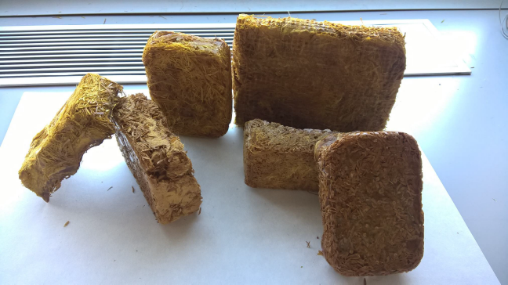

Figure 1: Thermal insulating panels made of rice and wool waste
Recent Publications

- Pennacchio R, Savio L, Bosia D, Piccablotto G, Patrucco A, Fantucci S (2017) Fitness: sheep-wool and hemp sustainable insulation panels Energy Procedia 111:287-297.
- Bosia D, Savio L, Thiebat F, Patrucco A, Fantucci S, Piccablotto G, Marino D (2015) Sheep wool for sustainable architecture Energy Procedia78:315-320,

Patrucco A, Tonin C, Ravasio N (2014) Materiali isolanti bio-compositi in lana-canapa. In VeLiCa. Da antiche colture materiali e prodotti per il futuro, Ravasio N, Galasso I, Sacchi MC, Ottolina G, Speranza G, Terreni M Eds., 105-112, ISBN: 978-88-907569-1.

Bianchetto Songia M, Patrucco A, Ramella Pollone F, Ravasio N, Tonin C (2014) Materiale composito di origine naturale e metodo per la sua fabbricazione. Brevetto N° 0001410155.
- Zoccola M, Aluigi A, Patrucco A, Tonin C (2012) Extraction, Processing and Applications of Wool Keratin, in: R. Dullaart, J. Mousquès (Eds.), Keratin: Structure, properties and applications, Nova Science Publisher Inc., New York, pp. 36-62.

 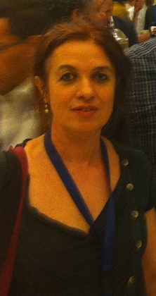Biography
Dr. Marina Zoccola has been working since 1989 as a researcher at the National Research Council, Institute for Macromolecular Studies, textile section of Biella. Her principal interests are in the study and characterisation of biopolymers, mainly structural proteins (wool, fine animal fibres, silk, human hair). She has participated in national and international research projects in the textile and biopolymer field. She was author of over 30 scientific works published in international journals.
Email: m.zoccola@bi.ismac.cnr.it

Presenting author details
Full name: Marina Zoccola
Contact number: (+39) 015 8493043
Mail id: m.zoccola@bi.ismac.cnr.it
Category: (Oral presentation/ Poster presentation) Poster presentation

