Evaluation and analysis of municipal solid wastes in Tehran, Iran

Mohammad Hadi Dehghani^{*1}, Emad Dehghanifard ²

1. Tehran University of Medical Sciences, School of Public Health, Department of Environmental Health Engineering, Tehran, IRAN
2. Iran University of Medical Sciences, School of Public Health, Department of Environmental Health Engineering, Tehran, IRAN

Abstract
Waste management for municipal solid waste is considered a public health services, providing citizens with a system of disposing of their waste in an environmentally sound and economically feasible way. The amount and composition of waste generated comprise the basic information needed for the planning, operation and optimization of waste management systems. In this study, paper and plastic quantity changes in the MSW (municipal solid waste) of the region 10 of Tehran city were evaluated. This study was conducted in 6 months, in the summer and autumn seasons, at the region 10 of Tehran city. In this study, paper and plastic were segregated and data were analyzed by SPSS software. The paper parameter of solid wastes was consisted of folder paper, cardboard and used newspaper. The plastic parameter of solid wastes was consisted of plastic materials, plastic house shoes, plastic sack, nylon sack, linoleum, radiology photograph and PET. Samples were collected and weighed daily. The total quantity of paper and plastic portion of this region solid waste were 203,930 Kg and 180,101 Kg, respectively. The percentage of paper and plastic portion of this region solid waste also were 6.82% and 6.03%, respectively. The analyses showed a significant difference between these parameters and season, some months and days (P-value < 0.05). So, because of the results of this study and economical issues, the paper and plastic segregation from generated source point and recycling them are important.

Fig. The percentage of plastic components

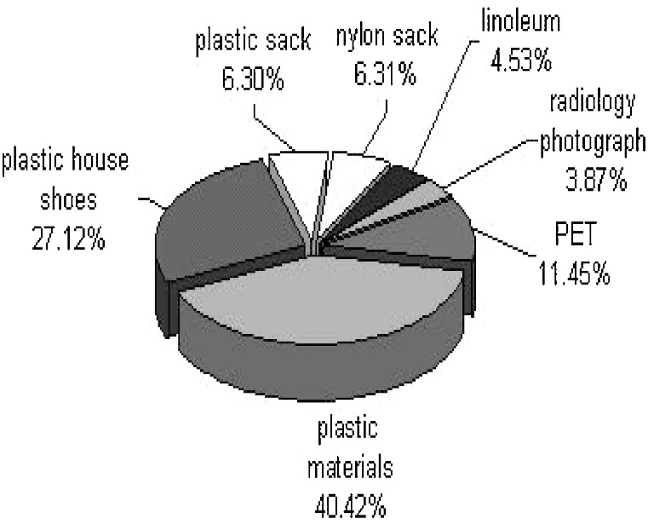
Recent publications

1. Hristovski, K., Olson, L., Hild, N. (2007).The municipal solid waste system and solid waste characterization at the municipality of Veles
Maced. Waste Manag. 27, 1680-1689.
2. Eugenia, M., Bennagen, C., epomuceno G. (2002). Solid Waste Segregation and Recycling in Metro Manila: Household Attitudes and Behavior. No. 2002-RR3
3. Gidarakos, E., Havas, G., Ntzamilis, P.(2006).
Municipal solid waste composition determination supporting the integrated solid waste management system in the island of Crete. Waste Manag., 26, 668-679.
4. Droodgar, A., Mostafaei, Q.R., Arbabi, M.(2002).The evaluation of MSW and recycling materials in Kashan city Feiz J., 22 (2002), pp. 59-64.
5. Rahmani, H.R., Elyasi Brojeni, H. (2001). Physical analysis of MSW in Yazd city, Sci. J. Environ., 31, 57-63.

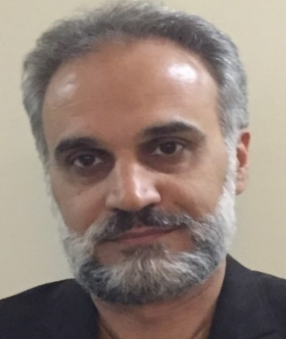

Biography
Professor Dr. Mohammad Hadi Dehghani (PhD) is a Full Professor at the Tehran University of Medical Sciences (TUMS), School of Public Health, Department of Environmental Health Engineering, Tehran, IRAN. His scientific research interests include the Environmental Health Science. He is the author of various research studies published at national and international journals, conference proceedings and Head of several research project at the TUMS. He has authored 8 books and more than 150 full papers published in peer- reviewed journals. He is an editorial board member and reviewer in many internal and international journals and is member of several international science committees around the world. He has supervisor and advisor PhD and MSc theses at the TUMS.
Email: hdehghani@tums.ac.ir

