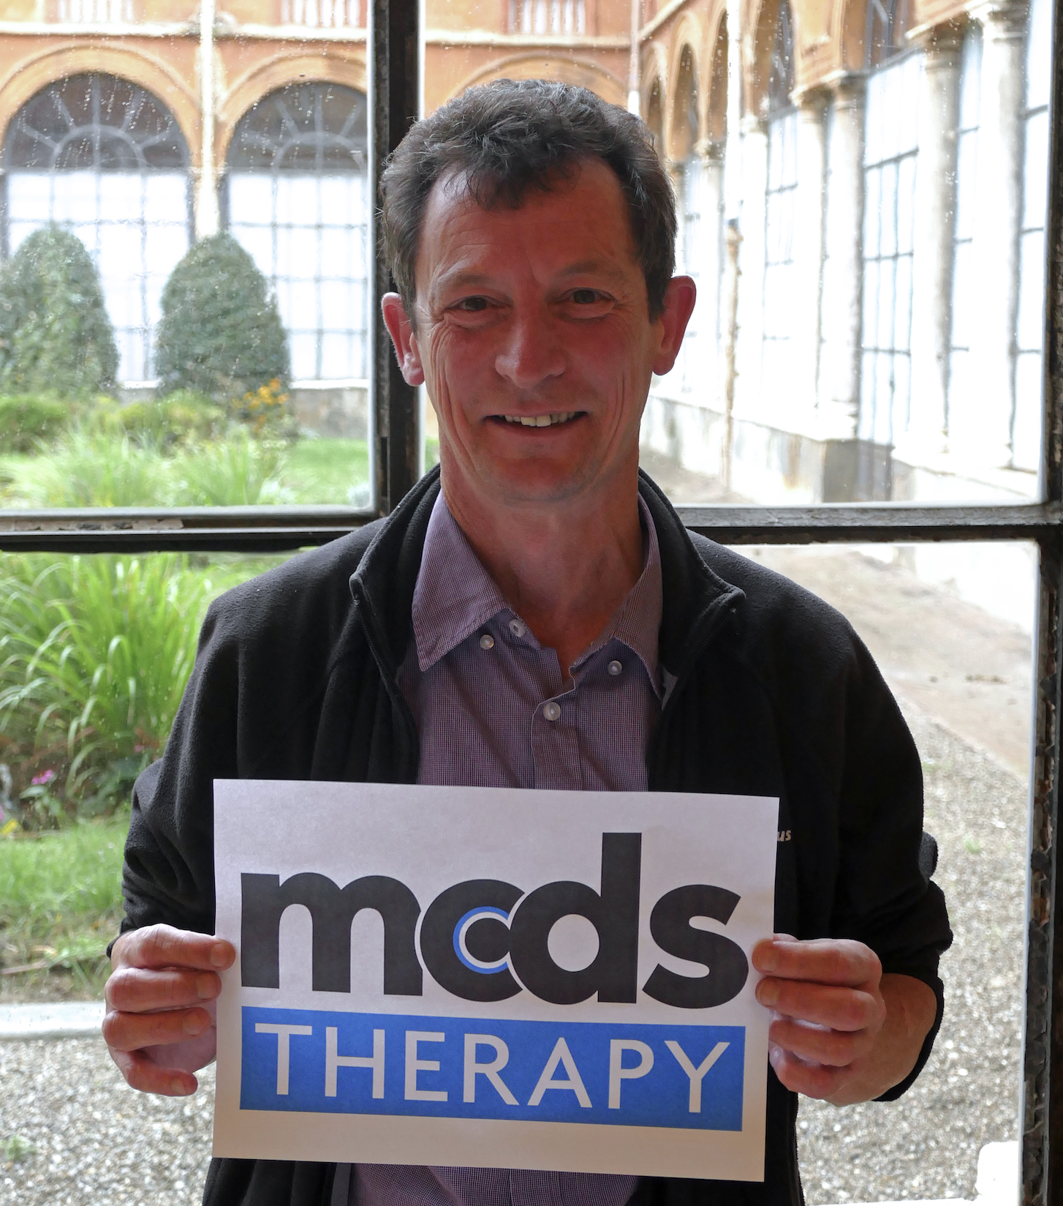

New therapies in genetic skeletal diseases achieved through drug repurposing

Michael D Briggs PhD, Newcastle University, UK

Abstract
Genetic skeletal diseases (GSDs) are an extremely diverse and complex group of diseases that primarily affect the development and homeostasis of the skeleton. There are more than 450 unique and well-characterised phenotypes that range in severity from relatively mild to severe and lethal forms and although individually rare, as a group of related orphan diseases, GSDs have an overall prevalence of at least 1 per 4,000 children, which represents a large unmet medical need.
Our studies have focussed on a group of clinically-related GSDs that present with disproportionate short stature and early onset OA and result from dominant-negative mutations in a range of cartilage structural proteins including cartilage oligomeric matrix protein (COMP), matrilin-3, aggrecan and types II, IX and X collagens. We have unequivocally established that endoplasmic reticulum (ER) stress, induced in chondrocytes as a result of accumulated misfolded mutant proteins, is the primary cause of growth plate dysplasia and reduced bone growth in a broad group of GSDs. Moreover, we have recently demonstrated that reducing ER-stress, through the administration of a repurposed anti-epileptic drug carbamazepine (cbz), in both cell and mouse models, restores cell homeostasis and bone growth in metaphyseal chondrodysplasia, type Schmid (MCDS) resulting from collagen X mutations. These preclinical data recently allowed the granting of orphan drug designation for cbz use in MCDS and an EMA approved 5-year clinical trial funded by the EU Horizon 2020 programme (2018-2023) [www.mcds-therapy.eu].

Recent Publications
1: Bell PA, Dennis EP, Hartley CL, Jackson RM, Porter A, Boot-Handford RP, Pirog KA, Briggs MD. Mesencephalic astrocyte-derived neurotropic factor is an important factor in chondrocyte ER homeostasis. Cell Stress Chaperones. 2019 Jan;24(1):159-173.
2: Mullan LA, Mularczyk EJ, Kung LH, Forouhan M, Wragg JM, Goodacre R, Bateman JF, Swanton E, Briggs MD, Boot-Handford RP. Increased intracellular proteolysis reduces disease severity in an ER stress-associated dwarfism. J Clin Invest. 2017 Oct 2;127(10):3861-3865.
3: Gibson BG, Briggs MD. The aggrecanopathies; an evolving phenotypic spectrum of human genetic skeletal diseases. Orphanet J Rare Dis. 2016 Jun 28;11(1):86.
4: Briggs MD, Bell PA, Pirog KA. The utility of mouse models to provide information regarding the pathomolecular mechanisms in human genetic skeletal diseases: The emerging role of endoplasmic reticulum stress (Review). Int J Mol Med. 2015 Jun;35(6):1483-92.
5: Cameron TL, Gresshoff IL, Bell KM, Piróg KA, Sampurno L, Hartley CL, Sanford EM, Wilson R, Ermann J, Boot-Handford RP, Glimcher LH, Briggs MD, Bateman JF. Cartilage-specific ablation of XBP1 signaling in mouse results in a chondrodysplasia characterized by reduced chondrocyte proliferation and delayed cartilage maturation and mineralization. Osteoarthritis Cartilage. 2015 Apr;23(4):661-70.

Key words: genetic skeletal disease, drug repurposing, clinical trial

Biography: Mike Briggs obtained a PhD in molecular genetics at the MRC-Clinical Research Centre in Harrow (89-92) and undertook a Genetics Fellowship at Cedars-Sinai Medical Center in Los Angeles (93-95). In 1996 he moved to the University of Manchester and in 2012 he was appointed Professor of Skeletal Genetics at Newcastle University. Over the last 15 years Mike has been instrumental in establishing four Pan-European consortia for the clinical diagnosis and research of genetic skeletal diseases. His primary research interested is focused on refining diseases mechanisms in genetic bone diseases to identify new therapies for future clinical trials.

Full name (As per the passport): Michael Darren Briggs
University/Industry/Organization name: Newcastle University
Designation (Director/Prof/Assistant or Associate prof/Researcher/Student): Professor
Country: UK
Mobile number (country code – number) : +44 7805 406966
Email: michael.briggs@newcastle.ac.uk
Track number: https://rarediseases.insightconferences.com/call-for-abstracts.php (For track number follow this link)
Category (Oral presentation/ Poster presentation/Young researcher forum/E-poster): Oral
Research interest: Rare bone disease, cartilage biochemistry, drug repurposing
Your profile page URL in your department: https://www.ncl.ac.uk/igm/staff/profile/michaelbriggs.html#background
Year of birth: 1967
Linked In/Facebook/twitter account: @MD_Briggs

