Rare Genetic Variation associate with Autism Spectrum: A Brief Report

Thais C Vieira, PhD, LaGene, UEG
Marc A D Gigonzac, PhD, LaGene, UEG
Irene Plaza Pinto, MsC, Replicon/PUC-GO
Aparecido Divino da Cruz, PhD, LaGene,Replicon/PUC-GO

Abstract
Statement of the Problem: Autism Spectrum Disorder (ASD) is a complex and heterogeneous clinical condition that involves behavior with different repetitive patterns, inability to establish affective and interpersonal contact. There are convergent pathways between hundreds genes that could lead to the autistic phenotype, such as those of neuronal development, axoniogenesis and synaptic functioning. In recent years, the development of molecular techniques allowed to identify more than 600 genes associated with ASD. The etiology of this disorder may be associated with different genes, and the large-scale genome screening techniques such as Chromosomal Microarray Analysis (CMA) is usually required for its determination. The purpose of this study is to describe a child with neuropsychomotor development delay (NPMD), idiopathic mental retardation and characteristics of ASD, evaluated by CMA in the Human Cytogenetics and Molecular Genetics Laboratory (LaGene) of the Secretary of Goias State for Public Health and Replicon Research Center (NPR). Methodology & Theoretical Orientation: The analysis was performed with multiple allele-specific hybridization probes complementary to the SNP regions present in the reduced fraction of the amplified genome in the assay. Findings: Using the CytoScan HD platform (Affymetrix®), a de novo microdeletion of 248.87Kb was detected at the 21q11.2 locus, in the linear position 15.006.457-15.255.326, recognized as a uncommon variation in the general population. In the analysis by OMIM (Online Mendelian Inheritance in Man) / NCBI (National Center for Biotechnology Information), the range of microdeletion recorded involves two genes, called POTED and C21orf15. Conclusion & Significance: CMA proved to be an effective method for the identification of genes with potential relation to ASD, and new research that allows the recognition of the affected neurobiological pathways is still necessary for a correct understanding of the molecular mechanisms involved.

Image
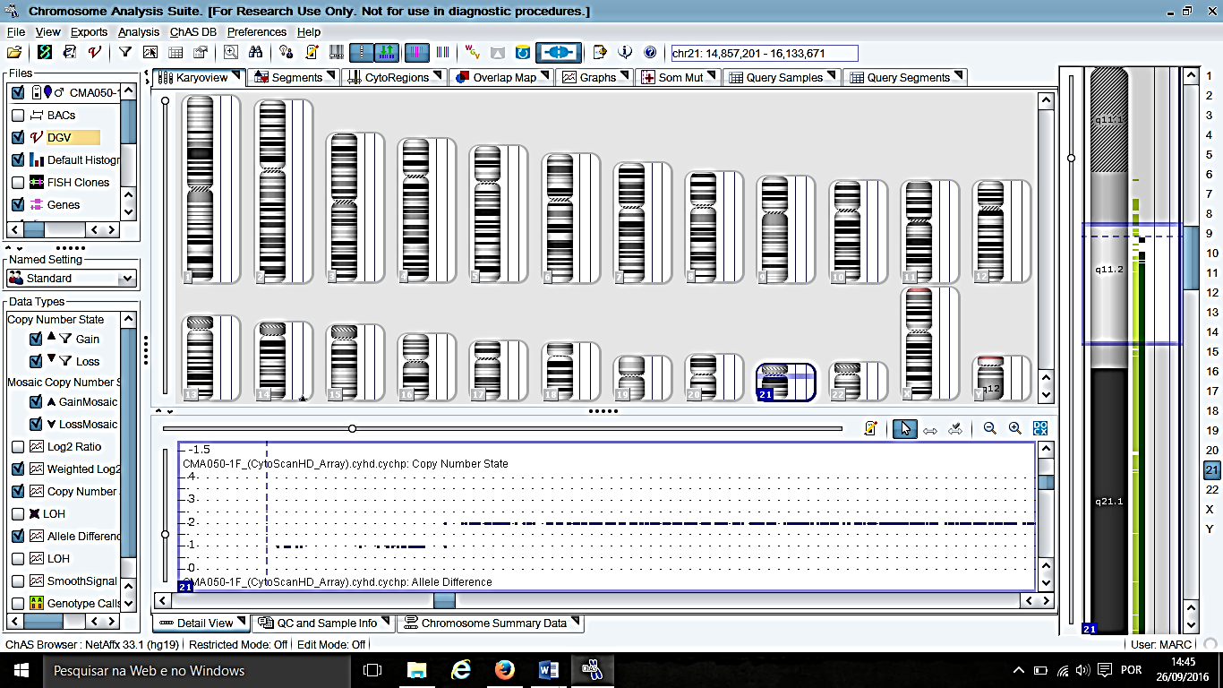
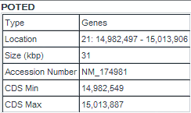

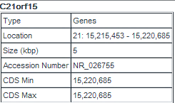

Figure 1: ChAS software indicating a microdeletion of 248.87Kb at the 21q11.2 locus.

Recent publications
- Bray, N. (2017). Neurodevelopmental disorders: Converging on autism spectrum disorder. Nature Reviews Neuroscience.
- Ballouz, S., & Gillis, J. (2017). Strength of functional signature correlates with effect size in autism. bioRxiv, 043422.
- Butler, M. G., Rafi, S. K., Hossain, W., Stephan, D. A., & Manzardo, A. M. (2015). Whole exome sequencing in females with autism implicates novel and candidate genes. International journal of molecular sciences, 16(1), 1312-1335.
- Lay-Son, G., Espinoza, K., Vial, C., Rivera, J. C., Guzmán, M. L., & Repetto, G. M. (2015). Chromosomal microarrays testing in children with developmental disabilities and congenital anomalies. Jornal de pediatria,91(2), 189-195.
- Hens, K., Peeters, H., Dierickx, K. (2016). Genetic testing and counseling in the case of an autism diagnosis: A caregivers perspective. European Journal of Medical Genetics, v. 59, n. 9, p. 452-458.


Biography
Biomedical, PhD in Cellular and Molecular Biology, Federal University of Goiás (UFG), Master in Biology (Genetics) by the Federal University of Goiás (UFG) and Specialist in University Teaching. Professor at the State University of Goiás (UEG), currently Research Coordinator at Eseffego-Câmpus Goiânia and Geneticist at the Laboratory of Human Cytogenetics and Molecular Genetics (LAGENE-LACEN / SES-GO). Permanent Professor of the PPG - Master in Genetics of PUC Goiás and Collaborating Researcher at the Replicon Research Center / PUC-GO. Working in Genetics, with emphasis on Human Genetics, Clinical Genetics, Molecular Genetics and Genetic Counseling.
Email: thaiscidalia@gmail.com

