Rare mutation in FMR1 gene in woman with Fragile X-Syndrome

Marc A D Gigonzac, PhD, LaGene, UEG
Thais C Vieira, PhD, LaGene, UEG
Irene Plaza Pinto, MsC, Replicon/PUC-GO
Aparecido Divino da Cruz, PhD, LaGene,Replicon/PUC-GO

Abstract
Statement of the Problem: The Intellectual Disability (ID) is one of the most prevalent development disorders, which appears before 18 years of age, characterized by adaptive and cognitive limitations with significant impairment in intellectual functioning. Due to its heterogeneity, the etiology of ID is variable and difficult to identify, often referred to as Idiopathic Intellectual Disability. Several studies highlight the genetic changes as factors that significantly contribute to this condition. The aim of this study was to investigate the genomic cause of Intellectual Disability Idiopathic in an individual with clinical indication of developmental delay. Methodology & Theoretical Orientation: Initially we conducted a study with G cytogenetic banding and Ikaros® software analysis (Meta systems Corporation, Germany) to identify potential chromosomal abnormalities. Then the molecular analysis of the promoter region of the FMR1 gene on chromosome Xq27 was performed by capillary electrophoresis genetic analyzer ABI3500 (Applied Biosystems®) to check possible CGG expansions. Subsequently, the investigation for SNPs and CNVs via Chromosomal Analysis of Microarrays (CMA) was tested with high density CytoScan™ HD platform Array (Affymetrix, USA). Findings: The karyotype 46,XX did not provide numerical and/or structural changes detectable by G banding. However, through molecular analysis was possible to identify a single allele with 28 repeats in FMR1, indicating the absence of the other allele on chromosome X. The analysis by microarray the patient presented a de novo microdeletion in Xq27.3-q28 of 4,176 kb region. The microdeletion involving 34 genes, and of these, five have direct relation to the phenotype of DI and neurological disorders, including the FMR1 gene. Conclusion & Significance: This study reinforces the importance of holding the chromosomal microarray analysis as a diagnostic method in patients with idiopathic intellectual disabilities, contributing to the description of rare chromosomal changes or not previously described in the literature.

Image- (a) Electropherogram showing a single allele of FMR1 gene in X chromosome in woman and (b) CgH array showing the deletion region of the FMR1 gene

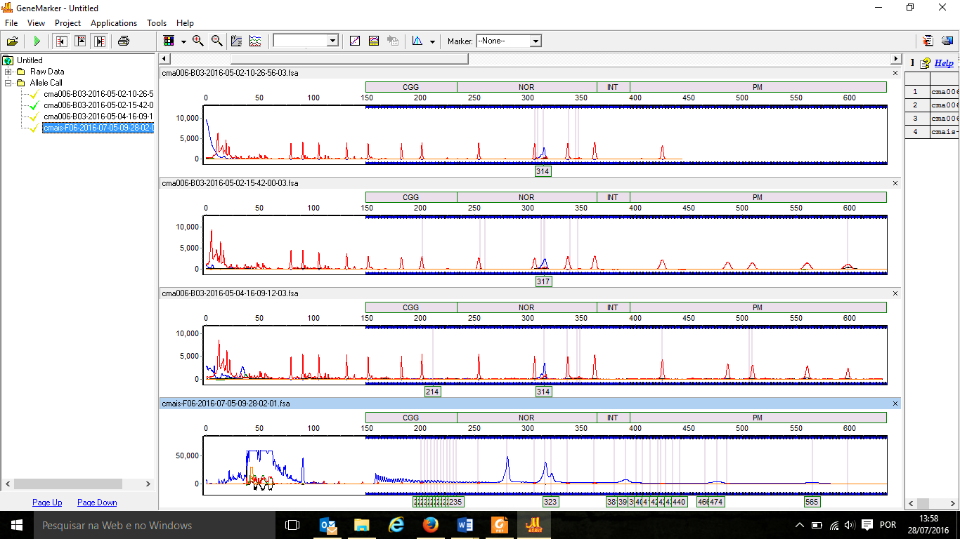
a.

b.
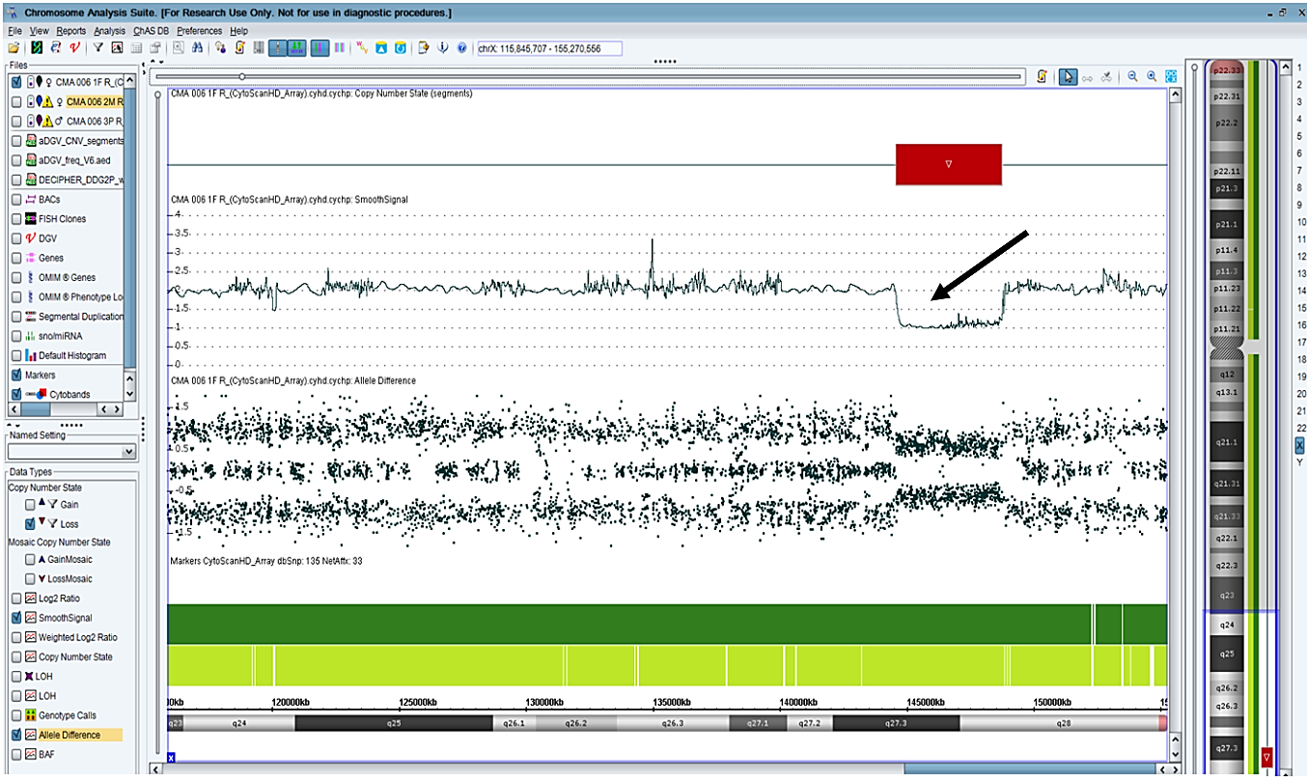
Recent Publications
- Luo, S. Y., Wu, L. Q., & Duan, R. H. (2016). Molecular medicine of fragile X syndrome: based on known molecular mechanisms. World Journal of Pediatrics, 12(1), 19-27.
- Quartier, A., Poquet, H., Gilbert-Dussardier, B., Rossi, M., Casteleyn, A. S., des Portes, V. & Thevenon, J. (2017). Intragenic FMR1 disease-causing variants: a significant mutational mechanism leading to Fragile-X syndrome. European Journal of Human Genetics.
- Edwards, M., Brescianini, S., Allgood, C., Freelander, M., Dunstan, R., Patradoon‐Ho, P., ... & Burgess, T. (2016). Syndrome diagnosis with single‐nucleotide polymorphism (SNP) microarray. Journal of paediatrics and child health, 52(1), 85-89.
- Narayanan, V. K., Kharbanda, M., & Donaldson, M. (2016). A case of 46, XX dysgenesis and marked tall stature; the need for caution in interpreting array comparative genomic hybridization (CGH). Journal of Pediatric Endocrinology and Metabolism, 29(12), 1407-1412.
- Tabolacci, E., & Neri, G. (2016). What Mechanisms Induce Methylation of FMR1 Gene Full Mutation? A Still Unanswered Question. In Epigenetics-A Different Way of Looking at Genetics (pp. 145-173). Springer International Publishing.
- Zink, A. M., Wohlleber, E., Engels, H., Rødningen, O. K., Ravn, K., Heilmann, S. & Hoffmann, P. (2014). Microdeletions including FMR1 in three female patients with intellectual disability-further delineation of the phenotype and expression studies. Molecular syndromology, 5(2), 65-75.


Biography
Marc A. D. Gigonzac.He holds a bachelor's degree in Biomedicine from the Federal University of Goiás, a Master's Degree in Human Genetics from the Federal University of Goiás and a PhD from the Biotechnology and Biodiversity Program of the Pró-Centroeste Network. He is currently an effective professor at the State University of Goiás - UEG, Estácio de Sá Faculties and the Pontifical Catholic University of Goiás - PUC / GO, as well as postgraduate courses. He also acts as an effective Biomedical / Geneticist at LaGene / LACEN - State Health Secretariat, and is a consultant in State policies for the care of rare diseases. His areas of practice involve the topics of Clinical Genetics, Forensic Genetics, Autism, X-Fragile Syndrome, DNA Methylation, Oncogenetics and Genetic Counseling.
Email: m.gigonzac@gmail.com

