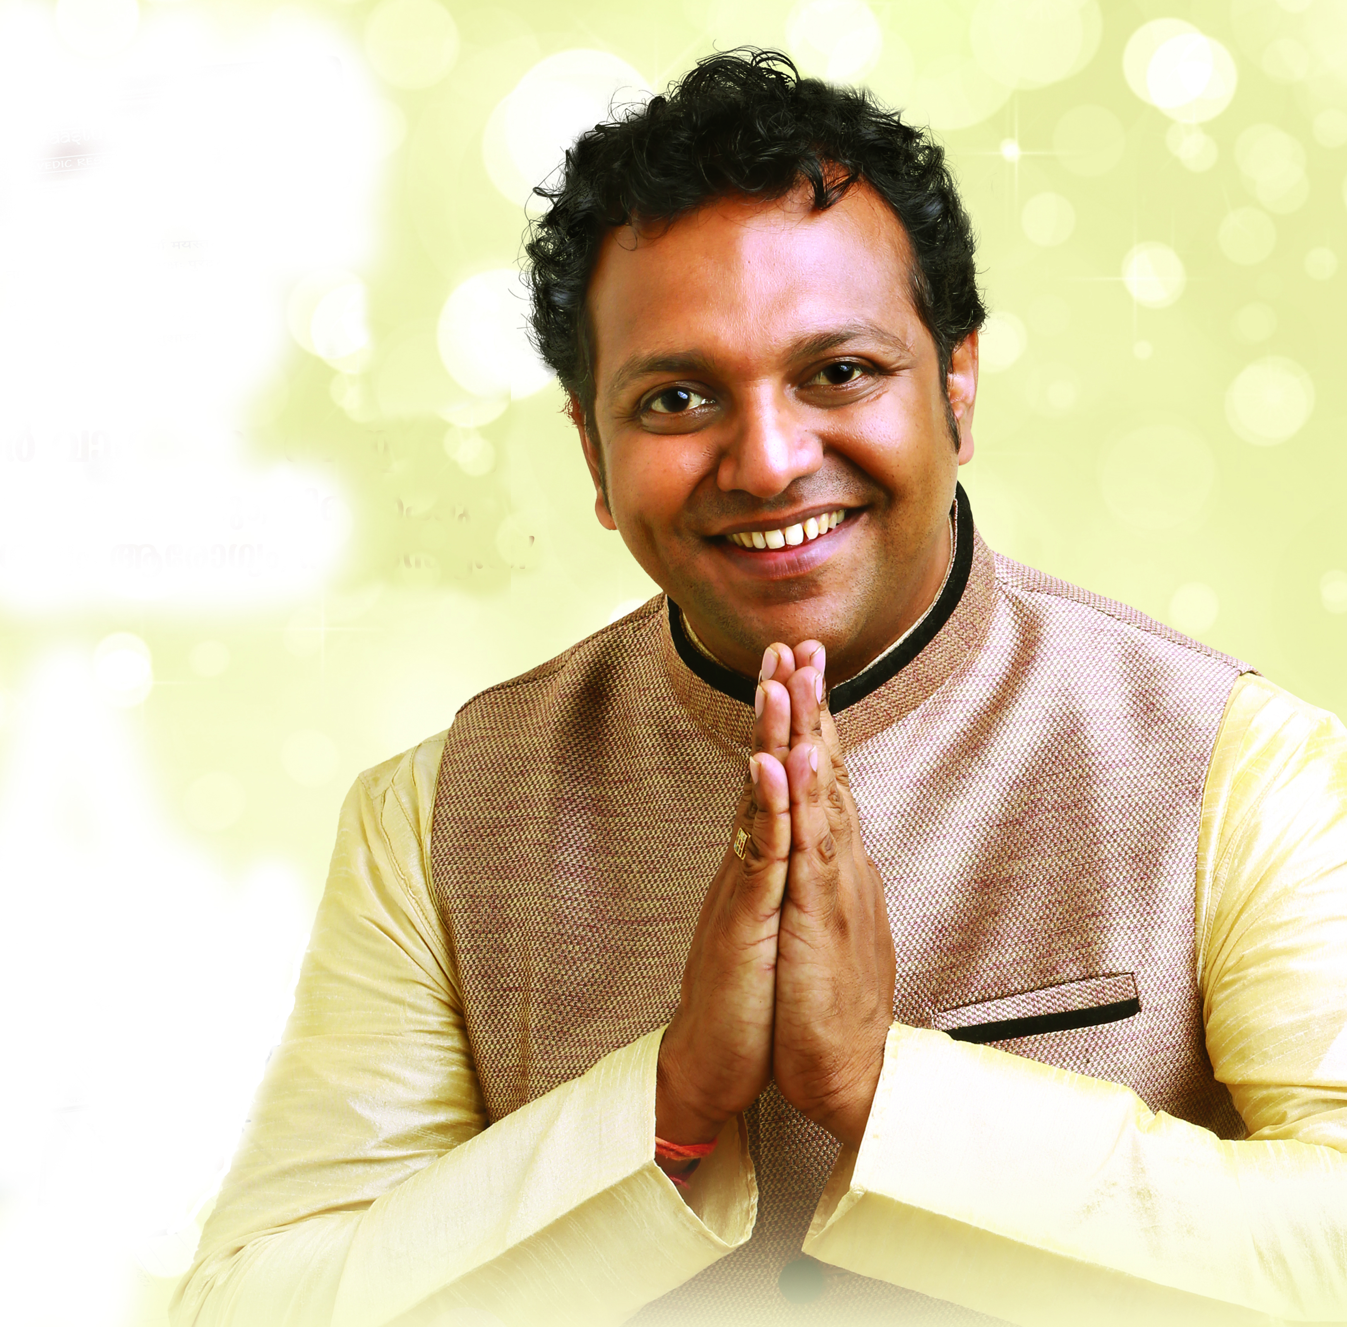
Title: Benifits of Vaastu Shastra on Health & cure.

Name: Dr.Nishanth Thoppil.M.Phil,Ph.D. Research Scholar-Vastu Shastra, Kerala, India

Vaastu shastra Vaastu=Building , Shastra= science,
VaastuShastra is an ancient Indian Vedic Science of Architecture that puts down guidelines on the construction of buildings such that they are in harmony with the environment or nature. The harmony management is achieved by managing the flow of cosmic energy through and around the buildings, which in turn promotes the well-being, peace and prosperity of the inhabitants.
Nature keeps on moving in its own rhythm , we human beings even though part of nature we can move in our own rhythm with our own intellectual power. As per Vaastu, when buildings are in tune with the underlying cosmic principles, they become a part of the basic structure of the universe and vibrate in harmony with it. These positive vibrations are believed to have a positive effect on inhabitants.
Influences of Five elements ,Earth, Water, Fire, Air, Space. Influences of Planetary positions , full moon , No moon day effect cardinal and polar effects we will discus with the help of a slideshow.
There is a concept of Vaasthupurusha , a human form lying downwards in our building. According to cardinal direction North east head and South west leg, which is symbolically showing relation ship between our own body and building. For example genital part of vaastupurusha is one South-West mean if a couple is putting master bed room at South-West couple will be blessed with newborn baby. It is the best solution to fertility problems, like this with the help of vaastu shastra we can cure pregnancy problems, skin problems, asthmatic and breathing problems , leg pain and all kinds of pains, back born problems, and all types of health problems. There is a particular direction where you should put your should put your head while you are sleeping. So that you may stay healthy and energetic.

Biography

Dr. Nishanth Thoppil has completed his PhD at the age of 38 years zoroastrian college and postdoctoral studies from Calicut University. He is the director ofVaastu Barathy, a premier Vaastu Shastra Researcher and service organization. He has published more than 25 papers in reputed journals and has been serving allover the world with Vaastu Shastra the science for abundance in all positive things.

Presenting author details
Full name: Dr.Nishanth Thoppil.M.Phil,Ph.D.
Contact number:+919744830888,+919900867888
Twitter account: Dr.Nishanththoppil@DrNishanththop1,srisrivaastu@gmail.com
Linked In account:srisrivaastu@gmail.com
Session name/ number: Benifits of Vaastu Shastra on Health & cure.
Category: (Oral presentation)

