Farnaz Akbarian-Tefaghi
Lecturer in dental and maxillofacial radiology in Queen Mary University London
Horary Lecturer in Royal London Hospital
Jimmy Makdissi
Consultant in Dental and Maxillofacial Radiology, Royal London Hospital

Title: Utilising previous radiographs: the forgotten principle of dose optimisation

Introduction:

In dentistry, Imaging is the most frequently used diagnostic tool. The easy access to medical and dental imaging has made us clinicians more accepting to requesting radiographic examinations. This has been coupled with recent advances in medical imaging technology including software reconstruction and detector resolution. As a result, a steady increase in the use of imaging modalities is leading to an increase in healthcare cost and increase in patients’ radiation exposure.

Case report:

We present a case where the use of previous imaging has aided the diagnosis and prevented unnecessary exposure to the patient. This is a 67-year-old patient attended for a surgical removal of lower left third molar. A sectioned panoramic radiograph showed an incidental finding of a well-defined, unilocular radiolucency measuring 10x7 mm apical to the lower left second and third molars. This was partially superimposed over the outline of the ID canal. A Stafne’s bone cavity (SBC) was considered as the most likely diagnosis2. Further imaging was considered due to location not being fully below the ID canal as usually described in the literature. A radiologist opinion was sought. Reviewing previous imaging on PACS revealed the patient has had a CT Angiogram of the head and neck five years prior. This showed a lingual bone defect of the surface of the mandible in the region of interest. The extension of the submandibular gland into the defect confirmed the likely nature of SBC. This is a benign condition also known as lingual mandibular bone defect (LMBD), idiopathic bone cavity, static bone defect or ectopic salivary gland. It describes a cavity on the lingual surface of the mandible often filled with normal salivary gland tissue, but occasionally they contain skeletal muscle, fibrous connective tissue, adipose tissue, lymphatic tissue and blood vessels. It requires no further management. Previous imaging has rendered the need for any new imaging unnecessary.

Conclusion:

This case highlights the essential role of reviewing (if in the same practice) or requesting (from a different practice) previous images. The international Commission for Radiological Protection (ICRP) regularly publishes data relating to the principles of dose reduction; Justification, Optimization and Limitation.
All examinations have to be justified to ensure the benefit to the patient outweigh the risk and should be optimised to ensure radiation exposures are kept as low as reasonably achievable.

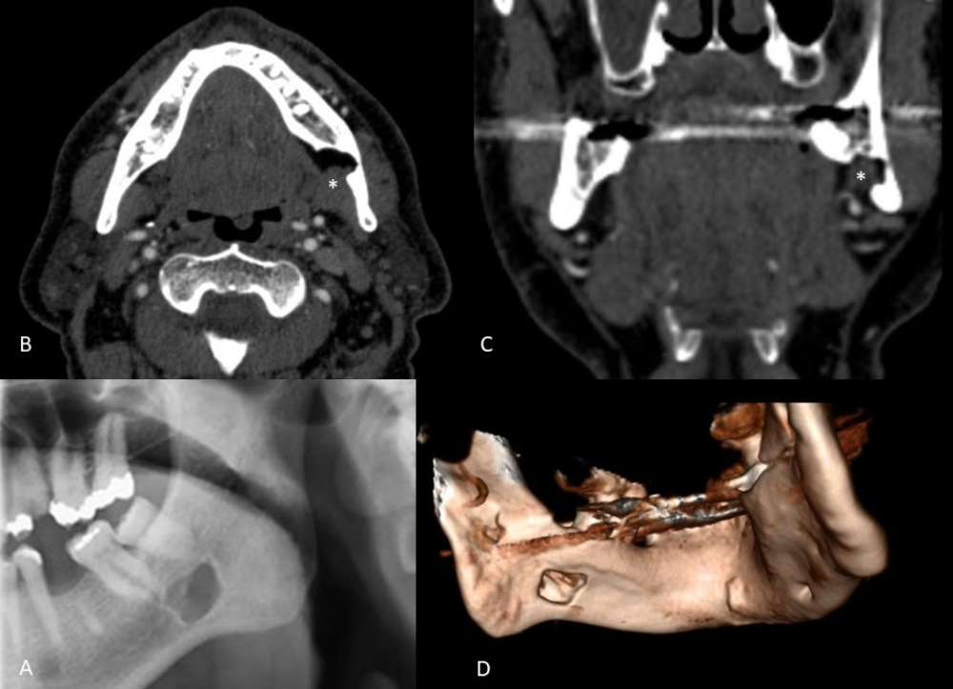

A: sectioned panoramic Radiograph
B, C: Constructed images of CT angiogram
D: 3D Image of mandible (constructed from CT angiogram)

