THE RADIOTHERAPY MIGHT BE A VACCINE FOR IMMMUN RESPONSE
Cengiz Kurtman (1), Iryna Sokur (2),
Mahmut Kemal Ozbilgin (3)
(1) MD, Prof.Dr, Ankara University Medical Faculty Department of Radiation Oncology, Ankara, Turkey, kurtman@medicine.ankara.edu.tr
(2) MD, Chief Doctor of Kherson Regional Oncological Center, Kherson, Ukraine, irina.v.sokur@gmail.com
(3) MD, Prof.Dr, Celal Bayar University Medical Faculty Department of Histology and Embriology, Manisa-Turkey, kemalozbilgin@yahoo.com

SUMMARY/ABSTRACT: Radiotherapy (RT) is one of the most important treatment options of cancer and also may activates immun response. Because of this we must discuss the question of “is the radiotherapy vaccine”. If RT increases the immun response we must learn some more about the RT effects on the cells, cell surface antigene, immun checkpoints and their inhibition (ICI; CTLA4, PD1, PDL1 inhibition). It will be discussed the role of the radiotherapy and biologic effects of the radiotherapy to activate the immun response, radiotherapy dose, radiotherapy timing and the side effects of immun checkpoints inhibitors. But with high conformal hypofractionated stereotactic radiotherapy the microenvironment around the cancer tissue such as fibroblast may survives and then may helps cancer stem cell progression.
KEY WORDS: Radiotherapy, Immun Response, Immun Checkpoints

INTRODUCTION; In the multimodally approch we are fighting against cancer with Radiotherapy (RT), Chemotherapy (CT), Surgery (S) and Immunotherapy (IT). There are new informations about to use IT and RT. In this paper will be discussed the role of radiotherapy for immun response.
The immun system inhibits the cancer cell growth and spread. As seen on the Figure 1, also over the basal membrane in the stage 0 (in-situ) epithelial cancer, the Langerhans Cell (L) acts as Antigen Presenting Cells (APC) for immune response (1).

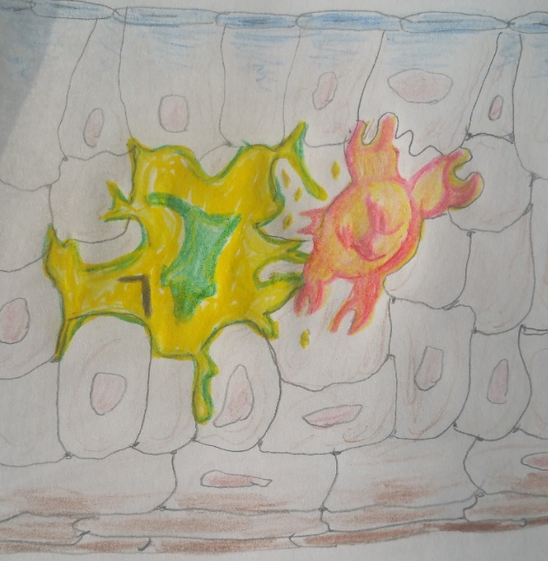

Figure 1: The Langerhans Cell (L) over the basal membrane
in the epithelial tissue.
In tumor microenvironment there are many cells; such as normal epithelial cells, mesenchymal cells, endothelial cells, macrophage (M), tumor assosiated macrophage (TAM), fibroblast (F), cancer associated fibroblast (CAF), dentritic cell (DC), antigen presenting cell (APC), T-B lymphocytes, cancer cells and many dead cells of cancer cells and normal cells. There are many dead tissues and necrotic secretions in the carcinoma microenvironment. These increase with treatments and may protects cancer. Inflammatory response increases pressure and may protects cancer. M2, TAM, CAF, peristicle, collagen tissue may protect cancer. (Figure 2).

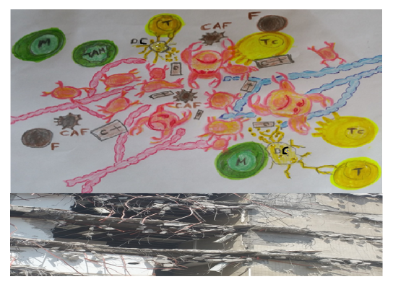
Figure 2: Cancer microenvironment has many living and dead cells (Tc: T cytotoxic, T: T lymphocyte, DC: Dentritic Cell, F: Fibroblast, CAF: Cancer Associated Fibroblast, M: Macrophage, TAM: Tumor Assosiated Macrophage, Ϲ ƚ: Dead Cells)

During RT planning usually we include in the treatment volume primary gross tumor volume + clinical target volume + lymph nodes (Figure 3) (2). But if we want a good immun response we need cancer antigens and lymphatics. Because of this we must discuss to save regional lymphatics and to give RT before surgery.
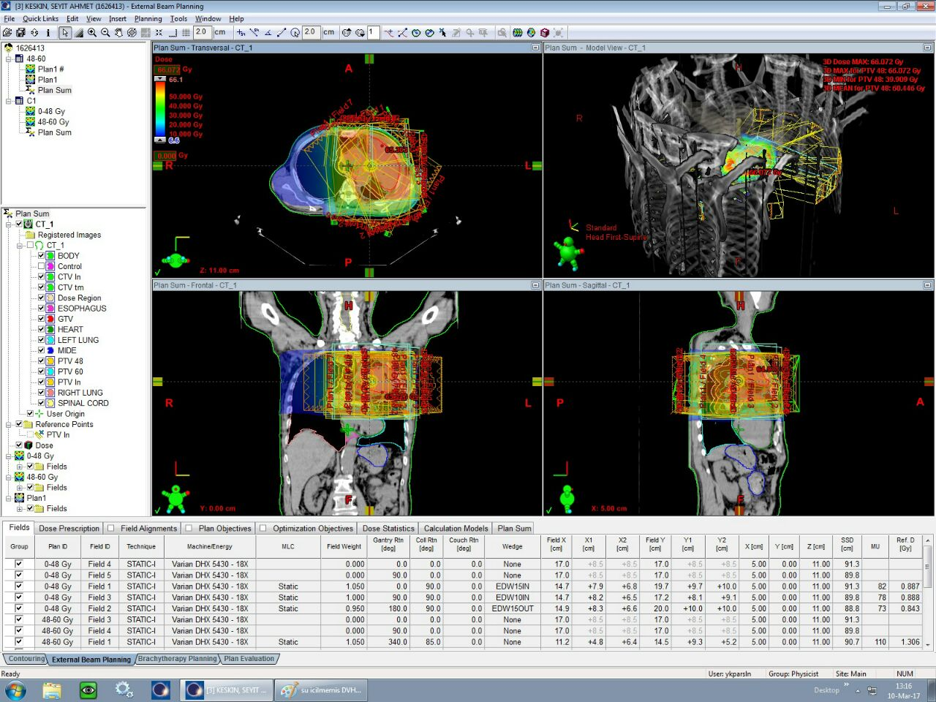
Figure 3: Radiotherapy treatment fields and isodoses
on the left lung cancer case.

In the past and in classic radiation biology had 4R (3); Repair, Redistribution, Reoxygenation (but RT may cause hypoxia, this may bad news and needs Anti VGF), Repopulation (This may bad news because RT may stimulates cancer growth) and 5R; Radioresistant/Radiosensitive tissue or cancer. Now we have 6R; IMMUN REJEKTION, this may be a good news? Because Radiotherapy activates immun responce (Figure 4). Also we have the 7R; Remodelling means cancer lives in a microenvironment and crosstalk with cancer and microenvironment such as CAF etc (4, 5).

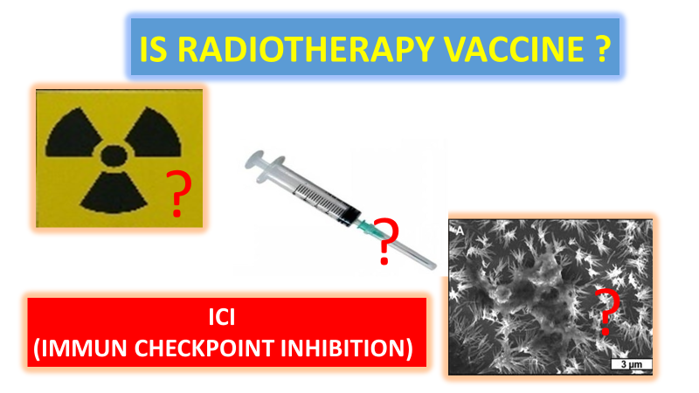
Figure 4: Is the radiotherapy vaccine (1, 6)?

In oncology practice there are some vaccines, such as; Oncolytic virus, BCG (7). Also;
Sipuleucel-T is a DC-based vaccine containing GM-CSF. White cells (DS, Mo-Ma, B cell) are taken from the patient’s with apheresis and transferred to the fabrication, where meeting with recombinant antigen-Sipuleucel-T / Provenge, Dendritic cells mature with GM-CSF and the T cell is matured and activated, then is given back from the vein the patient. This is an active cell immunotherapy in castration-resistant prostate cancer, and
Cimavax-EGF (CUBA): If meningitis bacteria inoculated to patient body, produces antibodies against EGF. The EGF amount is reduced (8, 9). Cancer can not progresses and can not metastasis. Another non-vaccine treatment also against the EGF receptor as TKI. Including to above;
Is the radiotherapy vaccine? If RT increases the immun response we must learn some more about immun checkpoint inhibition (ICI; CTLA4, PD1, PDL1 inhibition) (10).
There are some molecules called Major Histocompatibility Antigene (MHC) or Human leukocyte Antigene (HLA) for immun activation after RT; MHC 1 (HLA- A, B, C) cell surface molecules is to deliver intracytoplasmic antigens such of viruses and tumor antigens presented to CD8 + cytotoxic T cells by cell. MHC 2 (HLA-DP, DR, DQ) are the cell surface molecules, which has been taken by bacterial endocytosis to presented to CD4 + helper T (Figure 4-5) (11).

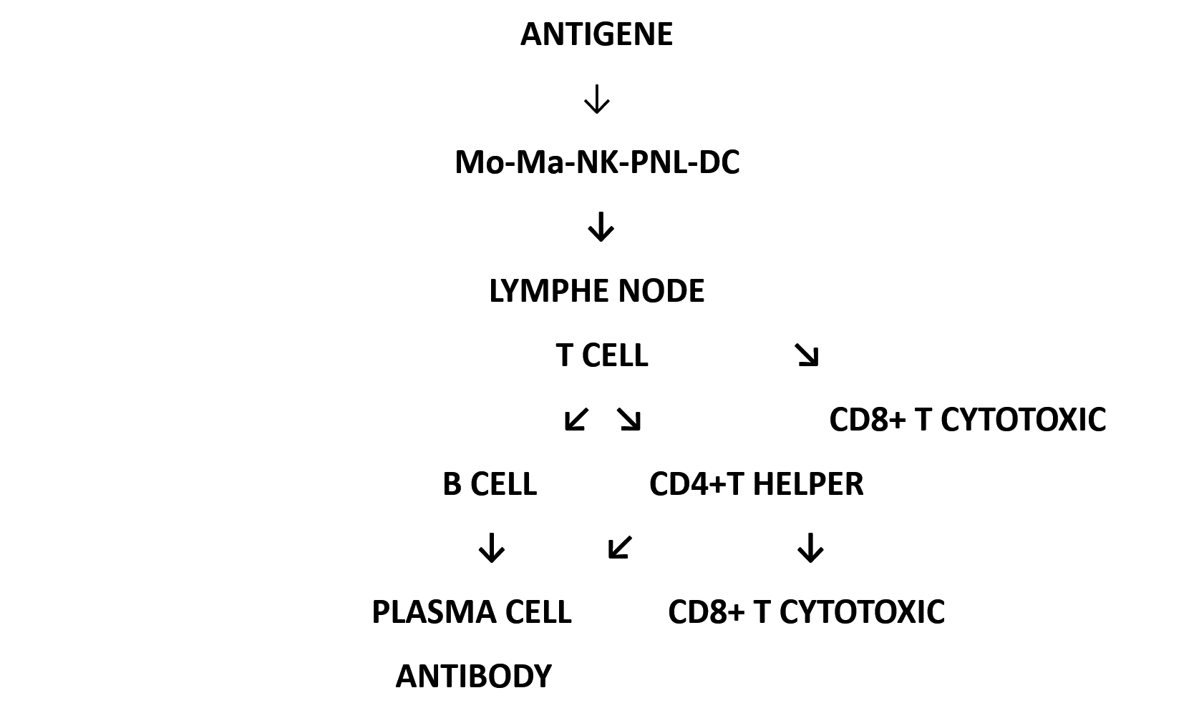
Figure 4: Immun activation after RT

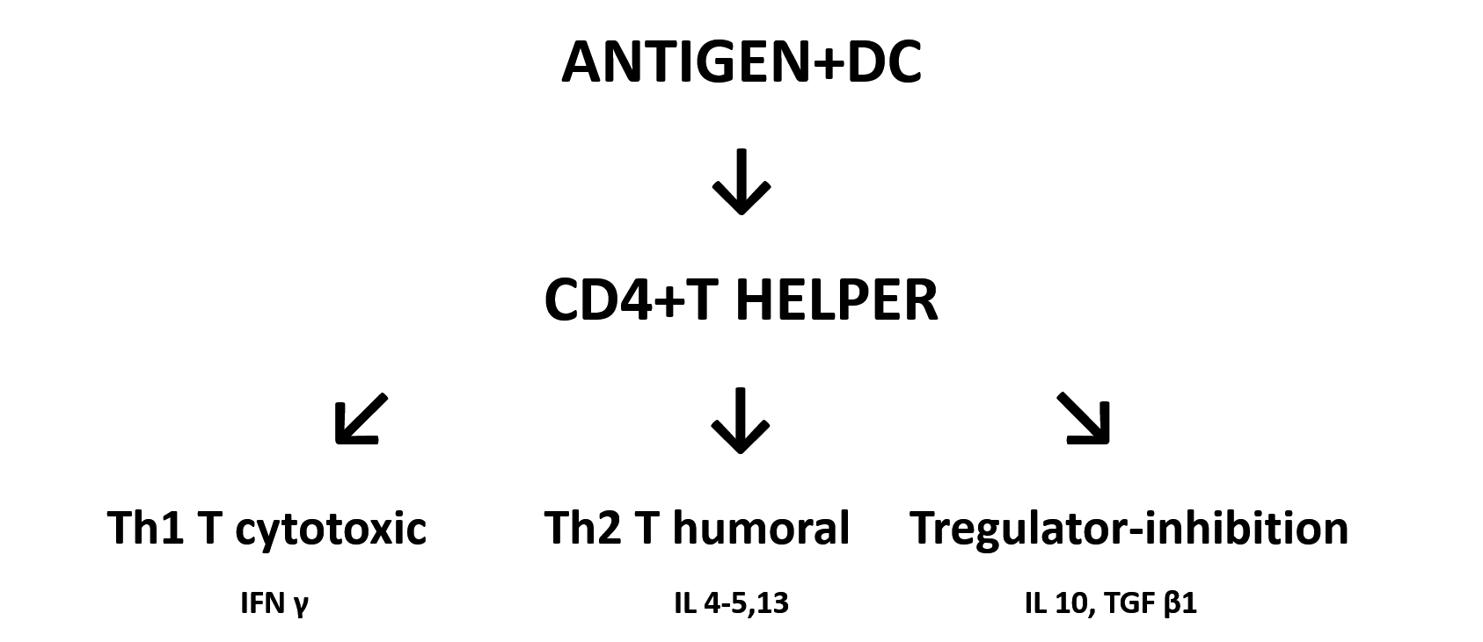
Figure 5: CD4 + T helper

Th1 cells provide the cellular immunity of the person with interferon gamma (IFN-γ), interleukin-2 (IL-2) and tumor necrosis factor-alpha (TNF-alpha). IL-2 specifically proliferates cytotoxic T-cells and activates IL-2 NK-cells. Also the TNF-alpha stimulates T-cells and NK-cells to attack the tumor. INF-γ helps HLA-expression and enhances antigen presentation to effector T-cells(10-12).
Th2-cells secrete more IL-4, IL-5 and IL-10 than Th1-cells and Th2-cells support the immune response with antibody production. IL-4 stimulates B-cells through IgE. IL-10 contributes to the formation of B-cells, monocytes and granulocytes (10-12).

RADIOTHERAPY RESPONSE; When we give RT to cancer microenvironment we may will see many reactions (13-18);
1. Tumor antigens (MHC1/2) excrete to extra cellular matrix. Macrophages and dendritic cells (Dentritic-Cell DC) take them, go to the lymph glands, and these antigens present to the effector T cells and activate T cytotoxic cells (Tc) (CD8 + T lymphocytes).
2. DNA binding protein HMGB1 (High Mobility protein Group Box 1) Increases with radiation. The HMGB1 protein release to extra cellular space. HMGB1 is TLR4-associated dendritic cell activator.
3. ATP (Adenosine triphosphate) appears after RT damage, activate immun response.
4. When DNA is damaged, ATM (Anti telengectase mutated protein) comes out.
5. NKG2D (Natural Killer group 2D) ligands are increased. NK and active CD8 + T cells attack these ligands on cancer. Also the activeted Tc attacks to metaplasia and metastasis.
6. From the endoplasmic reticulum, Calreticulin appears on the tumor surface. Calreticulin pre-apoptotic is released and it is the message to "eat me" in cell translocation.
7. Uric acid and Nitric oxide increases are released into the tumor space and cancer is eliminated by macrophages
8. HSP (heat shock protein) increases. They stimulate the Dentritic Cell (DC). DC stimulates CD8 + Tc.
9. Ceramide is present in the vascular endothelial membrane and also in all membranes. Ceramide is a member of the siphingolipid family, leads to apoptosis. It also helps in immunotherapy (IT) by providing Dentritic Cell maturation with MHC1 increase.

10. ICAM1 (CD54): Intra Celluler Adhesion Molecul/Inter Celluler Adhesion Molecul. After RT lymhatic endotelial cell adhession increased to keep the immun cells for immun response
11. Fas (CD95): First Apoptosis Signal (Apo1 or tumor necrosis factor receptor superfamily member 6) binds to the protein ligand (FasL), resulting in apoptosis signaling from the nucleus leading to cancer cell death.
12.The formation of ROS (reactive oxygen substrate) also kills cancer.
13. Radiation kills cancer directly but also activate immune responses through the Stimulator of Interferon Genes (STING)-mediated DNA-sensing pathway.

14. After RT, IFN gamma released against cancer to increases immune cell migration to the tumor site, has anti- proliferative and antiangiogenic effects, cytotoxic effect on cancer. IFN causes apoptosis in the cancer. Also IFN gamma / IL-12 are secreted by tumor-infiltrating monocysts / macrophages / DCs and these activate the Natural Killer (NK) cells and these helps to open holes in the cell with perforin granule enzyme and por forming cytolytic protein. Por caspase or Fas-L caspase stimulus kill the cancer.

ABSCOPAL EFFECT (Ab: remote, away from. Scopes: target, purpose, aim, scope); Divided into two; The near abscopal effect (bystander effect, audience effect) and the remote abscopal effect (19-21).
Abscopal effect cannot be obtained in non-T cells rats. After RT, close and distant cancer cells may shrink and disappear. Because the antigens released by RT-receiving cells are taken up by Macrophages and DCs, and in the lymph node these antigens recognized by the effector T-cell and the activated immune system kills close and distant cancer cells. CD8 + Tc and Type1 Interferon increase. As seen on the figure 6, the left lower metastatic lesion has disappeared after RT to only the left hiler primary and mediastinal lymph nodes because of the abscopal effect of RT (22).

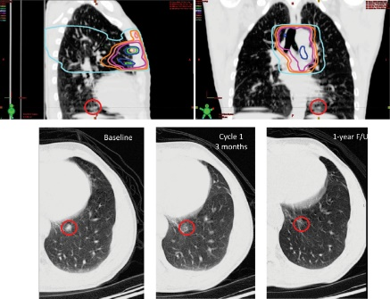
Figure 6: Abscopal effect (22)
BUT, if proliferating cancers and metastases mutate, it may be a new antigenic construct and we can not see abscopal effect. Cancer cells are heterogeneous and each cancer cell has similar and dissimilar antigens. For this reason, the immune response may not be against every cell. Also it is very importantly that normal person has immun check points (ICP) to protect its self from over immun attack to from auto immun diseases. If ICP works in cancer patients our immun system can not attact to kill the cancer cells. Because of these, we must discuss how the ICP works and we need ICP inhibition to fight against cancer (Figure 7).

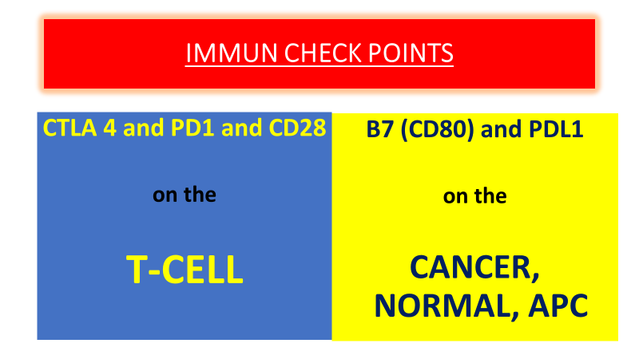
Figure 7: Immun Check Points (ICP)

There are naturel immunocompromised checkpoints against autoimmunization (CTLA4, PD1, PDL1) and block the immune response, otherwise the body will accept its normal cells as foreign.
CTLA4 (Cytotoxic T Lymphocyt Associated antigen 4) immunity checkpoint prevents self-attack in normal human and normal tissues, protects us and prevents autoimmune disease. CTLA4 is on T lymphocyte, and if B7 (B; Bursa of Fabricius was used to identify unknown B cell antigens and ligands in studies previously performed with monoclonal antibodies. Now this terminology is also used in APC and DC. B7 peripheral membrane protein; T cell surface co stimulatory molecule) are on the normal and APC or cancer cells. If CTLA4 and B7 binds; T lymphocyte can not attacks.
The MHC antigen stimulates APC and DC receptors, also at the same time directly stimulates on T cell receptors. CD28 (Cluster of Differentiation 28) in the T cell communicates with B7 in APC provides immun activation. When this activation reaches a certain level, CTLA4 which is on the active T cell binds to the B7 ligands on DS or APC in order to avoid autoimmune attack, and immuno-suppression. If anti-CTLA4 is given, B7 continuously stimulates the T cell and increases the immune response.
B7 and CTLA4 receptor interaction between tumor cell and APC then inactivates T cell. If Anti CTLA4 is given, T cell becomes active. Anti CTLA4 T blocks CTLA4 on the cell. The APC stimulus continues at T and T attacks the cancer. If anti-CTLA4 (Ipilimumab) is given, B7 can not bind to CTLA4 in dendritic cells or in APC, and the attack continues (Figure 8). Also, APC (antigen presenting cell) stimulation continues on T-lymphocytes, the attack is exacerbated, but it is also necessary to pay careful attention to the attacking of normal tissues which cause hazards and side effects.
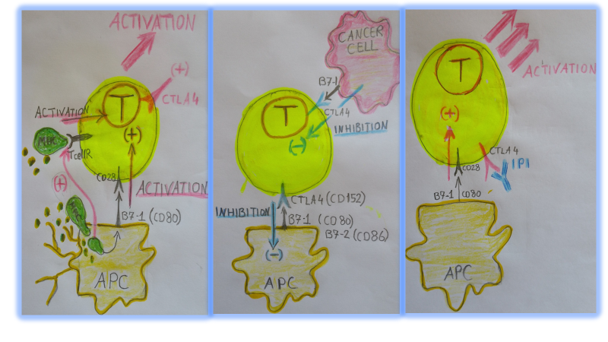
Figure 8: Activation and inhibition with B7, CD28 and CTLA4 interactions
The PD1 is on T CELL and PDL1 is on NORMAL and APC and cancer cells. When RT is given, PD1 and PDL1 are overexpressed. If contact on T cell PD1+PDL1 on the tumor cell/normal/APC cell deactivates the immun T cell. ICI antibodies (anti-PD, anti-PDL1) are continue to activate immune response against cancer (Figure 9).
PD1 is present in activated T cells and must bind to PDL1 to suppress T cell immunity. PDL1-2 is present not only in antigen presenting cells but also in cancer cells, and T cell inhibition occurs when the PDL1 ligand of APC or tumor cell meets with PD1. Therefore, if anti PDL1 is given, PDL1 and PD1 will not meet, APC will not be suppressed, and it will be continuously stimulates APC and the killer cell will attack to cancer in active state. Cancer can not prevents T cell attacks.

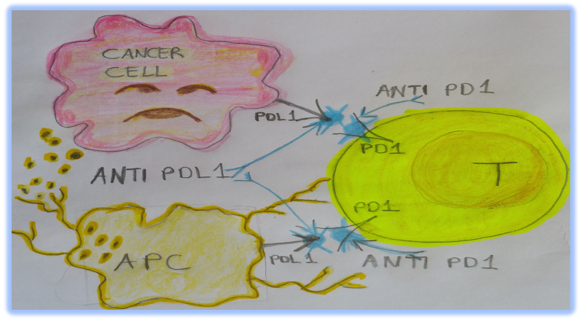
Figure 9: PD1/PDL1 interactions and anti PD1/anti PDL1
Anti PDL1 closes the PDL in the cancer and in APC. The PD1 in the cancer and in the APC can not contact with PDL and the T attack continues. if we give an ICI, auto-immunity is exacerbated and side effect increases. If B7 is blocked, the CD28 stimulus is turned off and immun stimulation is reduced (23, 24).
SIDE EFFECTS of ICI+RT (25, 26): The most common autoimmune side effect is on the skin, like vitiligo, but G3-4 is less. In addition, the gastroenteritis, nausea, vomiting, reduced appetite, fatigue can be seen. Also colitis, pneumonia, hepatitis, nephritis may occur. Attacks on the endocrine system can lead to hypothyroidism, thyroiditis, hypophysitis, colitis, pneumonia, these are threating the life.
CTLA4 is the first and early control point and early side effects can be expected (dermatitis, vitiligo, gastroenteritis, hepatitis, endocrinopathy, thyroid dysfunction). PD1 / PDL1 is the second control point and late side effects can be expected. (Lung pneumonia in the late period).

RT DOSE and TIMING (10-14, 27); Low-dose RT is insufficient to activate the immune system. Very high doses completely eliminate the anti-tumor effect of the immunizing system. In addition, excessive antigen presentation may also exert a stifling effect on the immune response. Because of this the dose must be stimulate cytotoxic cells while decreasing T regulatory cells.
Low doses below 2Gy can not kill cells. It is more likely to induce macrophage stimulation, where the macrophages (M2/ TAM) provide anti-inflammatory effects and thus impair the immune response. At doses above 2 Gy, cancer cell surface antigens (MHC1, ICAM, Fas) are exaggerated from the cell.
In X-Ray RT, the input and output doses act on normal tissues and also suppress the immunological response at the around and within the cancer. Proton is better in this respect (28).
The hypo fractionated RT with stereotactic body RT (SBRT) with 1x20Gy, 3x8Gy, 5x6Gy is recommended (3 or 5 fractions are preferred to 1 fraction. The best is 3x8Gy) such as 3x8Gy or 5x6Gy + anti-CTLA4 (3 mg/kg every 1-3 weeks for 4 doses) instead of a single dose of 1x20Gy or 1x15Gy, 5x3Gy, 3x5Gy, 2x7.5Gy (The best is 2x7.5Gy).
If ICI is given too long before RT, the RT given later will destroy existing cytotoxic T lymphocytes and the response will diminish. If immunotherapy is given just prior to RT, there is an immunologically prepared environment and RT effect is increased. If RT is given first, the cells that are found to recognize and to kill the tumor cells die and the immune response can only be achieved by introducing immunogenic cells from the outside. The best is given; just before RT, or during RT, or immediately after RT. But, in the near future we must discuss for the use of SBRT because the microenvironment is very important and with hypofractionated stereotactic radiotherapy the microenvironment around the cancer tissue such as fibroblast may survives and then may helps cancer stem cell progression (4, 5).

CONCLUSION; It is clear that the RT activates the immune response (6). It is popular to use hypo fractionated SBRT, but we have risk because of the protected fibroblasts around the irradiated volume may survive and then help cancer stem cell progression (4, 5). After RT there are many changes in the cancer cell or around the tumor microenvironment and these activate the immune response. But the cells have some immune check points to protect auto immune disease after a certain level of immune activation. If we use the ICI with RT we may see better immune response but we may pay attention to the side effects of these application.

REFERENCES;

1. Jaitley S, Saraswathi TR, Pathophysiology of Langerhans cells. J Oral Maxillofac Pathol. 2012; 16 (2): 239–44.
2. Purdy JA, Current ICRU definitions of volumes: limitations and future directions. Semin Radiat Oncol. 2004;14: 27-40.

3. Pajonk F, Vlashi E, WH, Radiation Resistance of Cancer Stem Cells: The 4 R’s of Radiobiology Revisited Stem Cells. 2010; 28: 639-48.

4. Ishii G, Crosstalk Between Cancer Associated Fibroblasts and Cancer Cells in the Tumor Microenvironment After Radiotherapy. EBioMedicine. 2017; 17: 7–8.

5. Arnold KM, Flynn NJ , Raben A, et al, The Impact of Radiation on the Tumor Microenvironment: Effect of Dose and Fractionation Schedules. Cancer Growth and Metastasis. 2018; 11: 1-17.

6. Kurtman C, Sokur I, Zaplatina S, et al, Radiotherapy and Immun Response. Is the Radiotherapy Vaccine? Good News? Accepted for publication. Celal Bayar University-Health Sciences Institute Journal. 2019; 6 (1)
7. Redelman-Sidi G, Glickman MS, Bochner BH, The mechanism of action of BCG therapy for bladder cancer - a current perspective. Nature Reviews Urology. 2014; 11, 153-62.
8. Rodríguez PC, Rodríguez G, González G, Lage A. Clinical development and perspectives of CIMAvax EGF, Cuban vaccine for non-small-cell lung cancer therapy. MEDICC Rev. 2010; 12: 17-23.
9. Saavedra D, Crombet T, CIMAvax-EGF: A New Therapeutic Vaccine for Advanced Non-Small Cell Lung Cancer Patients. Front Immunol. 2017; 8: 1-7.
10. Hwang WL, Pike LRG, Royce TJ, Mahal BA, Loeffler JS. Safety of combining radiotherapy with immune-checkpoint inhibition. Nat Rev Clin Oncol. 2018;15: 477-94.
11. Esposito A, Criscitiello C, Curigliano G. Immune checkpoint inhibitors with radiotherapy and locoregional treatment: synergism and potential clinical implications. Curr Opin Oncol. 2015; 27: 445-51.
12. Manda K, Glasow A, Paape D, Hildebrandt G, Effects of ionizing radiation on the immune system with special emphasis on the interaction of dendritic and T cells. Front Oncol. 2012; 2: 1-9.
13. Demaria S, Golden EB, Formenti SC. Role of Local Radiation Therapy in Cancer Immunotherapy. JAMA Oncol. 2015;1: 1325-32.
14. Demaria S, Coleman CN, Formenti SC. Radiotherapy: Changing the Game in Immunotherapy. Trends Cancer. 2016; 2: 286-94.
15. Shi X, Shiao SL. The role of macrophage phenotype in regulating the response to radiation therapy. Transl Res. 2018; 191: 64-80.
16. Hanahan D, Weinberg RA. Hallmarks of cancer: the next generation. Cell. 2011; 144: 646-74.
17. Gameiro SR, Jammeh ML, Wattenberg MM, Tsang KY, Ferrone S, Hodge JW. Radiation-induced immunogenic modulation of tumor enhances antigen processing and calreticulin exposure, resulting in enhanced T-cell killing. Oncotarget. 2014; 5:403-16.
18. Kaur P, Asea A, Radiation-induced effects and the immune system in cancer. Front Oncol. 2012; 2: 1-10.
19. Hu ZI, McArthur HL, Ho AY, The Abscopal Effect of Radiation Therapy: What Is It and How Can We Use It in Breast Cancer? Curr Breast Cancer Rep. 2017; 9: 45-51.
20. Jatoi I, Benson JR, Kunkler I, Hypothesis: can the abscopal effect explain the impact of adjuvant radiotherapy on breast cancer mortality? NPJ Breast Cancer. 2018; 4: 1-8.
21. Zhang X, Niedermann G, Abscopal Effects With Hypofractionated Schedules Extending Into the Effector Phase of the Tumor-Specific T-Cell Response. IJ Rad Oncol Biol Phys. 2018; 101: 63-73.
22. Formenti SC, Demaria S, Combining Radiotherapy and Cancer Immunotherapy: A Paradigm Shift. J Natl Cancer Inst. 2013; 105: 256-65.
23. Garon EB, Rizvi NA, Hui R, et al, for the KEYNOTE-001 Investigators. Pembrolizumab for the Treatment of Non–Small-Cell Lung Cancer. N Engl J Med. 2015; 372:2018-28.
24. Antonia SJ, Villegas A, Daniel D, et al, for the PACIFIC Investigators. Durvalumab after Chemoradiotherapy in Stage III Non-Small-Cell Lung Cancer. N Engl J Med. 2017; 377: 1919-29.

25. Winer A, Bodor JN, Borghaei H, Identifying and managing the adverse effects of immune checkpoint blockadeJ Thorac Dis. 2018; 10 (Suppl 3): 480-9.
26. Kähler KC, Hassel JC, Heinzerling L, et al for the “Cutaneous Side Effects” Committee of the Work Group Dermatological Oncology (ADO). Management of side effects of immune checkpoint blockade by anti-CTLA-4 and anti-PD-1 antibodies in metastatic melanoma. J Dtsch Dermatol Ges. 2016; 14: 662-81.

27. Wang Y, Deng W, Li N, et al, Combining Immunotherapy and Radiotherapy for Cancer Treatment: Current Challenges and Future Directions. Front Pharmacol. 2018; 9: 1-11.
28. Ebner DK, Tinganelli W, Helm A, et al, The Immunoregulatory Potential of Particle Radiation in Cancer Therapy. Front Immunol. 2017; 8: 1-8.

