Submission Type: Scientific Papers
Contact: Ahmed Shokry, MD  INSTITUTION: National Cancer Institute - Cairo University  Radiology Department | E-Mail: ahmedmshokry@yahoo.com
Primary Category: Body Imaging
Secondary Category: CT scan Applications
Preoperative assessment of vascular invasion in exocrine pancreatic cancer by multidetector CT
Ahmed Shokry *, Omnia Mokhtar, Amr Salah, Mohammed Gomaa, Ayman Abdelmottelb.
ABSTRACT:
Purpose: To evaluate dynamic multidetector CT (MDCT) signs of vascular invasion in pancreatic carcinoma.
Patients and methods: Institutional review board approval and patient informed consent were obtained from 42 patients with pathologically proven pancreatic carcinoma. Review of preoperative dynamic MDCT with IV contrast injection was done and multiple signs of vascular invasion were assessed for all cases. The evaluated signs of involved vessels were: vascular contact, vessel wall irregularity (vascular infiltration), diameter stenosis, vascular occlusion. Data were analyzed regarding multiple signs of vascular invasion. Operative and pathological data was the gold standard reference.
Results: Twelve of 42 cases (28.6%) were surgically resectable and 30 cases (71.4%) were surgically unresectable.
Dynamic MDCT showed surgically confirmed invaded vessels of 19 arteries and 33 veins. The overall accuracy of signs of vascular invasion was 75%.
Conclusion: Significant advances have been made in the ability of MDCT to stage pancreatic carcinoma when special attention is paid to multiple signs of vascular invasion.
Keywords:
Pancreatic cancer; vascular invasion; MDCT.
CLINICAL RELEVANCE / APPLICATION
Dynamic multidetector CT (MDCT) is considered a revolution in imaging that can be used as an accurate tool of imaging and staging of pancreatic cancer

Figures (optional):
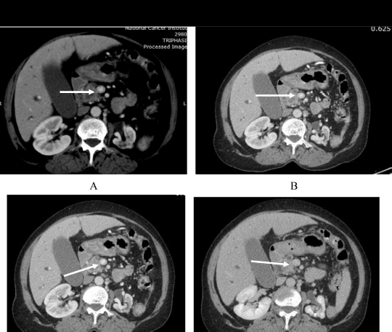
Pathologically proved pancreatic head carcinoma in 51 year old female, (A), (B), (C) portal phase and (D) pancreatic parenchymal phase. The lesion showed <50% circumferential involvement of superior mesenteric vein (arrow), the case was resectable.

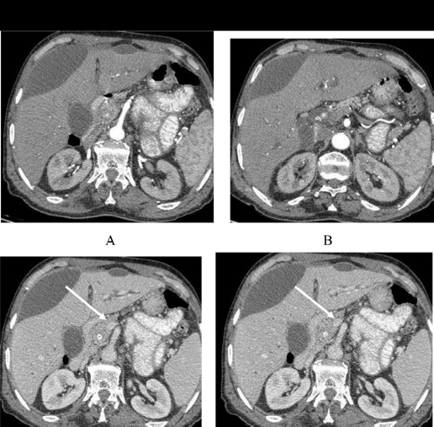
Pathologically proved pancreatic head carcinoma in 72 year old male, (A), (B), arterial phase, (C), (D) venous phase. The lesion showed >50% circumferential involvement of superior mesenteric vein seen in venous phase images (arrow), the case was resectable. Two non-enhanced sub capsular bilomas were noted.

