Elastic scattering of a muon neutrino by an electron in the presence of a circularly polarized laser field
S. El Asri,1 S. Mouslih,1,2 M. Jakha,1 B. Manaut,1 Y. Attaourti,3 S. Taj,1 and R. Benbrik4
1 Polydisciplinary Faculty, Laboratory of Research in Physics and Engineering Sciences, Team of Modern and Applied Physics,
Sultan Moulay Slimane University, Beni Mellal 23000, Morocco
2 Faculty of Sciences and Techniques, Laboratory of Materials Physics (LMP), Beni Mellal 23000, Morocco
3 High Energy Physics and Astrophysics Laboratory, FSSM, Cadi Ayyad University, Marrakesh, 40000, Morocco
4 Polydisciplinary Faculty, Laboratory of Fundamental and Applied Physics, Sidi Bouzid, B.P. 4162 Safi, Morocco

Abstract (300 word limit)
In view of the great contribution of neutrino-electron scattering to the deep understanding of electroweak interactions, we focus in this work on the study of elastic scattering of a muon neutrino by an electron in the presence of a circularly polarized electromagnetic field. We perform our theoretical calculation within the framework of Fermi theory using the exact wave functions of charged particles in an electromagnetic field. The expression of the differential cross section (DCS) for this process is obtained analytically in the absence and presence of the laser field. The effect of the field strength and frequency on the exchange of photons as well as on the DCS is presented and analyzed. Massive neutrino effects are also
included and discussed. This study, added to the previous ones, will significantly enrich our knowledge in fundamental physics.

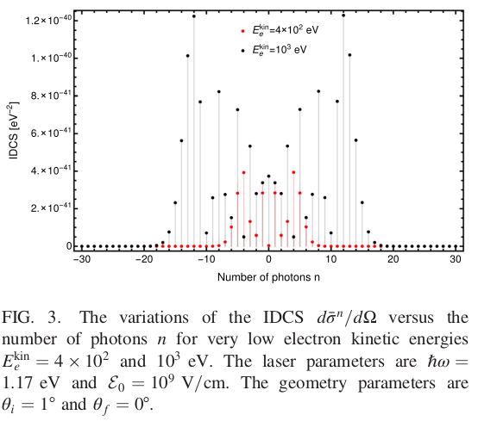

Recent Publications (minimum 5)
- M. Jakha, S. Mouslih, S. Taj, and B. Manaut, Laser effect on the final products of Z-boson decay, Laser Phys. Lett. 18, 016002 (2021).
- M. Jakha, S. Mouslih, S. Taj, Y. Attaourti, B. Manaut, Influence of intense laser fields on measurable quantities in W-boson decay, Chin. J. Phys. (2021).
DOI: https://doi.org/10.1016/j.cjph.2021.09.011
- M. Jakha, S. Mouslih, S. Taj, B. Manaut, M. El Idrissi, E. Hrour, E. Siher, Relativistic electron-impact ionization of hydrogen atom from its metastable 2S-state in the symmetric/asymmetric coplanar geometries, Chin. J. Phys. (2021).
DOI: https://doi.org/10.1016/j.cjph.2021.09.005
- S. Mouslih, M. Jakha, S. Taj, B. Manaut, and E. Siher, Laser-assisted pion decay, Phys. Rev. D 102, 073006 (2020).
5. I. Dahiri, M. Jakha, S. Mouslih, B. Manaut, and S. Taj, Elastic electron-proton scattering in the presence of a circularly polarized laser field, Laser Phys. Lett. 18, 096001 (2021).


Biography (150 word limit)

I am currently 3rd year PhD student in Polydisciplinary Faculty, Sultan Moulay Slimane University, Beni Mellal, Morocco. I have got my Master degree in Modern Physics at the same university. My research area is about the study of the laser effect on the different QED and electroweak processes.
Email: mohamed.jakha@usms.ma

Notes/Comments:
Presenting author details
Full name: JAKHA Mohamed
Contact number: +212 6 23 21 70 42
ORCID iD: https://orcid.org/0000-0003-4801-2142
Google Scholar: https://scholar.google.com/citations?user=9UZ6EgMAAAAJ&hl=fr
Session name/ number: Track 12 : Quantum Field Theory (QFT)
Category: Oral presentation

