On-chip electrical control of nonlinear quantum optics using a quantum dot in a waveguide
D D.Hallett, A.P.Foster, B. Royall, E. Clarke, D.Hurst, P.Kok, A. M. Fox, M. S. Skolnick and L.R.Wilson
Department of Physics and Astronomy, University of Sheffield, S3 7RH, United Kingdom

Abstract

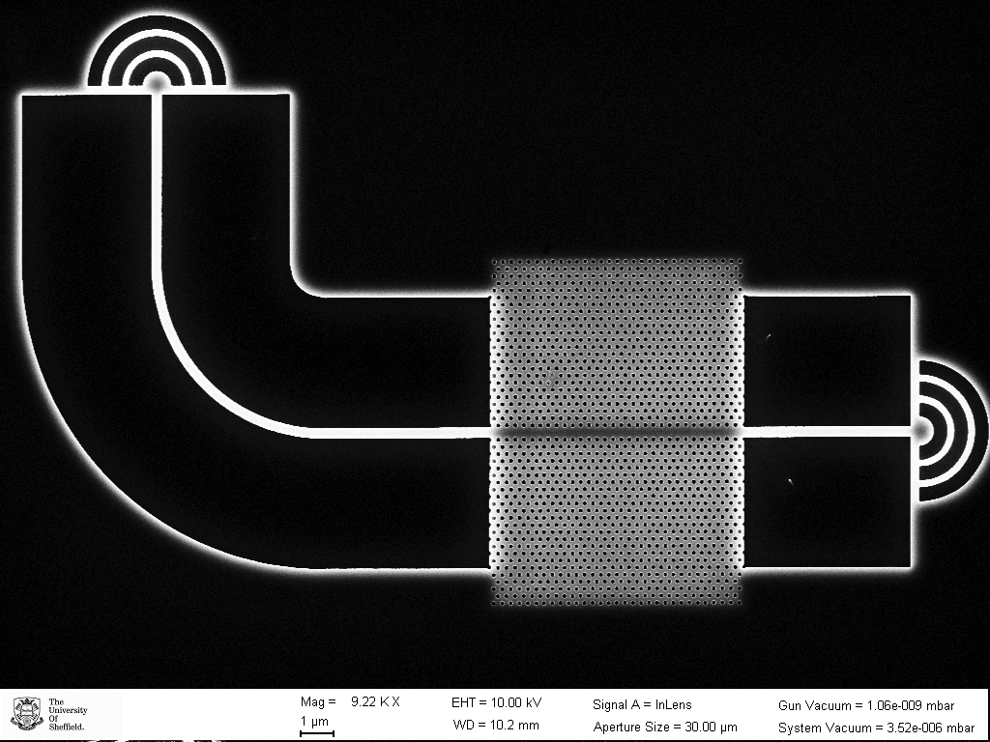
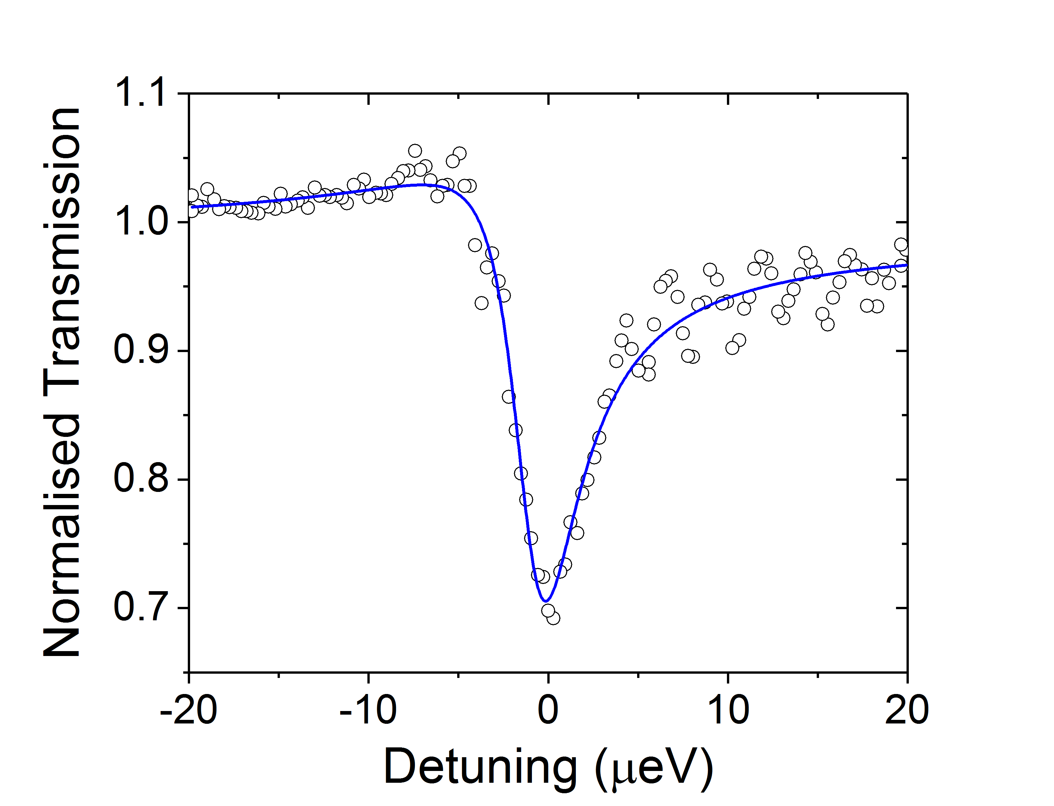
We demonstrate on-chip electrical control of the non-linear optical response at the single/few photon level using a single semiconductor quantum dot embedded in a p-i-n junction nano-photonic waveguide. We study the nonlinear response using resonant transmission of a weak narrow band, tunable laser source and through quantum statistics measurements of the scattered photons, which contain contributions from an entangled photon-photon bound state. The electrically tunable and switchable transmission change is as large as 30% on resonance in a single pass. Observation of a clear, voltage-controlled bunching signal in the photon statistics of the transmitted light demonstrates the single-photon character of the nonlinear response. Control of the quantum dot charge state with applied bias enables the study of the neutral and charged exciton complexes, with future potential for spin-photon studies. Our work represents an important step towards deterministic quantum-information processing with photons.
Image

Fig. 1. (Left) Top-down SEM image of the device, showing output couplers, nanobeam waveguide and slow-light photonic crystal section in which the QD is embedded. (Right) A typical resonant transmission spectrum.

Recent Publications
- F.Liu et al. (2017) High Purcell factor generation of coherent on-chip single photons, arXiv: 1706.04422v1
- C.Bentham et al. (2016) Single-photon electroluminescence for on-chip quantum networks, Appl. Phys. Lett. 109, 161101.
- N.Prtljaga et al. (2016) On-chip interference of single photons from an embedded quantum dot and an external laser, Appl. Phys. Lett. 108, 251101.
- C.Bentham et al. (2015) On-chip electrically controlled routing of photons from a single quantum dot, Appl. Phys. Lett. 106, 221101.
5. A.P. Foster et al. (2015) Linearly polarized emission from an embedded quantum emitter using nanowire morphology control, Nano. Lett. 15, 1559.

Biography
Luke Wilson is an academic staff member in the Department of Physics, University of Sheffield UK. He presently leads the ‘Quantum nano-optics’ workpackage of the £5.6m EPSRC-funded Programme Grant EP/N031776/1, investigating semiconductor quantum photonics and is a long-standing member of the large LDSD Research Group, headed by Prof. Maurice Skolnick (see https://ldsd.group.shef.ac.uk/ ). He has published over 180 journal articles and given more than 20 invited talks at international conferences.
Email: luke.wilson@sheffield.ac.uk

Notes/Comments:

