Quantum decoration transformation for spin models
F. F. Braz MsC, Departamento de Física, Universidade Federal de Lavras, 37200000 MG Brazil.
F. C. Rodrigues MsC, Departamento de Física, Universidade Federal de Lavras, 37200000 MG Brazil.
S. M. de Souza PhD, Departamento de Física, Universidade Federal de Lavras, 37200000 MG Brazil.
Onofre Rojas PhD, Departamento de Física, Universidade Federal de Lavras, 37200000 MG Brazil.

Abstract (300 word limit)

The classical version of decoration transformation has been used to map lattice spin models into another equivalent lattice spin models.

This transformation is a very useful tool for identifying a class of lattice spin models, since, it is possible to show a class of lattice spin models that can be map into another class of exactly solvable models. Here we present a quantum version of decoration transformation and show how this transformation could be applied to Heisenberg type models. This transformation can be useful to study the equivalence between two quantum spin systems such as a small cluster of quantum spin models or even lattice quantum spin models. The quantum decoration transformation by itself is an exact transformation, although the proposed transformation cannot be used to map exactly a quantum spin lattice model onto another quantum spin lattice model, since, the operators are non-commuting. However, it is possible mapping in the classical limit, establishing the equivalence between two quantum lattice spin models. To study the validity of this approach for quantum spin lattice model, we use the Zassenhaus formula, and we verify how the correction could influence the decoration transformation. The correction term involves the second-nearest-neighbor coupling, as well as the next nearest neighbors, which leads into a cumbersome task to establish the equivalence between both lattice models. This correction also gives us valuable information about its contribution, for most of the Heisenberg type models, this correction could be irrelevant at least up to the third order term of Zassenhaus formula. This transformation is applied to a finite size Heisenberg chain, so we compare with exact numerical results, and our result is consistent when the xy-anisotropy coupling is weak, we also apply to bond-alternating Ising-Heisenberg chain model, obtaining an approximate result.
Image

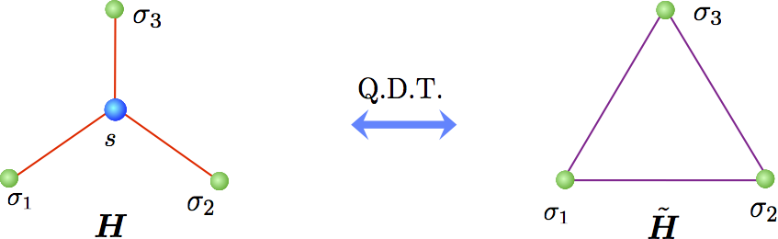
An example quantum decoration transformation, here H is the star Hamiltonian and is the triangle Hamiltonian, with Heisenberg spins.
Recent Publications (minimum 5)
- F. F. Braz, F. C. Rodrigues, S. M. de Souza, O. Rojas, Quantum decoration transformation for spin models, Annals of Physics 372, 523 (2016).
- J Torrico, M Rojas, SM de Souza, O Rojas, Zero temperature non-plateau magnetization and magnetocaloric effect in an Ising-XYZ diamond chain structure, Phys. Lett. A 380, 3655-3660 (2016).
- M Rojas, O Rojas, SM de Souza, Frustrated Ising model on the Cairo pentagonal lattice, Phys. Rev. E 86, 051116 (2012).
- O. Rojas, S.M. De Souza, Direct algebraic mapping transformation for decorated spin models, Journal of Physics A: Mathematical and Theoretical 44, 245001 (2011)
- O. Rojas, J.S. Valverde, S.M. De Souza, Generalized transformation for decorated spin models, Physica A: Statistical Mechanics and its Applications 388, 1419-1430 (2009).

Biography (150 word limit)
Onofre Rojas has his expertise in quantum mechanics, mathematical physics and condensed matter physics, particularly focusing in some recent topics such as entanglement in condensed matter physics, magneto caloric effect among other properties of condensed matter physics. His group developed in last decade a series of progress concerning decoration transformation for classical and quantum spin models, recently new attempts was performed for quantum spin operators. This work was proposed to his MSc student F. F. Braz who is a blind man and currently is enrolled as a Ph.D. student in physics in Federal University of Minas Gerais; this work was developed in collaboration with his colleague S. M. de Souza and another MSc student F. C. Rodrigues.
Email: ors@dfi.ufla.br

Notes/Comments:

