Abstract
Tuberous sclerosis is a rare autosomal dominant disease characterized by numerous benign tumors in different parts of the body caused by mutations in either of two different genes ,TSC1 and TSC2.
This patient,16 years old girl presented with bilateral spontaneous pneumothorax .she had a history of left nephrectomy for angiomyolipoma(AML) of left kidney with a history of fits at the age of 1 month. General physical examination revealed multiple papules on face and neck (adenoma sebaceum).high resolution CT chest showed multiple small cysts consistent with overall diagnosis of Tuberous Sclerosis.Her management included prompt chest intubation bilaterally for lungs re-expansion, oxygen therapy and intravenous antibiotics plus chestphysiotherapy. During regular follow up of the patient, she was having only occasional shortness of breath which was relieved with bronchodilators.
Introduction
Tuberous sclerosis is a rare ,multi-systemic autosomal dominant disorder that causes benign tumors in various organs of the body like brain ,kidney ,lungs ,heart and skin etc.it is caused by mutations in either of the genes TSC1 or TSC2,which encode for the proteins hemartin and tuberin respectively. These proteins are tumor growth suppressorsthat regulate cell proliferation and differentiation. The live birth prevalence is estimated to be 10 and 16 cases per 100,000.A 1998 study estimated total population prevalence between 7 -12 cases per 100 live births. There is no definitive treatment, but medicine, education and occupational therapies decrease the symptomatology of the patients.

CASE REPORT
A 16 years old girl ,resident of Mardan,presented to Pulmonology department of Lady Reading Hospital Peshawar dated 7th March 2019(medical record number 000-03384229 ) with sudden onset of shortness of breath ,severe chest pain and dry cough for one day. She was having significant past history of left sided nephrectomy for angiomyolipoma (AML) in Jan 2016 in Mardan medical complex.She experienced her first fit at the age of one month for which she was started on antiepileptic’s but discontinued by her parents as she remained fits free for the last 10 years.
On physical examination of chest there was significantly decreased air entry bilaterally. Oxygen saturation was 86 percent on room air. There were multiple small red-brown papules over the central part of the face and lower part of the neck as well as on upper part of the chest on right side which was consistent with adenoma sabaceum (figure 1).CNS and CVS examinations were normal.

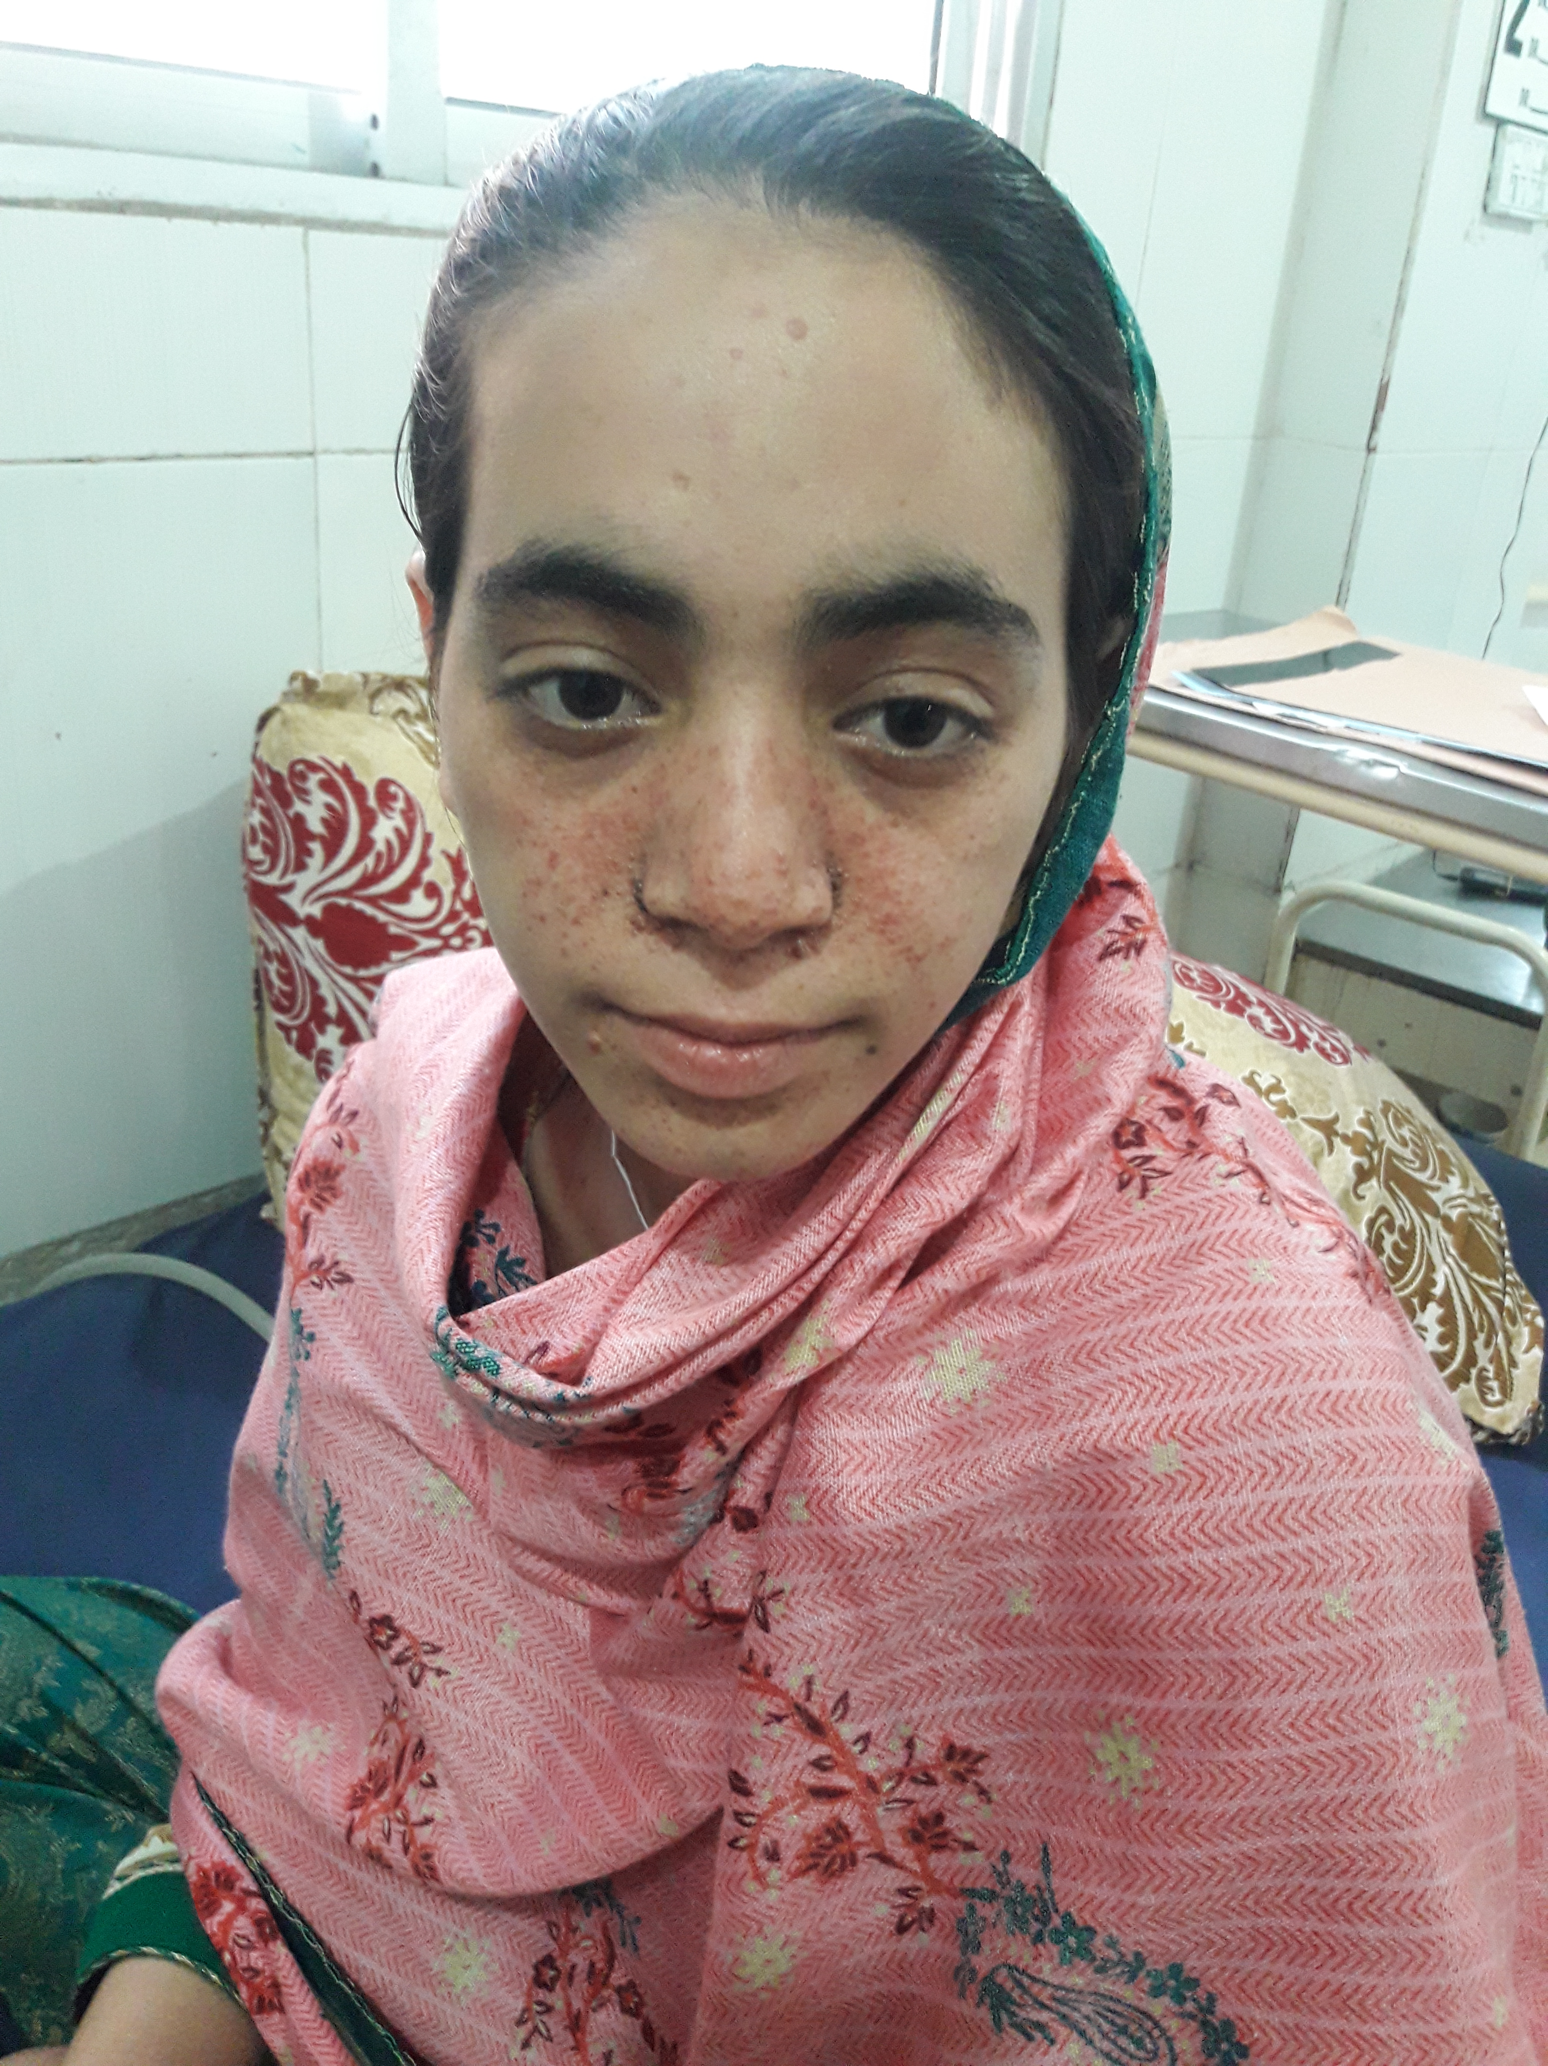
Figure 1 ; multiple small papules on face since childhood (Adenoma sebaceum).

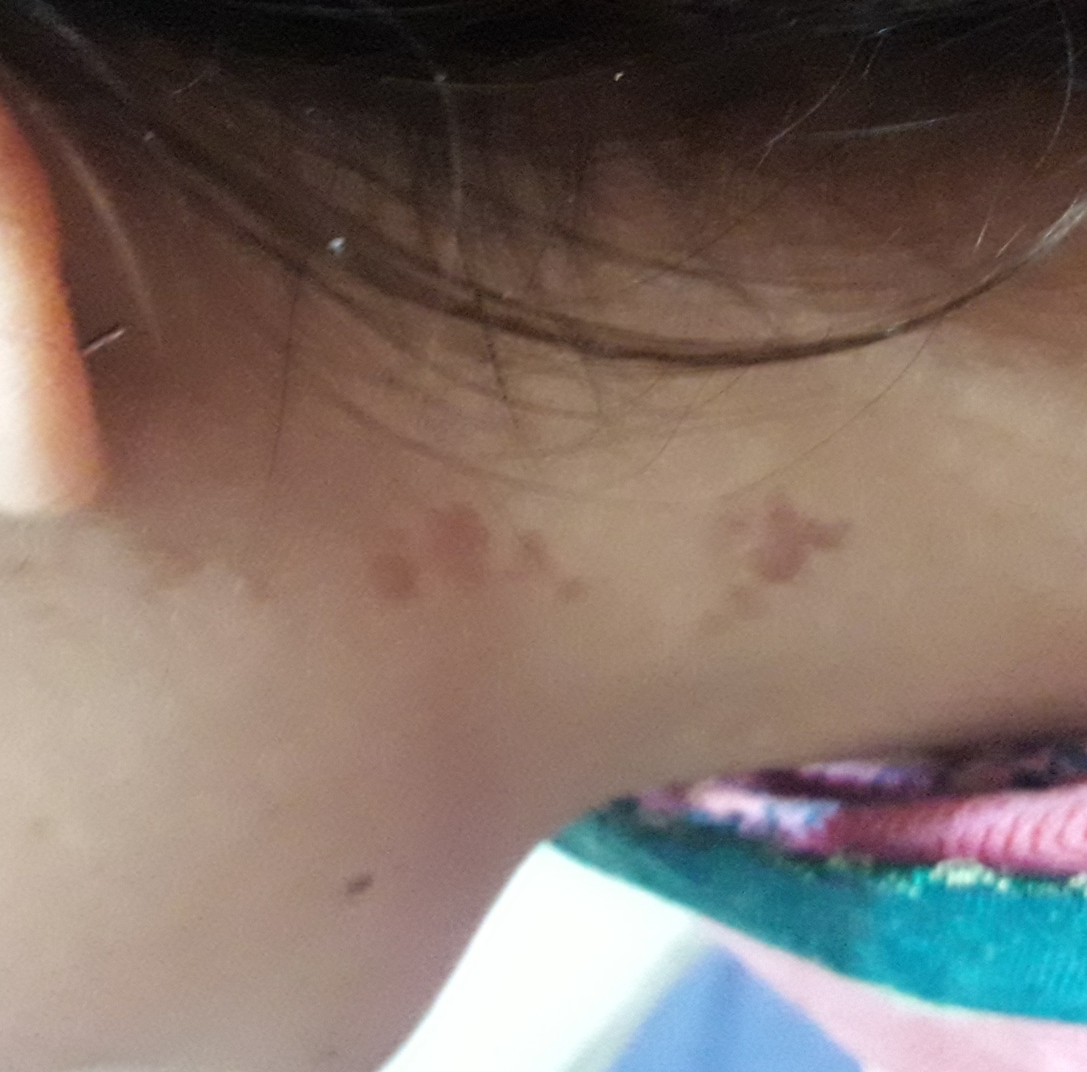
Figure 2; Rash on left lower jaw and upper part of neck.

Investigations
At arrival to our unit we did chest xray that showed
bilateral pneumothorax (figure 3).Baseline
investigation were normal included normal
leukocytes count, normal renal function tests and
normal liver function tests .HRCT showed bilateral
pneumothorax with multiple cysts/bullae more on
the right lung parenchyma largest one measuring
18mm in right lower lobe (figure 4).there was no
pleural effusion noted. Ultrasound abdomen
showed postsurgical absence of left kidney and
normal right kidney.
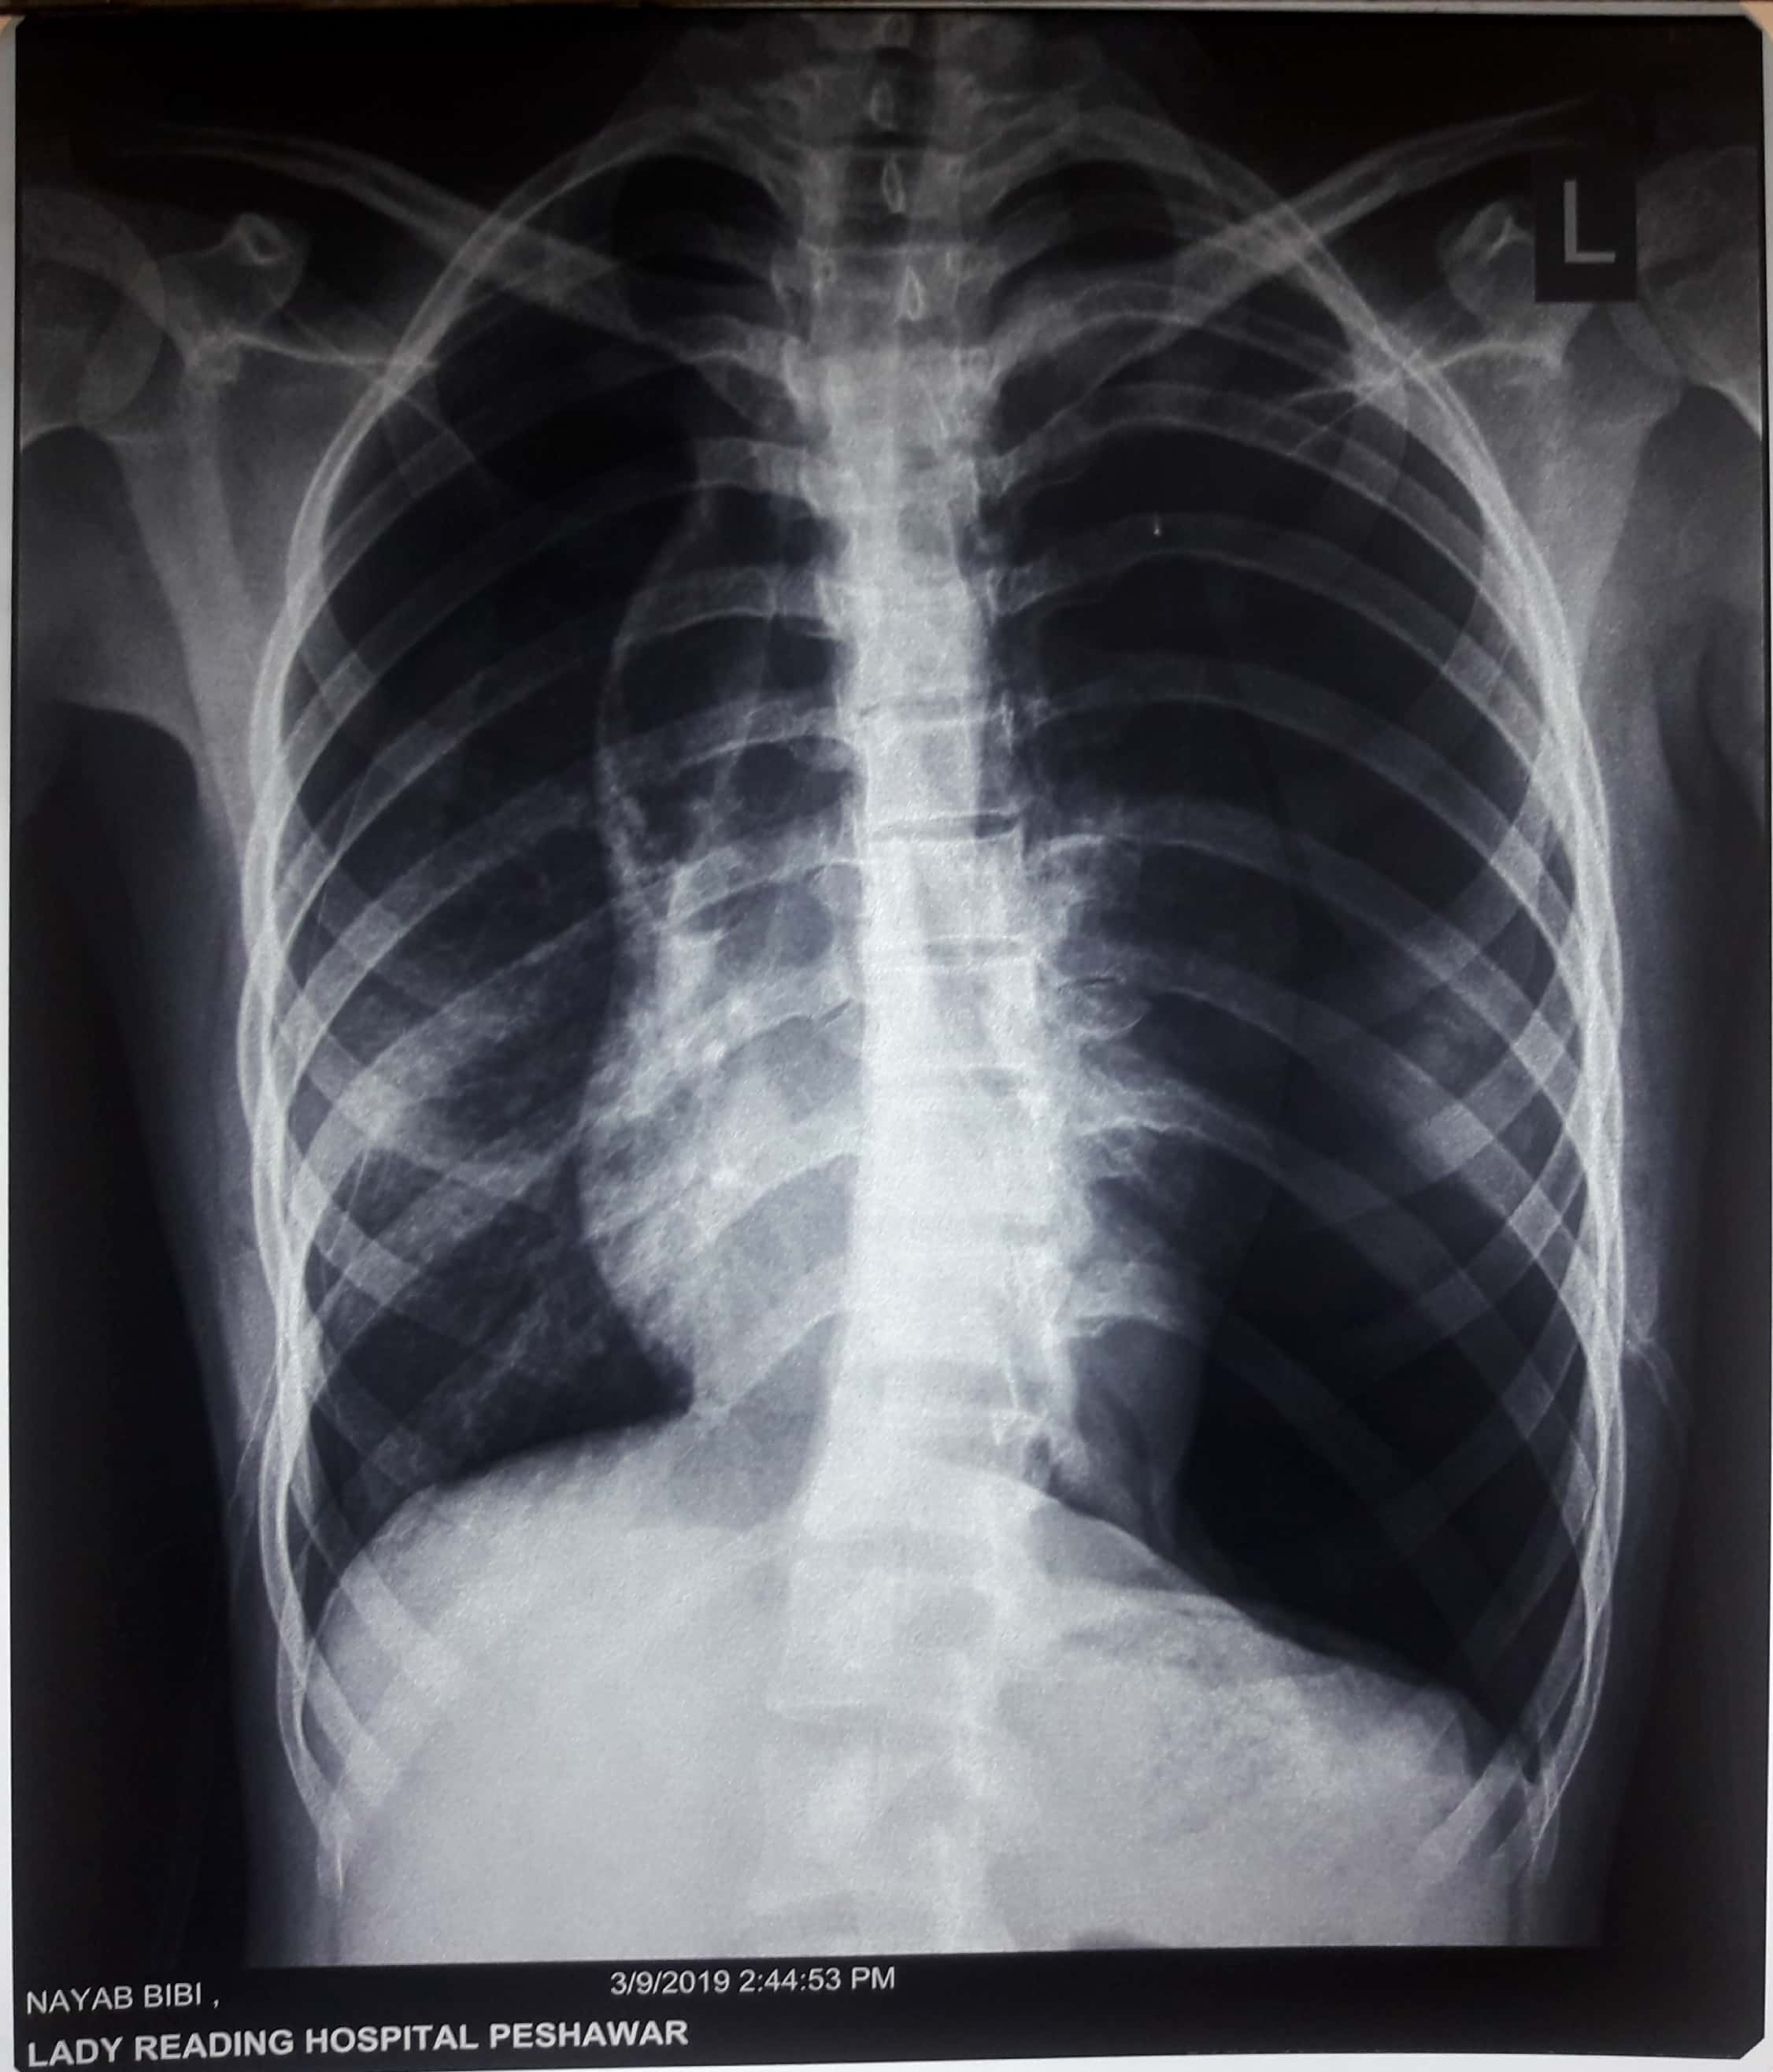
Figure 3:chest radiograph showing bilateral spontaneous pneumothorax ,for which bilateral tube thoracostomy was done urgently.
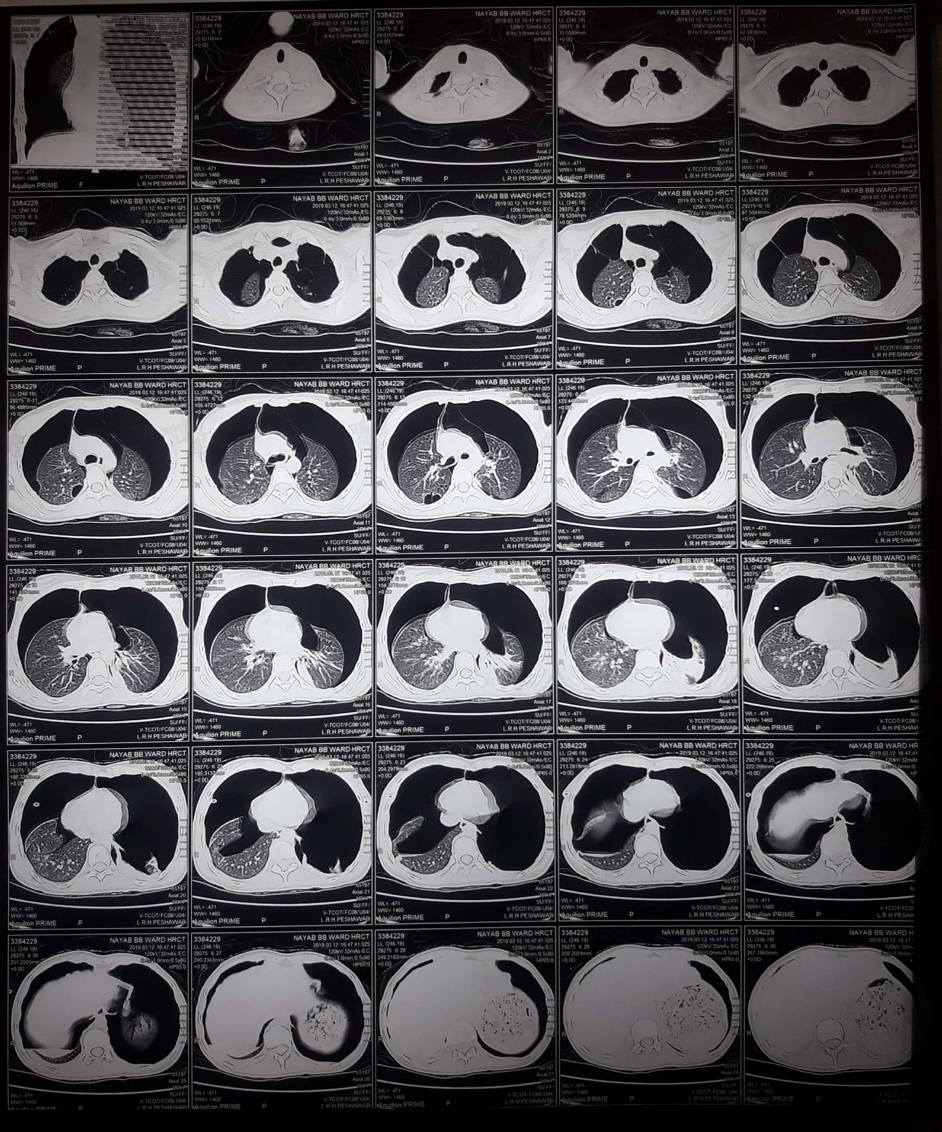
Figure 4 :High-resolution CT scan of the chest showing marked pneumothoraxes.
Diagnosis
Keeping her clinical presentation,significant past history ,extensive physical signs and investigations, the definitive diagnosis of Tuberous Sclerosis were made.
Management and Outcome
The acute treatment of the patient included urgent chest intubation bilaterally for lung re-expansion. Oxygen therapy and chest physiotherapy.
The patient symptomatically better after following lung re-expansion, antibiotics and chest physiotherapy. She was discharged and having occasional shortness of breath on exertion only which was relieved with nebulized bronchodilators on regular follow up. She was then referred to thoracic unit for future management and she is enrolled in a clinical trial.

Refrences
1.Wienecke R, Klemm E, Karparti S, Swanson NA, Green AJ, DeClue JE. Reduction of expression of tuberin, the tuberous-sclerosis-complex-gene-2 product in tuberous sclerosis complex associated connective tissue nevi and sporadic squamous and basal cell carcinomas. J Cutan Pathol 2002.
2.Behnes CL, Schutze G, Engelke C, Bremmer F, Gunaean B. 13-year-old tuberous sclerosis patient with renal cell carcinoma associated with multiple renal angiomyolipomas developing multifocal micronodularpneumocyte hyperplasia. BMC Clinical Pathology. 2013;13.
3.Yates JR. Tuberous sclerosis. Eur J Hum Genet 2006; 14: 1065-73.
Seibert D., Hong CH., Takeuchi F., Olsen C., Hathaway O., Moss J; Recognition of tuberous sclerosis in adult
women: delayed presentation with life-threatening consequences; Ann Intern Med; 2011; 154; 806-13.
Seibert D., Hong CH., Takeuchi F., Olsen C., Hathaway O., Moss J; Recognition of tuberous sclerosis in adult
women: delayed presentation with life-threatening consequences; Ann Intern Med; 2011; 154; 806-13.

