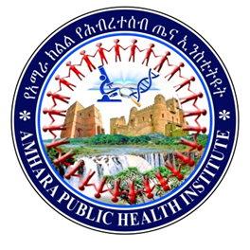
AMHARA PUBLIC HEALTH INSTITUTE
PUBLIC HEALTH EMERGENCY
MANAGEMENT DIRECTORATE
REGIONAL FIRST QUARTER MAJOR EMERGENCY OUTBREAK SUMMARY REPORT 2012 BUDGET YEAR BY
RESPONSE AND RECOVERY CASE TEAM

October, 2019 Bahir Dar, Ethiopia

Table of Contents
List of Tables II
List of Figures II
List of Acronyms III
Executive Summary IV
1. Introduction 1
1.1. Background 1
1.2. Significance of the Report 4
2. Objectives 5
2.1. General Objective 5
2.2. Specific Objectives 5
3. Methods and Materials 6
3.1. Reporting Area/ Setting 6
3.2. Study Design and Period 7
3.3. Data Source 7
3.4. Data Collection Procedure 7
3.5. Data Quality Control, Processing and Analysis 7
3.6. Operational Definitions 7
4. Results 8
4.1. Measles Report 8
4.2. Pertussis Report 13
4.3. Rabies/ Dog Bite 18
4.4. Anthrax Situation 23
5. Challenges 26
6. Conclusion 26
7. Recommendations 27
8. References 28

List of Tables
Table 1: Six Years Measles Vaccination Coverage (MCV1) of affected woredas Amhara Region, Tikemt 2012 EFY. 12
Table 2: Six Years Penta three coverage of pertussis affected Woreda, Amhara Region, Meskerem 2012 E.C. 17

List of Figures
Figure 1: Map of Amhara Region by Zone to indicate study area, 2012 EFY. 6
Figure 2: Map of Woredas occurred measles outbreak in first quarter of Amhara Region, Tikemt 2012 EFY. 8
Figure 3: Number of Suspected measles cases by date of onset in Amhara Region, Tikemt 2012 EFY. 9
Figure 4: Number of Suspected Measles cases by age distribution of Amhara Region, Tikemt 2012 EFY. 10
Figure 5: Suspected Measles cases by vaccination status of Amhara Region, Tikemt 2012 EFY. 11
Figure 6: Map of Dehana and Sayint Woredas location in Amhara Region, Tikemt 2012 EFY. 13
Figure 7: Number of Pertussis cases by date of onset in Amhara Region, Tikemt 2012 EFY. 14
Figure 8: Number of Pertussis cases by age distribution Amhara Region, Tikemt 2012 EFY. 15
Figure 9: Number of Pertussis Cases By level of Vaccination status Amhara Region, Tikemt 2012 EFY. 16
Figure 11: Suspected Rabies Cases distribution by Woredas From Addis Alem Hospital Bahir Dar Town, Amhara Region, Tikemt 2012 EFY. 18
Figure 12: Suspected Rabies Cases by date of exposure Reported from Addis Alem Hospital Bahir Dar Town, Amhara Region, Tikemt 2012 EFY. 19
Figure 13: Number of Rabies suspected cases reported with age distribution Addis Alem Hospital Bahir Dar Town, Amhara Region, Tikemt 2012 EFY. 20
Figure 14: High Rabies Suspected Cases Reported Woredas from Addis Alem Hospital Bahir Dar Town, Amhara Region, Tikemt 2012 EFY. 21
Figure 15: Cases Based on Post Exposure Prophylaxis Administration Reported from Addis Alem Hospital Bahir Dar Town, Amhara Region, Meskerem 2012 EFY. 22

List of Acronyms

APHI | Amhara Public Health Institute
CFR | Case Fatality Rate
EFY | Ethiopian Fiscal Year
EPHI | Ethiopian Public Health Institute
EPI | Expanded Program of Immunization
IDSR | Integrated Disease Surveillance and Response
MCV | Measles Containing Vaccine
MOH | Ministry of Health
PEP | Post Exposure Prophylaxis
PHEM | Public Health Emergency Management
VPD | Vaccine Preventable Diseases
WHO | World Health Organization

Executive Summary
Background: Public health surveillance is an on-going, systematic collection, analysis, and interpretation of health-related data essential to the planning, implementation, and evaluation of public health practice, with timely dissemination of these data to those who are responsible for action. Diseases control and prevention programs have been successful when resources were dedicated to detecting targeted diseases, obtaining laboratory confirmation of the disease, and using thresholds to initiate action at the district level.
Objective: To assess the magnitude, disease distribution and risk factors of immediately reportable diseases that occurred in Amhara Region, from Hamele 1 to Tikemt 2, 2012 EFY.
Methods: We described the outbreak using descriptive epidemiology. Regional identified outbreaks registered by line list and laboratory based public health surveillance database. We were developed check lists to extract the valuable data from regional immediately reportable diseases line list data base. Data were cleaned and analyzed using Microsoft Office Excel 2019 and Tableau. Attack rate and case fatality rate also calculated.
Results: During the study period (Hamele 1 to Tikemt 2, 2012 EFY) a total of 148 suspected measles cases and two deaths line listed and reported in the region. Suspected measles outbreak in this quarter reported by Oromia 63(43%), Wag Himra 49(33%) and Central Gondar 36(24%) Zones. Woredas report suspected measles outbreak were Dehana 49(33%), Dewachefa 28(19%), Tach Armachiho 23(16%), Kemissie Town 18(12%), Artuma Fursi 17(11%) and Tegede 13(9%). The overall AR in this outbreak was 2.5/10,000 population. Among the total reported cases females account 78(52.7%). A total of 97 measles cases sample taken for confirmation 28 measles cases IgM positive for measles. Highly affected age groups were < 5 years old age group which accounts 65(44%) and ≥ 15 years old age group accounts 48 (32%). Vaccination status of measles cases 52% vaccination status unknown, 34% vaccinated and 14% unvaccinated. A total of 185 suspected pertussis cases were line listed and reported from Wag Himra and South Wollo Zones. Pertussis cases were reported from two woredas Dehana Woreda 131 (70.8%) and Sayint 54(29.2%). From total reported pertussis cases males account 97(52%). Highly affected age group by pertussis were 5-9 years account 60(32%) and 1-4 years account 56(30%). Vaccination status of pertussis cases those who took Penta 3 account 48%, Penta 1 3% and vaccination status unknown account 10%.
A total of 112 rabies suspected cases were line listed and reported from by Addis Alem Hospital Bahir Dar town. High number of rabies cases came from West Gojjam Zone 45(40.2%), South Gondar Zone 33(29.5%) and Bahir Dar town 16(14.3%). Among total reported rabies cases Bahir Dar town report only 15(13.4%) but the rest 97(86.6%) reported from other woredas. Among the total reported rabies cases Male cases account 59(52.7%) the other cases were Females. Most affected age groups by suspected rabies cases were <15 years old which accounts 55(49.1%) from the total reported cases. All exposed rabies cases the source of exposure was rabide suspected dog. Vaccination status of the dogs unknown. A total of 124 human anthrax cases were line listed and reported from Central Gondar Zone 80(64.5%) and Wag Himra Zone 44(35.5%). Anthrax Cases were reported from three Woredas Mirab Belesa 80(64.5%), Abergelie 27(21.8%) and Sahala 17(13.7%). From total anthrax cases five deaths reported with 6.3% CFR from Mirab Belesa Woreda. Females account 70(56.5%) from total anthrax cases. Highly affected age group by anthrax cases were 15-44 years account 54(44 %) and 5-14 years account 37(30%). Anthrax Cases distribution by occupation farmers 45(36.3%), Children 42(33.9%), students 27(21.8%) and House Wife 10(8.1%) were reported. All anthrax cases exposed contact with animal product 108 (87%) and 16 (13%) cases have no contact. Vaccination status of the animal all not vaccinated.
Conclusion and Recommendation: the report shows that high number of vaccine preventable diseases cases were vaccinated but develop the diseases. Late detection of cases. specimen for measles cases not send to regional or national laboratories. Under reporting of cases for immediately reportable diseases. Rabies cases source of exposure were rabide dogs. High number of stray dogs were source of exposure for rabies cases. All dogs not vaccinated. Anthrax cases source of exposure were contact with infected animal products. Woredas/ Zones Should investigate the outbreaks early. Should strength coordination b/n PHEM and EPI departments for VPD outbreak response. Should report on time for rabies and anthrax outbreaks. should strength coordination b/n health sector and livestock agency.

Introduction

Background
Public health surveillance is an on-going, systematic collection, analysis, and interpretation of health-related data essential to the planning, implementation, and evaluation of public health practice, with timely dissemination of these data to those who are responsible for action; it also defined as “Information for Action”. Surveillance could not be carried out for all diseases and conditions (1).
Diseases control and prevention programs have been successful when resources were dedicated to detecting targeted diseases, obtaining laboratory confirmation of the disease, and using thresholds to initiate action at the district level. Accordingly, the World Health Organization (WHO) Regional Office for Africa (AFRO) proposed an Integrated Disease Surveillance and Response (IDSR) approach for improving public health surveillance and response in the African Region linking community, health facility, district and national levels. IDSR promotes rational use of resources by integrating and streamlining common surveillance activities. Surveillance activities for different diseases involve similar functions (detection, reporting, analysis, interpretation, feedback, action) and often use the same structures, processes and personnel (1).
The Ethiopian Ministry of Health has designed a new system to ensure rapid detection of any public health threats, preparedness related to logistic and fund administration and prompt response to and recovery from various public health emergencies. The system is fully integrated, adaptable, all-hazards and all health approach national preparedness and response system. The system comprised of four major components, which included Public Health Emergency Preparedness, Early Warning, Response, and Recovery. Ethiopian Ministry of Health (MOH) currently identified 22 top priority diseases and conditions (15 immediately reportable and 7 weekly reportable) for surveillance activities that are epidemic prone, internationally required under IHR 2005, public health importance and diseases targeted for eradication and elimination. These diseases are set to be reported as mandatory notification by designated bodies through available means of communication (telephone, email and paper-based reporting so on) to the next level according to the reporting period (immediately or weekly) (1).
Overall purpose of surveillance of all diseases is to monitor the trend against the stated tolerance limits, as early warning and response system, and pick any deviation from the limit at the earliest point in time for prompt response to assess diseases performance activities and attributes of surveillance system (1).
Measles is an acute, highly contagious viral disease caused by measles virus. This highly contagious virus is transmitted primarily by respiratory droplets or airborne spray to mucous membranes in the upper respiratory tract or the conjunctiva. Common source outbreaks associated with airborne transmission of measles virus have been documented (2).
The measles virus is a member of the genus Morbillivirus of the Paramyxoviridae family. The virus appears to be antigenically stable—there is no evidence that the viral antigens have significantly changed over time. However, sequence analysis of viral genes has shown that there are distinct lineages (genotypes) of wild-type measles viruses. When considered along with epidemiological information, identification of a specific virus genotype can suggest the origin of an outbreak. The measles virus is sensitive to ultraviolet light, heat, and drying. The virus has a short survival time (<2 hours) in air or on objects and surfaces (2).
Pertussis (whooping cough), caused by Bordetella pertussis, is endemic in all countries. Globally, it is estimated that there were 24.1 million pertussis cases and 160 700 deaths from pertussis in children < 5 years of age in 2014, with periodic epidemics occurring every two to five years. Pertussis is transmitted from infected to susceptible individuals by airborne droplets (3).
In developed countries, up to 6% of unimmunized children can have complications, such as bronchopneumonia, with higher rates in young infants. In developing countries, although pertussis surveillance data is less robust, the average case-fatality ratio has been estimated at 4% in infants < 12 months and 1% in children 1–4 years old; pertussis might account for 1% of mortality of children < 5 years of age, with infants too young to be vaccinated at highest risk (3).
Rabies is a highly fatal viral disease of all warm-blooded animals including human. It is widely distributed across the globe, with only a few countries (mainly island and peninsulas) being free of the disease. In developing countries, dogs remain the principal host transmitting infection to human. Rabies is an endemic disease in Ethiopia, and dogs, cats, and wild life species are known to transmit Rabies Virus (RV) to both humans and livestock. Dog is the main animal to transmit human Rabies in Ethiopia. Among people who self-presented to Ethiopian Public Health Institute (EPHI) Rabies Diagnosis Center from 2009 to 2011GC, about 88.2% were exposed to the virus by dog bite. The global annual burden of rabies is estimated to reach 55,000 human lives loss on average, about 56% of which occur in Asia and 44% in Africa, particularly in rural areas on both continents.
Anthrax is a zoonotic bacterial disease caused by Bacillus anthracis. It primarily occurs in herbivorous wildlife and livestock, in which it is usually fatal. Anthrax causes four main clinical forms of disease in humans: cutaneous, gastrointestinal, inhalation and injection anthrax. Humans contract cutaneous anthrax through direct skin contact with B. anthracis infected animals or during slaughtering animals or processing animal by-products. Gastrointestinal anthrax results from consumption of raw or undercooked meat contaminated with B. anthracis. Humans develop inhalation anthrax through inhalation of spores aerosolized during processing or contact with contaminated hides, bones, hair or wool. Of these forms, cutaneous anthrax comprises >95% of the human infections (4).
Anthrax is caused by Bacillus anthracis, a gram-positive, rod-shaped bacterium. B. anthracis produces a toxic complex comprising three factors: oedema factor, protective antigen and lethal factor. Together, these factors kill phagocytes, damage capillary walls and interfere with blood clotting, leading to oedema, shock and death. Protective antigen provides the mechanism for lethal factor to enter cells. Once outside the host and exposed to air, B. anthracis starts sporulation. Spores are extremely resistant to heat, cold, pH, desiccation, chemicals, irradiation and other adverse conditions, and can survive for years in soil, wool, and hair of infected animals (4).
Ultimately, public health surveillance systems should produce information to guide public health decisions in many areas, including disease prevention, control program planning and management, health promotion, quality improvement and resource allocation. However, there is no organized/aggregated line list summary report for immediately reportable diseases to give brief information on immediately reportable diseases for public health workers to make evidence-based decisions. There for, we will be produced this quarterly report for identified immediately reportable diseases in advancing to accessing public health information for action.

Significance of the Report

Public health surveillance contributes data and information to assess and characterize the burden and distribution of adverse health events, prioritize public health actions, monitor the impact of control measures, and identify emerging health conditions that may have a significant impact upon public health. This report will help to identify the situation of immediately reportable diseases and major challenges of reporting cases based on line list and weekly PHEM report. Also, the report important to identify potential exposures for immediately reportable diseases transmission, risk factors and provide evidence-based recommendations.

Objectives

General Objective
- To assess the magnitude, disease distribution and risk factors of immediately reportable diseases that occurred in Amhara Region, from Hamele 1 to Tikemt 2, 2012 EFY.

Specific Objectives
- To determine disease magnitude of immediately reportable diseases that occurred in the region.
- To define immediately reportable diseases distribution by place person that occurred in the region.
- To identify risk factors of immediately reportable diseases that occurred in the region.

Methods and Materials

Reporting Area/ Setting
The study was conducted in Amhara Region, North West Ethiopia 2012 EFY. The region consists of twelve Zones and three city administrations with 164 districts. The region has a total population of 21,865,927 under the surveillance based on 2007 census projection. Health Services are delivered through both government and private health care providers. The region public health emergency management directorate has collected weekly and immediately report from governmental and non-governmental health facilities. Currently region has collected public health surveillance data from 3502 health posts, 852 health centers, and 74 hospitals governmental and 470 private and 15 non-governmental health facilities.
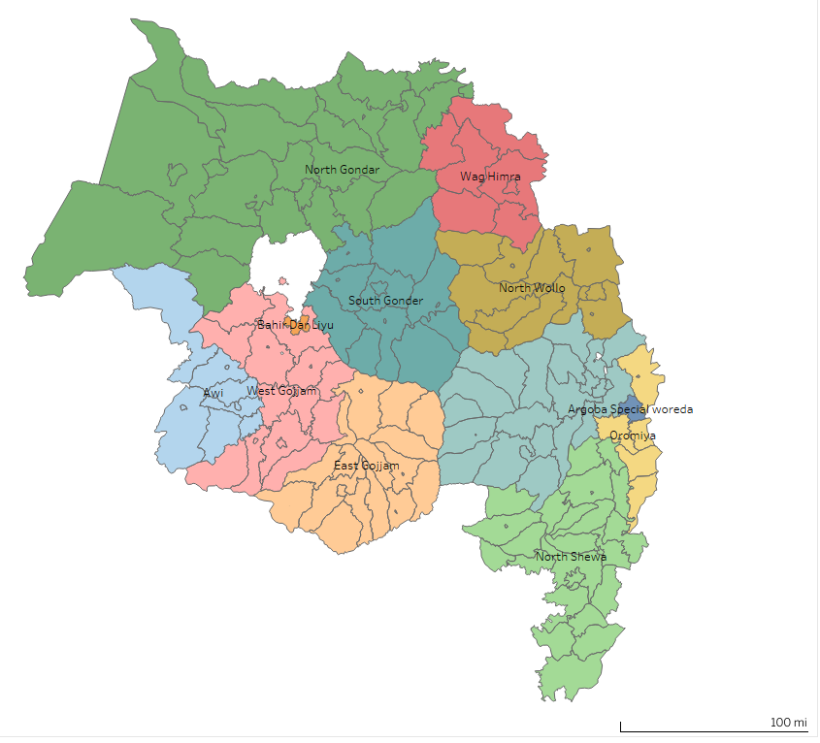
Figure 1: Map of Amhara Region by Zone to indicate study area, 2012 EFY.

Study Design and Period
We described the outbreak using descriptive epidemiology. We included all confirmed and suspected cases occurring during the course of the outbreak from Hamele 1 to Tikemt 2, 2012 EFY.

Data Source
Regional identified outbreaks registered by line list and laboratory based public health surveillance database. The data source was government and nongovernment health facilities registered cases by line list and report to the region.

Data Collection Procedure
We were developed check lists to extract the valuable data from regional immediately reportable diseases line list data base.

Data Quality Control, Processing and Analysis
Data were cleaned and analyzed using Microsoft Office Excel 2019 and Tableau. Results were presented using graph and table. Attack rate and case fatality rate also calculated.

Operational Definitions
- A suspected measles case is defined as: Any person with generalized maculo-papular rash and fever plus one of the following: cough or coryza (runny nose) or conjunctivitis (red eyes). Or Any person in whom a clinician suspects measles.
- Measles death: is defined as any death from an illness that occurs in a confirmed case of measles within one month of the onset of rash.
- Suspected Rabies: A person who is bitten by animal or human and developed headache, fever, malaise, apprehension, Hydrophobia, aerophobia and Paralysis or a person who died within 10 days after bite by animal.

Results

Measles Report
During the study period (Hamele 1 to Tikemt 2, 2012 EFY) a total of 148 suspected measles cases and two deaths line listed and reported in the region. A total of 97 measles cases sample taken for confirmation 28 measles cases IgM positive for measles. Suspected measles outbreak in this quarter reported by Oromia 63(43%), Wag Himra 49(33%) and Central Gondar 36(24%) Zones. A total of six woredas affected by suspected measles outbreak in this quarter. Woredas report suspected measles outbreak were Dehana 49(33%), Dewachefa 28(19%), Tach Armachiho 23(16%), Kemissie Town 18(12%), Artuma Fursi 17(11%) and Tegede 13(9%). The overall AR in this outbreak was 2.5/10,000 population. Among the total reported cases females account 78(52.7%) and from total reported cases 82(55.4%) were treated in outpatient department whereas 66(44.6%) cases treated as inpatient.
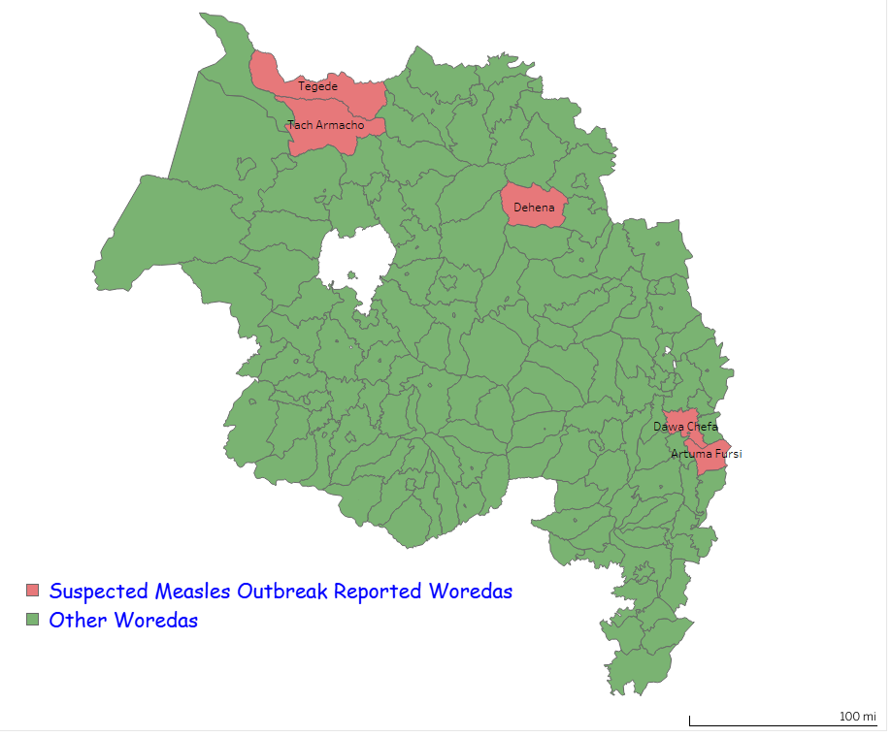
Figure 2: Map of Woredas occurred measles outbreak in first quarter of Amhara Region, Tikemt 2012 EFY.
Index case for suspected measles cases occurred by Ginbot 27, 2011 EFY and first case seen at health facility by Hamele 1, 2011 EFY. High number of cases seen at health facility by Hamele and Nehassie which report 52 and 72 cases respectively.
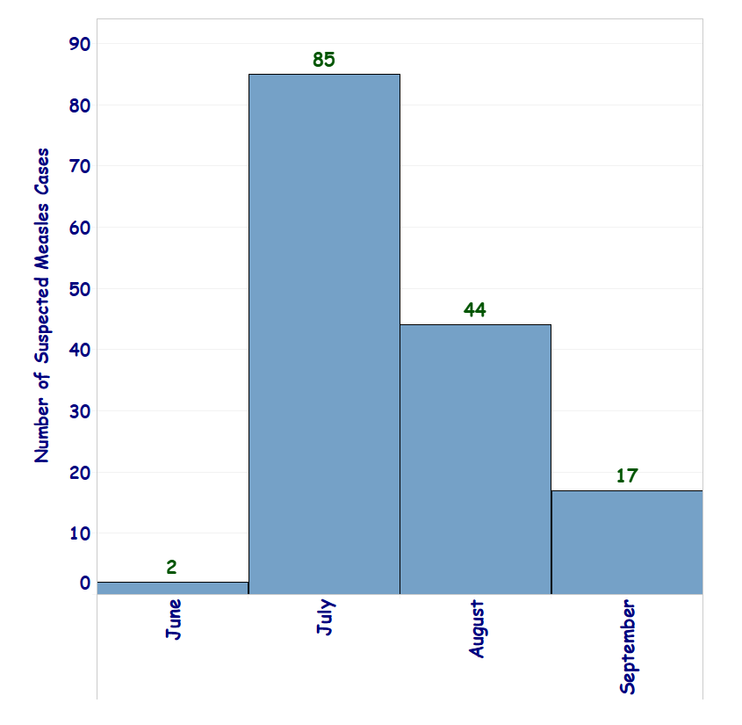
Figure 3: Number of Suspected measles cases by date of onset in Amhara Region, Tikemt 2012 EFY.

Highly affected age groups were < 5 years old age group which accounts 65(44%) and ≥ 15 years old age group accounts 48 (32%). All cases have no history of previous exposure to measles.

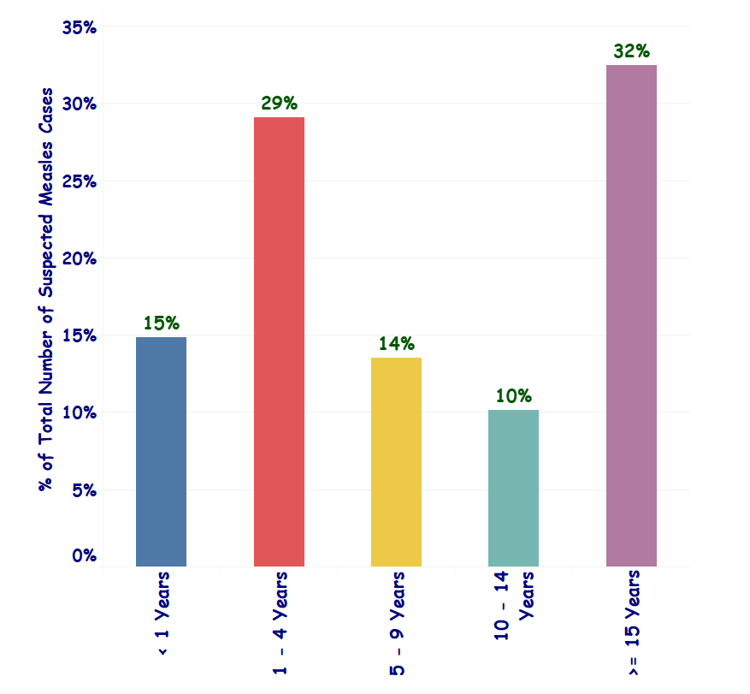
Figure 4: Number of Suspected Measles cases by age distribution of Amhara Region, Tikemt 2012 EFY.
High number of cases 77(52.0%) vaccination status were unknown and 51(34%) of Cases were vaccinated.
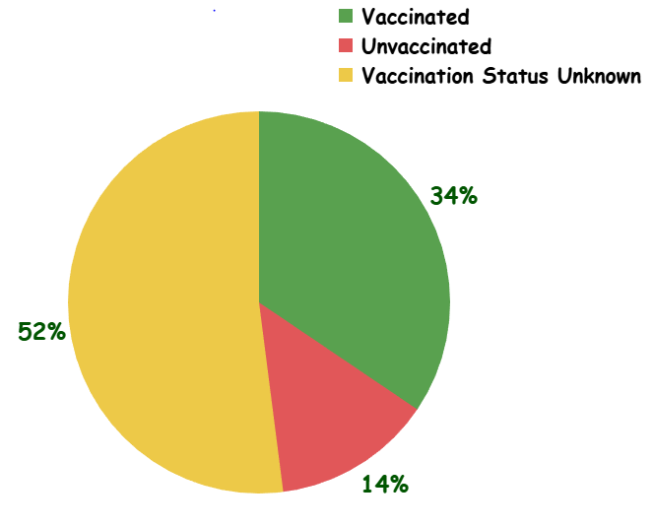

Figure 5: Suspected Measles cases by vaccination status of Amhara Region, Tikemt 2012 EFY.

Table 1: Six Years Measles Vaccination Coverage (MCV1) of affected woredas Amhara Region, Tikemt 2012 EFY.

Zone | Woredas | 2006 EC | 2007 EC | 2008 EC | 2009 EC | 2010 EC | 2011 EC | Six Years Average (%)
C/Gondar | Tach Armacho | 93% | 93% | 125% | 126% | 138% | 85% | 110%
C/Gondar | Tegede | 106% | 106% | 95% | 94% | 80% | 81% | 94%
Oromia | Artuma Fursi | 101% | 101% | 99% | 110% | 111% | 117% | 106%
Oromia | Dawa Chefa | 93% | 93% | 91% | 99% | 94% | 99% | 95%
Oromia | Kemissie Town | 126% | 126% | 141% | 147% | 137% | 177% | 142%
Wag Himera | Dehana | 81% | 81% | 94% | 104% | 98% | 93% | 92%

Pertussis Report
A total of 185 suspected pertussis cases were line listed and reported from Wag Himra and South Wollo Zones. Cases were reported from two woredas Dehana Woreda 131 (70.8%) and Sayint 54(29.2%). From total reported cases males account 97(52%). All of cases were get the treatment in the outpatient department (OPD).
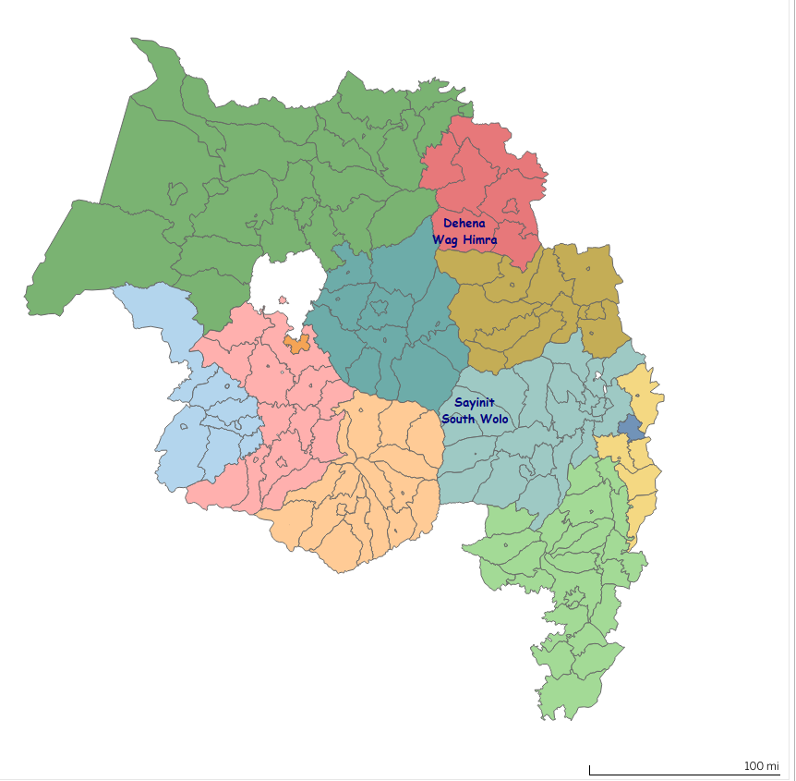
Figure 6: Map of Dehana and Sayint Woredas location in Amhara Region, Tikemt 2012 EFY.

Date of onset of cases on Miyazia 11, 2011 E.C. and first case seen at health facility on Hamlie 22, 2011 EFY.

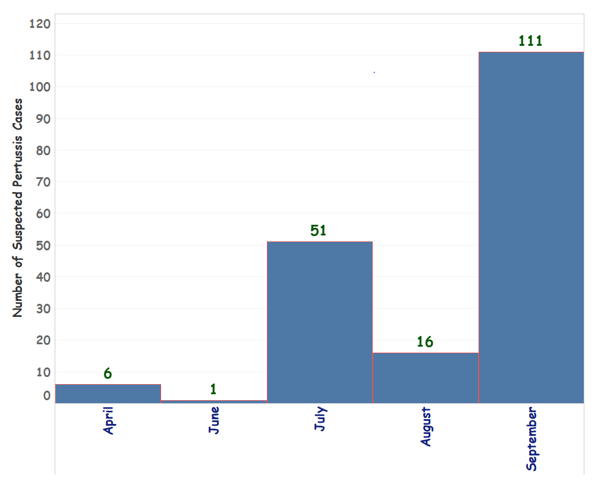
Figure 7: Number of Pertussis cases by date of onset in Amhara Region, Tikemt 2012 EFY.

Highly affected age group were 5-9 years account 60(32%) and 1-4 years account 56(30%). All cases were not had history of previously exposed.

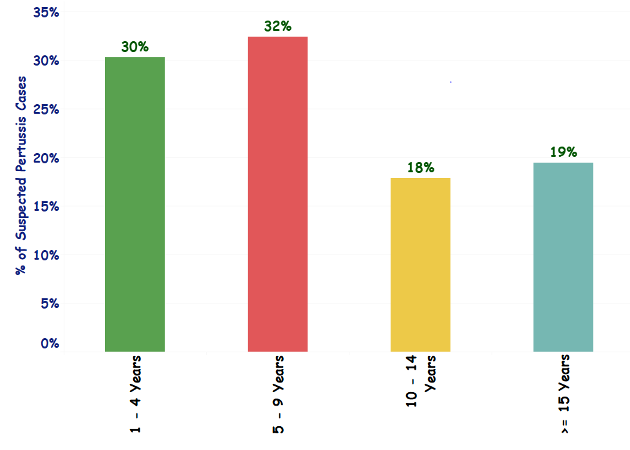
Figure 8: Number of Pertussis cases by age distribution Amhara Region, Tikemt 2012 EFY.

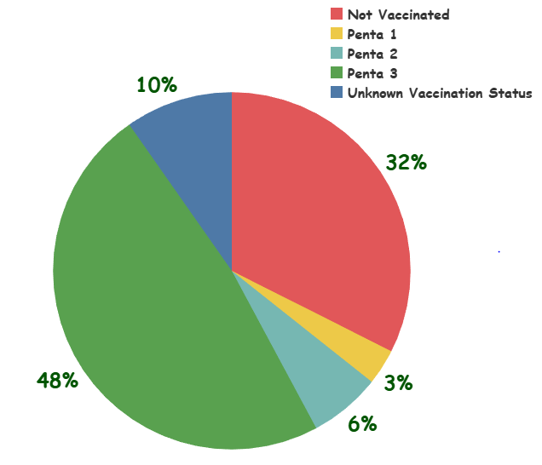

Figure 9: Number of Pertussis Cases By level of Vaccination status Amhara Region, Tikemt 2012 EFY.

Table 2: Six Years Penta three coverage of pertussis affected Woreda, Amhara Region, Meskerem 2012 E.C.

Years (EFY) | Dehana Penta 3 Coverage (%) | Sayint Penta 3 Coverage (%)
2006 | 87% | 98%
2007 | 87% | 98%
2008 | 93% | 107%
2009 | 100% | 92%
2010 | 108% | 82%
2011 | 101% | 71%
Average Coverage | 96% | 92%

All cases manifest sign and symptoms of Cough, Vomiting and Fever but didn’t seen diarrhea Sample from cases were not taken for confirmation. All cases treated by Erythromycin antibiotics. No death reported.

Rabies/ Dog Bite
A total of 112 suspected rabies cases were line listed and reported from Addis Alem Hospital Bahir Dar town. High number of cases came from West Gojjam Zone 45(40.2%), South Gondar Zone 33(29.5%) and Bahir Dar town 16(14.3%). Among total reported cases Bahir Dar town report only 15(13.4%) but the rest 97(86.6%) reported from other woredas. Total reported Male cases account 59(52.7%).
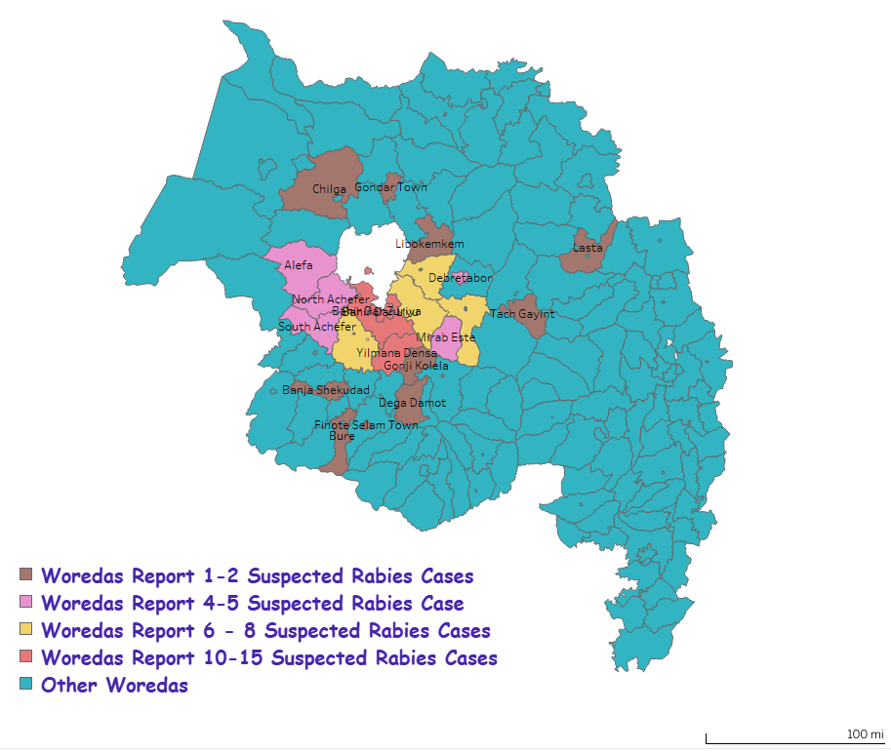
Figure 10: Suspected Rabies Cases distribution by Woredas From Addis Alem Hospital Bahir Dar Town, Amhara Region, Tikemt 2012 EFY.
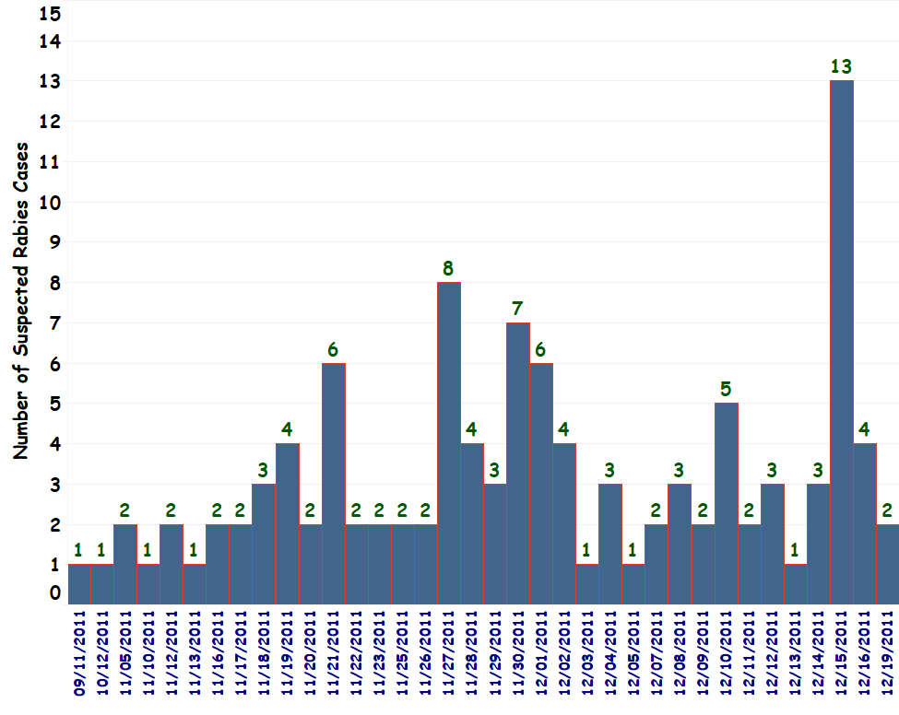
Figure 11: Suspected Rabies Cases by date of exposure Reported from Addis Alem Hospital Bahir Dar Town, Amhara Region, Tikemt 2012 EFY.
Most affected age group were < 15 years old which accounts 55(49.1%) from the total reported cases. From total reported cases students and farmers accounts 55(49.1%) and 29(25.9%) respectively. Number of Days for prophylaxis started after exposure average 10 days taken but Maximum 64 and minimum one day taken.

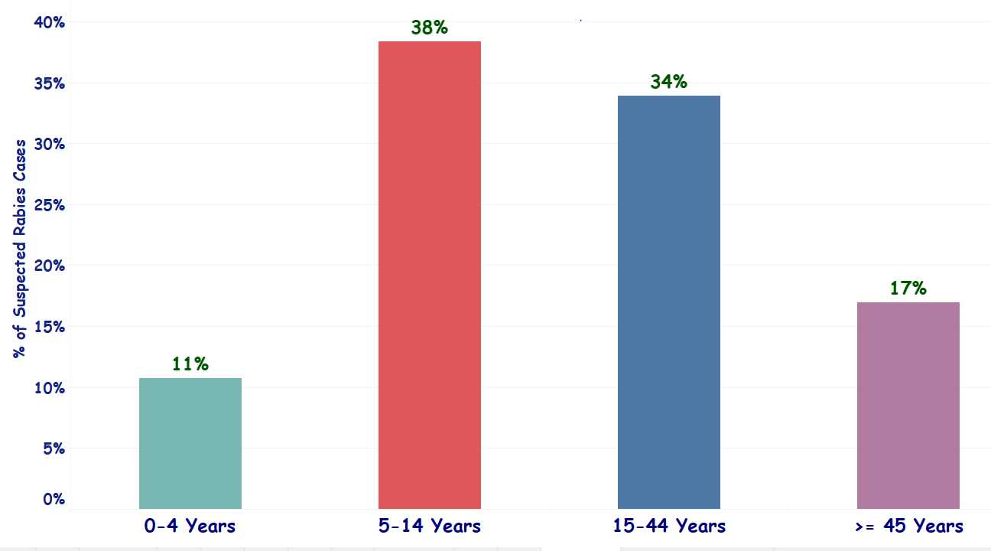
Figure 12: Number of Rabies suspected cases reported with age distribution Addis Alem Hospital Bahir Dar Town, Amhara Region, Tikemt 2012 EFY.
High number of cases came from different woredas to take rabies post exposure prophylaxis; high number of cases came from Bahir Dar town 15(13.9%), Bahir Dar Zuria 14(13.0%), Yilmana Densa 10(9.3%) and the rest from other woredas.

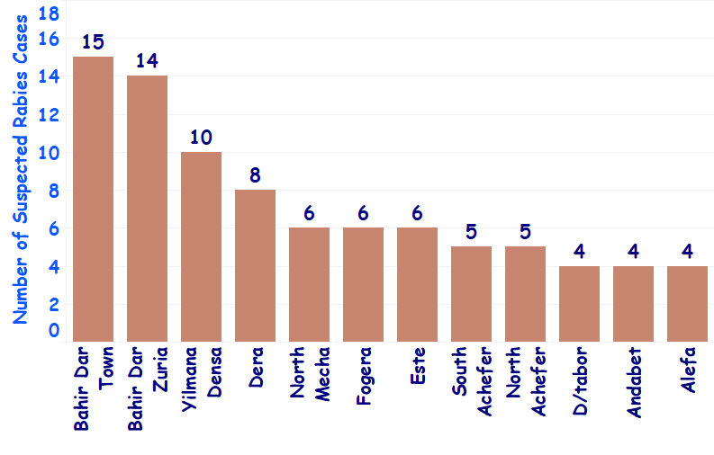
Figure 13: High Rabies Suspected Cases Reported Woredas from Addis Alem Hospital Bahir Dar Town, Amhara Region, Tikemt 2012 EFY.
Among total reported rabies suspected cases all cases didn’t vaccinated. All exposed cases the source of exposure was rabide suspected dog. Type of exposure to develop rabies suspected cases were by bite account 108 (96.4%) and contact with saliva 4 (3.6%). Based on site of exposure 74(66.1%) of cases exposed site were legs, Hand 24(21.7%), Buttock 6(5.4%), Leg & hand 3(2.7%), Hand and Buttock 2(1.8%), Face 2(1.8%) and leg & Buttock 1(0.9%). No death reported from PEP delivery site (Addis Alem Hospital).

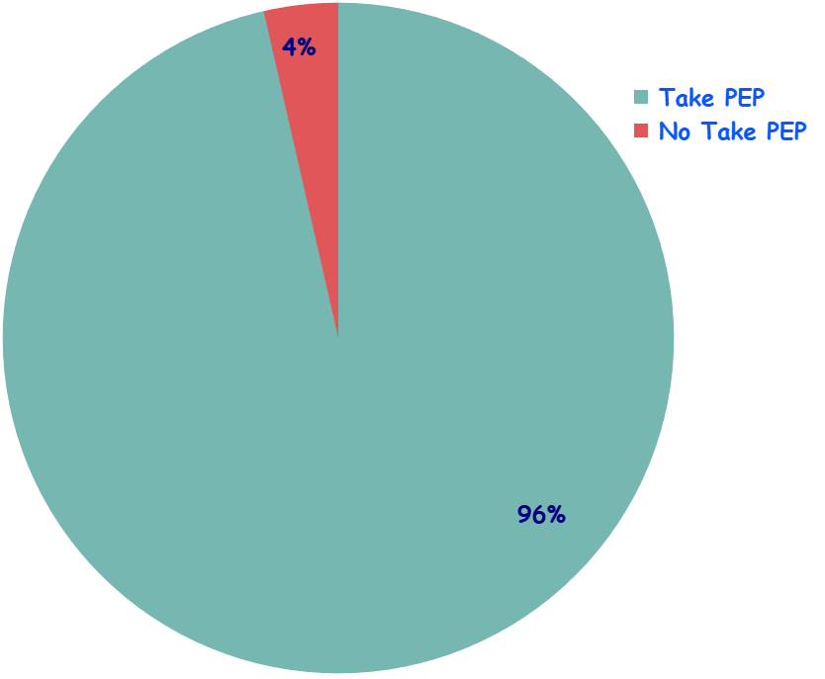
Figure 14: Cases Based on Post Exposure Prophylaxis Administration Reported from Addis Alem Hospital Bahir Dar Town, Amhara Region, Meskerem 2012 EFY.
Animal ownership status stray dogs 88 (78.6%) and 24(21.4%) of dogs had owner. Vaccination status of the dogs all were unvaccinated. Specimens were not taken from the dogs to confirm the disease.

Anthrax Situation
A total of 124 human anthrax cases were line listed and reported from Central Gondar Zone 80(64.5%) and Wag Himra Zone 44(35.5%). Cases were reported from three Woredas Mirab Belesa 80(64.5%), Abergelie 27(21.8%) and Sahala 17(13.7%). From total cases five deaths reported with 6.3% CFR from Mirab Belesa Woreda. Females account 70(56.5%) from total cases.

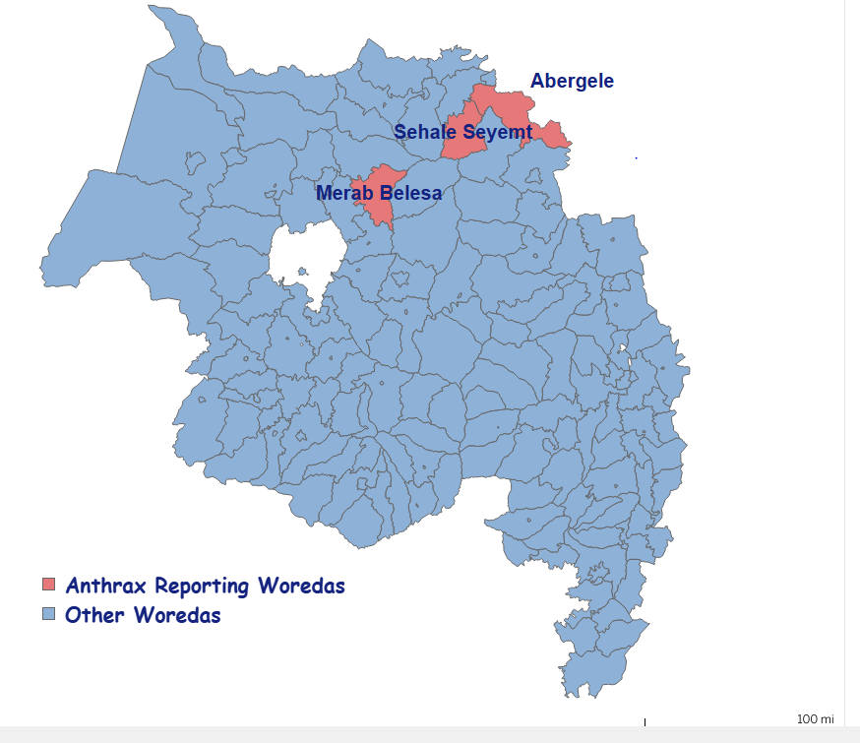
Figure 15: Map of location of Anthrax reporting Woredas Amhara Region, Tikemt 2012 EFY.

High number of cases occurred by date of exposure from Pagumie 6/2011 EC to Meskerem 3/ 2012 EC in Mirab Belesa Woreda.
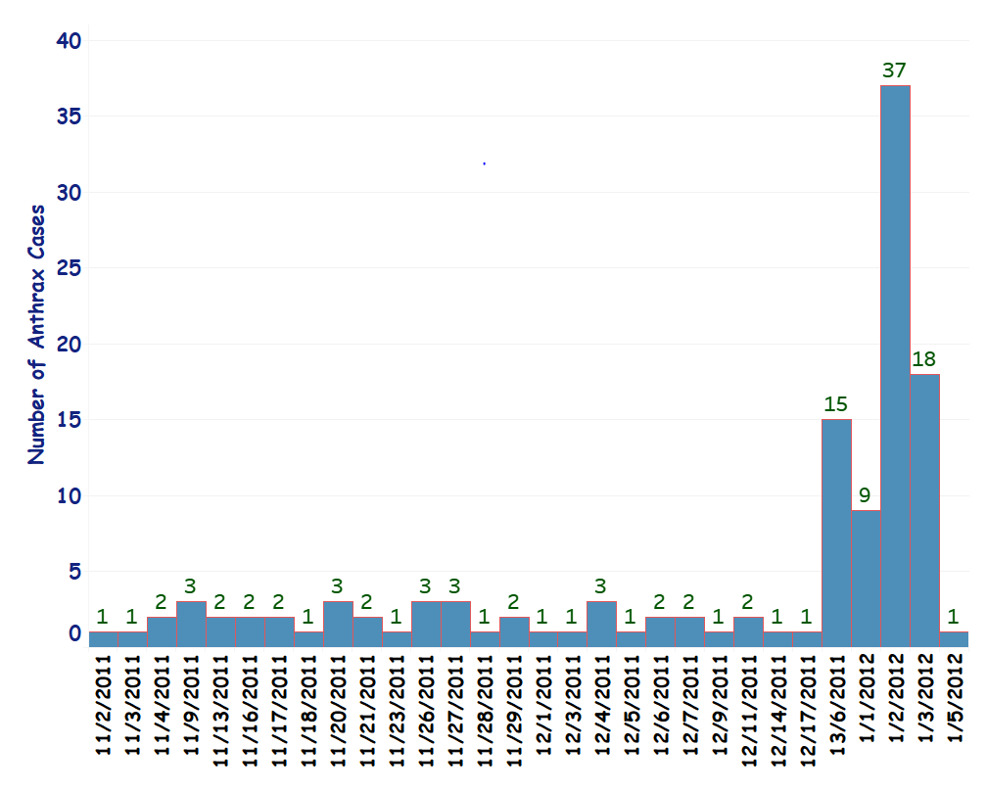
Figure 16: Number of Human Anthrax Cases by Date of Exposure Amhara Region, Tikemt 2012 EFY.

Highly affected age group were 15-44 years account 54(44 %) and 5-14 years account 37(30%). Cases distribution by occupation farmers 45(36.3%), Children 42(33.9%), students 27(21.8%) and House Wife 10(8.1%) were reported.
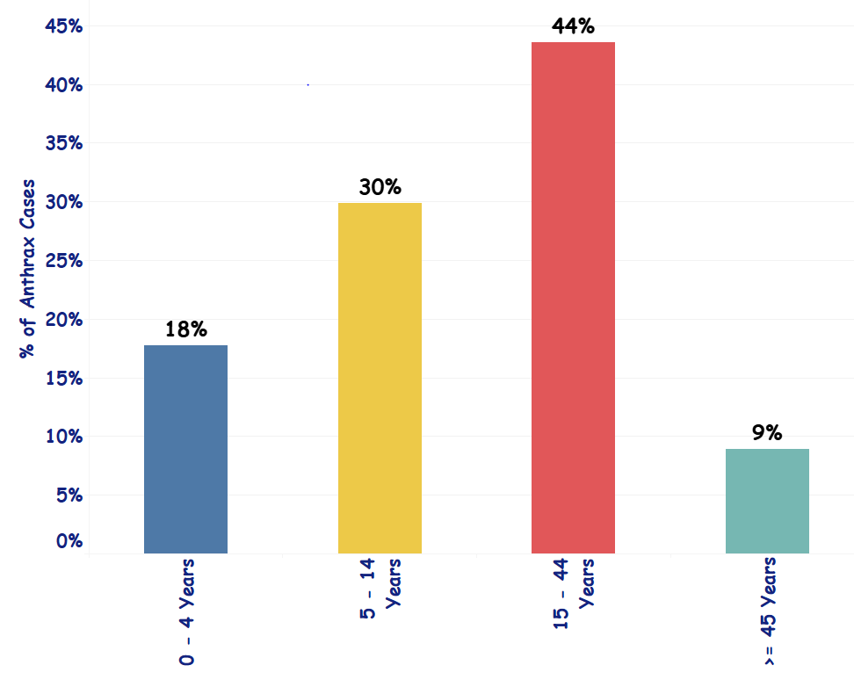
Figure 17: Number of Human Anthrax cases by age distribution Amhara Region, Tikemt 2012 EFY.
Majority of cases 80(64.5%) develop gastro intestinal type of anthrax and the rest 44 (35.5%) develop cutaneous type of anthrax. All cases exposed contact with animal product 108 (87%) and 16 (13%) cases have no contact. Vaccination status of the animal all not vaccinated. Laboratory specimen not taken from animals for confirmation.

Challenges
- Laboratory based surveillance was limited to confirm Pertussis, Anthrax and Rabies Cases.
- Poor data quality on registering of cases by line list.
- Delay of immediately reportable diseases reporting by line list.
- In some woredas not sending measles sample for laboratory confirmation
- Shortage of anti-rabies post exposure prophylaxis all over the region.
- Under reporting of cases by line list (Rabies, Anthrax and Pertussis)
- Vaccine shortage to do measles campaign.
- Lack of coordination between sectors on rabies and anthrax prevention and control.
- Poor coordination between PHEM and EPI department on responding vaccine preventable diseases at all level.
- Not used information for action by higher officials.
- Logistics shortage for responding VPD and zoonotic diseases response.

Conclusion
This summary report indicated that high number of measles cases vaccination status unknown. High number of measles cases occurred less than 5 years old. On this summary report also indicate late detection of measles cases by the woreda. Six years MCV1 coverage of the woreda shows high coverage.
This summary report indicated that high number of pertussis cases vaccinated by Penta three but they develop the disease. Also, high number of pertussis cases occurred < 10 years old. Six years Penta three vaccination coverage of the woreda shows high coverage. Late detection of pertussis cases and line listing. Sample not taken from pertussis cases for confirmation of the cases.
This summary report indicates that all exposed rabies cases the source of exposure was rabide dog bite. Most of rabies cases were came from different woredas to take PEP. The majority of dogs were stray dogs. Almost all dog’s vaccination status not known. Specimen from dogs were not taken to confirm the disease. Late reporting of rabies cases by line list.
This summary report indicates that all exposed anthrax cases the source of exposure was contact with animals. Vaccination status of the cow was not vaccinated. Specimen from the animal was not taken to confirm the disease. Late detection and reporting of anthrax cases.

Recommendations

- Woredas and Zones should early investigate measles/Pertussis outbreak.
- Woredas/Health Facilities should send measles specimen for laboratory confirmation.
- RHB should do measles/Penta 3 coverage survey in repeatedly measles outbreak occurring woredas.
- RHB should avail measles vaccine to conduct vaccination campaign.
- Woredas/Health Facilities should create community awareness on vaccination.
- Coordination should be formed and strengthen b/n PHEM and EPI departments at all level.
- Regional health bureau should to follow availability of anti-rabies post exposure prophylaxis in health facility.
- The livestock agency should to vaccinate dogs and manage dog population continuously.
- RHB & livestock agency should do community awareness on dog vaccination.
- Zones and Woredas should strength rabies cases surveillance system.
- EPHI should increase production of rabies PEP.
- ARHB should avail rabies PEP to nearby woredas for easy access of anti-rabies post exposure prophylaxis.
- Woreda/Zone should to create community awareness on human anthrax cases prevention and control.
- Regional livestock agency should schedule to vaccinate cows annually.
- RHB should to create political leader’s advocacy workshop on human anthrax prevention and control strategies.
- APHI_PHEM should to develop documents/Guidelines on human anthrax case management and surveillance.
- Health Facilities/Woredas/Zones should to report human anthrax cases immediately to APHI-PHEM.

References
- Analysis of five years Indicator Based Surveillance Data in Amhara Region, 2006 to 2010 Ethiopian Fiscal Year, Amhara Public Health Institute, February, 2019.
- EPHI guideline on measles surveillance and outbreak management. 3rd edition, 2012.
- WHO Vaccine Preventable Diseases Surveillance Standards, September 5, 2018.
- Ethiopian National Anthrax prevention and Control strategic plan, Joint Ministry of Health, Ministry of Livestock and Fisheries and Ethiopian Wildlife, July 2017.

