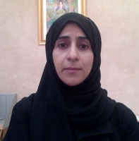
Title: Healthy Work Enviornmnt: Concept Analysis
Name: Asma Al Yahyaei, Debbie Carrick-Sen,Alistair Hewison

University of Birmingham, Birmingham, UK

Background: One of the most effective ways of retaining staff, and enabling healthcare organisations to redress the nursing workforce shortage, is to create a healthy work environment (HWE). This results in high levels of nurse productivity and positive patient outcomes. However, there is little consistency in existing definitions of a HWE in the nursing literature.
Aim: To examine how the concept of a HWE is used in the nursing literature and develop a more precise definition of the concept.
Method: A concept analysis was conducted using Walker and Avant’s model to clarify the main attributes, antecedents and consequences of a nursing HWE. The literature on HWE and its associated terms was obtained by searching the ProQuest, PubMed, CINAHL, Business Source Premier (EBSCO), and PsycINFO and IBSS databases. Papers written in English published between 1990 and 2017 were retrieved. However, some seminal work prior to 1990 was also retrieved during searching for relevant references. Cases and empirical referents were constructed to clarify the concept and support the analysis.
Result: the main attributes of a nursing HWE were identified as: effective leadership, effective teamwork, empowered nurses, adequate staffing, and availability of development opportunities including training and promotion.
Implications for nursing management: The findings of this concept analysis emphasise the importance of creating a HWE for nursing and patient care. The contribution of this paper is the development of a precise definition of the concept in order to advance research. In addition, it identifies the areas healthcare organisations need to address to improve nurse well-being and organisational outcomes.
Conclusion: The concept of a healthy work environment is complex and has important implications for practice and research. This concept analysis contributes to the understanding of HWE by producing a more precise definition which can inform research in this area and identifying strategies to improve the working environment and thus patient care.
Keywords: nurses; healthy work environment; concept analysis; leadership; teamwork; staffing; patient care.

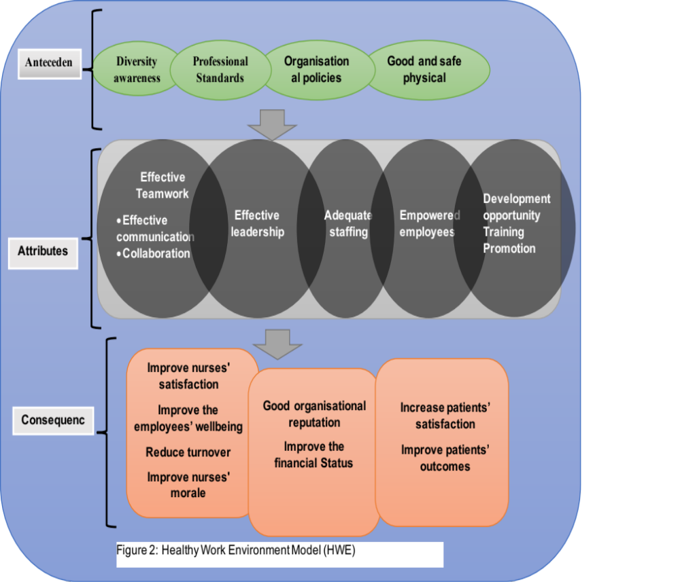

Biography

Asma Al Yahyaei is currently working as Lecturer at Sultan Qaboos University in Sultanate of Oman. She has completed her bachelor’s degree in nursing science from Sultan Qaboos University and master’s degree in nursing and healthcare administration from California State University, Long Beach, USA. She is currently PhD student at University of Birmingham, UK.

Presenting author details
Full name: Asma Al Yahyaei
Contact number: +96897676457
Twitter account:Asma15486
Linked In account:
Session name/ number:
Category: (Oral presentation/ Poster presentation)
Passport Number: ZG6187779

