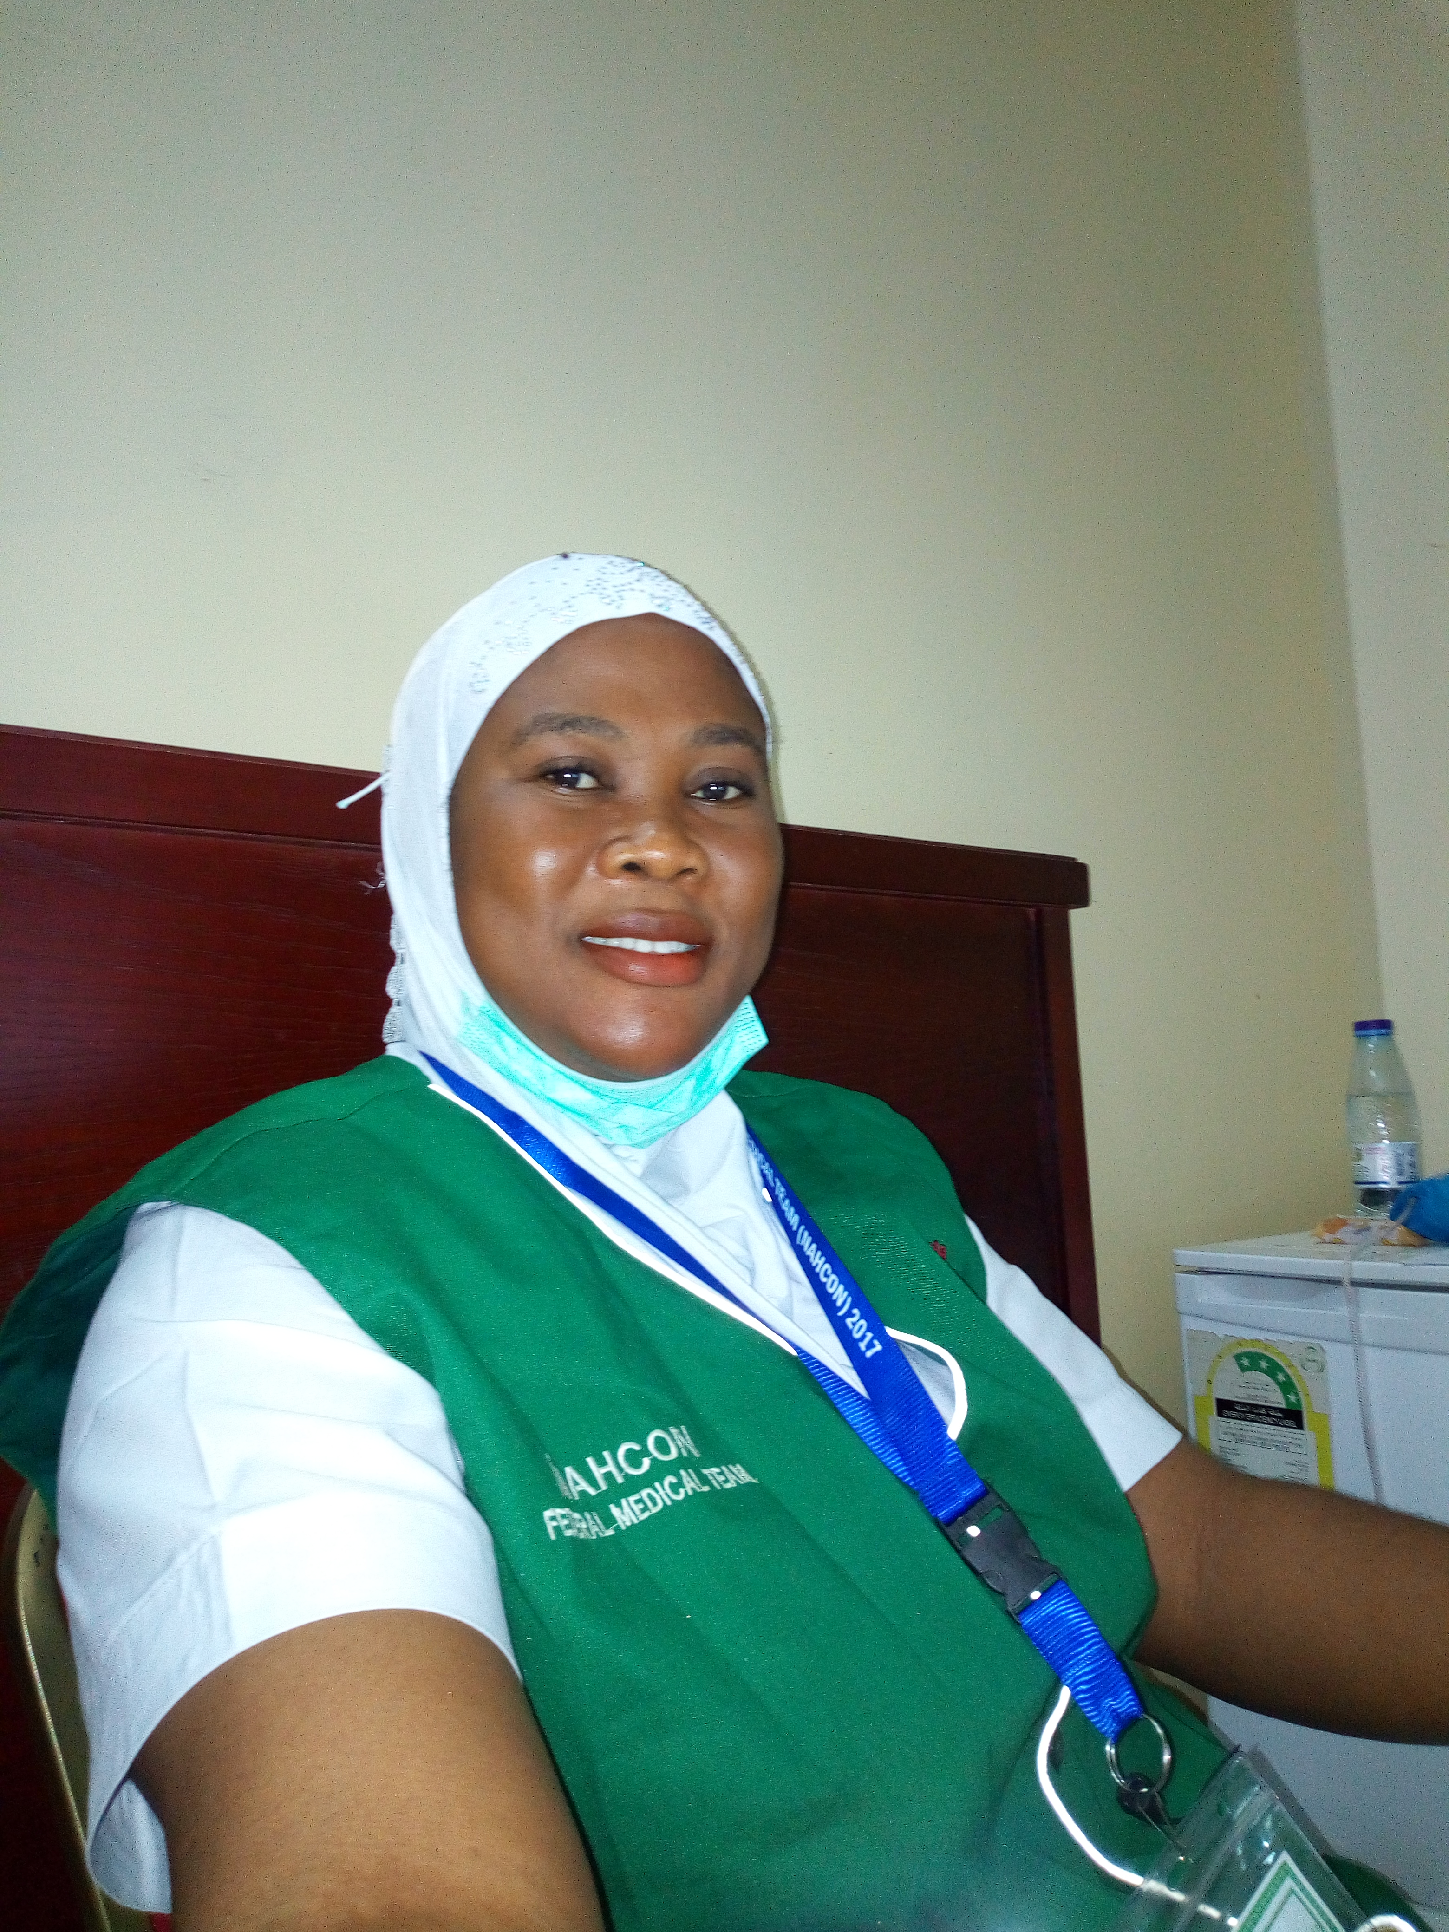
Title: Factors influencing utilization of antenatal care services in Jahi PHC, Jahi district Abuja, Nigeria.
Name: Bawa-Muhammad Hassanat
Brighter Maternal and Child Health Foundation, Abuja, Nigeria
Antenatal care is strategy for reducing maternal and neonatal morbidity and mortality rate. ANC utilization is still low in Nigeria. The underutilization varies from region to region. The objective of the study was to review the factors that influence the utilization of antenatal care services in Jahi 1 phc in AMAC. The study was literature based and an extensive search was carried out to find relevant studies. Data was collected using quantitative methodology. Descriptive statistics was used to analyse the data generated. The tool used for the collection was questionnaire. Data was collected from ANC clients and postnatal mothers in the facility. The study observed that socio-demographic factors like female literacy, socio economic status, age of women, cultural beliefs, knowledge of pregnant women about ANC, access to ANC influenced the utilization of ANC. Characteristics of mothers in the area of study affect the decision to utilize ANC. The study recommended that there is need to train health providers on service delivery, respectful maternity care and community sensitization on the values of ANC. Government should enact a law that would permit women to seek for their own health, more efforts should be given to educate women and empower them, reduction on hospital/ clinic charges, equipping and stocking of enough drugs.
Biography:
Bawa-Muhammad Hassanat is a registered nurse with Nigeria NMCN, with over 12 years experience working in the community. She received her BNSc from National Open University of Nigeria. She is the founder of Brighter Maternal and Child Health Foundation, an NGI, currently a student midwife at UDUTH, Sokoto, Nigeria. She is the vice chairman of Federations of Local Government Nurses and Midwife, AMAC, FCT Nigeria. She was the nurse in charge of maternity ward, PMTCT/HCT and the DOTs in Jahi Phc, from 2012 July till September 2017. Her current research study is factors influencing under-utilization of maternal postnatal care in UDUTH, Sokoto.
Name Bawa-Muhammad Taiwo Hassanat.
Contact number: +2348035233507
taiwo bawa-muhammad
Oral presentation

