Title: Mental health and religious extremism - International Health System perspectives

Jean-Claude Javet, MD M.Sc., University Psychiatric Services (UPD), Bern (Switzerland)
Abstract: (300 word limit)
What can mental health as an integral part of the international health system contribute to prevent terrorist attacks that are motivated by violent religious extremism? Mechanisms of the international health system provide various political tools to address cross-border and domestic public health challenges. But are the mechanisms in place powerful enough to address the current threat of fundamentalist terrorism? The mental health dimension of violent religious extremism is not yet represented sufficiently on the global health agenda while the burden of mental health related problems is gaining more and more attention, political weight and funding. Traditional if not strict secularism in policy making by the World Health Organization (WHO) and many of its member states does not help efforts to increase collaboration and to promote stronger leadership among the most powerful religious groups in addressing mental health as an important component of counterterrorism. The willingness of WHO, other UN agencies and member states to include participation of religious groups in public mental health based counterterrorism efforts is key. At the same time, mental health should be more prominent among the proposed strategies of the UN Counterterrorism Committee (UNCTC). This would pave the way for mental health approaches to become more influential in informing ongoing initiatives of the UNCTC, including public-private partnerships with social media- and internet companies.

Biography: (150 word limit):
Jean-Claude Javet holds a doctorate in Neurology from Zurich University and a M.Sc. in health system management from Montreal University. Dr. Javet was stationed in Kenya and Afghanistan prior to joining the United Nations Population Fund (UNFPA) where he served in different management positions. Dr. Javet has shown an increasing interest in private-public partnerships and served as Executive Director of the International Association of Infant Food Manufacturers (IFM) in relations with the World Health Organization, UN agencies and NGO’s. Mr. Javet is Managing Partner at Swiss Health Invest (SHI), an International Health consulting firm offering a platform for strategic partnerships in global health. On the clinical side Dr. Javet is serving at the department of forensic psychiatry of Berne University Clinic where he focuses on the mental health challenges in the penitentiary context both of regular and migrant inmates.

Photo:
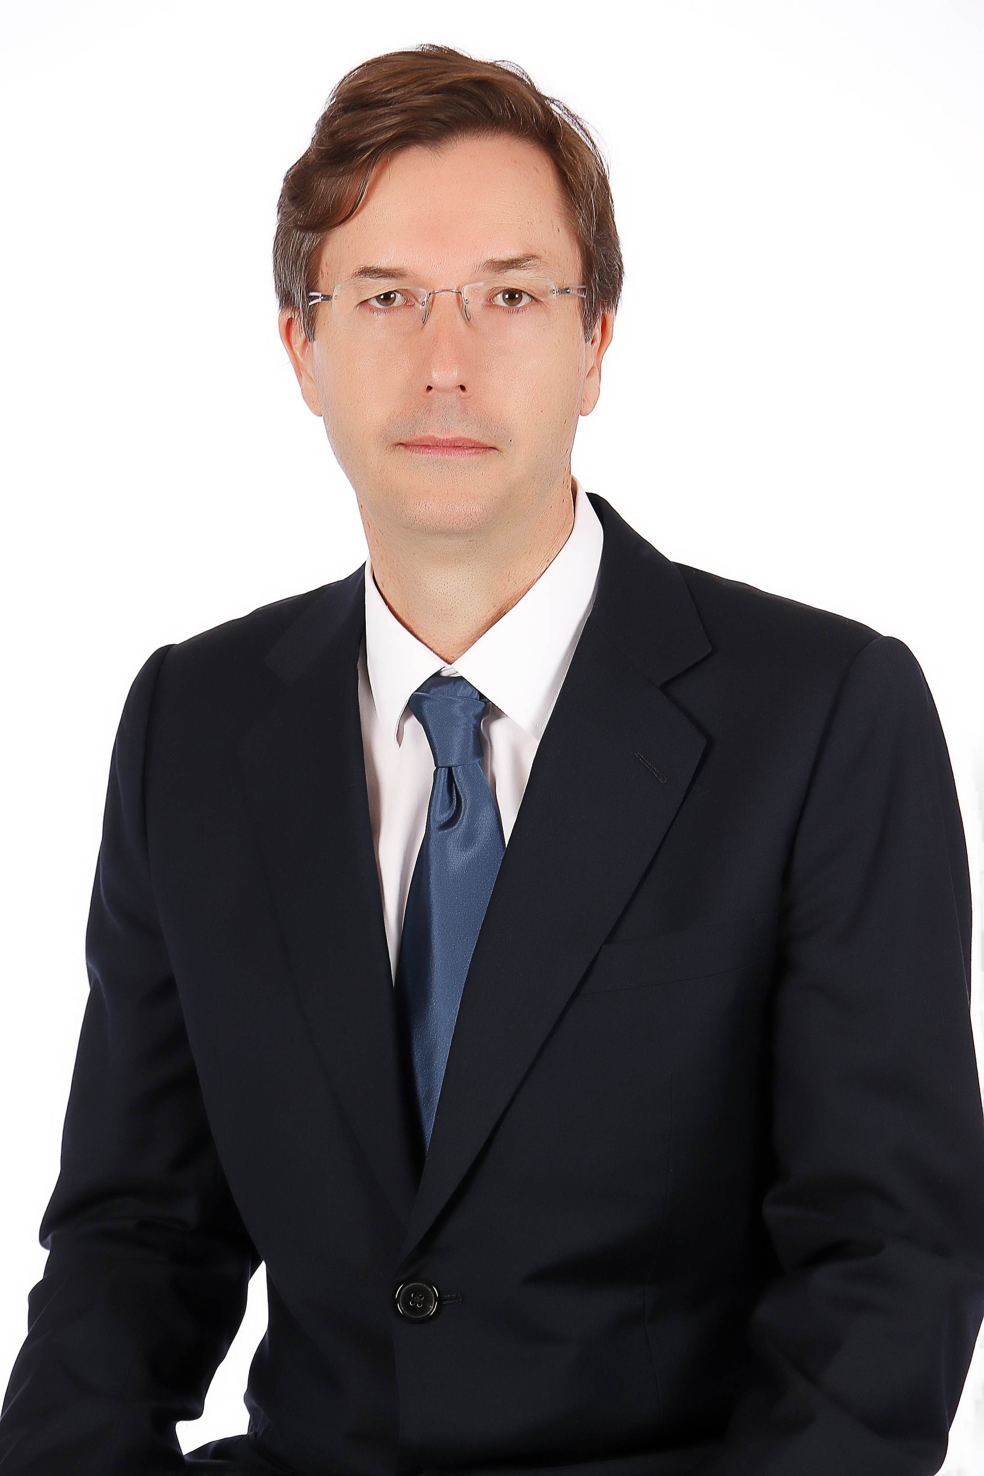
Speaker Mobile Number: +41227761262
Facebook URL to Contact:
Linked In URL to Contact:
Email Id: jean-claude.javet@upd.ch

