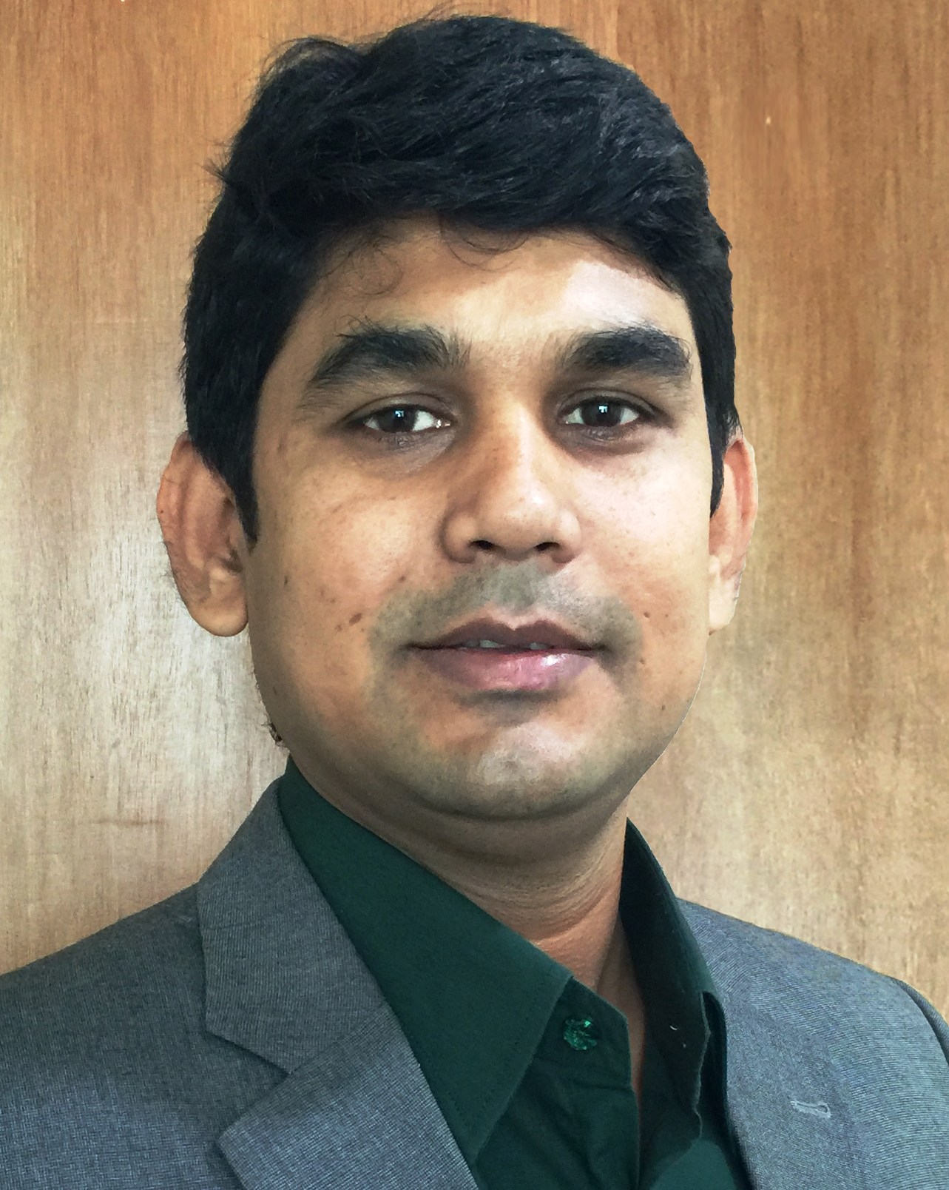

Abstract
Child Labor in Bidi Factories: Current Situation and Way Forward

Sushanta Kumar Singha
Senior Reporter, Jamuna Television
Dhaka, Bangladesh

Bidi is one of the major tobacco products consumed in Bangladesh. There are 280 thousand workers in 117 Bidi factories and a significant proportion of these workers are children. It is important to explore the child labor situation in Bidi factories to highlight the need for regulating this harmful sector not only as a priority area for tobacco control but also to ensure that children are protected from hazardous child labor in light of the prevailing laws.
The study was conducted in four region of Bangladesh with highest concentration of Bidi factories. A total of 160 child labour (aged 7-14 years) and 160 parents of those child interviewed by household semi structured survey questionnaire. In addition, 28 in-depth interviews were conducted among experienced workers, factory managements and doctors
Survey findings revealed that about half of the respondents’ child was working in the factories for 2-4 years. 4 out of 10 children worked over six hours a day and 8 out of 10 child worked over three hours a day. A quarter of the working children had dropped out of school. None of the children were found to have used protective gears like masks or gloves during work. As a result, more than 8 out of 10 child workers feel sick during their work in Bidi factories. More than 60 percent were getting less than 50 Taka ($ 0.75 cents) daily.

Biography:
Currently, working as senior Reporter of Jamuna Television, I produce some investigative TV stories and articles in different newspaper on Tobacco Control and Public health related issues in seven years career. As a founder member of Anti-Tobacco Media Alliance-ATMA, I was co-researcher of the country based first report on Bidi industry titled, “Bidi in Bangladesh: Myths and Reality” in association with Campaign for Tobacco-Free Kids in 2012. I attended week long workshop on ‘Bangladesh Tobacco Control Leadership’ in 2013 by BCCP and Johns Hopkins Bloomberg Scholl of Public Health.

Presenting Author details:
Full name: Sushanta Kumar Singha
Contact Number: +8801712657540
Email: sinhasmp@yahoo.com
Linked in Account: bd.linkedin.com/in/sushanta-sinha-a10a8378

Category: Oral Presentation

