Nonagon Leadership grid

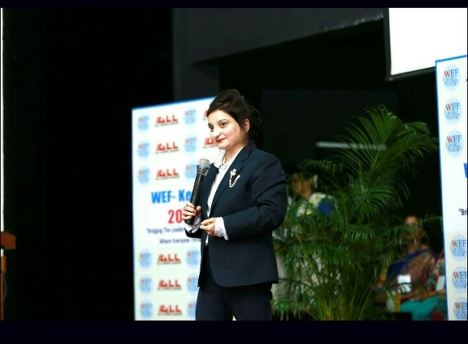
Nonagon Leadership Grid
Timing |  | Empathy
 | Decision Making |  | Passion
Contingency Intelligence |  | Locus of self control |  | Positivity
 | Positional Intelligence |  | Interpersonal  Communication skills

Leadership is a strong word by its pronunciation and its essence of existence in every heart and mind that encourages to transform at each step of life.
Every human is a born leader,but few make it to the strength of its word as among all the humans few realize their true strengths to lead themselves and others to the journey of excellence with the true guidance of vision and perseverance to their strength to rise each day to create a better version of themselves.
Leadership is not about a good leader or a bad leader its about understanding the functioning of the system of heart and mind aligned to take a decision of excellence with love, care and kindness with firm perseverance to positive outcomes..
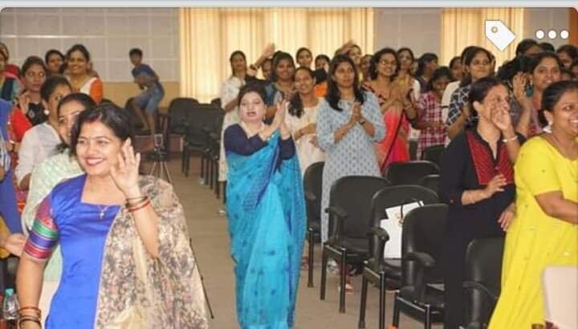

1-Timing:-
When I say timing ,It has nothing to do with the clock,its all about your timing of the right words that you choose during discussions with your friends and colleagues.

Its your right timing of nonverbal communication in the situations when you meet the person for the first time in formal and non formal meetings ,do not wait for the other person to greet first or shake hands, always initiate to greet and start a great conversation with a smile to bring the other person in the comfort zone of interaction. At events, meet and greet personally as it shows your love, kindness and sincerity .

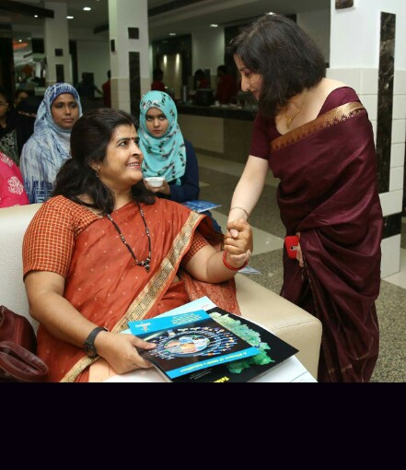

2-CONTINGENCY INTELLIGENCES: A leader must have the situational intelligence to deal with any situation coming their way in surprise wrapped with complexities and as a leader, we must analyse the situation as a third person observing it closely at every end and by considering the situation in the viewpoint of the parties at both end and the situational outcome of your decision. Take a decision by keeping view the following factors in emergency that your decision has to help the organization from getting into loss , keeping in view that emotional casualties can be well handled to recover hearts to maintain the trust of togetherness and stay calm at contingency situation by analyzing as the person watching it as an observer by keeping yourself out of the situational contingency for sometime and that will bring out the decision of justice,kindness and excellence by analyzing it at the factors completely with sincerety and calmness.

3-Positional Intelligences : A leader must possess the intelligences of appointing people at the right time and identifying their expertise areas and positioning them to their expertise area to raise the organization with excellence and utilizing their expertise in the most effective way that must be aligned to the objectives of the organization and its vision .Positional intelligence is the most important factor for organizational growth and development.

4-Decision Making : Decision making is the most important element of organizational efficiency and once its handled with right attitude considering the variables attached and bringing out stable strategies to witness the positive and efficient outcome.

5-Empathy : Heart and Mind are two major elements that act as the backbone of our decisions, actions, reactions and judgement .When your heart encourages kindness and love towards everyone,then comes the major end of the threats that can hurt the team spirit of love and togetherness .
6-Locus of self control:- when we interact in the organization, there are internal and external variables that affect the functioning of organization and people and to have control over these variables ,we need to have the major control over the variables within our heart and mind once we settle and align our thoughts in the right direction ,we control all the conditions ,reactions and judgement internally and externally. To understand it better I believe to eradicate air ,water and land pollution ,first we need to eradicate the most important pollution that results in all kinds of pollution, which is Mind pollution ,once we eradicate the pollution in our thoughts then we eradicate all the problems resulting in through different ways. Everything around you and within you comes into control with your thoughts,actions and beliefs of understanding each others point of view, accepting the fact of freedom of expression of thoughts and suggestions by team , control over the reactions to different situations with appropriate verbal and nonverbal reactions to situations .

7- Interpersonal skills
The efficiency of communication is directly linked with your thought process that is being guided by your heart,when we align our thoughts to words ,our communication improves in an efficient way internally and externally .verbal and non verbal communication ,both play an important role to connect and build relationships as it’s the way we interact with people that represents our heart and mind to the other person ,make your communication as pleasant as possible with logic,care,love ,kindness and trust.
Non verbal communication includes your body language and especially your eyes that give a trust to another person's heart that you care and love the person with utmost sincerity and wants the best for him.

8- Positivity
Positivity is not just confined about thinking good all the time ,its basically about understanding situations at both ends of the people ,once we start understanding the reaction and judgement of other person in regard with his situations,experiences and his personal problems ,our attitude towards everything happening with and around that person changes amazingly ,once we start analyzing the situation as a third person consideroing each aspect of situation we understand every problem in an appropriate way which results into immediate solutions of each problem occurring and brings an end to negative understanding and reactions .the organization flourish with positivity .

9-Passion.
To excel in any department of life, first we need to love that particular thing, thought and vision intensely to give your best ,when you start loving what you want to do in life then you start rising with excellence and this defines your passion . Main ingredients of Passion are sincerity,honesty,love and dedication.

