The Mental Health Matters of Christians Leaders in Jamaica

February 3, 2020
Paul Andrew Bourne
Northern Caribbean University, Jamaica

ABSTRACT: Major depressive disorder is a medical condition that influences peoples’ mood, behaviour and decision-making skills. Despite knowledge on this medical condition, for centuries, religious leaders have suffered from this disorder; yet a dearth of empirical information is available on the matter. A comprehensive review of the literature unearths not a single study that has examined the psychological state of religious leaders in Jamaica. Objective: This study seeks to: 1) evaluate the mental health status among religious leaders in Central Jamaica, and 2) examine the state of fatigue and emotional well-being among religious leaders in Central Jamaica, and whether these differ based on self-reported major depression, Methods and materials: A correlational research design was used for this research, with a sample of 206 religious-leaders in Central Jamaica. A standardized questionnaire was developed to evaluate the various research objectives. Results: Three and four-tenth per cent of the sampled respondents indicated that they suffer from major depression. On the other hand, general fatigue was high among the sampled respondents (50.1±11.3, 95%CI: 48.5-51.7, from a maximum value of 85.0). It was found that only emotional well-being and age emerged as factors of general fatigue among religious leaders in Central Jamaica (F[2,173]=12.847, P < 0.0001) that accounted for 11.9 per cent of the variance of general fatigue (Adjusted squared R). Conclusion: With a part of this phenomenon being irritability, sadness, and lack of interest, untreated religious leaders who suffer from this condition pose a problem to effective leadership and themselves.

- Introduction

Major depressive disorder is a medical condition that influences peoples’ mood, behaviour and decision-making skills. For centuries, religious leaders have suffered from this disorder. Sowder (2018) wrote an article captioned “Church leaders reaffirms need for mental-health crisis training after a New York Police Department (NYPD) officer was acquitted in the killing of Episcoplian” pastor for wheeling a machete in the streets and this brings to the forefront that even religious leaders may be suffering in silence from ill-health.
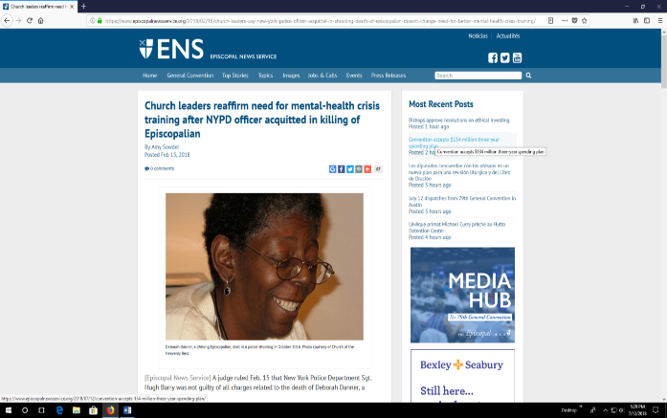

Figure 1: Murder of mentally ill religious leader in New York

Jim Howard, pastor of Real Life Church in California, shot himself in the head on Wednesday, January 23, 2019 after battling mental illness for some time (Blair, 2019). Despite knowledge on this medical condition for centuries, religious leaders have suffered from this disorder; yet a dearth of empirical information is available on the matter. A comprehensive review of the literature unearths not a single study that has examined the psychological state of religious leaders in Jamaica.
Objectives
Evaluate the mental health status among religious leaders in Central Jamaica,

Examine the state of fatigue and emotional well-being among religious leaders in Central Jamaica, and whether these differ based on self-reported major depression.

Theoretical framework

Huang, et al. (2017) developed pathway personality model that provides some answer to the question, ‘Does personality affect health-related quality of life?’ By way of a meta-analysis of some 5,312 related researches, Huang and colleagues were able to conclude that personality characteristics affect one’s health-related quality of life (HRQoL).
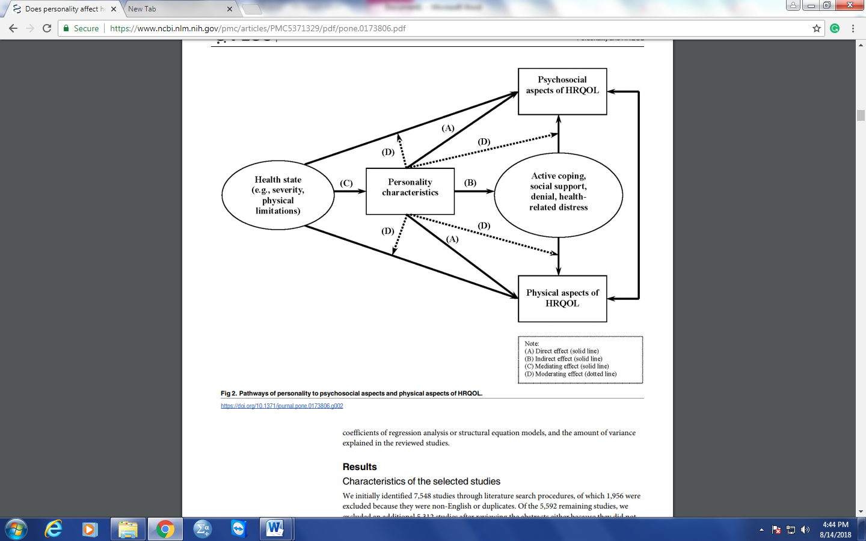
Figure 2: Huang, et al. (2017) developed pathway personality model

- Methods and materials
A correlational research design was used for this research, with a sample of 206 religious-leaders in Central Jamaica. A standardized questionnaire was developed to evaluate the various research objectives.

The population for this research was leaders who serve in the certain religious denomination in Central Jamaica. Initially, the researchers chose a simple random probability sample of the number of pastors, associate pastors, and first elders in the various Churches in Central Jamaica. A sample size was calculated based on the number of pastors, associate pastors and first elders in Central Jamaica and this was found to be less than 90 leaders, which would be smaller than the stipulated recommended number of people by different scholars (Hsieh,1989; Long, 1997; Bujang, Sa'at, Sidik, & Joo, 2018).
The researcher changed the sample design to one of total population-selection. Hence the researcher expanded the sample unit to all board members who serve in the churches in Central Jamaica. This decision was taken as it provided more leaders than initially sought, and this makes it generalizable to the population of leaders in the churches in Central Jamaica. As such, all leaders serving in the churches in Central Jamaica were given a copy of the instrument.
A standardized questionnaire was developed to evaluate the various research objectives. This was administered between August and September 2019. The general instrument comprised of two major established questionnaires (The Multifactor Leadership Questionnaire (MLQ 5X ) and Self-reported health status (SF-36)), which were designed by Bass and Avolio (1989, 1995, 1997, 2000) and RAND Corporation respectively.
To accommodate the analysis of the large volume of data, Statistical Packages for the Social Sciences (SPSS) for Windows Version 25.0 (SPSS Inc; Chicago, IL, USA) was used. Data were analyzed by way of descriptive statistics, percentage and frequency distributions (include percentages and frequency counts), and multivariate analysis.
Descriptive statistics allowed the researcher to meaningfully describe the many pieces of data collected that provide for background information on the study (Gay, Mills, & Airasian, 2009).
Statistical significance was determined a p-value less than or equal to five percentage points (≤ 0.05)– two-tailed test. Bivariate analysis was conducted by way of 1) Independent sample t-test and 2) cross-tabulation. Furthermore, Ordinary Least Square (OLS) regression was used to model factors that influence general fatigue among religious leaders in Central Jamaica.

- Findings

Table 1 presents the socio-demographic characteristics of the sampled respondents. The majority of respondents were females (61%), married (66.1%), and had at least one noncommunicable condition (56.7%).
Table 1:
Demographic characteristics of sampled respondents, n=206
Details | N (%)
Leadership entity
Church | 206
Gender
Male | 76 (39.4)
Female | 117 (60.6)
Marital Status
None/Single | 38 (20.1)
Married | 125 (66.1)
Common-Law | 6 (3.2)
Widowed | 6 (3.2)
Divorced | 11 (5.8)
Separated | 1 (0.5)
Visiting | 2 (1.1)
Non-communicable diseases
No | 88 (43.3)
Yes | 115 (56.7)
Healthcare seeking behaviour
No | 44 (22.2)
Yes | 154 (77.8)
Religiosity | 4 times (range = 15 days)
Age | 49.6 years±16.6 years, 95%CI: 47.1-52.1 years

Objective One:
An examination of the prevalence of mental health conditions among religious leaders in Central Jamaica

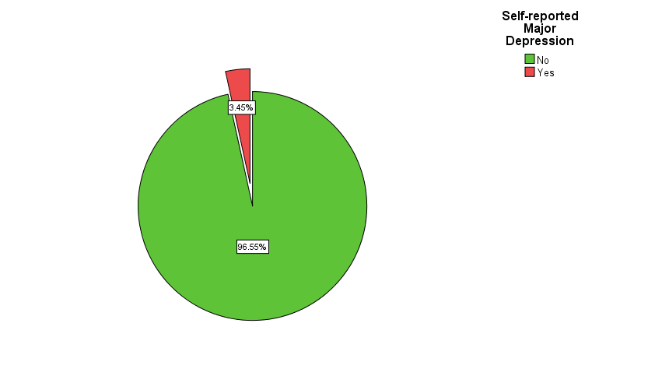
Figure 1: Self-reported diagnosed with major depression

Objective Two:
An evaluation of the relationship between healthcare-seeking behaviour and self-reported mental health conditions among religious leaders in Central Jamaica
Table 2 presents a cross-tabulation between healthcare-seeking behaviour and self-reported mental health conditions of religious leaders in Jamaica. Fifty-seven and one-tenth per cent of those who indicated that they have major depression sought medical and other curative care compared to 78.5 per cent, which is not statistically associated (χ2(df=1)=1.788, P = 0.181).

Table 2:
Cross-tabulation between healthcare-seeking behaviour and self-reported mental health condition (major depression), n=198
Details | Major Depression
Healthcare seeking behaviour | No | Yes
No | 21.5 | 42.9
Yes | 78.5 | 57.1
Total | 191 | 7

Objective Three
More female than male-religious leaders suffer from a major depressive disorder
More female than male-religious leaders suffered from a major depressive disorder
A cross tabulation between major depression and gender of religious leaders in Central Jamaica revealed no significant statistical association ((χ2(df=1)=0.355, P = 0.551)-Table 3. However, 4.3 per cent of the female-religious leaders in Central Jamaica reported suffering from major depression compared to 2.6 per cent of their male counterparts.

Table 3:
Cross-tabulation between healthcare-seeking behaviour and self-reported mental health condition (major depression), n=198
Details | Gender
Major depression | Male | Female
No | 97.4 | 95.7
Yes | 2.6 | 4.3
Total | 76 | 117

Objective Four
An examination of the state of fatigue and emotional well-being among religious leaders in Central Jamaica, and whether these differ based on self-reported major depression
Table 4 presents the descriptive statistics on emotional well-being and fatigue among religious leaders in Central Jamaica. The emotional well-being of the sampled respondents was a moderate one (40.0±10.4, 95%CI: 38.5-41.4, from a maximum value of 80.0). On the other hand, general fatigue was high among the sampled respondents (50.1±11.3, 95%CI: 48.5-51.7, from a maximum value of 85.0).

Table 4:
Descriptive statistics of emotional well-being and fatigue among religious leaders in Central Jamaica n=192
Details | Mean (SD), 95% CI
Emotional Well-being | 40.0 (10.4), 38.5-41.4
Fatigue | 50.1 (11.3), 48.5-51.7

Using OLS regression model, the researcher examines:
F = ƒ(E, A, G, M, N)…………………………..[1]
Where F is fatigue, E being emotional well-being, A represents Age, G is gender, M is self-reported depression, and N symbolizes self-reported non-communicable diseases.
It was found that only emotional well-being and age emerged as factors of general fatigue among religious leaders in Central Jamaica (F[2,173]=12.847, P < 0.0001) that accounted for 11.9 per cent of the variance of general fatigue (Adjusted squared R), and the account presented in Equations [2]-[3]:
Emotional well-being account for more of the variance in general fatigue of the religious sampled respondents in Central Jamaica (Adjusted squared R of 7.7 per cent) followed by age of the respondents (Adjusted squared R of 4.2 per cent). It should also be noted that a direct statistical relationship existed between emotional well-being and fatigue, which is the opposite of age and fatigue.

- Conclusion
major depressive disorder is a mental health condition that affects the individual's mood and behaviour as well as decision-making choices. With a part of this phenomenon being irritability, sadness, and lack of interest, religious leaders who suffer from this condition pose a problem to effective leadership. The Jamaican churches have a responsibility to identify symptoms of the major depressive disorder to address the matter before it leads to suicide and other destructive acts as the case of Rev Danner and Pastor Jim Howard.

- References
Huang, I-C., Lee, J.L., Ketheeswaran, P., Jones, C.M., Revicki, D.A., & Wu, A.W. (2017). Does personality affect health-related quality of life? A systematic review. PLoS ONE, 12(3): e0173806.
Diener, E. (1984). Subjective well-being. Psychological Bulletin, 95(3), 542-75.
Diener, E. (2000). Subjective well-being: The science of happiness and a proposal for a national index. American Psychological Association, 55,34-43.

