Tile: The implications of psychopathic moral deficit for therapy: towards a theoretical model
Sarah, J.H. Coldwell M.Sc. & David A.L. Coldwell D.Litt et Phil, FCIPD.
Statement of the problem: Measures taken to address psychopathy may have been ineffective because the individual psychopath’s degree of ‘moral deficit’ is not accounted for in the application of therapy. Purpose of the study: The paper develops a theoretical model of ‘moral deficit’ that is aligned with the appropriateness of therapy ranging from the extreme ‘classical approach’ of total confinement to the modern therapy that aims to reintegrate the psychopath with society with ‘moralizing therapy’. Methodology: Analysis of secondary data from extant literature is used to develop the theoretical model of ‘moral deficit’. Findings: Secondary data analysis suggests that the extent of psychopathic ‘moral deficit’ is an important factor in the selection of appropriate therapeutic measures for psychopathy treatment. Conclusion & Significance: Degrees of psychopathic moral deficit have an important bearing on the appropriateness of therapeutic treatment. Recommendations: It is recommended that therapeutic treatment of psychopathy makes greater provision for the extent of psychopathic ‘moral deficit’ in assessing the most appropriate applications.

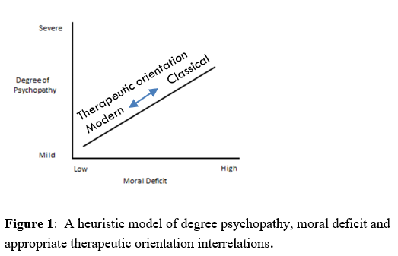

- Aaltola, E. (2013) Affective empathy as core moral agency: psychopathy, autism and reason revisited. Philosophical Explorations. [Online] 17 (1), 76-92.
- Aharoni, E. et al. (2012) Can psychopathic offenders discern moral wrongs? A new look at the moral/conventional distinction. Journal of Abnormal Psychology. [Online] 121 (2), 484-497.
- Edens, J.F., Petrila, J., & Kelley, S.E. (2018). Legal and ethical issues in the assessment and treatment of psychopathy. In C. Patrick (Ed.). Handbook of Psychopathy (2nd ed.). New York. Guilford.
- Glenn, A. et al. (2008) The neural correlates of moral decision-making in psychopathy. Molecular Psychiatry. [Online] 14 (1), 5-6.
- Gordon, H. et al. (2004) Functional differences among those high and low on a trait measure of psychopathy. Biological Psychiatry. [Online] 56 (7), 516-521.
- Gutting, G. (2005). Foucault: A very short introduction. Oxford: Oxford University Press Harper C (2009) The neuropathology of alcohol-related braindamage. Alcohol Alcohol 44:136-140.

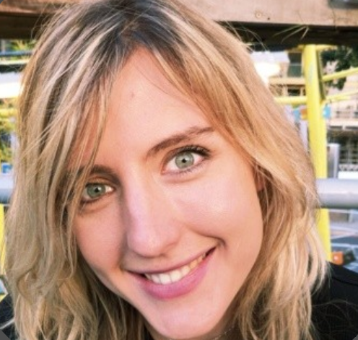
Sarah Coldwell, M.Sc., graduated from the Institute of Psychiatry, Psychology & Neuroscience and The Dickson Poon School of Law Kings College, London and currently works as a Mental Health adviser and trainer for the Electrical Industries Charity in London, England. David Coldwell D.Litt et Phil, FCIPD, is a Professor in Management at the University of the Witwatersrand in Johannesburg. He is interested in employee behavior, mental health and organizational entropy and has recently published in Entropy and the Journal of Environmental and Public Health
Email: scoldwell90@gmail.com; david.coldwell@wits.ac.za
- Full Name: Sarah Coldwell
- Personal Email: scoldwell90@gmail.com
- Mobile Number: +44 (0)7780528257
- Linked In: https://uk.linkedin.com/in/sarah-coldwell-385b186b
- Facebook:
- Session Name/ number: Mental Disorder
- Category: Oral presentation
- Date of Birth: 24/09/1990
- Postal Address: 38 Milton Road, London, United Kingdom, SW19 8SE

Notes or Comments:

