Virtual Reality for developing Social Skills in Autistic populations: A Review and Case Study
Nigel Newbutt, PhD, University of the West of England, UK

Abstract (300 word limit)
This talk will provide a brief review of where and how virtual reality technologies (VRTs) have been used within research-contexts to support people on the autism spectrum. Autism Spectrum Disorder (ASD) is typically characterised as differing in degree and severity, and by core deficits with regard to two primary domains: (1) social interaction and communication and (2) repetitive and/or stereotypic behavior (American Psychiatric Association, 2013). One area of innovation and research that has evolved since the mid-1990s, to aid people with an ASD, is that of the use of virtual reality technology (VRT). Research has focused on helping develop personal, social, functional, and pre-vocational/vocational skills (Kandalaft et al., 2013; Mitchell et al., 2007; Newbutt, 2013; Parsons et al., 2004; 2005; Smith et al., 2014, 2015). This talk will distil some of the key affordances, issues and challenges identified so far in this evolving area of research. The talk will focus on the potentially useful application of VRTs to train and support people with an ASD in developing life-skills (i.e., social skills, job skills, independent living skills) and where there has been successful implementation in applied contexts. The talk will then describe a recent project that sought to ask questions surrounding the role of head-mounted displays and the impact these might have for this population. The talk will report, in a rich, descriptive and illustrative manner, the process of working with a range of participants with ASD (here range refers to low-high functioning ASD with a wide range of IQ) to assess and measure the acceptability of, and experiences within, HMD VRTs (immersion, presence, ecological validity, and any negative effects). Finally, I will conclude by discussing how HMDs and VRTs might be used in the future to help enable ASD populations overcome some of the challenges faced on a daily basis.

Image
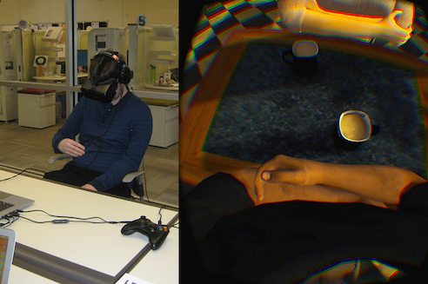
Recent publications (minimum 5)
- Newbutt, N, Sung, C, Kuo, H-J, Leahy, M. J. (2016). The potential of wearable technology (head-mounted displays) and virtual reality to support people with autism: acceptance, challenges, and future applications. In: Recent Advances in Technologies of Inclusive Well-Being: Wearables, Virtual Interactive Spaces (VIS)/Virtual Reality, Emotional Robots, Authoring tools, and Games. Eds. Brooks, A., Brahnam, S. & Jain, L. Springer.
- Newbutt, N and Nevin, C (in press). Investigating the Effectiveness of Paper-Based and Computer-Presented Social Stories for Children with Autism Spectrum Conditions in an Autism-Specific Special School. Virtual Reality Technologies For Health And Clinical Applications. Vol. 3: Games For Rehabilitation. Eds. Petersson Brooks, E & Brown, D.
- Newbutt, N, Sung, C, Kuo, H-J, Leahy, M. J, Lin, C-C and Tong, B. (2016). ‘Brief Review: The use of a virtual reality headset in autism populations, a pilot study of technology acceptance and immersion’. Journal of Autism and Developmental Disorders. 46 (9): 3166–3176 DOI: 10.1007/s10803-016-2830-5
- Parsons, S. Newbutt, N & Wallace, S. (2014). Technology Tools for Students with Autism: Innovations that Enhance Independence and Learning. Chapter 4: Virtual Spaces and Classroom Learning Using Virtual Reality Technology to Support the Learning of Children on the Autism Spectrum. Ch4. Pp. 63-84. Brookes Publishing. USA.
- Newbutt, N. (2014) ‘The Development of Virtual Reality Technologies for People on the Autism Spectrum’. In Innovative Technologies to Benefit Children on the Autism Spectrum, Ed. Silton, N. R, pp. 230-52. (IGI Publishers)

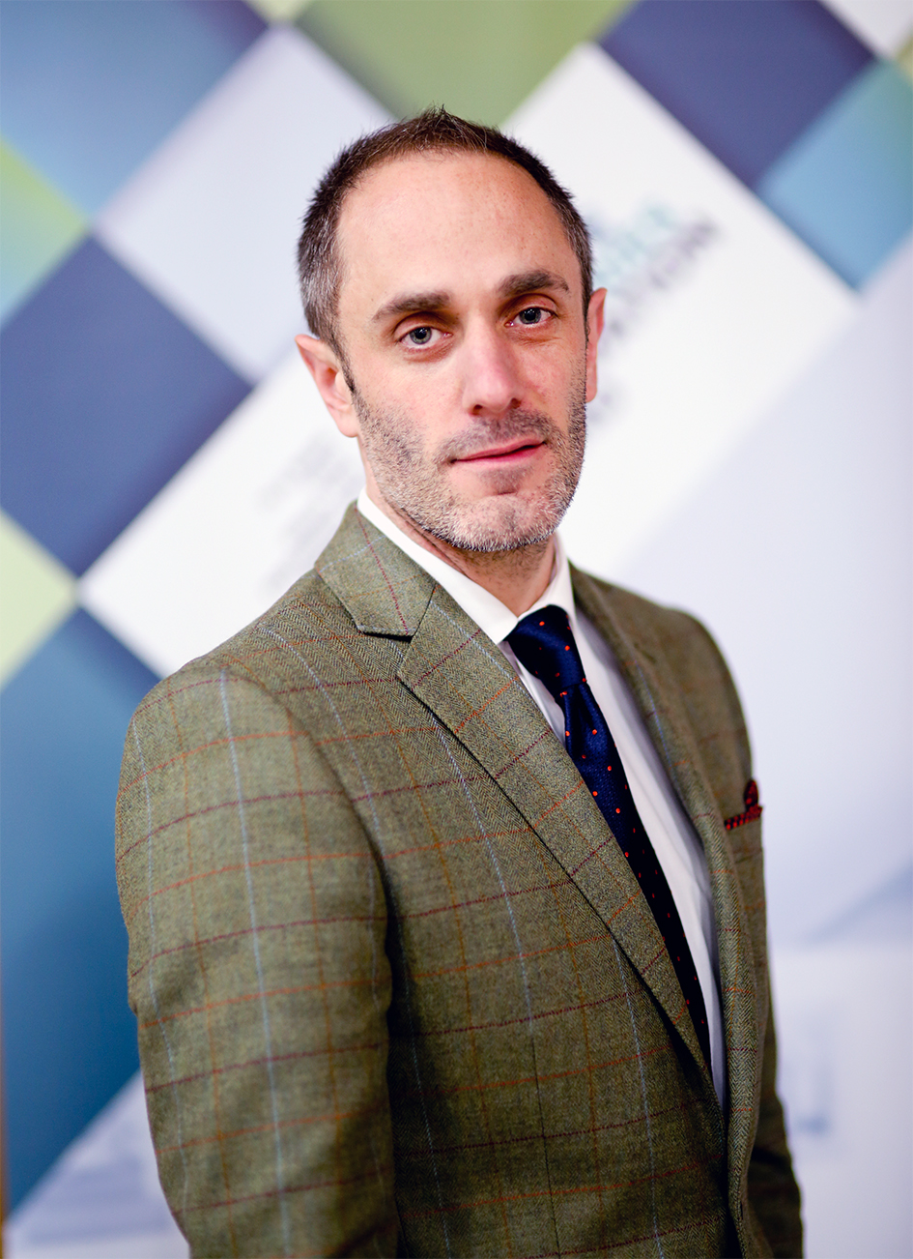
Biography (150 word limit)
Dr Nigel Newbutt’s work covers areas of computer-mediated communication, internet-based communication and virtual environments. It draws upon theories related to non-verbal communication (Hall, 1966) and the more recent work of Yee, Schroeder and Axelsson. I have developed virtual worlds and worked with autistic groups to help enable computer-mediated communication (CMC) opportunities. In addition, I have led research projects on virtual reality and head-mounted displays at Michigan State University working in a inter-disciplinary context.
Email: Nigel.Newbutt@uwe.ac.uk

Notes/Comments:

