“EFFECT OF TRANSCRANIAL DIRECT CURRENT STIMULATION ON RELAPSE OF ALCOHOL DEPENDENCE SYNDROME AND ASSOCIATED CHANGES IN FUNCTIONAL BRAIN IMAGING”

Biswal J¹, Chand PK¹, Murthy P¹, Venkatsubramanian G¹, Benegal V¹, Bharath RD².
1 Department of Psychiatry, National institute of mental health and Neurosciences (NIMHANS), Bangalore, India.
2 Department of Neuro-radiology, National institute of mental health and Neurosciences (NIMHANS), Bangalore, India.

ABSTRACT
OBJECTIVE: Neuromodulatory interventions like transcranial direct current stimulation (tDCS) is a emerging and potential therapeutic strategy to help in reducing craving and relapse prevention in patients of alcohol dependence syndrome. This study was designed to explore the effect of tDCS treatment on relapse prevention and its correlation to dorsolateral prefrontal cortex (DLPFC) activation in alcohol dependent patients.
METHODS: Twenty-four patients of alcohol dependence syndrome were recruited following approval of NIMAHNS ethics committee (22nd MEETING/2015 DATED 19/05/2015). After detoxification underwent baseline fMRI and MRS scans. Followed by tDCS with intensity of 2mA and duration of 20 minutes per day was administered for 5 consecutive days with cathode over left dorsolateral prefrontal cortex (DLPFC) and anode over right DLPFC. On the 5th day post fMRI and MRS scan were repeated. Both investigator and subjects remained blind through out the study period. During scans patients were exposed to visual alcohol cues using VICE (visual image-Induced craving for ethanol) paradigm. Pre-treatment and post-treatment scans were analyzed using SPM-12 software.
RESULTS: 1. Direct correlation between DLPFC activation and prevention of relapse in alcohol dependent subjects treated with tDCS. 2. Significant difference in relapse to alcohol, found between the groups (80% sham-tDCS vs. 33.3% in true tDCS) during one-month follow up period.
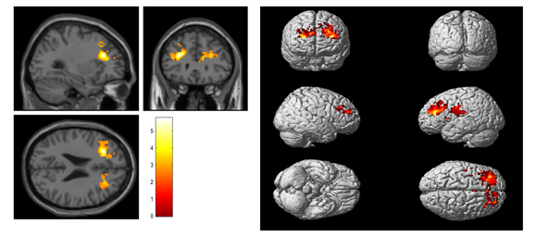
Effects of True tDCS (Post-Pre) showed significant activation in bilateral DLPFC (left>right) displayed at P < 0.005.
CONCLUSION: This fMRI study results suggests that tDCS is safe and potentially beneficial in combating relapse prevention in patients with alcohol dependence syndrome and provides a framework for further studies with larger sample size to investigate the same.
Declaration of No conflict of interest: This Study Was funded by – Center of Addiction Medicine, NIMHANS, Bangalore, INDIA.
There is no conflict of interest respect to the above study.

Biography: Dr. Jitendriya Biswal has completed his MD psychiatry at age of 32 years, currently a post doctoral fellowship student at NIMHANS, banagalore. He has one publication in addiction pharmacology.

Presenting Author:
DR JITENDRIYA BISWAL
9482345687
MAIL ID- DRJBISWAL@GMAIL.COM
ORAL/POSTER PRESENTAION

