AL-GHAZALI MODEL HELPED STUDENTS WITH GENDER IDENTITY CONFUSION AT EARLY ADOLESCENCE STAGE : A CASE STUDY
Mohammad Hazim, MEd., BEd. Teach. Foundation,
Aishah, Certif. Counselor , BEd. Counseling

Abstract
The disparity of gender identity paraphilia and social dysfunction is divided into four sections namely transexualism, transvertism, child gender identity confusion and atypical gender identity disorder. In this study emphasis is given to gender identity confusion. Although issues related to gender identity confusion among children is a taboo issue but there are still less studies conducted by researchers to help groups of students who facing this problem especially at primary level. The confusion of the gender identity among children occurs when they are uncomfortable with the gender they own and want to be the opposite sex (opposite). The objective of this study is to assist the standard 6 (12 year old) student who is facing the issue of gender identity confusion by using the model of al-Ghazali model of Islamic counseling. This study is a case study and use a qualitative study design. A total of three (3) subjects of study consisting of standard 6 (12 years old) student were taken from a primary school in Kuala Lumpur. Three (3) male students that involved as subjects of this study were selected based on the characteristics of gender identity confusion characterized by behavior and interest of inclination. The intervention in this study used the spiritual approach (Islam) applied through the "al-Ghazali model" in the individual counseling sessions. The results of the study show that the "al-Ghazali model" intervention that have been applied in this case study had successfully helped the participants to understand himself better and know the preventive measures that can be taken to encounter this problem through spiritual approach (islam).

Figure 1
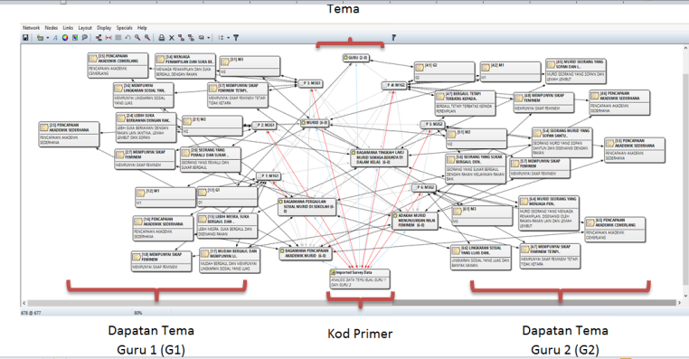
Figure 1 : relationship between the participant characteristic and the result of interview from the teacher using atlas.Ti.
Recent Publications (minimum 5)
- Aishah, Hazim, Nik and Shaheda (2017) . al-Ghazali approach in children counseling. Kedah : Hazzy Classic Enterprise
- Emma, (2005). Girls , boys and junior sexuality : exploring childrens gender and sexual relation in primary school. New york : Taylors and Francis Group.
- Hazim (2016). Ex-Peers technique helped student with Gender identity confusion : action research. Kedah : IPG Kampus Darulaman.
- Hazim (2016). Model al-Ghazali membantu murid bertingkahlaku delinkuen dengan mengunakan aplikasi teknik Muraqabah : satu kajian kes. Kedah : IPG Kampus Darulaman.
- Yatimah dan Tajuddin (2011). Teori kaunseling islam model al-Ghazali. Kuala Lumpur : PTS Publishing.



Biography Author
Mohd Hazim received his formal education at SMK Datok Lokman, Kuala Lumpur and continued his CCE studies at the University of Auckland, New Zealand in Psychology. Has graduated in the field of Bachelor of Teaching and Counseling from the Institute of Teacher Education Malaysia Darulaman Campus and is currently pursuing for post-graduate studies. He actively writes and presents research papers on national and international level.
Email: mohammad_hazim@yahoo.com

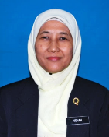

Biography Co- Author
Aishah is a lecturer at the Institute of Teacher Education Malaysia Malay Language Campus. Received her education at SMK Aminuddin Baki Kuala Lumpur for SPM and STPM level and continued her studies at Institute of Teacher Education Malaysia Gaya Campus, Sabah. She holds a Diploma in Management and Leadership from the Aminuddin Baki Institute, Genting Highland and get involved into counseling profession by continuing her studies at Institute of Teacher Education Malaysia Darulaman Campus (IPDA) and pursued her studies at Universiti Putra Malaysia (UPM) in Education Counseling. She has served as Headmaster at Grade A and Grade B primary school for six years, once served as a Student Counselor at a secondary school for eight years and served as the Head Unit of the Psychology and Counseling Institute of Teacher Education Malaysia Malay Language Campus for four years. She is also a registered counselor (K.B / P.A).

Email:
aishah.ghani@yahoo.com

Notes/Comments:

