Narrative Exposure Therapy as an Intervention to Promote Resiliency in Refugee Children and Youth with PTSD.
Anne Mantini, PhD, St. Michael’s Hospital, Canada; Nazilla Khanlou, RN PhD, York University, Canada, Morton Beiser, MD, St. Michael’s Hospital, Canada.

Abstract (300 word limit)
Statement of the Problem: Refugee children and youth have among the highest rates of PTSD in the world and they make up over half of the population of refugees. Growing evidence suggests that promotion of resiliency is an important component to improvement of symptoms and optimal adaptation. This study examined the efficacy of Narrative Exposure Therapy (NET) treatment, on symptom patterns and development of resiliency, for children and youth with post-traumatic stress disorder (PTSD) compared with untreated children in a wait list control group (WLC) participating in a randomized controlled trial (RCT). Measures of behaviour and adaptive development were also utilized. Follow up evaluations were repeated at 3, 6 and 12 months after completion of a course of NET.
Methodology & Theoretical Orientation: 300 refugee children and youth (7-25 years of age) with a DSM-V diagnosis of PTSD were randomly assigned to weekly NET sessions (8-12) or the WLC group. The UCLA-PTSD Trauma History and Reaction Index were used to evaluate their symptoms and outcome while measures of behaviour, resiliency, post-traumatic growth and adaptation are also administered at regular intervals.
Findings: Significant benefits were realized from the course of NET sessions. Scores from clinical symptoms declined immediately during the course of NET sessions while the PTSD growth and resiliency increased significantly compared to baseline and in relation to the control group. At each post-intervention evaluation point, up to twelve months, refugee children and youth demonstrated benefits through resiliency, positive growth and improved PTSD symptoms.
Conclusions: This is the first reported study to show benefits gained in resiliency from treatment of PTSD with NET among refugee children and youth. Given the high prevalence of PTSD in refugee children and youth, intervention that addresses clinical symptoms and supports resiliency and post-traumatic growth is essential.

Image

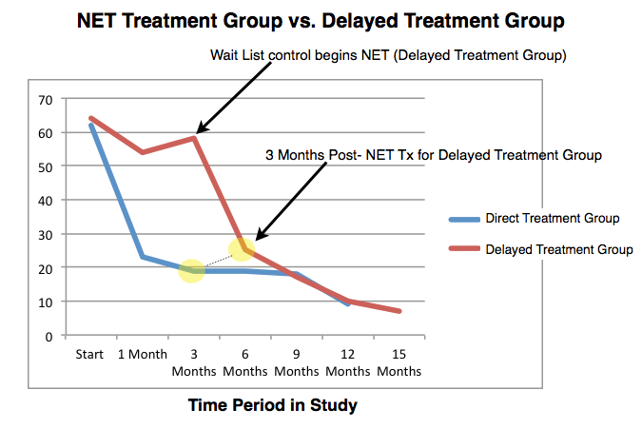

Recent Publications (minimum 5)
1. Beiser, M. & Mantini, A. (in press). “Stress, resilience and mental health: Perspective from a longitudinal study of immigrant youth in Canada.” In Pashang, Khanlou & Clarke (Eds.), Today’s Youth and Mental Health: Hope, Power, and Resilience. Springer, Toronto.

2. Beiser, M. & Mantini, A. (in press). “The Mental Health of Immigrant and Refugee Youth in Canada.” In Wilson-Forsberg, S. (Ed.), Immigrant Youth in Canada. Oxford University Press, Toronto.

3. Khanlou, N., Haque, N., Mustafa, N., Vazquez, L., Mantini, A., & Weiss, J. (accepted for publication). Structural and Instrumental Determinants of Social Support: Access Barriers to Services by Immigrant Mothers of Children with Autism in Canada. Journal of Autism & Developmental Disorders (JADD).

4. Khanlou, N., Haque, N., Skinner, A. & Mantini, A, . (accepted for publication). Scoping Review on Maternal Health among Immigrant and Refugee Women in Canada: Prenatal, Intrapartum and Postnatal Care. Reproductive Health Journal.

5. Mantini, A., McShane, K., Bramesfeld, K., Markarov, Y. & Shakyaver, L. (2016). Multi-platform Knowledge to Action: Using multimedia approaches to engage knowledge users.

Biography (150 word limit)
Dr. Anne Mantini is a Scientist in the Centre for Urban Health Solutions of St. Michael’s Hospital and consultant to the UNICEF Equity and Access Division Her research program examines public health initiatives and the mental health of refugees, children and youth, women. In particular, she examines how Post-Traumatic Stress Disorder (PTSD) and trauma exposure impact on these communities, its treatment through community intervention and training of healthcare providers. The intersection of individual, family, community, policy factors and developmental influences supporting intersectoral interventions, is central to her research.
Email: mantinia@smh.ca

